Fig. 11(b) data: The pie chart presented in Figure 11(b) is generated using values calculated from experimental data.
Power loss distribution
S1 | 3.49
S2 | 4.51
S3 | 3.18
T1 | 2.76
T2 | 2.94
T3 | 2.68
T4 | 2.83
L | 2.25
C1 | 1.34
C2 | 1.5
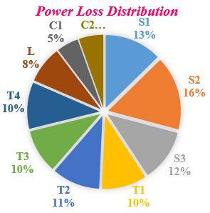
a=[125.7 140 171.5 197 220 245 265 300];
b=[92.4 93.1 93.93 93.3 92.8 92.3 92.5 92.1];
plot(a,b,'-*');
xlabel('Output power (W)'); ylabel('Efficiency (%)');
hold on;

Fig. 11(a) data: Figure 11(a) is generated from experimental results.
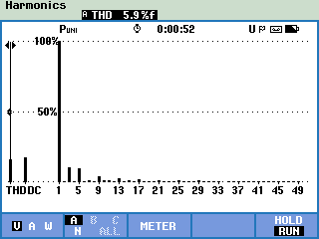

Fig. 11(c) data: The efficiency plot presented in Figure 11(c) is generated using values calculated from experimental data.
a=[125.7 140 171.5 197 220 245 265 300];
b=[92.4 93.1 93.93 93.3 92.8 92.3 92.5 92.1];
plot(a,b,'-*');
xlabel('Output power (W)'); ylabel('Efficiency (%)');
hold on;

Fig. 11(d) data: The bar chart presented in Figure 11(d) is generated using values calculated from experimental data.
Parameter | Simulation (W) | Experimental (W)
S1 | 1.23 | 3.29
S2 | 1.4 | 3.52
S3 | 2.37 | 3.18
T1 | 0.88 | 2.76
T2 | 0.63 | 2.94
T3 | 0.65 | 2.68
T4 | 0.9 | 2.83
L | 0.3 | 2.25
C1 | 0.08 | 1.34
C2 | 0.09 | 1.5

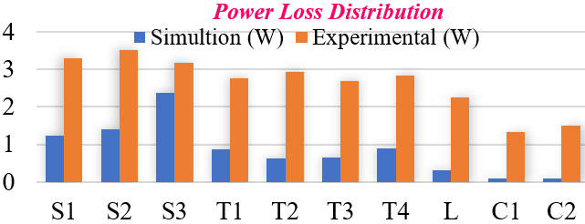

Fig. 12(a) data: The pie chart presented in Figure 12(a) is generated using values calculated from experimental data
Power loss distribution
Parameter | Loss (w)
S1 | 1.23
S2 | 1.4
S3 | 3.5
T1 | 0.8
T2 | 0.6
T3 | 0.65
T4 | 0.9
L | 0.3
C1 | 0.08
C2 | 0.09



Fig. 12(b) data: The efficiency plot presented in Figure 12(b) is generated using values calculated from experimental data.

figure;
%plot(P, EF, 'r', 'LineWidth', 2.5);
hold on;
x1=[ 190.05 205 217.15 233.34 253.4 276.37 304.01 337];
y1=[ 92.13 93.09 93.008 92.5 92.8 92.66 92 91.2];
plot(x1,y1,'o-','LineWidth',2)
ylim([80 100]);
xlabel('Output Power (W)');
ylabel('Efficiency (%)');
title('Efficiency vs Output Power');
grid on;
box on;

