Skyrun Customer Analysis: Findings & Recommendations
Oct 28, 2026 · @AMDARI

Executive summary
Skyrun currently has 4,339 identified customers who placed orders between 1 Dec 2024 and 9 Dec 2025. 54.7% of revenue can be attributed to 668 Champions (15.4% of customers). The second order is the most problematic, as only around 1 in 5 new customers orders again in the follow-up month to their first order.
Headline findings
- On average, 20% of new customers place a second order in their second month (15–24% for all 2025 cohorts). Customer retention is consistently low rather than diminishing over time.
- There is an increase in ordering for customers in later months for earlier cohorts. For example, the January 2025 cohort orders 33% and 36% in months 10 and 11 in October and November respectively.
- 2,234 Loyal Repeaters and Champions make up 51.5% of the total number of customers but account for 88.9% of all revenue.
- 1,190 New One-Time Buyers (27.4%) ordered recently (median 55 days ago) but typically only place 1 order. This is the cohort that would benefit the most from conversion.
- 915 Lost One-Time Buyers (21.1%) made their last order a median of 260 days ago and make up 5.2% of all revenue.
Top recommendations
- Introduce a second-order programme for New One-Time Buyers and all new customers.
- Introduce a loyalty programme to encourage Loyal Repeaters to order more like Champions.
- Keep Champions ordering through account management and loyalty perks.
- Send low-cost win-back offers to Lost One-Time Buyers before the autumn.
- Make sure a customer ID is captured on every order.

Background and data
The requirement for the project stated that Skyrun does a good job of acquiring new customers, but retention has suffered over the past 18 months. A large number of new customers make one transaction and then do not come back. The aim of this project was to assess customer retention by acquisition cohort, segment customers by value, and make recommendations for improving retention.
Item | Value
Source file | Skyrun dataset.csv (transaction lines)
Period covered | 1 Dec 2024 – 9 Dec 2025
Rows after removing cancelled orders | 532,621
Rows kept for analysis (CustomerID present) | 397,924 (134,697 rows, 25%, had no CustomerID)
Customers | 4,339 (total across the four segments)
Cancelled orders (invoice numbers that start with "C") were removed because they are not purchases. If they were counted, the number of orders, revenue and retention would all look higher than they really are. Revenue was calculated by multiplying quantity by unit price.
There is some issue with product category and country. For example the first invoice in the data set (invoice number 536365) has Egypt, Mali, South Africa and Rwanda in the first 5 lines. This cannot be for the same delivery. For this reason country and product category are ignored and the analysis is instead based on who purchased and when.

Methodology
Three methods were used for the analysis, all in Python (pandas, scikit-learn, seaborn and yellowbrick).
- Data cleaning: cancelled orders and rows without a customer ID were removed, and the invoice date was read in as a date.
- Cohort retention: each customer was placed in a cohort based on the month of their first order. Retention is the percentage of that cohort who ordered again in each of the following months. December 2024 was excluded because the data starts in that month, so customers who were already ordering before then would look like new customers. December 2025 was excluded because the data ends on 9 December.
- RFM segmentation: the following were measured for each customer:
  - Recency: the number of days since their last order, counted from the day after the last transaction
  - Frequency: the number of invoices
  - Monetary: total revenue
Frequency and monetary were log-transformed (np.log1p) because a small number of customers order and spend much more than everyone else. All three measures were then standardised and grouped using K-Means. The elbow method (k = 2–9) showed that 4 clusters was the best choice. Each cluster was then named based on its median profile.
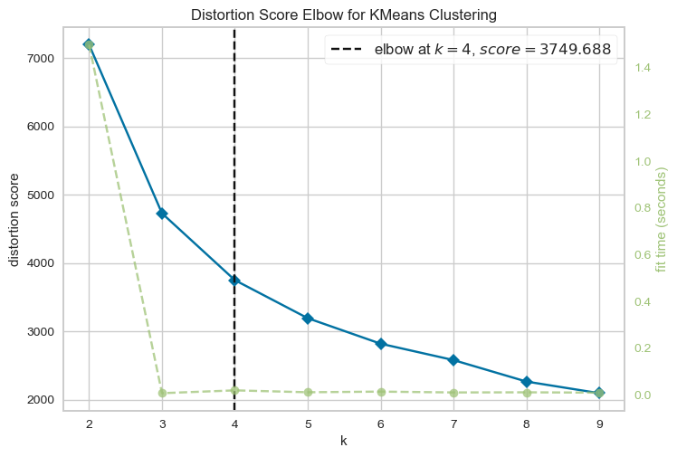
Analysis notebook · distortion score elbow for K-Means, with the elbow at k = 4

Key findings

1. Only around 1 in 5 new customers orders again in the following month
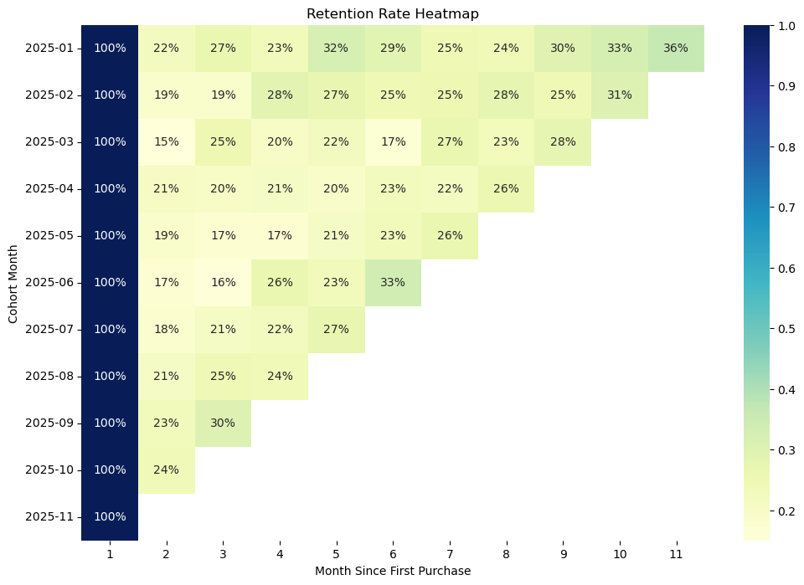
Analysis notebook (Retention_heatmap.png) · new-customer cohorts from January to November 2025, complete months only
- On average, 20% of new customers place a second order in their second month, ranging from 15% to 24% across the 2025 cohorts.
- There is no clear decline across 2025. Customer retention is consistently low rather than diminishing over time.
- Earlier cohorts order more in their later months. For example, the January 2025 cohort reaches 33% and 36% in months 10 and 11, which are October and November. This suggests that customers who stopped ordering come back in the autumn.
- The December 2024 cohort was left out because it is mostly made up of existing customers rather than new ones.

2. A small group of customers makes up most of the revenue
Segment | Customers | Share of customers | Median days since last order | Median orders | Median spend per customer (£) | Share of revenue
Champions | 668 | 15.4% | 11 | 11 | 567,282 | 54.7%
Loyal Repeaters | 1,566 | 36.1% | 32 | 4 | 184,753 | 34.2%
New One-Time Buyers | 1,190 | 27.4% | 55 | 1 | 43,135 | 5.8%
Lost One-Time Buyers | 915 | 21.1% | 260 | 1 | 41,924 | 5.2%
Share of revenue is the total spend of each segment divided by the total spend of all customers.
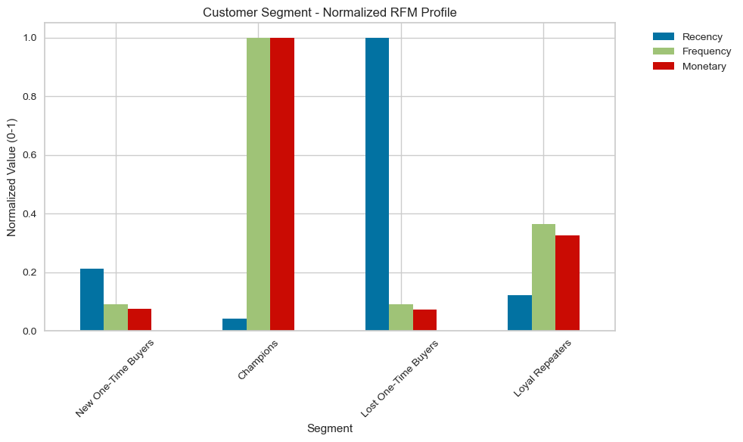
Analysis notebook (rfm_profile.png) · median recency, frequency and spend for each segment, each scaled from 0 to 1
- Champions (668) made their last order a median of 11 days ago, with a median of 11 orders each. They make up 15.4% of customers but 54.7% of all revenue.
- Loyal Repeaters (1,566) order regularly but less often, with a median of 4 orders, and make up 34.2% of all revenue. Moving them closer to how Champions order is the biggest opportunity for growth.
- New One-Time Buyers (1,190) ordered recently (a median of 55 days ago) but typically only have 1 order. They are recent enough to be converted into repeat customers.
- Lost One-Time Buyers (915) made their last order a median of 260 days ago, with a median of 1 order, and make up 5.2% of all revenue.

Recommendations
The recommendations are ranked by the size of the opportunity. Owners and targets are placeholders and need to be agreed with the team.
# | Recommendation | Segment | Why | KPI | Owner | Target
1 | Follow up after the first order with personalised recommendations and a second-order offer for a limited time | New One-Time Buyers (1,190) and all new customers | Only 20% of new customers order again in their second month (15–24% across cohorts), and most of this group have only made 1 order | Month-2 retention | [Owner] | [e.g. 20% → 25%]
2 | A tiered loyalty programme with points and free delivery to encourage customers to order more often | Loyal Repeaters (1,566) | They make up 34.2% of revenue but only have a median of 4 orders, compared with 11 for Champions | Orders per customer | [Owner] | [e.g. 4 → 6]
3 | Account management, early access and volume pricing to keep them ordering | Champions (668) | They make up 54.7% of revenue but only 15.4% of customers | Champions retained | [Owner] | [e.g. 95% retained]
4 | A low-cost win-back offer (for example a discount for a limited time) sent before the autumn. Stop after one offer with no response | Lost One-Time Buyers (915) | Their last order was a median of 260 days ago and they make up 5.2% of revenue. Earlier cohorts order more in October and November | Reactivation rate | [Owner] | [e.g. 10% reactivated]
5 | Make sure a customer ID is captured on every order (account, phone or loyalty number) | All | 134,697 rows (25%) had no CustomerID, so these customers cannot be tracked | Rows with a CustomerID | [Owner] | [e.g. 75% → 95%]

Limitations and next steps
Limitations
- Unreliable variables: product type and country vary across orders and are not used as segmentation or targeting variables for this analysis.
- Missing Customer IDs: 25% (134,697 rows) are missing a CustomerID and were excluded from the analysis. Revenue values only include transactions for customers that were found.
- Edge months: December 2024 consists largely of customers that were present prior to the start of the data and December 2025 only includes data from the 1st to 9th of December. These months were excluded from the cohort analysis.
- Clustering results: The number of clusters selected impacts the segments produced as well as the application of the log transform. Segment names refer to median values. For example, the median New One-Time Buyer has made 1 order, but some customers in this segment may have made more than one purchase.

