Telegram

2 Ways to Install Telegram on Ubuntu 16.04: PPA & Snap Package

April 12, 2018 by MUDAMBI RICHARDS

Telegram is a free and open source instant messaging client that values user’s privacy and data encryption. In this tutorial, I will show you 2 ways to install Telegram on Ubuntu 16.04.

Method 1: Install Telegram on Ubuntu 16.04 Via Snap

A Canonical employee has packaged a Telegram snap app. You can find it in Ubuntu Software by searching for “telegram”. Then click install button to install it on Ubuntu 16.04.
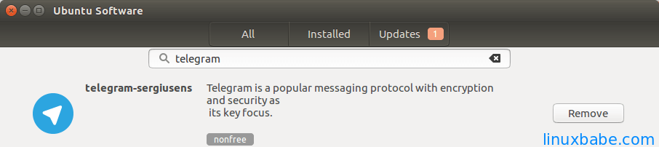

You can also open a terminal window and enter the following command to find the name of Telegram snap package.
$ snap find | grep telegram
Then run this command to install it.
$ sudo snap install telegram-sergiusens
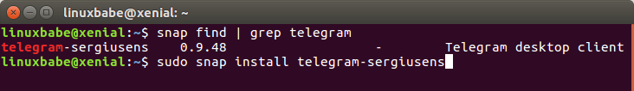

Method 2: Install Telegram on Ubuntu 16.04 via PPA

There’s also a Telegram PPA available for Ubuntu 16.04. Run the following 3 commands to install from PPA.
$ sudo add-apt-repository ppa:atareao/telegram

$ sudo apt-get update

$ sudo apt-get install telegram
If you can’t find Telegram in Unity Dash after it’s installed, log out and log back in, then you should be able to find it.
Snap packages and deb packages can live happily with one another. So you can install two Telegram clients on Ubuntu 16.04.
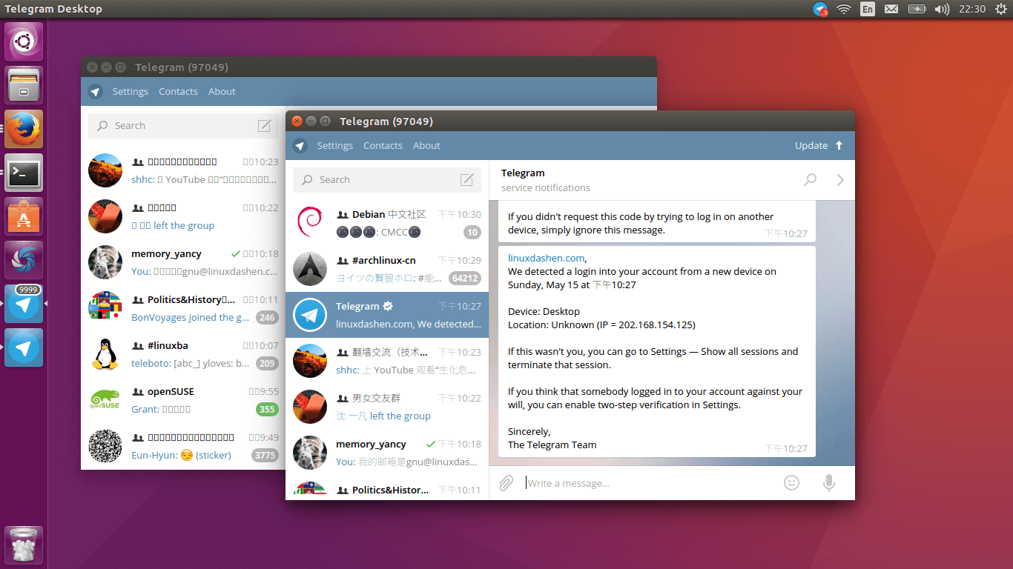
Two Telegram clients running at the same time on Ubuntu 16.04

The downside of this Telegram snap app is that there’s no tray icon. In addition, it can’t open link via Web browsers and CJK fonts are not displayed properly. From a pragmatic standpoint, I recommend installing Telegram from PPA.
In theory, snap package is safer to use because it is confined by sandbox. However, the default display server on Ubuntu 16.04 desktop is still X11 and as you may already know, X11 is inherently insecure. Applications in X11 can steal other application’s data.
Comments, questions and suggestions are always welcome. If you find this post useful, please subscribe to our free newsletter or follow us on Google+, Twitter or like our Facebook page.

