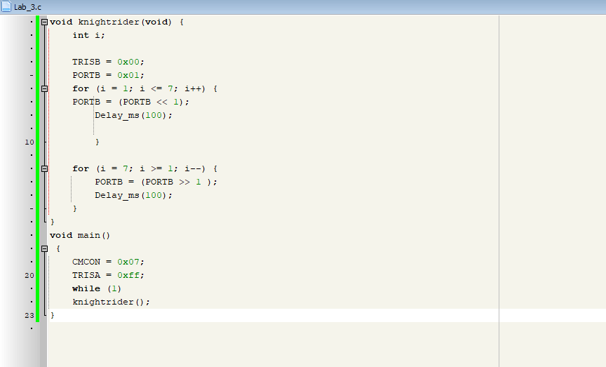

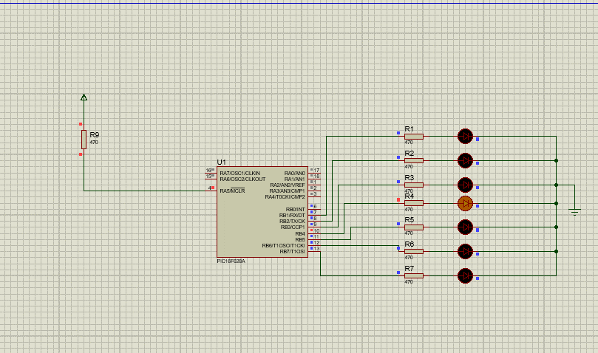

**DISCUSSION**

This experiment involved designing an LED chaser using the PIC16F628A microcontroller. The LED sequence was controlled through loop-based logic, where for and while loops were used to light up LEDs one by one and then reverse the direction of movement. To make the transitions visible, the Delay ms function was applied between steps. The LEDs were connected to PORTB, which was configured as output. Additionally, the CMCON register was set to 0x07 to disable the internal comparators and enable proper digital I/O operation. The program was compiled and uploaded to the PIC16F628A successfully. For the hardware setup, a breadboard was used along with an LM7805 voltage regulator to supply a stable 5V power source. When the system was powered on, the LEDs displayed the chaser effect as expected. This task demonstrated fundamental microcontroller skills such as I/O pin setup, loop control, delay management, and real-world implementation of embedded programming