Explaining about the FreeRTOS Kernal Folder
I have Downloaded FreeRTOS v202012.00
The below folder is called FreeRTOS Kernel.
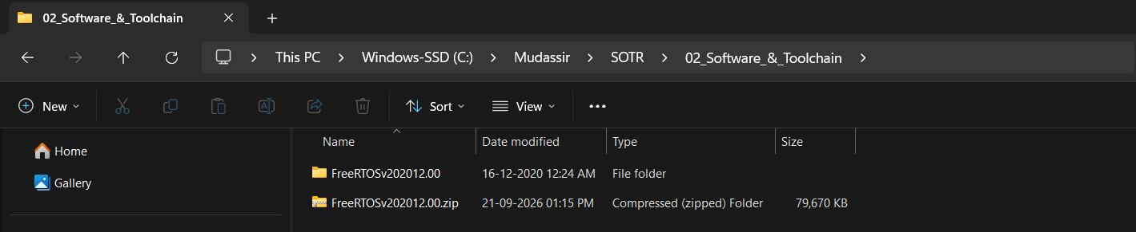
When you open the above folder, you will find two important folders, one is FreeRTOS and other is FreeRTOS-Plus
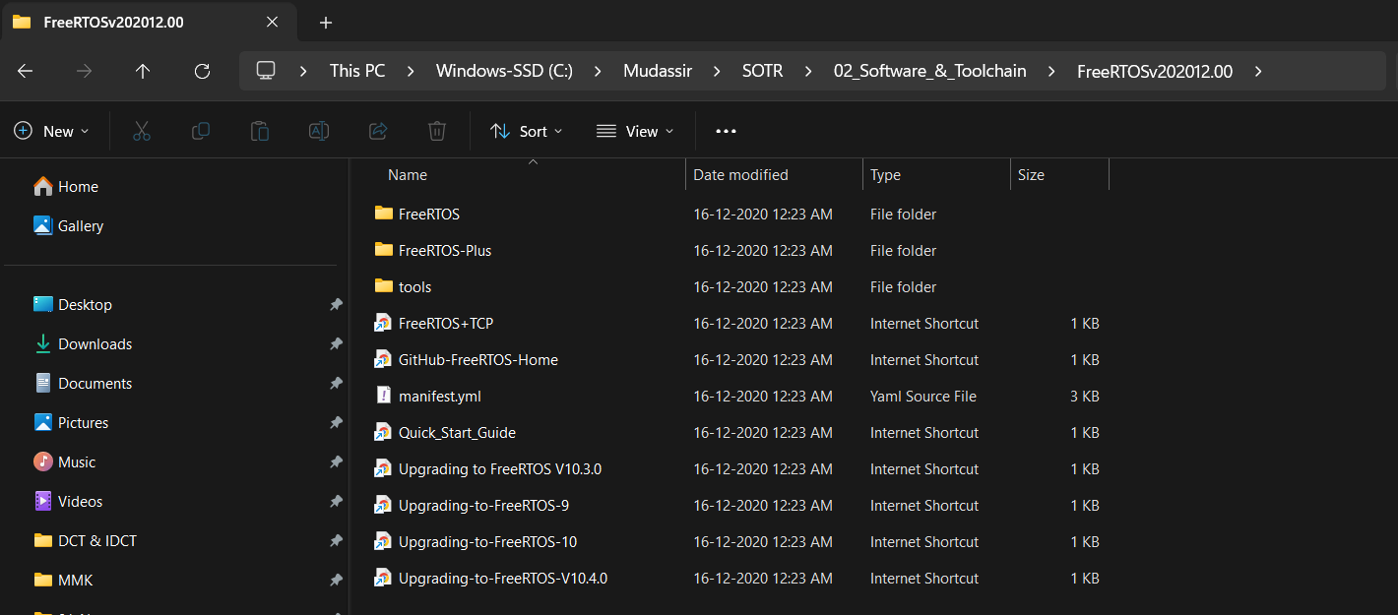
In the above image, the folder by the name FreeRTOS is the FreeRTOS Kernel Directory.
In that Directory open the Source folder. FreeRTOSv202012.00\FreeRTOS\Source
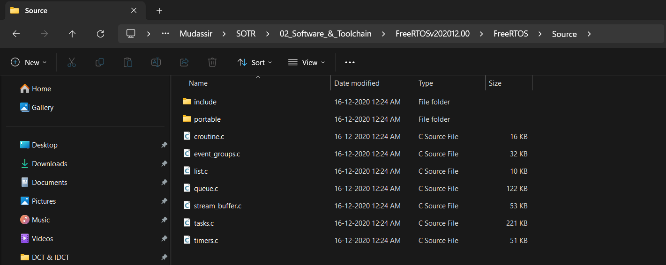
You will see the source code for FreeRTOS Kernel.
The above .c file inside the Source folder are architecture independent codes of the FreeRTOS Kernel.
The .c file inside the portable folder contains the architecture specific codes.
FreeRTOSv202012.00\FreeRTOS\Source\portable
The include folder contains the respective header files.
FreeRTOSv202012.00\FreeRTOS\Source\include
The portable folder contains the processor architecture specific codes.
FreeRTOSv202012.00\FreeRTOS\Source\portable
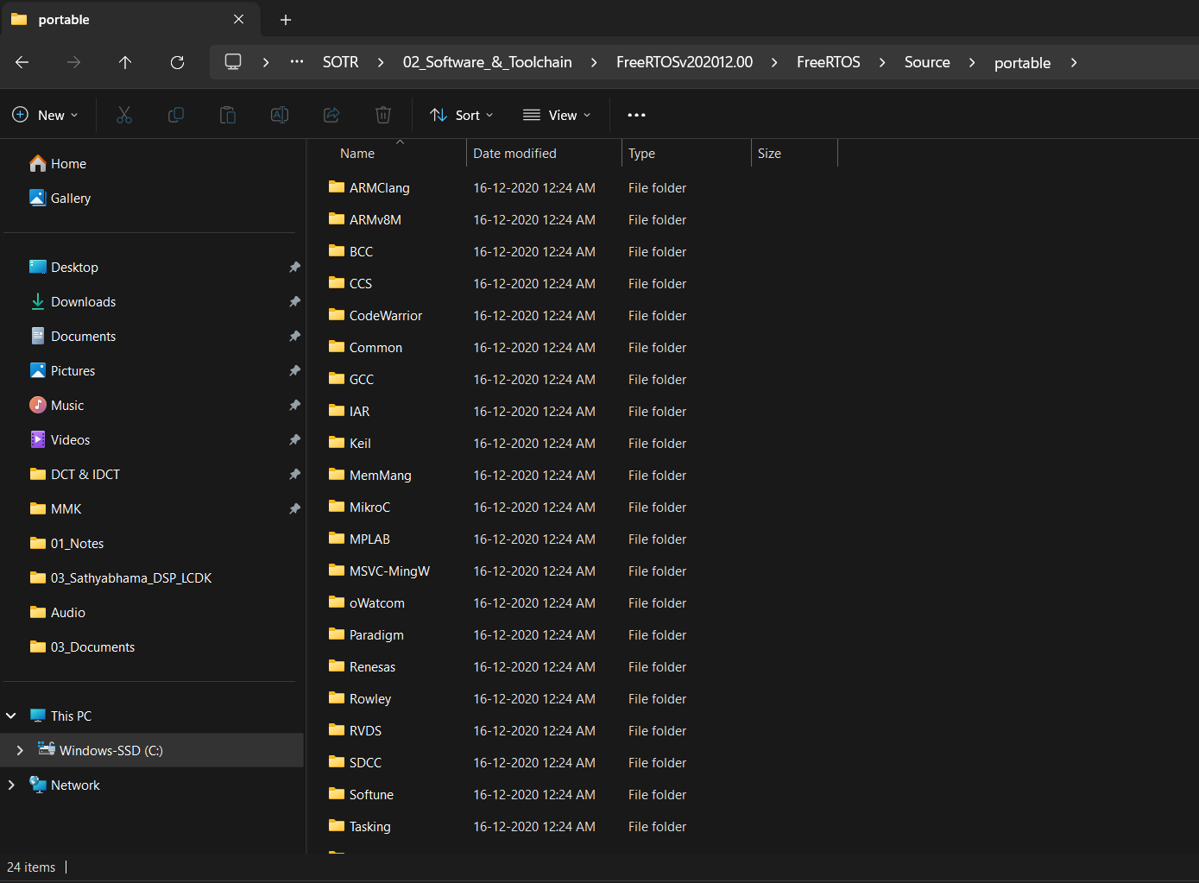
In the above image, these are the different folder related to different compiler, which we can use to compile the FreeRTOS Kernel source.
We will be using GCC compiler.
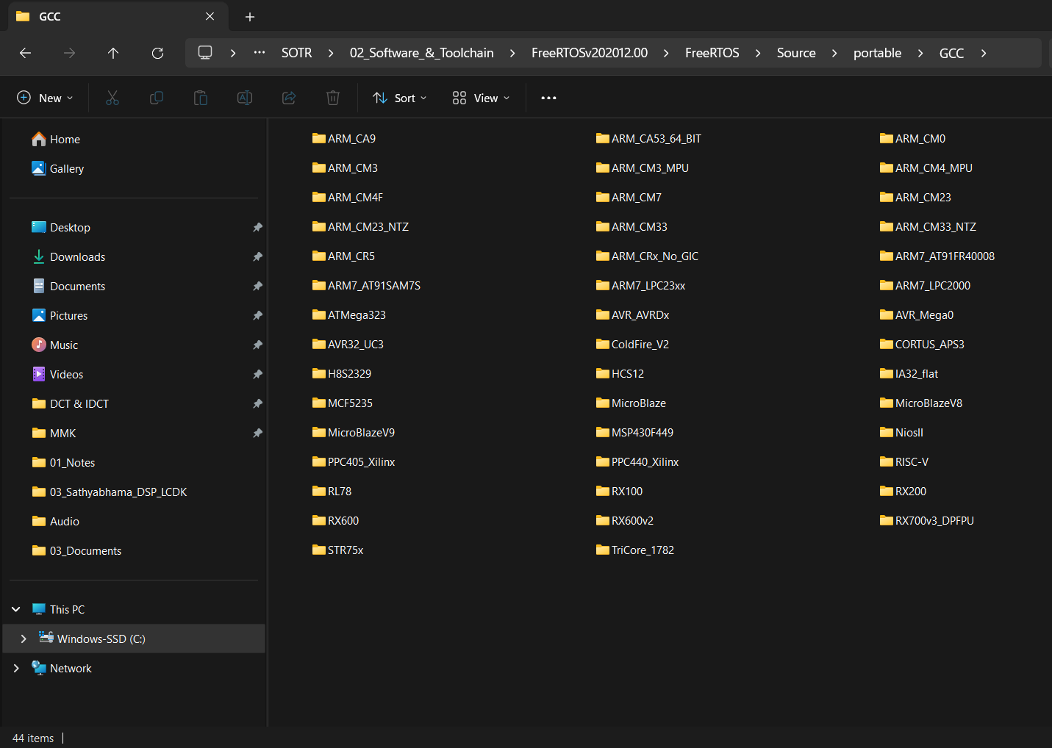
If you get inside the GCC folder you will see many folders related to different processor architecture. FreeRTOSv202012.00\FreeRTOS\Source\portable\GCC
By looking these folders, you can say FreeRTOS supports all this different processor architectures.
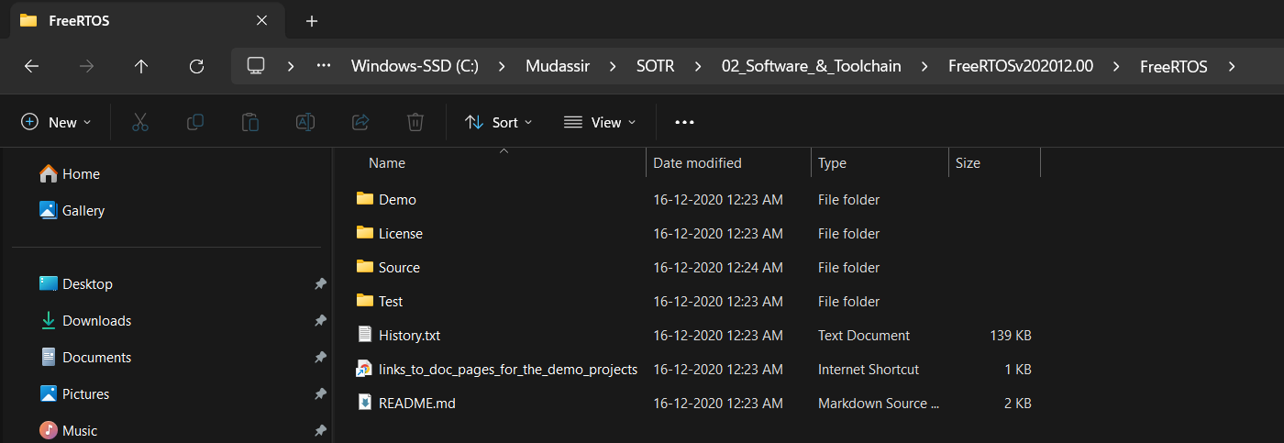
You can also see some Demo projects inside the Demo folder, which are given by FreeRTOS.org, for different microcontrollers. FreeRTOSv202012.00\FreeRTOS\Demo
And in the Licence folder you can see the Licencing scheme which is impose by FreeRTOS.org to use this Kernel source code.
FreeRTOSv202012.00\FreeRTOS\License
If you are plaining to produce any commercial product using FreeRTOS Kernel then you should go through the Licencing scheme.
FreeRTOSv202012.00\FreeRTOS-Plus
If you open FreeRTOS-Plus, this actually contain various middleware.
Like it contains CLI Libraries which you can use along with FreeRTOS Kernel, and it also contains various Networking related stacks such as TCP, UDP, etc...
FreeRTOSv202012.00\FreeRTOS\History.txt
And if you just open this History document here. It tells you what is the version of this FreeRTOS. This is FreeRTOS version 202012.00

Integrating FreeRTOS Kernal to our Project
We are using STM32F407-DIS01.
STM32Cude IDE version 1.17.0

Creating a Project in STM32Cube IDE
Step1: Create a FreeRTOS Workspace
Step2: Open that folder in STM32Cude IDE
Step3: Click File New STM32 Project.
Step4: Select the board and click Next.
Step5: Give a name to the Project and Targeted Project Type select STM32Cube as shown below and Click Next.
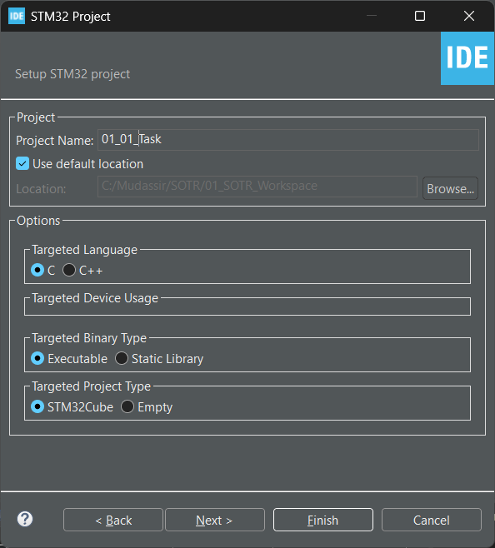
Step6: Select Copy only the necessary library files and Click Finish.
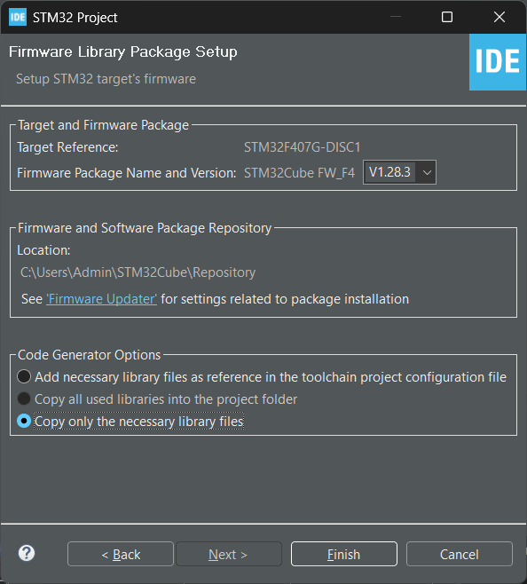
Step7: Below Option Select No.
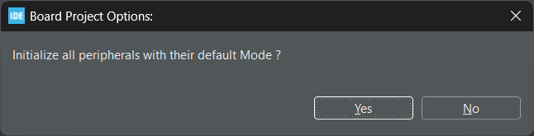
Step8: Below Option Select Yes.
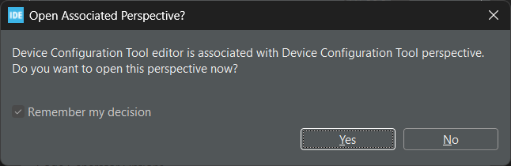

Step9: After the above steps, the Device Configuration Tool will open as shown below.
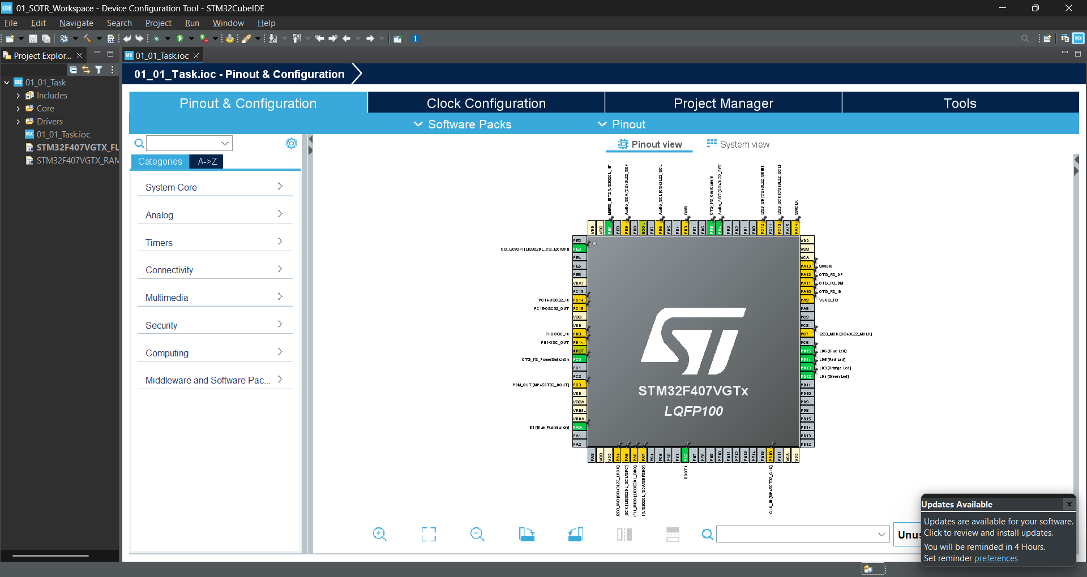
this is a device configuration tool, which is embedded in the STM32Cube IDE, so from which you can select various peripherals, you can configure the peripherals, you can set the clock and you can do so many other things.

Methods of Adding FreeRTOS Kernal to our Project
There are two methods by which we can add the FreeRTOS kernel.
Either we can add manually or by using STM32Cube's device configuration tool.
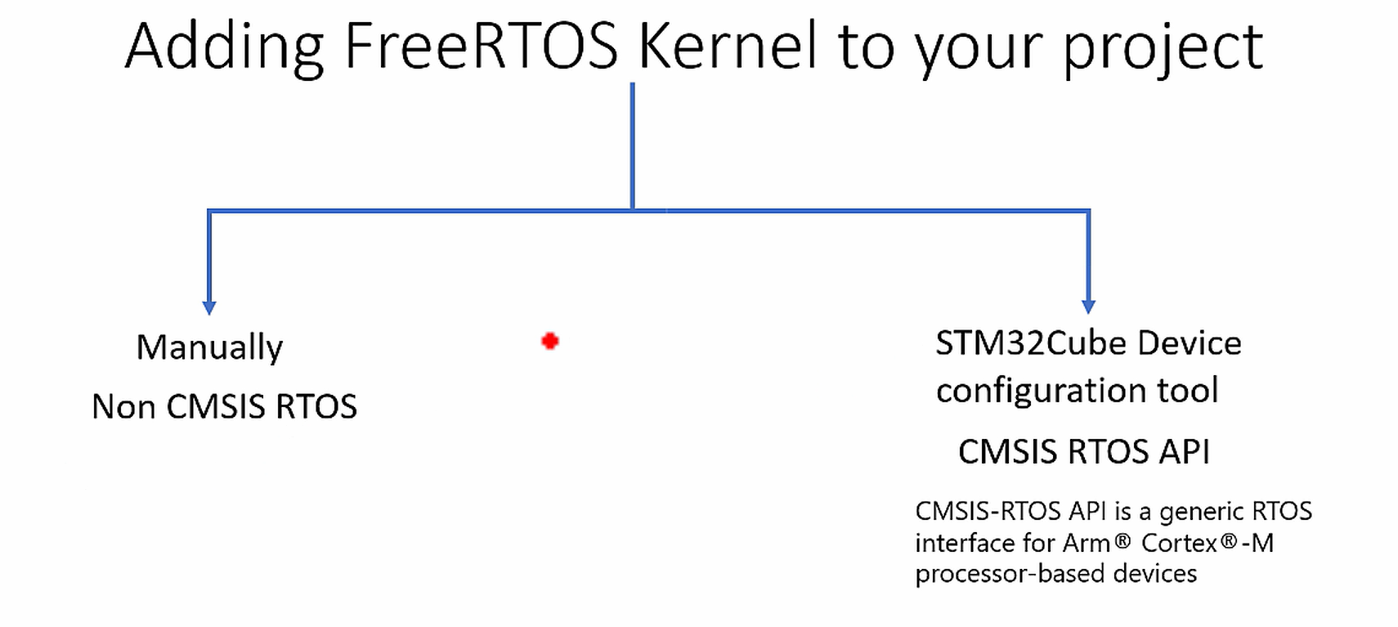

Brief Introduction about CMSIS RTOS API
If you’re wondering what exactly is CMSIS RTOS API.
It is actually from ARM.
Basically, it's a software layer.
It’s a generic RTOS interface.
That's an advantage of having a CMSIS RTOS API layer.
It's a generic RTOS interface for ARM Cortex M processor-based devices.
This layer actually provides a standardized API for software components that require RTOS functionality.
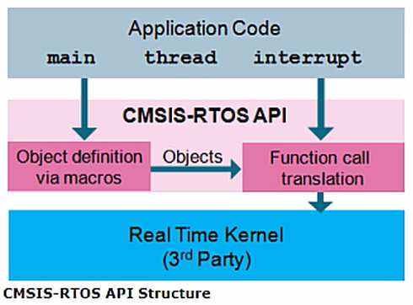
If you just check this picture here.
The blue box, this is a real time kernel code. It could be FreeRTOS or it could be Embos or it could be any other real time kernel.
The grey box, this is your application, that is real time kernel-based application.
In between these two layers, the pink box this is adaptation layer.
This layer exposes generic APIs for the application.
So, this layer doesn't let you to use the RTOS specific APIs.
The advantage here is, if tomorrow the blue box layer changes, you can still run the application code on different real time kernel without making any significant changes to the application code.
Why?
Because, the application depends on the APIs exposed by the CMSIS-RTOS layer.
That's why, even this layer changes tomorrow, your application code will still work on different real time kernel.
That's why, if you use a STM32 device configuration tool, it will also add this layer, along
with the FreeRTOS layer.
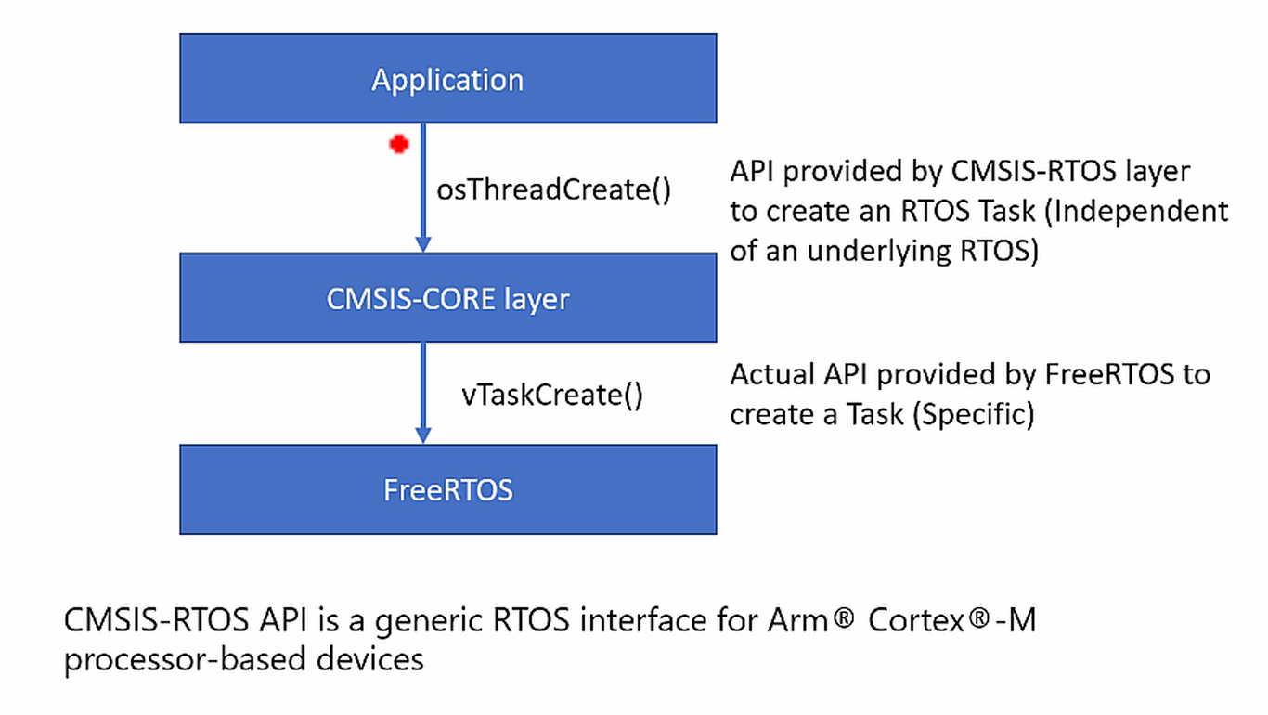
For example, let's say an application wants to create a task.
In that case, the application can just use a generic API provided by the CMSIS CORE.
In this case, the API name could be osThreadCreate. This is an API provided by CMSIS-RTOS layer to create an RTOS Task. This is independent of any underlying RTOS. Once application makes a call to this function, the CMSIS layer then converts that call to RTOS specific call.
Suppose, if you are using FreeRTOS, so if the underlying RTOS is FreeRTOS, then the actual API provided by the FreeRTOS is vTaskCreate.
This is RTOS specific. In some other RTOS it could be different. So, application need not to bother about what is a actual task creation API. It just has to call osThreadCreate. Independent of any underlying real time kernel source.

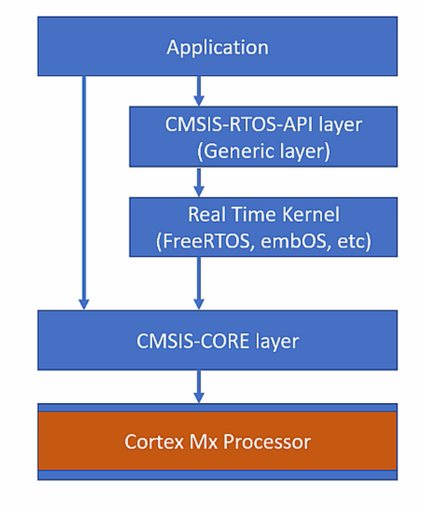
Our Project Layers

So, this is how our project layer looks like.
We have got application layer, where we write our main.c or user application.
We don’t have CMSIS-RTOS-API Layer.
We have got our FreeRTOS kernel source, we have to add this layer now.
And we have also got CMSIS-CORE layer. The CMSIS-CORE layer is again it gives you standardized APIs to deal with Cortex M processor-based peripherals.

If we go back to our project.
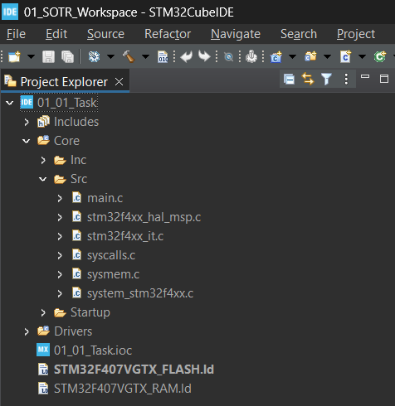

01_01_Task Core Src, This Src is your application layer.
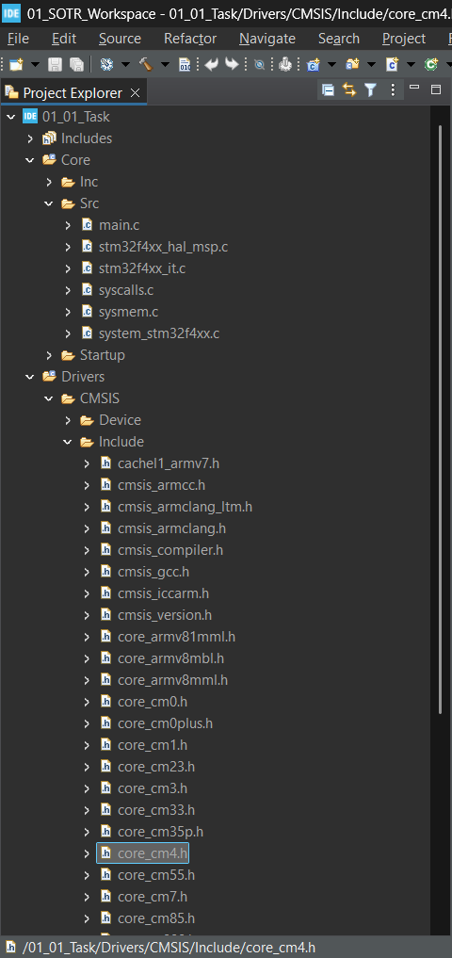
01_01_Task Drivers CMSIS Include, this is our CMSIS-Core Layer
We are using Cortex M4 so core_cm4.h is our CMSIS Layer, this includes CMSIS core API’s.
Which gives you the standardized functions to deal with peripherals of the Arm cortex Mx
processor.
Now let’s Add FreeRTOS Kernel to our project.

Adding FreeRTOS Kernel to our project (Manual Method).

Coping the FreeRTOS Kernal Code to out project
Step1: What I'm going to do now is, I'm going to create one folder here, inside the project.
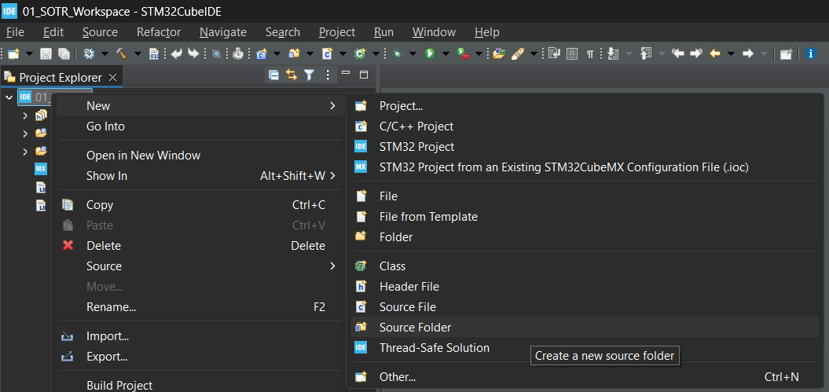
Right Click Project New Source Folder
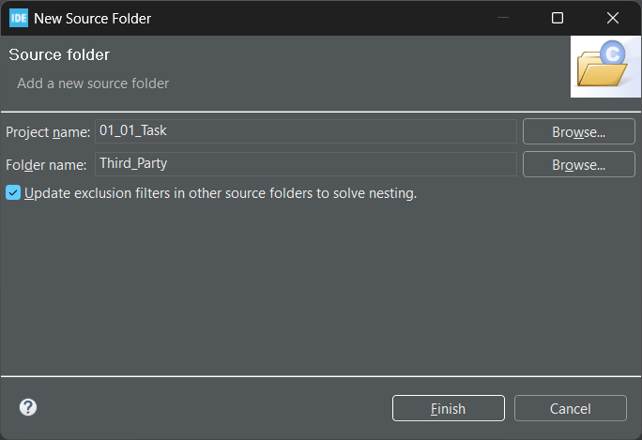
I would like to call it as Third_Party, Click Finish.
This is a folder to keep all Third-Party codes for our project.
Step2: Now, you do one thing, just go to the project location by using file explorer.
Open the Third_Party Folder, and create another folder by the name FreeRTOS, as shown below.
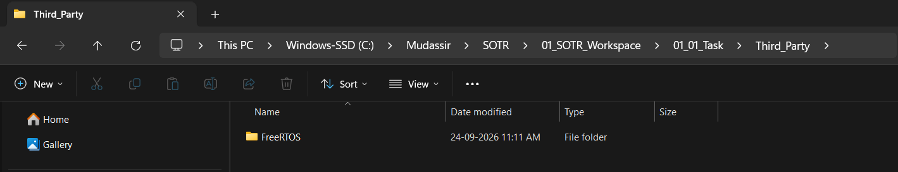
Step3: Now, in this folder, you have to copy the FreeRTOS kernel source, what you have extracted in the earlier part of this file.
Let’s start coping the FreeRTOS Kernel Source code into your project Third_Party folder.
Below I will write the file path that we have to copy:
Example below: copy License folder to our WorkspaceProject_nameThird_PartyFreeRTOS
FreeRTOSv202012.00\FreeRTOS\License 01_SOTR_Workspace\01_01_Task\Third_Party\FreeRTOS
FreeRTOSv202012.00\FreeRTOS\Source 01_SOTR_Workspace\01_01_Task\Third_Party\FreeRTOS
Copy every thing inside the Source folder to FreeRTOS, then inside the portable folder delete everything except GCC, MemMang and readme, now go inside GCC and delete everything which is not related to your processor architecture.
In this project we are going to use STM32F407 which is based on CortexM4 with floating point support. So, except ARM_CM4F delete everything inside the GCC folder.
If you check inside the ARM_CM4F you can find two files, one is the source file and another one is a header file. These are actually port codes or architecture level codes, which are required by the FreeRTOS to run on our processor architecture.
After every this this is how your project folder will look like below.
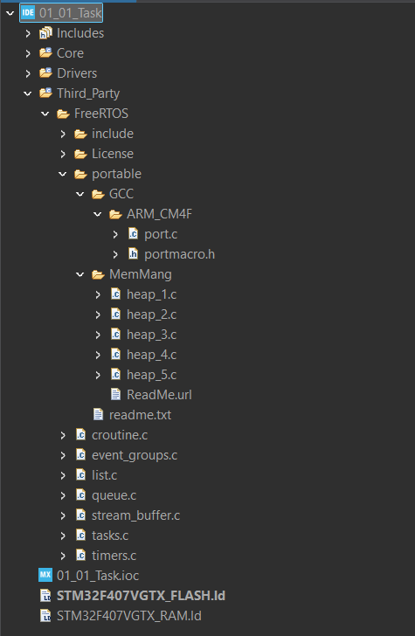
Inside the coreScr folder you will find the below things
In the main.c, we will be adding our application code.
The stm32f4xx_it.c contains all the interrupt handlers and system exception handlers.
The stm32f4xx_hal_msp.c which contains the device initialization code for different peripherals.
The syscalls.c this file actually implements some of the standard library system calls, such as write, read, etc. So, we will use them a little later.

And after that, we have got sysmem.c, which is for heap management.
For this project the FreeRTOS provides its own heap management code.
That is a code which handles a dynamic memory allocation.
That's why, we don't need this sysmem.c for this project. Just right click over that, select properties, and you can check this option exclude resource from build.
Because, the FreeRTOS gives you the heap management code, which is there in a portableMem management folder. Here you see one, two, three, four, five.
So, we'll discuss more on this later, but for this project we will be using heap_4.c
These are different heap management schemes provided by FreeRTOS.
You must use either one of these files, not all files.
So, we'll just use heap_4.c
That's why, I'm going to delete these files. heap_1, 2, 3, and 5. Just delete them.
Just keep heap_4.c
If you build the project now it will give you some header file not found error, we will solve it in next. (#include "FreeRTOS.h" no such file or directory)

Include Path settings
In the previous lecture, we tried to compile this project, but we met with couple of errors.
The errors are related to missing of header files.
That means, the build is not able to detect the header files, which are added by the FreeRTOS Kernel.
Now in this section we will resolve this issue.
Right click on the project, go to properties C/C++ Build Setting MCU/MPU GCC Compiler Include paths.
Below are the paths which are already included.
../Core/Inc
../Drivers/STM32F4xx_HAL_Driver/Inc
../Drivers/STM32F4xx_HAL_Driver/Inc/Legacy
../Drivers/CMSIS/Device/ST/STM32F4xx/Include
../Drivers/CMSIS/Include
We have to add some more path related to the FreeRTOS Kernal.

Click add Workspace Project_name Third_Party FreeRTOS

Now select the include folder and click OK, and again OK

In the same way do for the below folder also.
01_01_Task\Third_Party\FreeRTOS\portable\GCC\ARM_CM4F
So, you have added the path and it will look like this below.

Now, let's try to build the project once again.
Now you see most of the FreeRTOS related header files issues got resolved.
Now we met with another error that is FreeRTOSConfig.h.
(#include "FreeRTOSConfig.h" no such file or directory)
So, this FreeRTOSConfig.h is a configuration header file used to customize your FreeRTOS kernel source.
This doesn't come with FreeRTOS kernel source.
You have to add this externally.
So, we will add this in the next section

The final include path will look like.
"${workspace_loc:/${ProjName}/Third_Party/FreeRTOS}"
"${workspace_loc:/${ProjName}/Third_Party/FreeRTOS/include}"
"${workspace_loc:/${ProjName}/Third_Party/FreeRTOS/portable/GCC/ARM_CM4F}"

And the already containing path what I showed before.

Adding FreeRTOSConfig.h & what it is in brief
First of all, what is this FreeRTOSConfig.h?
As its name indicates, it's a configuration file to customize the FreeRTOS kernel. Basically, it's a C header file. This header file contains a various configuration item’s, by which you can customize the FreeRTOS kernel.
Interestingly, this doesn't come with FreeRTOS kernel download. You have to create it on your own, it is actually application specific. So, you have to create it.
FreeRTOSConfig.h is nothing but collection of various configurable items.
These are the standard configuration items, which you have to write as C Macros.
For example, let's consider this configuration item configUSE_PREEMPTION. If this configuration item is set to 1, then FreeRTOS will be configured for preemptive kernel.
That means, preemption will be enabled inside the kenel. If you set this configuration item to 0, then preemption inside the kernel will be disabled, like that.
If you consider this configuration item TICK_RATE_HZ, which is set to 250, this decides the FreeRTOS ticking frequency which is set to 250 Hz.
FreeRTOSConfig.h also contains configuration items which are processor dependent.
That's why, a FreeRTOSConfig.h used for one processor architecture may not be used for the project which is used for another processor architecture.
Please note this point.
If you want to know more about the configuration file you can check using the below link.
https://www.freertos.org/Documentation/02-Kernel/03-Supported-devices/02-Customization
Now we just have to include this header file to resolve our build issue.
To get the FreeRTOSConfig.h for our processor architecture we will go to the demo projects, that came with the FreeRTOS Kernal folder
Here is the path: FreeRTOSv202012.00\FreeRTOS\Demo\CORTEX_M4F_STM32F407ZG-SK
Inside this folder you will find the FreeRTOSConfig.h header file
Copy this file to your project Third_Party FreeRTOS folder.
And add this to your Include path other wise the build won’t recognize the header file.

We can build the project now.

After this you will see a new issue SystemCoreClock is undeclared
We are getting this error from the file what we just added that is FreeRTOSConfig.h

To resolve this issue, you have to extern SystemCoreClock variable in FreeRTOSConfig.h, that is already done here. But it is compiled out. So, we have to modify this now.
#ifdef __ICCARM__
#include <stdint.h>
extern uint32_t SystemCoreClock;
#endif

Here, they have used The IAR cross compiler for Arm. This is a macro to identify IAR workbench's cross compiler for Arm. In this course, we are not using IAR compiler.
We are using GCC compiler, right?
That's why, I have to modify this pre-processor directive. What I'm going to do now, I'm going to make this generic.
#if defined(__ICCARM__) || defined(__GNUC__) || defined(__CC_ARM)
#include <stdint.h>
extern uint32_t SystemCoreClock;
#endif
Basically, what this statement says is that, enable this code block, if any of these compilers have been used to compile this project.
(__ICCARM__) this macro identifies the IIR compiler,
(__GNUC__) this is for GNUC Compiler,
and this is for(__CC_ARM) the ARMs native compiler.
Ok let’s compile, So, the SystemCoreClock issue is resolved and now we have a new issue.
Basically, the error is coming from the port code.
That is architecture level code.
That is port.c, which is there in ARM_CM4F folder.
What it says is, multiple redefinition or multiple definition of some handlers.
If you remember from our arm cortex processor specific course, that there are exceptions in the ARM Cortex Mx processor like SVC exception, PendSV exception, and SysTick timer exception.
These are some of the exceptions of the Arm Cortex Mx processor.
And to handle those exceptions we write SVC_Handler, PendSV_Handler, and SysTick timer handler.
And these exception handlers are used to support FreeRTOS at the architecture level.
For example, the PendSV_Hander is used to implement the FreeRTOS scheduler.
And the SysTick_Handler is used to launch the scheduler at given intervals. Basically the SysTick timer of the processor is configured to generate SysTick interrupts, which is used to launch the scheduler at defined intervals, and also it is used for time keeping functionality.
So, let’s see how to resolve this error
The port.c already has definition for these hander's.
But, our STM32Cube project also given the definition of these handlers in some file, and that file is stm32f4xx_it.c
This file also gives empty functions or empty exception handlers.
But these handlers already been implemented in port.c
That’s why there is a conflict, to resolve this we will remove the exception handlers from stm32f4xx_it.c by using the Device configuration tool.
Open the Device Configuration Tool
Goto System Core NVIC Code Generation
and uncheck the below things
Pendable request for system service
Time base: System tick timer
System service call via SWI instruction
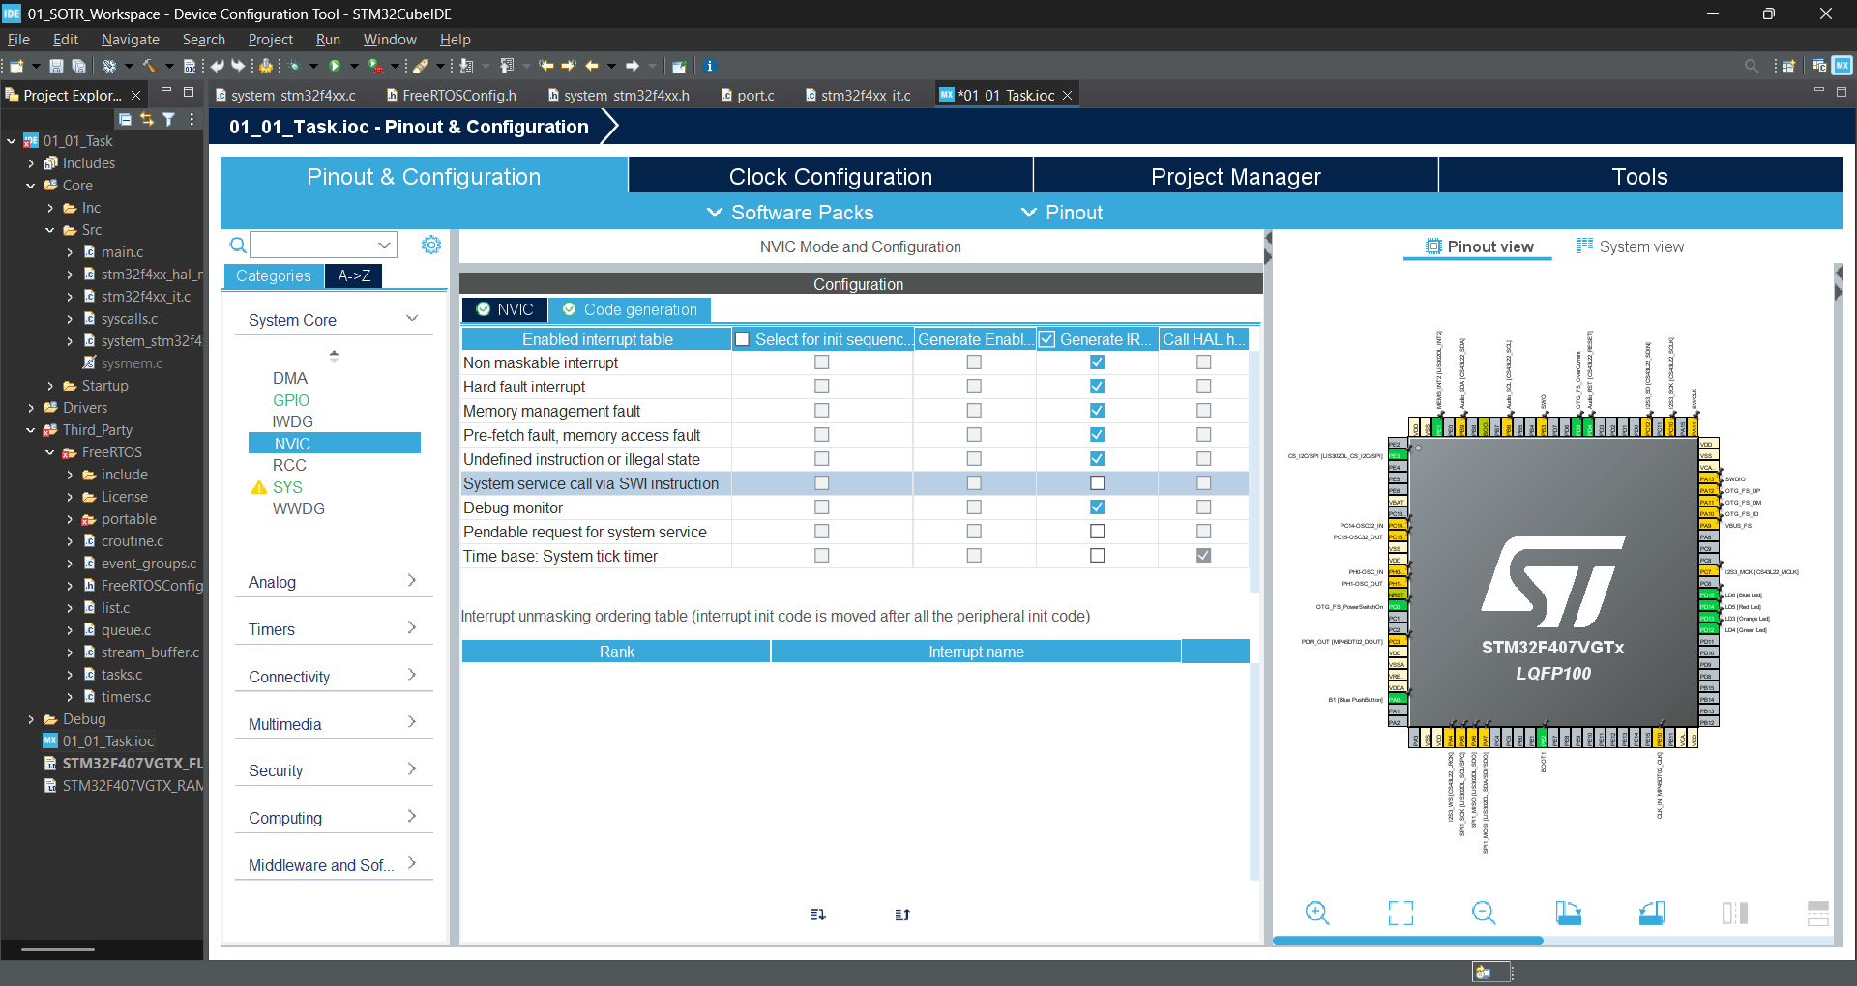
After that regenerate the code
Let’s again compile the code.
You can see new errors undefined reference to `vApplicationTickHook'
Let’s resolve this issue now.
Open FreeRTOSConfig.h
Turn off the below Macro, just make them 0.
configUSE_TICK_HOOK
configUSE_MALLOC_FAILED_HOOK
configCHECK_FOR_STACK_OVERFLOW
Now Let’s build the project once again.
Now you see our build is successful.
We have Successfully integrated the FreeRTOS to our project, with zero errors and zero warnings. That doesn't mean that this will run on our target, we have to do other changes as well and I will cover that in the next lecture.

Time base selection for STM32+FreeRTOS project
So the problem what we have now.
The FreeRTOS by default uses the Systick for its own purpose and the STM HAL layer also uses Systick for its own purpose.
If both are using one peripheral absolutely there will be a conflict.
So, we are resolving this conflict by changing the HAL layer timer-based source to Timer6.
Open the Device Configuration Tool, here goto System Core SYS.
And there you can see the TimeBased Source by default it will be SysTick you change it to TIM6.
And in this window itself you can also see Debug, if you want to use the Serial monitor for debugging purpose that change it to Serial Wire.
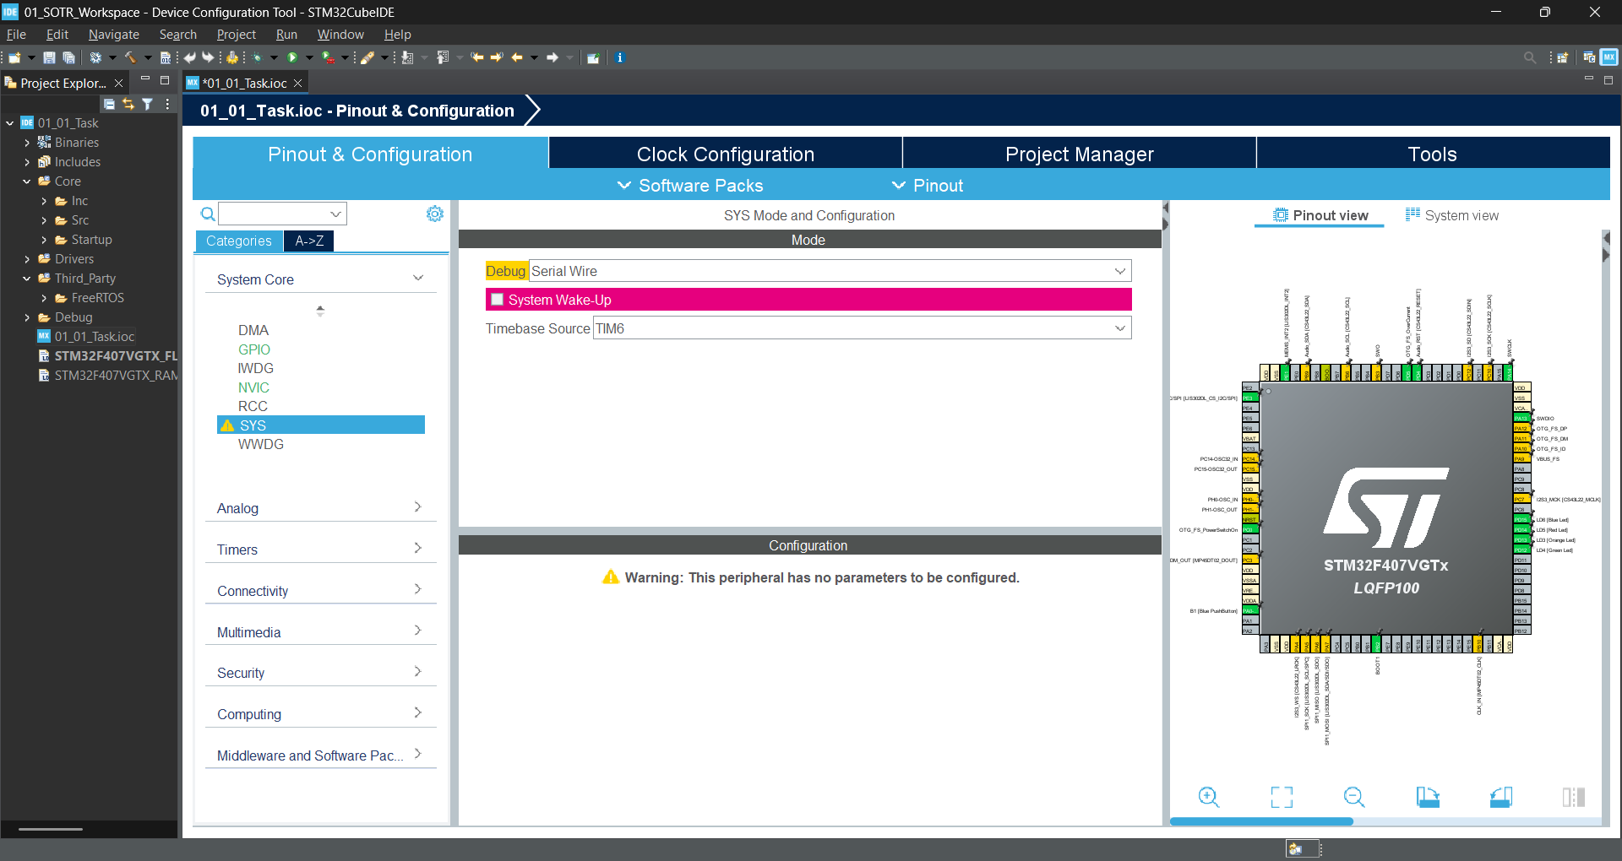
After that go to NVIC and change the Priority Group to: 4 bits for pre-emption priority 0 bits for subpriority
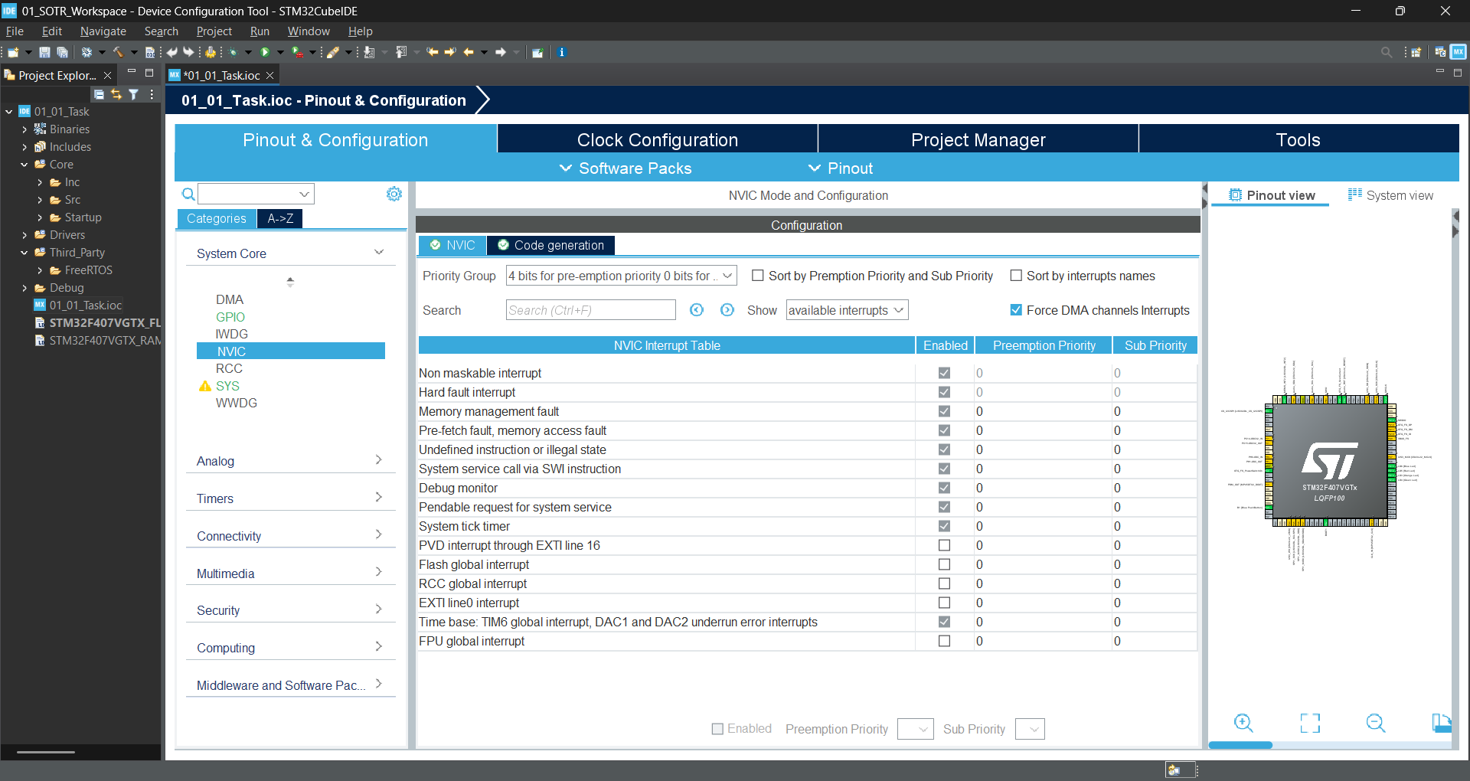
And after that just generate the code.
After generation the code in Src you can is that there is a new file generate called stm32f4xx_hal_timebase_tim.c
This file actually initializes the timer 6 to generate time base for every one millisecond.
We have Successfully Integrated the FreeRTOS Kernal to our Project using the Manual method.
Now you can add the task and schedule it in the project.

Adding FreeRTOS to STM32 Project Using STM32CubeIDE's Graphical Interface
To add FreeRTOS Kernal to any project, open the project ioc file then goto
Pinout & Configuration Middleware & Software FreeRTOS, now you have to select the interface, you can select either CMSIS_V1 or CMSIS_V2
After selecting the CMSIS_V1 or V2 below you will see the configuration window, which consists of a lot of tabs by using which you can configure the RTOS.
Make sure to chang the time-source for the HAL layer and enable the newlib before generating the code.

Links

Link to download SOTReerFv202012.00
https://github.com/FreeRTOS/FreeRTOS/releases#release-202012.00

Link for CMSIS RTOS Webpage
https://arm-software.github.io/CMSIS_5/RTOS2/html/index.html

