AIR UNIVERSITY  ACADEMIC PROJECT SUBMISSION | 

PROJECT REPORT
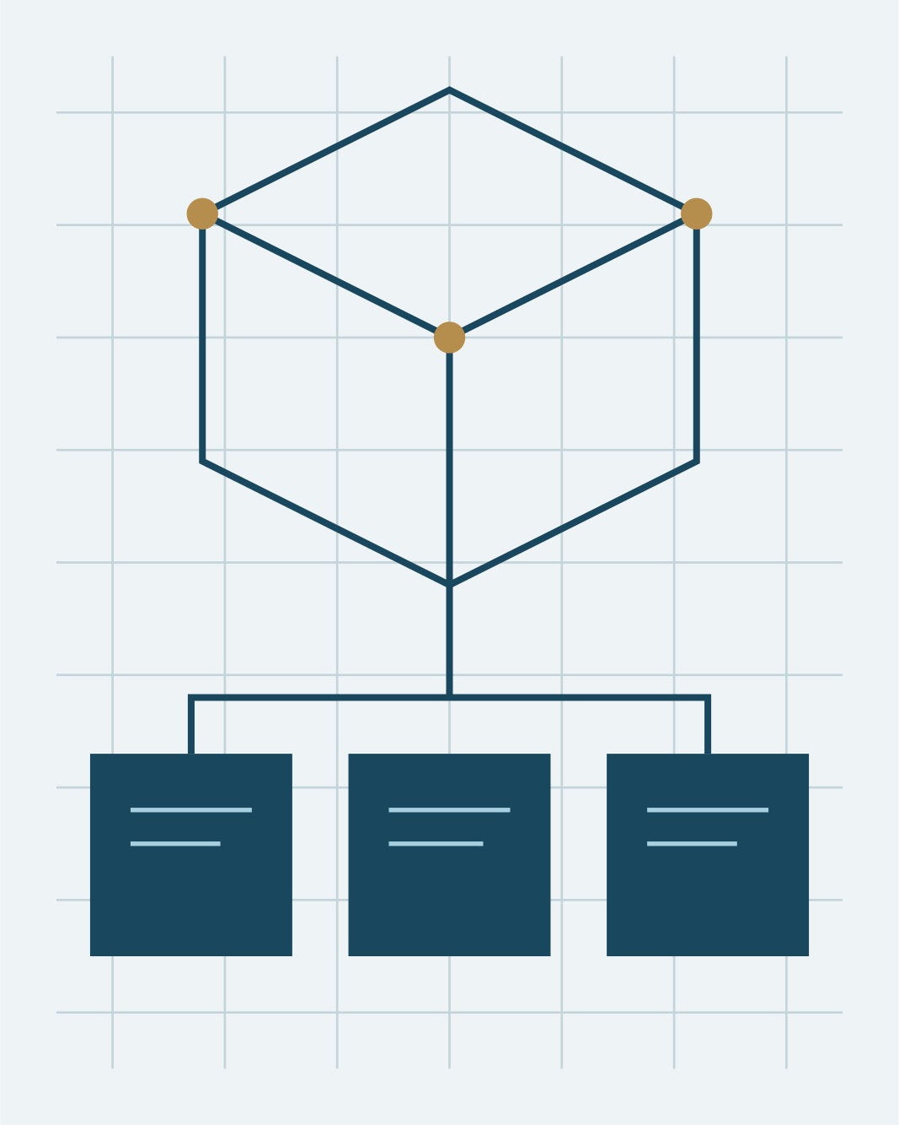 | Smart campus service platform  Software Engineering

SUBMITTED TO  Dr Sana Ahmed | SUBMISSION DATE  07 November 2026

PROJECT TEAM
REGISTRATION | TEAM MEMBER
FA23-BSE-042 | Ayesha Khan
FA23-BSE-043 | Muhammad Hamza
FA23-BSE-044 | Fatima Zahra
FA23-BSE-045 | Ahmed Raza
FA23-BSE-046 | Maryam Ali

