AIR UNIVERSITY  ACADEMIC PROJECT SUBMISSION | 

PROJECT REPORT
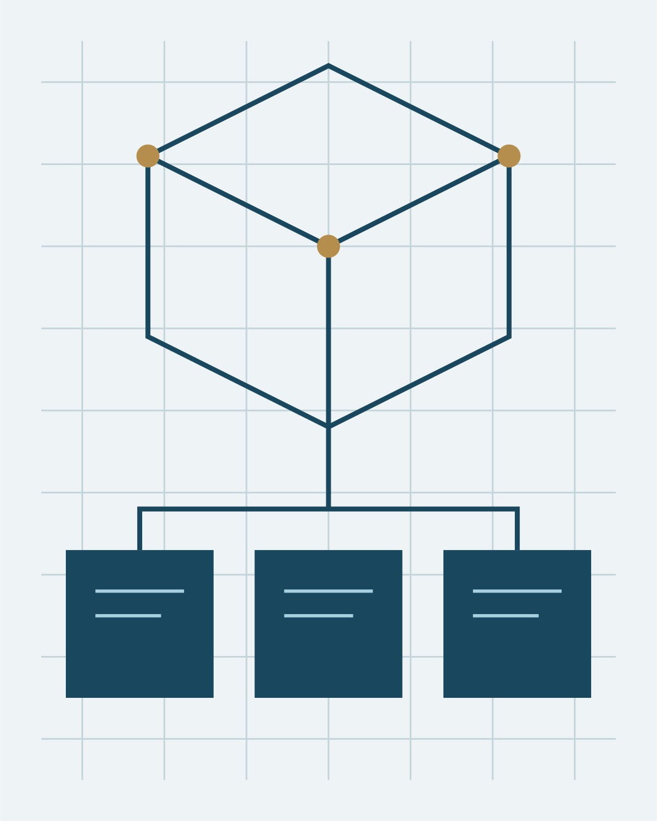 | Design and evaluation of a distributed campus navigation platform with accessible real time services  Advanced Software Engineering and Distributed Information Systems

SUBMITTED TO  Dr Muhammad Abdullah Siddiqui | SUBMISSION DATE  07 November 2026

PROJECT TEAM
REGISTRATION | TEAM MEMBER
FA23-BSE-042 | Ayesha Khan Siddiqui
FA23-BSE-043 | Muhammad Hamza Abdullah
FA23-BSE-044 | Fatima Zahra Mahmood
FA23-BSE-045 | Ahmed Raza Muhammad
FA23-BSE-046 | Maryam Ali Chaudhry

