[Faculty or department]
[Master’s thesis title]
[Explanation or subtitle]
[Forename Surname]
Master’s thesis in [study program]…[course code]…[Month 20xx]

Table of Contents
1 Heading level 1 1
1.1 Heading level 2 1
1.1.1 Heading level 3 1
Figures and Tables 2
Works cited 3
Appendix 4

List of Tables
Table 1 - Table with columns, rows and data 2
List of Figures
Figure 1 - UiT students. Photograph by Marius Fiskum. 2
Foreword
Information about the table of contents (delete this text before you deliver your thesis)
The table of contents is automatically generated based on the styles you use in the main part of your thesis. You must right-click in the table of contents and choose “Update field” and then “Update entire table” in order to update the table of contents.
If you want to add a forward to your thesis place your cursor at the start of the line after the list of figures and press “CTRL” + “Enter” (insert page break). The forward will start on a new page and will not be included in the table of contents or have a page number. Use the style “Forward heading” for the forward’s heading.

Heading level 1
Text

Heading level 2
Text

Heading level 3
Text

Heading level 4
Text
Information about the main part of the thesis (delete this information before you turn in your thesis)
You can start writing your thesis on this page. We have added four heading levels as an example. It will be simplest if you replace the text in “Heading level #” with your own headings.
When you need extra headings write the text you want to be in the heading. Then mark the text and choose the appropriate heading level style. (See image below.)
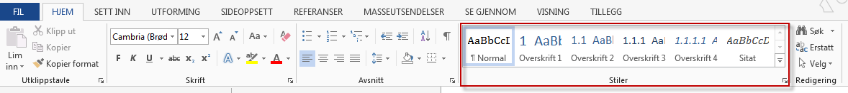
Learn more about long Word documents, use of styles, page numbering, and more.

Figures and Tables
You can give figures and tables captions by using Word’s references tools. If you do so, tables and figures will be numbered automatically. Afterwards you can generate lists of all tables and figures including which pages they are on.
Videos about captioning tables and figures.
Table 1 - Table with columns, rows and data
column 1 / row 1 | column 2 | column 3
row 2 | Data | Data
row 3 | Data | Data

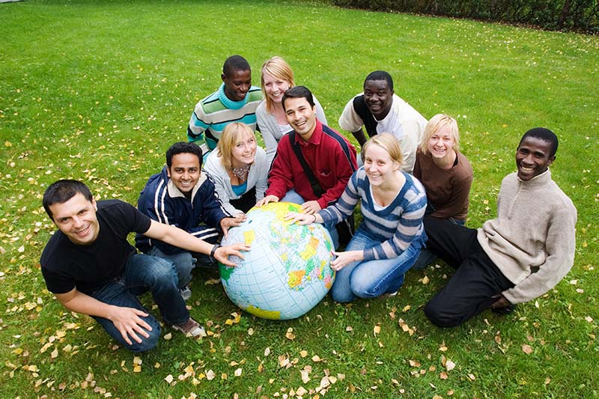
Figure 1 - UiT students. Photograph by Marius Fiskum.

Works cited
The citations you use in your paper need to be inserted into both the text of the paper and the list of works cited. The citation format varies depending on which citation style you use. For information about citation styles, and citation techniques in general, see iKomp.

Appendix
If you have one or more appendixes you can add them here. Use the “Heading 1 without numbering” style at the start of each appendix.

