**Arduino Blind Walking Stick**



**Submitted by: M.Mudassir 22-cs-91**

**M.Ehtisham-Ul-Islam 22-cs-82**

**Submitted To: Dr.Muhammad Munwar Iqbal**

**Department of Computer Science**

University of Engineering and Technology, Taxila

**Fall 2022**

ABSTRACT

The main objective of this project is to develop an Blind Stick using an Arduino UNO board with sensor and battery. As technology is advance and we can also see that a lot of work took place on every field of life. In this project, we will learn how to design Blind Walking Stick Using Arduino & Ultrasonic Sensor HC-SR04. Almost 30 million people are blind according to the recent WHO Report. These blind people are totally dependent on others as they can’t walk alone. This is the reason why we have designed the Blind Walking Stick device which will help blind people to walk with ease independently.

ACKNOWLEDGEMENT

First, I want to thank from the core of my heart to ALLAH Almighty who gave me the blessing in life and lifted me in need and give me firmness, zeal, and competence for accomplishment of this research work It is great pleasure for us to express our gratitude to our honorable professor Dr. Muhammad Munwar Iqbal. For giving the opportunity to work on a practical problem.

I want to present special thanks to my beloved parents. Who encouraged and helped  
me throughout the life and gave me quality education.  
I would also like to say thanks to my dear sisters and brothers for their endless  
support and their affection. And I would also like to thank my colleagues and dear  
friends who backed and inspired me during my study period.

TABLE OF CONTENTS

1. ABSTRACT ............................................................................................................

2. ACKNOWLEDGEMENT.......................................................................................

3. INTRODUCTION ..................................................................................................

4. PROJECT AIM & SCOPE.....................................................................................

5.Hardwear REQUIREMENT...................................................................................

6.Softwear REQUIREMENT....................................................................................

7. Description of hardwear requrement.....................................................................

8.Programming code ................................................................................................

13. CONCLUSION..................................................................................................

Introduction

The Audino Blind Stick is an innovative device designed to assist people who are blind or visually impaired in navigating their surroundings safely and independently. It is a type of electronic cane that uses ultrasonic sensors to detect obstacles and provides feedback to the user through vibrations and audible alerts.

The device is lightweight and easy to handle, making it a convenient tool for daily use. It is also equipped with a rechargeable battery, which ensures long-lasting performance and reduces the need for frequent battery replacements.

The Audino Blind Stick features adjustable sensitivity settings, allowing users to customize the device to their specific needs and preferences. It also includes a range of additional features such as a built-in flashlight and an emergency alarm, which can be activated in case of danger.

Overall, the Audino Blind Stick is an excellent tool for people who are blind or visually impaired, providing them with greater independence and safety as they navigate their surroundings.

Project Aim

The aim of the Audino Blind Stick project is to create a smart walking stick for visually impaired individuals that uses ultrasonic sensors and other technologies to detect obstacles and provide guidance while walking. The Audino Blind Stick can be used both indoors and outdoors and provides real-time feedback to the user about the distance and direction of nearby obstacles. The stick is also designed to be lightweight, durable, and easy to use, with a comfortable grip and ergonomic design. Overall, the goal of the Audino Blind Stick is to improve the mobility and independence of visually impaired individuals, allowing them to navigate their environment with greater confidence and ease.

Project scope and limitation:

Scope: The Audino Blind Stick is a device designed to help visually impaired people navigate their surroundings with more ease and independence. The device is equipped with various sensors that detect obstacles and provide feedback to the user in the form of auditory cues. The project aims to address the challenges faced by visually impaired individuals in daily life, such as avoiding obstacles and identifying the location of key landmarks.

The Audino Blind Stick project has the following scope:

* Developing a device with sensors that detect obstacles and provide auditory feedback to the user.
* Designing an intuitive user interface that enables easy interaction with the device.
* Ensuring the device is lightweight and easy to handle for users of all ages.

Limitations: Although the Audino Blind Stick project aims to provide visually impaired individuals with more independence, there are some limitations to the project. Some of the limitations include.

* The device may not provide accurate feedback in all situations, such as in noisy or crowded environments where auditory cues may be difficult to hear.
* The device may require regular maintenance and calibration to ensure accurate and reliable performance.

Top of Form

Hardware Requirement

Following are the Hardware require.

1. Arduino Uno Bord
2. Connecting wires
3. 9-volt battery
4. Buzzer
5. Ultrasonic Sensor HC-SR04

Software Requirement

1. Arduino 1.8.8 compiler

Description of Hardware Required

**Arduino uno**

The Arduino Uno is a microcontroller board based on the ATmega328P. It has 14 digital input/output pins (of which 6 can be used as PWM outputs), 6 analog inputs, a 16 MHz crystal oscillator, a USB connection, a power jack, an ICSP header, and a reset button. It contains everything needed to support the microcontroller; simply connect it to a computer with a USB cable or power it with AC-to-DC adapter or battery to get started.

The Uno differs from all preceding boards in that it does not use the FTDI USB to- serial driver chip. Instead, it features the Atmega8U2 programmed as a USB to- serial converter.

 Some Technical Specification of Arduino Uno are:

1. Microcontroller ATmega328P
2. Operating Voltage 5V
3. Input Voltage (recommended) 7-12V
4. Input Voltage (limits) 6-20V
5. Digital I/O Pins 14
6. Analog Input Pins 6
7. DC Current per I/O Pin 40 mA
8. DC Current for 3.3V Pin 50 mA
9. Flash Memory 32 KB of which 0.5 KB used by bootloader

.SRAM 2 KB

.EEPROM 1 KB

.Clock Speed 16 MHz

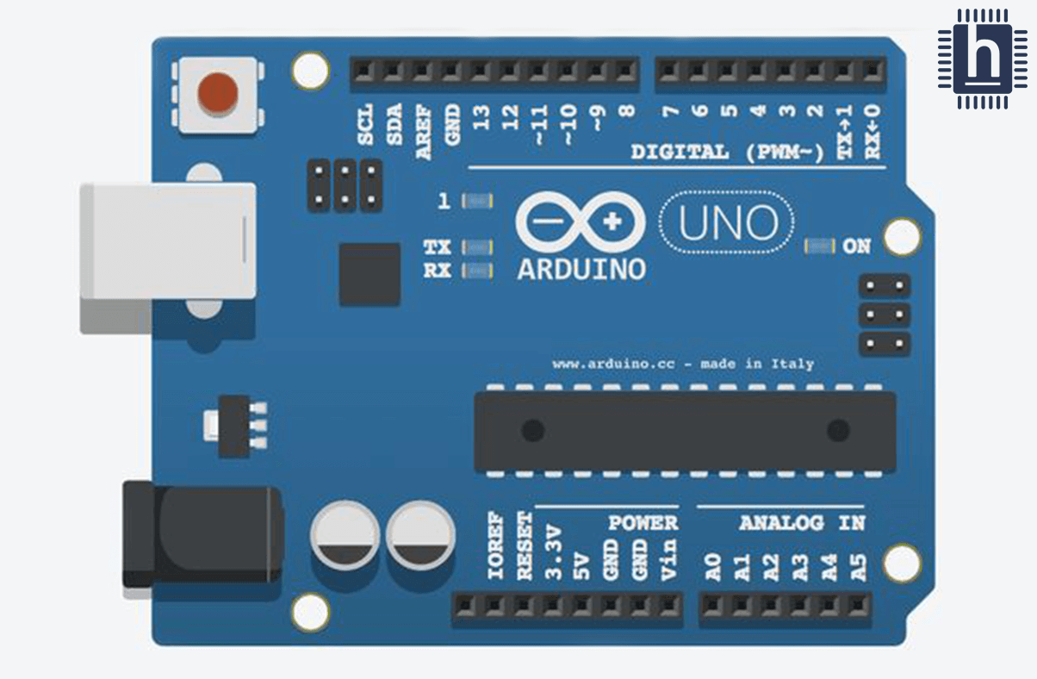

**Circuit Diagram**

**Figure 01. Circuit diagram for component of Arduino UNO**

**HC-SR04 Ultrasonic Sensor**

This economical sensor provides 2cm to 400cm of non-contact measurement functionality with a ranging accuracy that can reach up to 3mm. Each HC-SR04 module includes an ultrasonic transmitter, a receiver and a control circuit.

There are only four pins that you need to worry about on the HC-SR04: VCC (Power), Trig (Trigger), Echo (Receive), and GND (Ground).

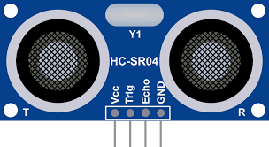

HC-SR04 Ultrasonic Sensor with Arduino UNO

HC-SR04 is an Ultrasonic Sensor that measures the distance using sound waves to object and them bounce back to make a reading.

Default settings of HC-SR04 Ultrasonic Sensor can be changed using certain pins connections.

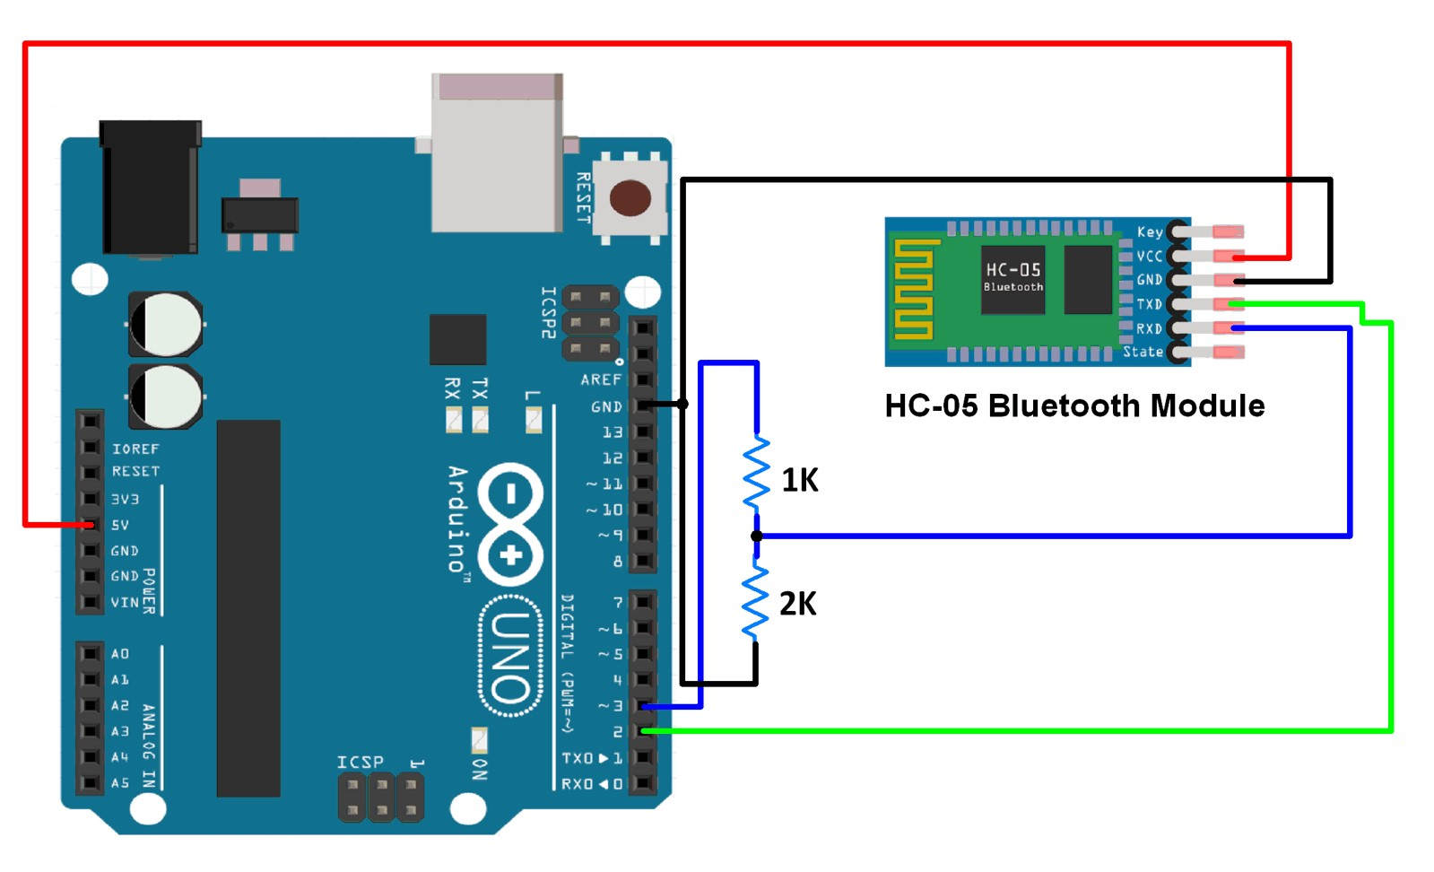

Program Code

#include <Ultrasonic.h>

int buzzer = 9;

Ultrasonic ultrasonic(12, 11);

void setup() {

  Serial.begin(9600);

  pinMode(buzzer, OUTPUT);

}

void loop()

{

  int distance = ultrasonic.Ranging(CM);

  if (distance < 50) {

    int dil = 2 * distance;

    digitalWrite(buzzer, HIGH);

//    digitalWrite(led, HIGH);

    delay(dil);

    digitalWrite(buzzer, LOW);

//    digitalWrite(led, LOW);

    delay(dil);}}

Conclusion

The technology is used for the betterment of society and must be used for rather than making it a purpose of enjoyment. This project will help the blind people to walk alone. We have learned a lot of things when we are trying to Bild this project, we have learned how to ultrasonic senser is detect the things.

With this project a blind man can walk easily where he want to go .

**THANK YOU**