1. Write a program to use for loop to print the following reverse number pattern

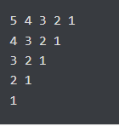

1. Print list in reverse order using a loop

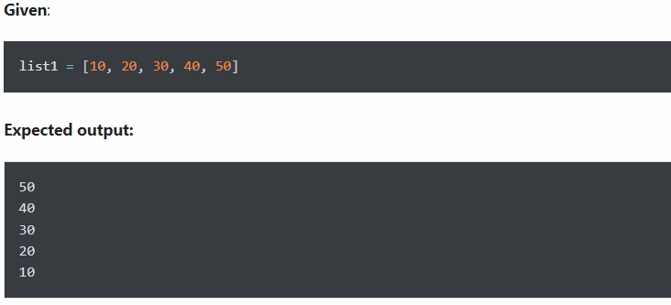

1. Use a loop to display elements from a given list present at odd index positions

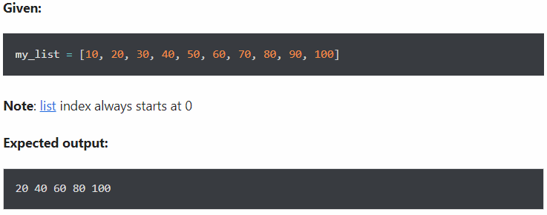

4: Write a program to create a function show_employee() using the following conditions.

* It should accept the employee’s name and salary and display both.
* If the salary is missing in the function call then assign default value 9000 to salary

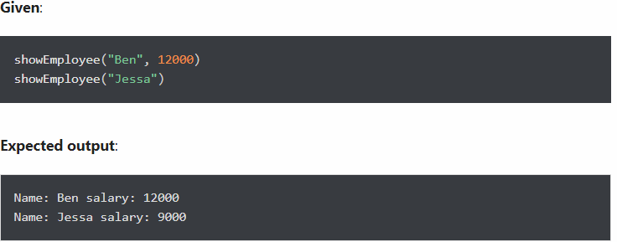

5.Write a program to create a **recursive function to calculate the sum of numbers** from 0 to 10.

A recursive function is a function that calls itself, again and again.

6. Write a program to take three names as input from a user in the single input() function call.

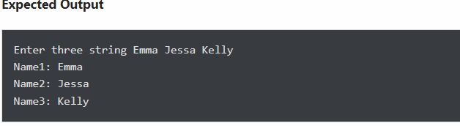

7. Create a new string made of the first, middle, and last characters of each input string

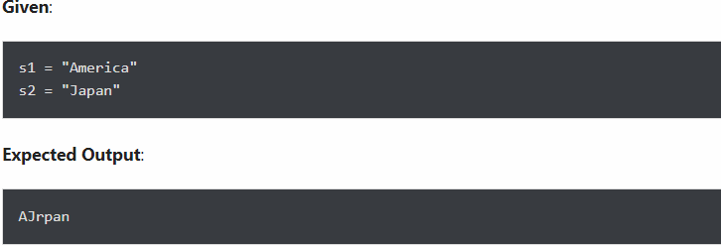

8. Count all letters, digits, and special symbols from a given string

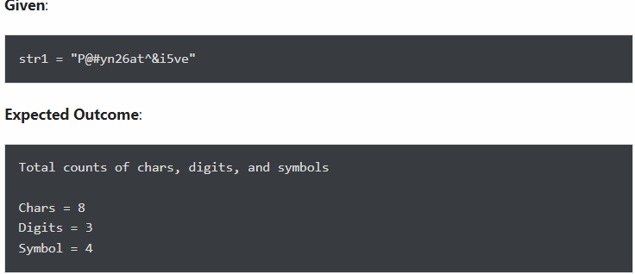

9. Concatenate two lists in the following order

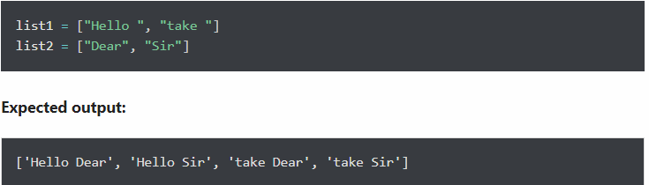

10. Print the value of key ‘history’ from the below dict

