**CyberPurge**

**Team Name:** **Triple M**

**Team Members:**

- Madhuj Agrawal

- Mayank Mokhere

- Mudassir Siddiqui

## Problem Statement(1):

## There are social engineering frauds in which fake accounts of prominent people are created on social media and their friends are approached to transfer certain money into the accounts of fraudsters. Give a technical solution to be adopted by social media firms in which such types of fraud accounts are automatically deleted.

## Proposed Solution:

Our solution, the **CyberPurge - Automated Review & Action Pipeline**, is a cutting-edge system designed to combat the growing issue of fraudulent accounts across online platforms. By integrating advanced **machine learning algorithms, real-time data analysis, and automated decision-making**, this solution ensures a highly effective and scalable approach to fraud detection and prevention.

At its core, CyberPurge operates through a **multi-layered risk assessment framework**, where user activities, behavioral patterns, network anomalies, and content authenticity are continuously monitored and analyzed. The system assigns a **risk score** to each account based on these factors, enabling dynamic fraud detection with minimal human intervention.

A key feature of CyberPurge is its **real-time reporting and action pipeline**, which allows for immediate flagging of suspicious accounts. Depending on the risk score, accounts may either be subjected to further human review or automatically flagged for deletion. In cases of high-risk fraudulent activity, the system can even escalate reports to relevant authorities, ensuring a proactive approach to cybersecurity.

Additionally, our platform integrates **user reporting mechanisms**, enabling the community to contribute to fraud detection while maintaining transparency. By leveraging a combination of **artificial intelligence, automation, and user insights**, CyberPurge minimizes false positives while maximizing the accuracy of fraud detection.

## Key Features:

### Risk Scoring Engine

This component assigns a fraud probability score based on multiple weighted parameters.

|  |  |  |
| --- | --- | --- |
| Parameter | Weight (%) | Data Sources |
| Profile Verification | 30% | Image recognition APIs, public databases |
| Behavioral Patterns | 25% | Login history, message frequency, friend request rate |
| Network Anomalies | 20% | Social graph analysis (e.g., sudden spikes in connections) |
| Content Analysis | 15% | NLP models scanning for scam keywords |
| User Reports | 10% | Real-time user flagging system |

### Scoring Mechanism

- 0–60: Low risk → No action required.

- 60–80:Medium risk → Sent for human review via a moderation dashboard.

- 80–100: High risk → Auto-delete + notify law enforcement if financial fraud is detected.

### User Reporting Integration

Real-time fraud detection is enhanced by a user reporting system, which aggregates and analyzes reports to identify malicious accounts.

### Automated Action Pipeline

The pipeline consists of multiple stages, including data collection, risk scoring, decision-making, and escalation handling.

## Technical Architecture

### Tools & Tech Stack

- **Backend**: Python (FastAPI/Flask) + TensorFlow/PyTorch for ML.

- -**Database:** PostgreSQL for user data, Redis for real-time reporting.

- **Cloud:** AWS/Azure for scalable compute (Lambda for serverless scoring).

- **Integration:** APIs to sync with social media platforms (e.g., Meta’s Graph API for Facebook/Instagram).

**Flowchart**

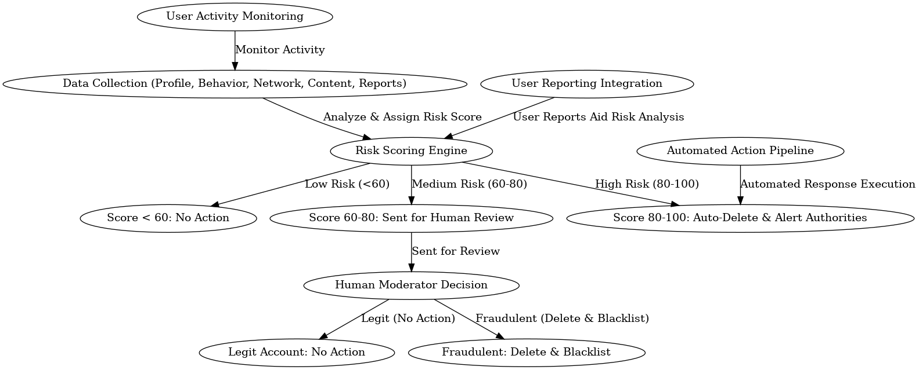

## Unique Innovations:

1. **Dynamic Weight Adjustment:** The risk scoring system adapts dynamically based on evolving fraud trends.

2. **Cross-Platform Blacklisting:** Fraudulent account fingerprints can be shared securely across platforms.

3. **User Transparency Dashboard:** Allows users to see why an account was deleted..

## Conclusion:

This solution combines automation with accountability, ensuring rapid fraud detection while minimizing false positives. With its intelligent architecture and scalable design, it presents an effective solution for modern digital platforms.