**Smart Irrigation System**

## ****Work Breakdown Structure (WBS) with Dependencies****

| **WBS ID** | **Task** | **Sub-Tasks** | **Dependencies** | **Resources** | **Time (weeks)** | **Budget** |
| --- | --- | --- | --- | --- | --- | --- |
| **1** | Planning and Design | **1.1.1 Create Project Scope** (deliverables and restrictions) | Start of the project | Project Manager, Agricultural Engineer | 2 | $1,500 |
|  |  | **1.1.2 Investigate Sensor Technologies** (soil moisture, weather data) | 1.1.1 | Agricultural Engineer, Electronics Engineer |  |  |
|  |  | **1.1.3 Constituent System Design** (hardware and software system design) | 1.1.2 | Electronics Engineer, Software Developer |  |  |
| **2** | Hardware Integration | **2.1 Buy Sensors and Microcontroller** (procure necessary hardware) | 1.1.3 | Electronics Engineer, Agricultural Engineer | 3 | $3,000 |
|  |  | **2.2 Integrate Sensors and Microcontroller** (connect and set up hardware) | 2.1 | Electronics Engineer, Agricultural Engineer |  |  |
|  |  | **2.3 Acquire and Integrate Weather Data** (add weather data integration) | 2.2 | Electronics Engineer, Agricultural Engineer |  |  |
| **3** | Software Development | **3.1 Design Mobile App Interface** (UI/UX for app monitoring) | 1.1.3 | Software Developer, Electronics Engineer | 3 | $2,500 |
|  |  | **3.2 Develop Control Algorithms** (using real-time sensor data) | 3.1, 2.3 | Software Developer, Electronics Engineer |  |  |
|  |  | **3.3 Integrate App with Hardware** (allow communication between app and system) | 3.2 | Software Developer |  |  |
| **4** | Testing and Refinement | **4.1 Collect Soil Samples and Test** (gather samples, test in diverse conditions) | 2.3, 3.3 | Field Tester, Agricultural Engineer | 2 | $1,000 |
|  |  | **4.2 Adjust Control Algorithms** (fine-tune irrigation parameters) | 4.1 | Software Developer, Agricultural Engineer |  |  |
|  |  | **4.3 Final System Testing and Validation** (full testing to ensure system reliability) | 4.2 | Field Tester, Agricultural Engineer |  |  |
| **5** | Final Deployment | **5.1 Install System in Agricultural Fields** (install system in target environment) | 4.3 | Project Manager, Agricultural Engineer | 2 | $2,000 |
|  |  | **5.2 Train Users on App and System** (train end-users on system and app use) | 5.1 | Software Developer |  |  |
|  |  | **5.3 Supervise Startup Process** (ensure smooth system startup and provide support) | 5.2 | Project Manager |  |  |

### ****Total Time:**** 12 weeks

### ****Total Budget:**** $10,000

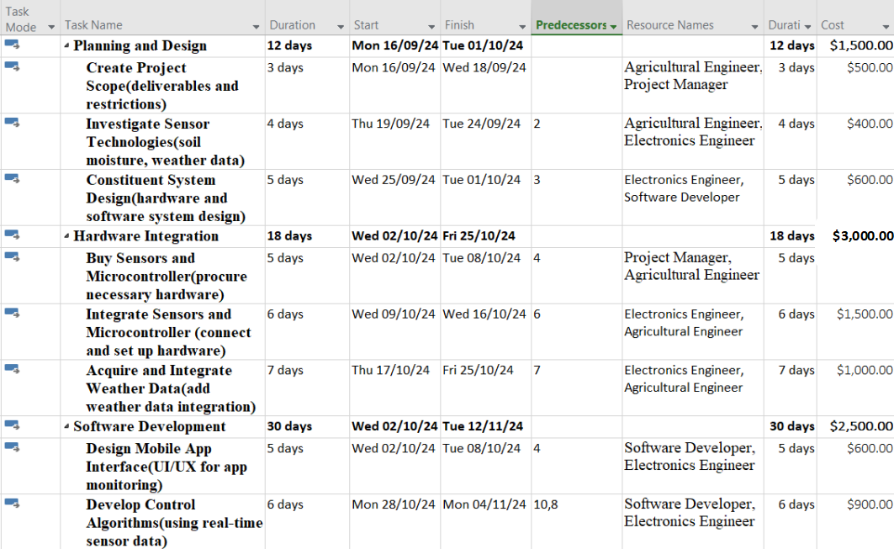

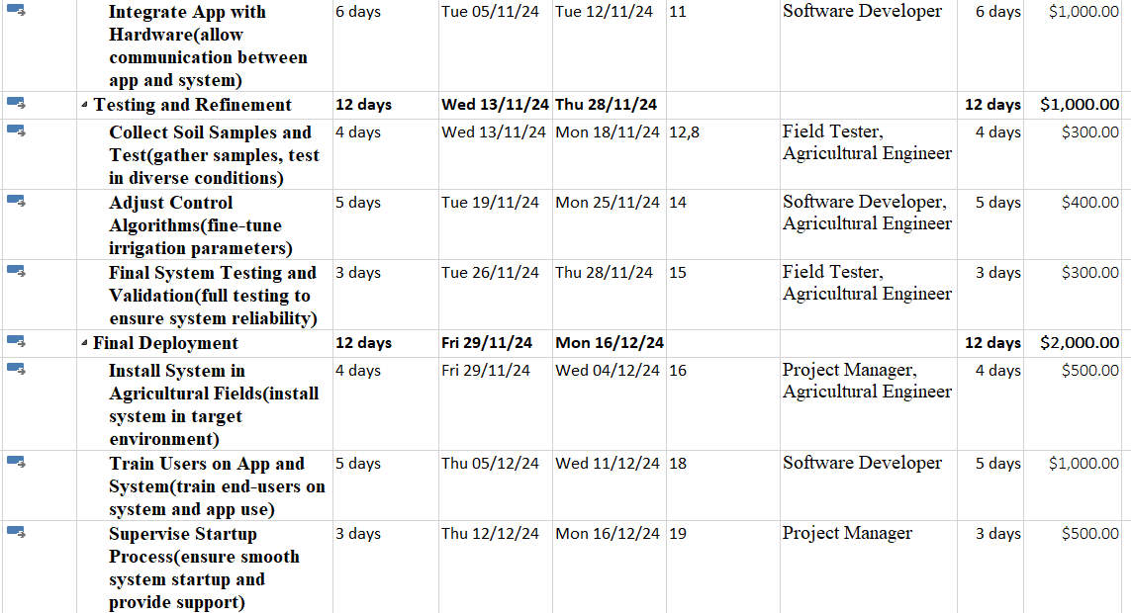

**WBS:**

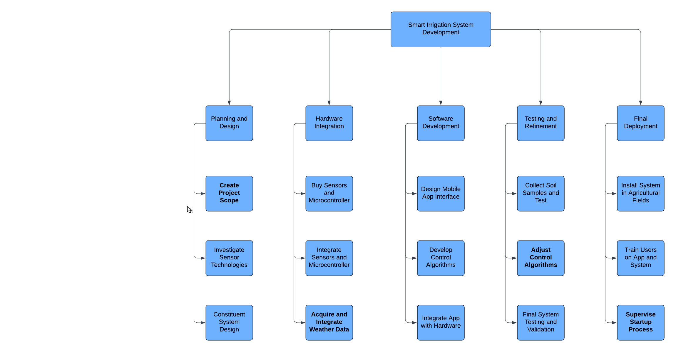

## **Completeness of WBS**

* Each of the above-stated phases of the project has been accompanied with sub-tasks that can be associated with high-level tasks. All the phases of smart irrigation system play an important role in planning, designing, developing and implementing the smart irrigation system.
* All the deliverables including the mobile application, handling integrated hardware, testing of the system are easily and accurately defined.
* End-to-end coverage:The WBS is useful in making the project take a kind of a guide path yet it does not omit aspects such as field tests and the final validation.

## ****Resources for High-Level Tasks****

| **WBS Task** | **Required Resources** |
| --- | --- |
| **Planning and Design** | Agricultural Engineer (sensor technology, soil data), Electronics Engineer (system architecture), Software Developer (app interface design), Project Manager (schedule, deliverables) |
| **Hardware Integration** | Electronics Engineer (hardware procurement and integration), Agricultural Engineer (sensor placement in soils), Microcontroller and Sensors (hardware components) |
| **Software Development** | Software Developer (application development, control algorithms), Electronics Engineer (weather data integration, app control) |
| **Testing and Refinement** | Field Tester (site testing), Agricultural Engineer (soil data, environment), Software Developer (control algorithm adjustment) |
| **Final Deployment** | Project Manager (supervise installation), Agricultural Engineer (sensor placement), Software Developer (train users on app) |

## ****Scope Definition****

**In Scope:**

* Construction of a Smart Irrigation System using soil moisture sensor as hardware component.
* Incorporation of the weather data in the control of the irrigation system.
* Mobile application to control remote system and monitor the systems status.
* Carrying out some touch tests in various environments and soils.

**Out of Scope:**

* Linkage with large scale irrigation networks.
* Use in other areas of agriculture for example to support processes such as fertilizing or pesticide spraying.
* Sustained performance assessment, and support for the system beyond the construction of the current prototype.

## ****Cost Analysis****

### ****Total Estimated Budget: $10,000****

The budget is allocated across different phases of the project. Here's a breakdown:

| **Category** | **Estimated Cost** |
| --- | --- |
| **Sensors and Hardware** | $3,000 |
| **Microcontroller and Control Systems** | $2,000 |
| **Mobile App Development** | $2,500 |
| **Plumbing Components** | $1,500 |
| **Testing and Miscellaneous** | $1,000 |

### ****Team Compensation****

Based on roles and task durations, we can estimate compensation for each team member.

| **Role** | **Estimated Compensation** | **Justification** |
| --- | --- | --- |
| **Project Manager** | $1,500 | 12-week involvement for supervision and coordination |
| **Agricultural Engineer** | $1,200 | Planning, design, sensor placement, testing |
| **Electronics Engineer** | $2,000 | Hardware integration, weather data integration |
| **Software Developer** | $2,500 | App development, control algorithms, user training |
| **Field Tester** | $800 | Testing system performance on-site |

# **Precedence Diagramming Method (PDM) Diagram**

**PDM Table**

| **ID** | **Task** | **Duration** | **Dependencies** |
| --- | --- | --- | --- |
| A1 | Create Project Scope (deliverables and restrictions) | 3 days | - |
| A2 | Investigate Sensor Technologies (soil moisture, weather data) | 4 days | A1 |
| A3 | Constituent System Design (hardware and software) | 5 days | A2 |
| B1 | Buy Sensors and Microcontroller (procure hardware) | 5 days | A3 |
| B2 | Integrate Sensors and Microcontroller (hardware setup) | 6 days | B1 |
| B3 | Acquire and Integrate Weather Data | 7 days | B2 |
| C1 | Design Mobile App Interface (UI/UX) | 5 days | A3 |
| C2 | Develop Control Algorithms (real-time sensor data) | 6 days | C1, B3 |
| C3 | Integrate App with Hardware (system communication) | 6 days | C2 |
| D1 | Collect Soil Samples and Test | 4 days | C3, B3 |
| D2 | Adjust Control Algorithms (irrigation fine-tuning) | 5 days | D1 |
| D3 | Final System Testing and Validation | 3 days | D2 |
| E1 | Install System in Agricultural Fields | 4 days | D3 |
| E2 | Train Users on App and System | 5 days | E1 |
| E3 | Supervise Startup Process | 3 days | E2 |

**PDM Diagram:**

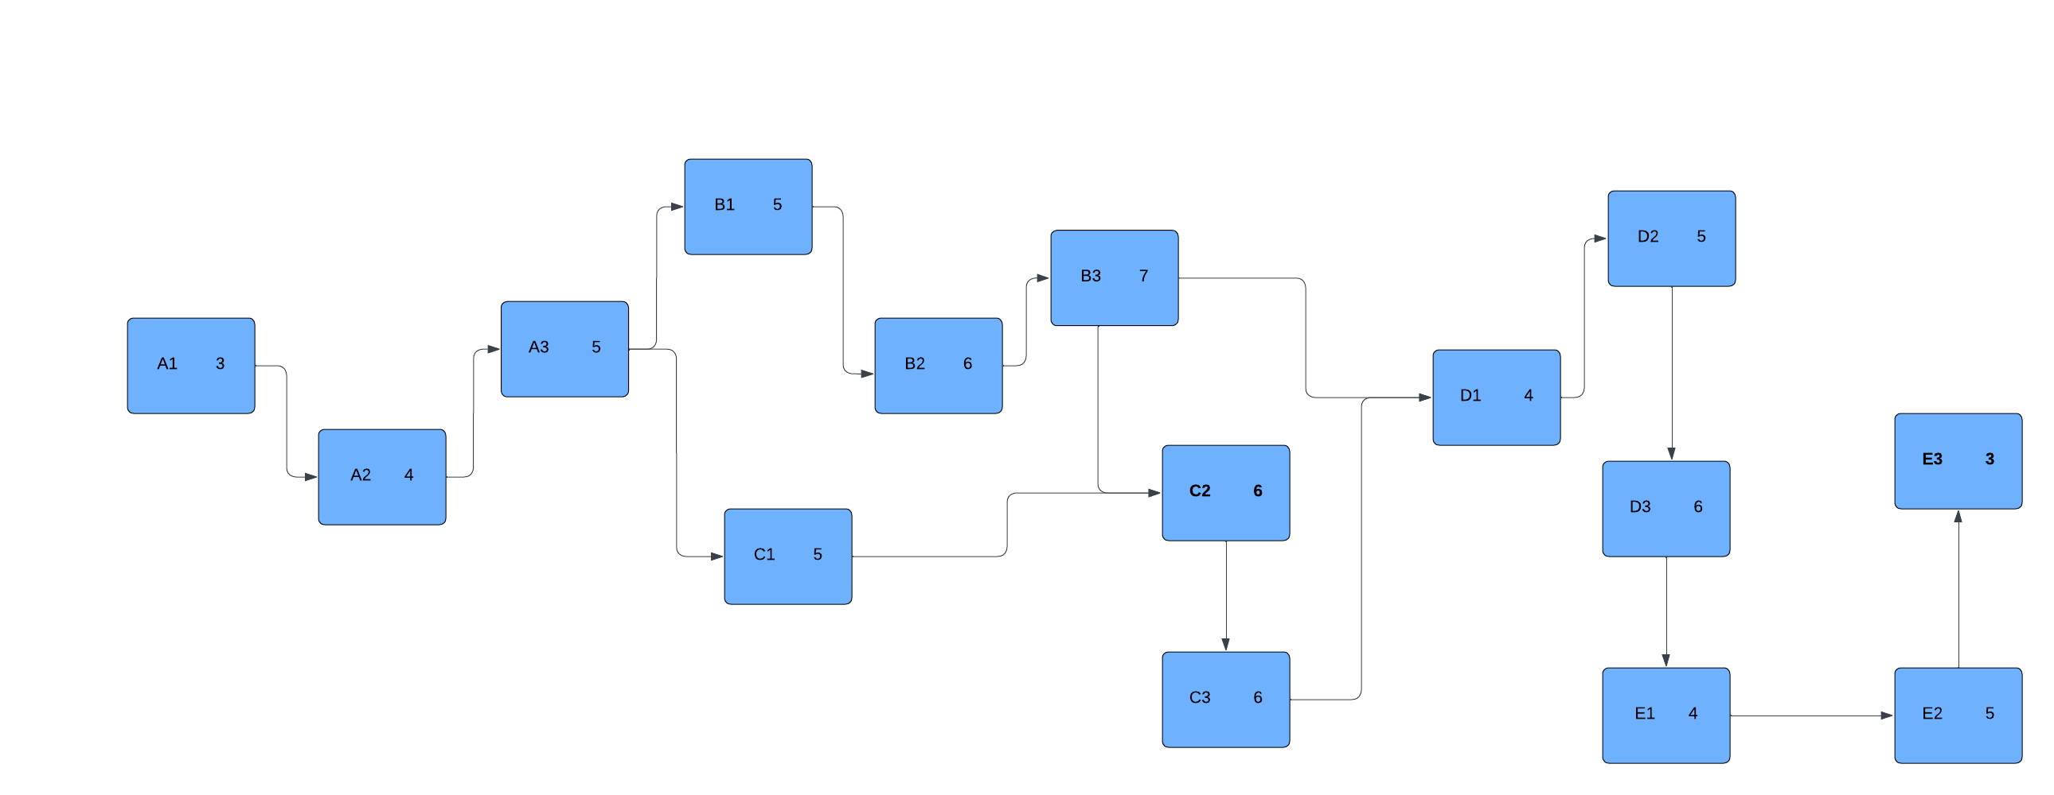

## **Time Management Plan**

#### ****Critical Path Analysis:****

The **critical path** is the longest path through the task network, meaning any delay on this path will delay the entire project. Here are the tasks that determine the critical path:

* A1 → A2 → A3 → B1 → B2 → B3 → C2 → C3 → D1 → D2 → D3 → E1 → E2 → E3

Total Critical Path Duration:

* **3 + 4 + 5 + 5 + 6 + 7 + 6 + 6 + 4 + 5 + 3 + 4 + 5 + 3 = 66 days** (~13 weeks)

This indicates the minimum time required for project completion is **13 weeks**, given no delays occur on the critical path.

### ****Lead Timing Table****

| **Task ID** | **Task Name** | **Successor Task** | **Lead Time (Days)** | **Justification/Comments** |
| --- | --- | --- | --- | --- |
| A1 | Create Project Scope | A2 | 0 | No lead time applicable. |
| A2 | Investigate Sensor Technologies | A3 | 0 | No lead time applicable. |
| A3 | Constituent System Design | B1, C1 | 0 | No lead time applicable. |
| B1 | Buy Sensors and Microcontroller | B2 | 0 | No lead time applicable. |
| B2 | Integrate Sensors and Microcontroller | B3, C3 | 1 | Start integrating app while completing hardware setup. |
| B3 | Acquire and Integrate Weather Data | C2, D1 | 0 | No lead time applicable. |
| C1 | Design Mobile App Interface (UI/UX) | C2 | 2 | Start algorithm development before UI/UX finalization. |
| C2 | Develop Control Algorithms | C3 | 0 | No lead time applicable. |
| C3 | Integrate App with Hardware | D1 | 0 | No lead time applicable. |
| D1 | Collect Soil Samples and Test | D2 | 0 | No lead time applicable. |
| D2 | Adjust Control Algorithms | D3 | 0 | No lead time applicable. |
| D3 | Final System Testing and Validation | E1 | 0 | No lead time applicable. |
| E1 | Install System in Agricultural Fields | E2 | 1 | Start user training while system installation nears completion. |
| E2 | Train Users on App and System | E3 | 0 | No lead time applicable. |
| E3 | Supervise Startup Process | - | 0 | No lead time applicable. |

### ****Lag Timing Table****

| **Task ID** | **Task Name** | **Successor Task** | **Lag Time (Days)** | **Justification/Comments** |
| --- | --- | --- | --- | --- |
| A1 | Create Project Scope | A2 | 0 | No lag time applicable. |
| A2 | Investigate Sensor Technologies | A3 | 0 | No lag time applicable. |
| A3 | Constituent System Design | B1, C1 | 0 | No lag time applicable. |
| B1 | Buy Sensors and Microcontroller | B2 | 2 | Possible delays in hardware procurement. |
| B2 | Integrate Sensors and Microcontroller | B3, C3 | 0 | No lag time applicable. |
| B3 | Acquire and Integrate Weather Data | C2, D1 | 0 | No lag time applicable. |
| C1 | Design Mobile App Interface (UI/UX) | C2 | 0 | No lag time applicable. |
| C2 | Develop Control Algorithms | C3 | 0 | No lag time applicable. |
| C3 | Integrate App with Hardware | D1 | 0 | No lag time applicable. |
| D1 | Collect Soil Samples and Test | D2 | 1 | Delay in soil sample analysis may require extra time. |
| D2 | Adjust Control Algorithms | D3 | 0 | No lag time applicable. |
| D3 | Final System Testing and Validation | E1 | 0 | No lag time applicable. |
| E1 | Install System in Agricultural Fields | E2 | 0 | No lag time applicable. |
| E2 | Train Users on App and System | E3 | 2 | Allow for complete training before startup supervision. |
| E3 | Supervise Startup Process | - | 0 | No lag time applicable. |

#### ****Slack Calculation****

| **ID** | **Task** | **Duration** | **ES** | **EF** | **LS** | **LF** | **Slack (LF - EF)** |
| --- | --- | --- | --- | --- | --- | --- | --- |
| A1 | Create Project Scope | 3 days | 0 | 3 | 0 | 3 | 0 |
| A2 | Investigate Sensor Technologies | 4 days | 3 | 7 | 3 | 7 | 0 |
| A3 | Constituent System Design | 5 days | 7 | 12 | 7 | 12 | 0 |
| B1 | Buy Sensors and Microcontroller | 5 days | 12 | 17 | 12 | 17 | 0 |
| B2 | Integrate Sensors and Microcontroller | 6 days | 17 | 23 | 17 | 23 | 0 |
| B3 | Acquire and Integrate Weather Data | 7 days | 23 | 30 | 23 | 30 | 0 |
| C1 | Design Mobile App Interface | 5 days | 12 | 17 | 31 | 36 | 14 |
| C2 | Develop Control Algorithms | 6 days | 30 | 36 | 30 | 36 | 0 |
| C3 | Integrate App with Hardware | 6 days | 36 | 42 | 36 | 42 | 0 |
| D1 | Collect Soil Samples and Test | 4 days | 42 | 46 | 42 | 46 | 0 |
| D2 | Adjust Control Algorithms | 5 days | 46 | 51 | 46 | 51 | 0 |
| D3 | Final System Testing and Validation | 3 days | 51 | 54 | 51 | 54 | 0 |
| E1 | Install System in Agricultural Fields | 4 days | 54 | 58 | 54 | 58 | 0 |
| E2 | Train Users on App and System | 5 days | 58 | 63 | 58 | 63 | 0 |
| E3 | Supervise Startup Process | 3 days | 63 | 66 | 63 | 66 | 0 |

* **Critical Path:** A1 → A2 → A3 → B1 → B2 → B3 → C2 → C3 → D1 → D2 → D3 → E1 → E2 → E3 (Slack = 0 for all tasks).
* **Non-critical task with slack:**
  + C1 (Design Mobile App Interface) has **14 days of slack**, meaning it can be delayed by up to 14 days without impacting the project completion.

Total project duration = **66 days**.

#### ****Contingency Planning:****

* **Contingency Time**: Adding 2 weeks buffer in case of unexpected delays in hardware procurement, testing conditions, or software bugs. This means the project might extend up to **15 weeks**.
* **Contingency Budget**: Allocating 15% contingency in the budget (~$1,500) to accommodate unforeseen costs like hardware malfunction or additional testing.

### ****Cost Estimation Table****

| **Task Name** | **Estimated Cost (USD)** |
| --- | --- |
| **Planning and Design** | **$1,500** |
| Create Project Scope | $500 |
| Investigate Sensor Technologies | $500 |
| Constituent System Design | $500 |
| **Hardware Integration** | **$5,000** |
| Buy Sensors and Microcontroller | $3,000 |
| Integrate Sensors and Microcontroller | $1,500 |
| Acquire and Integrate Weather Data | $500 |
| **Software Development** | **$2,500** |
| Design Mobile App Interface | $1,000 |
| Develop Control Algorithms | $1,000 |
| Integrate App with Hardware | $500 |
| **Testing and Refinement** | **$1,000** |
| Collect Soil Samples and Test | $500 |
| Adjust Control Algorithms | $300 |
| Final System Testing and Validation | $200 |
| **Final Deployment** |  |
| Install System in Agricultural Fields | $1,200 |
| Train Users on App and System | $500 |
| Supervise Startup Process | $300 |
| **Contingency** | **$1,500** |
|  | **$11,500** |

# **Risk Matrix: Top 5 Risks by Category, Severity, and Likelihood**

Here’s a risk matrix showing the top 5 risks, categorized by severity (impact) and likelihood (probability).

| **Risk ID** | **Risk Description** | **Category** | **Impact (Severity)** | **Likelihood** | **Risk Level** |
| --- | --- | --- | --- | --- | --- |
| **R1** | Delays in hardware procurement (sensors) | Supply Chain | High | Medium | High |
| **R2** | Integration issues between app and hardware | Technical | Medium | High | High |
| **R3** | Weather data inaccuracy | Data Reliability | High | Medium | High |
| **R4** | Incomplete soil testing and algorithm tuning | Testing & Validation | Medium | Medium | Medium |
| **R5** | End-user training challenges | Human Resources | Low | Medium | Low |

# **One-Page Risk Resolutions Suggestions**

#### ****Risk ID: R1 – Delays in Hardware Procurement (Supply Chain)****

**Resolution Strategy**:

* **Mitigation Plan**: Secure multiple suppliers for key components (sensors and microcontrollers) to prevent dependency on one supplier.
* **Contingency Plan**: Build extra time buffers into the schedule for hardware arrival. Ensure a stock of critical components for future needs.
* **Action**: Proactively track procurement and maintain close communication with suppliers for updates.

#### ****Risk ID: R2 – Integration Issues Between App and Hardware (Technical)****

**Resolution Strategy**:

* **Mitigation Plan**: Conduct early testing of app-hardware interaction with simulation data to identify potential issues in communication protocols.
* **Contingency Plan**: Involve experienced system integration engineers to troubleshoot in real-time, and prioritize flexibility in the software to adjust based on hardware constraints.
* **Action**: Set up cross-functional meetings between software and hardware teams for collaborative problem-solving.

#### ****Risk ID: R3 – Weather Data Inaccuracy (Data Reliability)****

**Resolution Strategy**:

* **Mitigation Plan**: Use multiple weather data sources and integrate them to improve accuracy through redundancy.
* **Contingency Plan**: Allow for manual override of weather data in the app, enabling adjustments when inaccuracies are detected.
* **Action**: Set up regular checks on weather data accuracy and compare it with ground-based sensors for validation.

#### ****Risk ID: R4 – Incomplete Soil Testing and Algorithm Tuning (Testing & Validation)****

**Resolution Strategy**:

* **Mitigation Plan**: Perform soil testing in parallel with app development to avoid delays. Consider running tests on sample environments that reflect the target agricultural conditions.
* **Contingency Plan**: Prepare alternative control algorithms based on historical soil data in case real-time tuning is delayed.
* **Action**: Assign more resources to the testing phase and set up interim checkpoints to monitor progress.

#### ****Risk ID: R5 – End-User Training Challenges (Human Resources)****

**Resolution Strategy**:

* **Mitigation Plan**: Develop user-friendly training materials, including videos, user manuals, and hands-on workshops.
* **Contingency Plan**: Provide ongoing support post-launch through customer service or help desks for troubleshooting.
* **Action**: Conduct a pilot training session with selected end-users to identify knowledge gaps early and refine the materials accordingly.