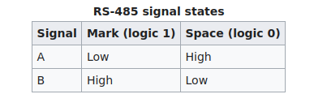
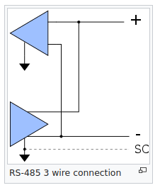
SIGNALS IN RS485:-

- The RS-485 differential line consists of two signals:
- A, which is low for logic 1 and high for logic 0 and,
- B, which is high for logic 1 and low for logic 0.
Because a mark (logic 1) condition is traditionally represented (e.g. in RS-232) with a negative voltage and space (logic 0) represented with a positive one, A may be considered the non-inverting signal and B as inverting. The RS-485 standard states (paraphrased):[14]
- For an off, mark or logic 1 state, the driver's A terminal is negative relative to the B terminal.
- For an on, space or logic 0 state, the driver's A terminal is positive relative to the B terminal

