MQTT PROTOCOL:-
- MQTT stands for message telemetry transport
- it is a nice light weight publish and subscribe system where you can publish and recieve messages as a client and it makes it really easy to establish a communication between multiple devices.

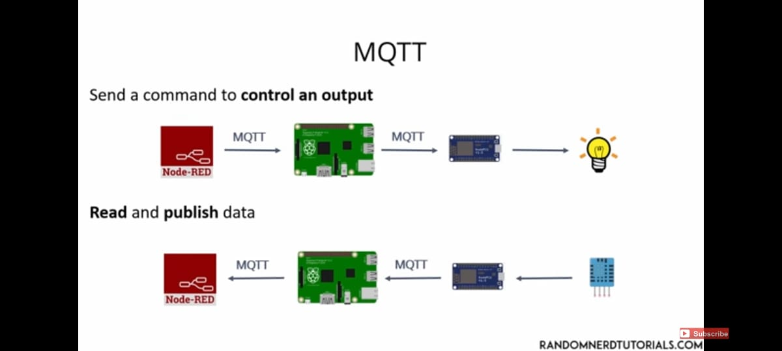

- simple communication between multiple devices
- it is a simple messaging protocol and designed for contrained devices and low bandwidth so its perfect solution for internet of things applications
- the overview of what MQTT allows to do send a command to control an output

READ AND PUBLISH DATA:-
An read data from a sensor and publish it

