MQTT BASIC CONCEPTS:-

- Publish/subscribe
- messages
- topics
- broker

PUBLISH/SUBSCRIBE:-

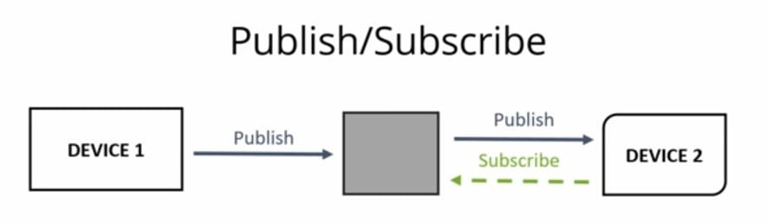

In this device can publish messages to other devices or your device can subscribe to a particulat topic to recieve those messages
EX:-

- Device1 pubishes on a topic
- Device2 is subscribed to the same topic in which device1 is publishing in and Device2 receives the messages

MESSAGES:-Information exchanged between your devices whether its command or data

TOPICS:-
- Interest for incoming messages
- specify where you want to publish
- topics are the way you register interest for incoming messages or it specify where we want to publish our message.
- Topics are represented with strings seperated by slashes “/” slashed indicate the topic level
- EX:- To create a topic for a lamp in your home office
HOME/OFFICE/LAMP
HOME,OFFICE-Topic level
SLASH-Topic level seperator

If we want to turn on a lamp in your office you would publish a message to a topic using NODE-RED saying ON the ESP8266 would be subscribed to the same topic so it will recieve the ON message and finally turn on the lamp

