RS485:-

- RS-485 supports inexpensive local networks and multidrop communications links, using the same differential signaling over twisted pair as RS-422.
- It is generally accepted that RS-485 can be used with data rates up to 10Mbit/s or, at lower speeds, distances up to 1,200m (4,000ft).
- As a rule of thumb, the speed in bit/s multiplied by the length in metres should not exceed 108.
- Thus a 50-meter cable should not signal faster than 2 Mbit/s.
- In contrast to RS-422, which has a driver circuit which cannot be switched off, RS-485 drivers use three-state logic allowing individual transmitters to be deactivated
- This allows RS-485 to implement linear bus topologies using only two wires. The equipment located along a set of RS-485 wires are interchangeably called nodes, stations or devices.
- The recommended arrangement of the wires is as a connected series of point-to-point (multidropped) nodes,
- i.e. a line or bus, not a star, ring, or multiply connected network. Star and ring topologies are not recommended because of signal reflections or excessively low or high termination impedance.
- If a star configuration is unavoidable, special RS-485 repeaters are available which bidirectionally listen for data on each span and then retransmit the data onto all other spans.
- Ideally, the two ends of the cable will have a termination resistor connected across the two wires. Without termination resistors, signal reflections off the unterminated end of the cable can cause data corruption.
- Termination resistors also reduce electrical noise sensitivity due to the lower impedance.[further explanation needed] The value of each termination resistor should be equal to the cable characteristic impedance (typically, 120 ohms for twisted pairs).
- The termination also includes pull up and pull down resistors to establish fail-safe bias for each data wire for the case when the lines are not being driven by any device.
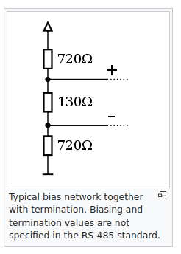
- This way, the lines will be biased to known voltages and nodes will not interpret the noise from undriven lines as actual data; without biasing resistors, the data lines float in such a way that electrical noise sensitivity is greatest when all device stations are silent or unpowered.

