Q.1: Apply following effects on an image:
- rotate the image by 90 degrees
- Blur the image
- Enhance edges of the image
Q.2: Draw following image using pillow lib methods
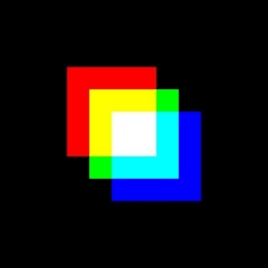
Q.3 Find the difference between two images, house_left.jpeg, house_right.jpeg

