

**COMSATS University Islamabad**

**Abbottabad, Pakistan**

**EASY BUY WITH 3D AUGMENTED REALITY**

***By***

**Muhammad Akhlaq CIIT/SP21-BSE-056ATD**

**Huzaifa Sajjad CIIT/SP21-BSE-012ATD**

**Rimsha Muneer CIIT/SP21-BSE-082ATD**

***Supervisor*Sir Umair Mujtaba**

***Bachelor of Science in Computer Science (2021-2024)***

**The candidate confirms that the work submitted is their own and appropriate  
 credit has been given where reference has been made to the work of others**.



**COMSATS University, Islamabad Pakistan**

**<EASY BUY WITH 3D AUGMENTED REALITY>**

**A project presented to**

**COMSATS Institute of Information Technology, Islamabad**

**In partial fulfillment**

**of the requirement for the degree of**

***Bachelor of Science in Computer Science (2021-2024)***

**By**

**Muhammad Akhlaq CIIT/SP21-BSE-056ATD**

**Huzaifa Sajjad CIIT/SP21-BSE-012ATD**

**Rimsha Muneer CIIT/SP21-BSE-082ATD**

**DECLARATION**

We hereby declare that this software, neither whole nor as a part has been copied out from any source. It is further declared that we have developed this software and accompanied report entirely on the basis of our personal efforts. If any part of this project is proved to be copied out from any source or found to be reproduction of some other. We will stand by the consequences. No Portion of the work presented has been submitted of any application for any other degree or qualification of this or any other university or institute of learning.

Student Name 1 Student Name 2 Student Name 3

Muhammad Akhlaq Huzaifa SajjadRimsha Muneer

--------------------------- --------------------------- ---------------------------

**CERTIFICATE OF APPROVAL**

It is to certify that the final year project of BS (CS) “Project title” was developed by   
**Huzaifa Sajjad (CIIT/SP21-BSE/TN-012)** and Muhammad Ikhlaq **(CIIT/SP21-BSE/TN-056)** and **Rimsha Muneer (CIIT/SP21-BSE/TN-082)** under the supervision of “Umair Mujtaba” and that in (their/his/her) opinion; it is fully adequate, in scope and quality for the degree of Bachelors of Science in Computer Sciences.

Umair Mujtaba

---------------------------------------

**Supervisor**

---------------------------------------

**External Examiner**

---------------------------------------

**Head of Department**

**(Department of Computer Science)**

**EXECUTIVE SUMMARY**

IIn the home decor industry, one of the main challenges for customers is envisioning how items will look and fit in their own spaces, leading to lower purchase confidence, higher return rates, and less overall satisfaction. Traditional online shopping lacks the interactive, personalized experience that customers need to make informed decisions. To bridge this gap, we developed the "Easy Buy with 3D Augmented Reality" app, a solution that brings immersive AR technology into the home decor shopping experience.

The "Easy Buy with 3D Augmented Reality" app revolutionizes home decor shopping by enabling users to virtually place decor items within their real environments. Using AR technology, customers can view 3D models of products such as furniture, wall art, and decorative items, assessing their style, color, and fit within their personal spaces before making a purchase. This feature greatly enhances buyer confidence, reduces return rates, and provides a visually engaging and user-friendly shopping experience.

The app combines a cross-platform mobile interface developed with Flutter and a robust back end powered by Django. These technologies enable smooth, responsive navigation, accurate AR rendering, and secure data handling. The app’s architecture leverages Object-Oriented Programming (OOP) principles and follows a hybrid 3-tier MVC structure, ensuring modularity, scalability, and maintainability. Adopting an Agile development methodology has allowed us to refine the app iteratively based on stakeholder feedback, aligning with user needs and industry standards.

**ACKNOWLEDGEMENT**

All praise is to Almighty Allah who bestowed upon us a minute portion of His boundless knowledge by virtue of which we were able to accomplish this challenging task.

We are greatly indebted to our project supervisor “Dr. Majid Iqbal Khan” and our Co-Supervisor “Mr. Mukhtar Azeem”. Without their personal supervision, advice and valuable guidance, completion of this project would have been doubtful. We are deeply indebted to them for their encouragement and continual help during this work.

And we are also thankful to our parents and family who have been a constant source of encouragement for us and brought us the values of honesty & hard work.

Student Name 1 Student Name 2 Student Name 3

Muhammad Akhlaq Huzaifa SajjadRimsha Muneer

--------------------------- --------------------------- ---------------------------

**ABBREVIATIONS**

|  |  |
| --- | --- |
| **SRS** | Software Require Specification |
| **PC** | Personal Computer |
| **SDD** | Software Design Document |
| **PRE** | Pre-Condition |
| **API** | Application Programming Interface |
| **SDLC** | Software Development Life Cycle |
| **FR** | Functional Requirement |

**TABLE OF CONTENTS**

**1 Introduction** 11

1.1 Brief 11

1.2 Relevance to Course Modules 11

1.3 Project Background 11

1.4 Literature Review 11

1.5 Analysis from Literature Review (in the context of your project) 11

1.6 Methodology and Software Lifecycle for This Project 11

1.6.1 Rationale behind Selected Methodology 11

**2** **Problem Definition** 12

2.1 Problem Statement 12

2.2 Deliverables and Development Requirements 12

**3** **Requirement Analysis** 13

3.1 Use Cases Diagram(s) 13

3.2 Detailed Use Case 13

3.3 Functional Requirements 13

3.4 Non-Functional Requirements 13

**4 Design and Architecture** 14

4.1 System Architecture 14

4.2 Data Representation [Diagram + Description] 14

4.3 Process Flow/Representation 14

4.4 Design Models [along with descriptions] 14

**5** **Implementation** 15

5.1 Algorithm 15

5.2 External APIs 15

5.3 User Interface 15

**6 Testing and Evaluation** 16

6.1 Manual Testing 16

6.1.1 System testing 16

6.1.2 Unit Testing 16

6.1.3 Functional Testing 17

6.1.4 Integration Testing 17

6.2 Automated Testing: 18

Tools used: 18

**7** **Conclusion and Future Work** 19

7.1 Conclusion 19

7.2 Future Work 19

**8** **References** 20

**LIST OF FIGURES**

3.1 Use Cases Diagram(s) 13

4.3 Process Flow/Representation 14

4.4 Design Models [along with descriptions] 14

4.1 System Architecture 14

1. **Introduction**

The "Easy Buy with 3D Augmented Reality" app aims to transform home decor shopping by AR technology with an intuitive, user-friendly interface. This section provides an overview of the Software Requirements Specification (SRS) document, explaining how it is structured and how readers can utilize it effectively. The SRS document serves as a guide for developers, stakeholders, and users, detailing the necessary requirements for the app's successful development and implementation. It ensures that everyone involved has a clear understanding of the app’s goals, features, and operational procedures.

* 1. **Brief**

The "Easy Buy with 3D Augmented Reality" app project aims to revolutionize the home decor shopping experience by integrating AR technology, allowing users to virtually place decor items in their own spaces. This approach enhances the shopping experience, helping users make more confident purchasing decisions and reducing the likelihood of returns. The outcome of this project is a feature-rich, user-centric mobile application with a visually engaging and intuitive interface that leverages 3D visualization for improved product exploration.

**Tools and Methodology:** The project utilizes a combination of Flutter for the front-end and Django for the back end, along with AR SDKs to power augmented reality functionalities. The development process follows the Agile methodology to facilitate iterative design and constant improvement through regular feedback loops with stakeholders, ensuring alignment with user needs and expectations.

**Project Structure and Report Highlights:** The report begins with a Software Requirements Specification (SRS) to outline key requirements and functionalities for development. The design and software architecture section details the use of Object-Oriented Programming (OOP) principles for modularity, reusability, and maintainability, supported by a hybrid 3-tier and MVC architectural model. This structure enables clear separation of concerns, scaling potential, and efficient data handling through distinct Presentation, Logic, and Data tiers. The activity diagram in the report visually represents the user journey, from product selection and AR visualization to checkout and order success, mapping the complete flow of user interaction with the app

* 1. **Relevance to Course Modules**

**Object-Oriented Programming (OOP):** The project heavily relies on OOP principles to create modular, reusable components for user profiles, AR models, and products. Courses like *Object-Oriented Programming* and *Advanced Object-Oriented Design* provided the foundational knowledge of classes, inheritance, polymorphism, and encapsulation, which are applied in the app's design and implementation.

**Mobile Application Development:** This project integrates skills from *Mobile Application Development*, particularly in Flutter, which enables cross-platform mobile development. Understanding platform-specific UI design and optimization techniques directly contributed to creating a responsive, user-friendly interface for iOS and Android.

**Web Technologies and Programming:** Utilizing Django for back-end development and database management connects with skills acquired in *Web Technologies* and *Web Application Development* courses. Knowledge of frameworks, server-side scripting, and CRUD operations has been essential in building the logic and data handling layers.

**Augmented Reality (AR) Fundamentals:** The project applies AR technology, allowing users to visualize products in their own space. Courses in *Computer Graphics* and *Human-Computer Interaction* (HCI) provided insight into visual rendering, 3D modeling, and user experience design, all of which were crucial for building engaging AR experiences.

**Software Engineering:** The use of Agile methodology for iterative development, requirements gathering, and testing aligns with concepts from Software Engineering and Software Project Management courses. These courses introduced essential practices in version control, project management, and documentation, ensuring that the project follows a structured approach.

**Database Management Systems (DBMS):** The data layer, which handles product, user, and transaction information, is based on concepts from the Database Management Systems course. This includes understanding relational databases and security, all of which are essential for managing app data effectively.

* 1. **Project Background**

The idea behind the "Easy Buy with 3D Augmented Reality" app is rooted in the need to transform the traditional online shopping experience for home decor by leveraging Augmented Reality (AR) technology. In the home decor market, users often struggle to visualize how products like furniture, wall art, and other decorative items will look and fit in their actual spaces. This uncertainty can lead to lower buyer confidence, higher return rates, and reduced customer satisfaction.

AR technology bridges this gap by allowing users to place virtual representations of decor items in their real-world environments through their mobile devices. By integrating 3D models of decor items, the app enables users to assess product dimensions, colors, and overall fit within their space before making a purchase.

**How AR Works in Home Decor Shopping:** Augmented Reality overlays digital information—such as images, 3D models, and animations—onto the real world through the device’s camera. In the context of home decor shopping, the user’s mobile device scans the room or selected space, and the AR engine processes this visual data to place a virtual object within that physical environment. The app then aligns the virtual decor item with the spatial dimensions captured by the camera, enabling the user to walk around, view from different angles, and adjust parameters (e.g., size, color) to see how the item would look in real life.

The AR component is complemented by a user-friendly interface, developed with Flutter, and a robust backend using Django. This app structure provides smooth navigation, accurate AR rendering, and secure data handling, offering a seamless shopping experience.

* 1. **Literature Review**

The "Easy Buy with 3D Augmented Reality" app aligns with several current trends and ongoing research in AR, e-commerce, and home decor. This literature review explores key developments, trends, and existing products that contribute to the evolving landscape of AR-integrated shopping experiences.

1. **Current Trends in Augmented Reality in E-commerce:**

Here is the current trends of the system

* **Augmented Reality in Retail:** Over recent years, AR technology has gained significant traction in retail, particularly in e-commerce. According to a Deloitte study, retailers leveraging AR have seen improvements in customer engagement, with shoppers spending up to 40% more time on AR-enabled products than on standard listings. This shows the potential of AR to boost engagement and support more confident buying decisions by allowing customers to visualize products realistically.
* **Personalized Shopping Experiences:** Consumers increasingly seek personalized shopping experiences that cater to their preferences. AR offers a unique way to achieve this by tailoring the shopping experience to the customer’s physical environment, enabling them to make informed decisions based on their personalized home layout.
* **Reducing Return Rates:** A significant trend in e-commerce is the use of AR to help reduce return rates. By allowing users to “try before they buy” virtually, AR mitigates uncertainty, leading to a decrease in returns due to incorrect product fit or appearance, a common issue in the decor market.

**2. Research in Augmented Reality for Home Decor**

* **Spatial Computing and Object Placement:** Research in spatial computing has focused on enhancing AR’s ability to detect surfaces, assess room dimensions, and accurately position virtual objects in real-world spaces. Studies, such as those from Stanford's Virtual Human Interaction Lab, highlight the importance of spatial computing for accurately placing decor items within different room layouts, enhancing realism and user satisfaction.

* **User Experience and Interaction Design:** Recent studies underscore the importance of intuitive interfaces in AR applications. Research published in *The Journal of Visual Languages and Computing* highlights that an intuitive user interface (UI) and user experience (UX) design in AR applications are critical for user adoption and engagement, especially for non-technical users. This influences the development of user-friendly interfaces, as seen in popular AR-based decor apps like IKEA Place and Wayfair.
* **Rendering and Realism in AR****:** Research in AR has advanced realistic rendering, allowing users to see lifelike textures and shadows on virtual items in real time. Enhanced rendering techniques, as discussed in publications by ACM SIGGRAPH, focus on lighting and material accuracy, both of which are essential for decor apps to provide an authentic visualization experience.

**3. Existing Products and Applications**

* **IKEA Place:** One of the pioneers in AR decor applications, IKEA Place, allows users to place virtual IKEA furniture in their homes. By using ARKit, the app accurately scans room dimensions and overlays scaled 3D models of furniture, showcasing the potential of AR in creating a seamless, life-like product experience. IKEA Place demonstrates that AR can effectively support large inventories and complex 3D assets.
* **Wayfair’s AR Feature:** Wayfair, another leader in home decor, integrates AR capabilities to allow users to place virtual decor items in their homes before purchasing. Its emphasis on simplicity and user-friendliness shows that easy-to-use AR functions can enhance the shopping experience, even for users who may not be familiar with advanced technology.
  1. **Analysis from Literature Review (in the context of your project)**

The insights from the literature review provide a strong foundation for the development of the "Easy Buy with 3D Augmented Reality" app, enabling us to build upon existing AR solutions while addressing their limitations. The following analysis draws comparisons with the existing research, trends, and products discussed in the literature review, highlighting how our project innovates and improves upon them.

**1.** **Advancing the User Experience and Interaction Design**

* **Comparison with Existing Products:** IKEA Place and Wayfair's AR features are known for their user-friendly design and simplicity, which is essential for attracting a broad audience. However, these apps often have limited interaction options, such as restricted ability to adjust colors, sizes, or styles of products in the AR view.
* **Innovations in "Easy Buy":** Our app aims to provide a more customizable and interactive AR experience. Users will be able to adjust product parameters like color, material, and size within the AR view, offering a more dynamic experience than current solutions. This customization enhances the user’s decision-making process, addressing a significant limitation identified in existing AR decor applications.

1. **Improved Accuracy in Object Placement and Spatial Scaling**

* **Limitations in Current AR Solutions:** One of the main challenges identified in existing AR solutions, such as Amazon’s AR View, is the occasional lack of scaling accuracy and placement precision. Users often find that virtual items appear inaccurately scaled, affecting their ability to make confident purchasing decisions.
* **Innovations in "Easy Buy":** The "Easy Buy" app addresses this challenge by incorporating advanced spatial computing algorithms and high-quality rendering to ensure accurate placement and scaling. By implementing the latest developments in spatial detection, our app reduces the chance of scaling errors, providing a more realistic and reliable AR shopping experience that instills confidence in users’ buying decisions.

**3.** **Enhancing Rendering Quality for Realism**

* **Comparison with Existing Products:** Current products like Wayfair and IKEA Place have made strides in rendering but still face occasional discrepancies between virtual representations and real-life products, especially regarding textures and lighting.
* **Innovations in "Easy Buy":** To address this, "Easy Buy" prioritizes advanced rendering techniques, including realistic lighting and shadow effects that align with the room’s natural lighting. Drawing on insights from research in *ACM SIGGRAPH*, our app seeks to produce life-like AR representations by accurately simulating textures and lighting, which is crucial for an authentic visualization experience.

**4.** **Customization and Flexibility in Product Visualization**

* **Limitations in Existing Solutions:** Many current AR home decor apps have limited product variety and customization in the AR view, which can restrict users’ ability to find the perfect match for their unique spaces.
* **Innovations in "Easy Buy":** Our app addresses this by offering a more extensive catalog of customizable decor items. Users can tailor product aspects (e.g., size, color) and preview different configurations in real-time, a feature inspired by the personalized shopping trend. This enhanced flexibility makes "Easy Buy" stand out as a more adaptable solution in AR shopping for home decor.
  1. **Methodology and Software Lifecycle for This Project**

For the development of the "Easy Buy with 3D Augmented Reality" app, the **Agile methodology** has been selected due to its flexibility, iterative structure, and user-centered approach. This methodology, combined with the **Object-Oriented Programming (OOP)** paradigm, ensures a modular and scalable codebase while promoting continuous improvement and adaptation throughout the project lifecycle.

The **Software Development Life Cycle (SDLC) model** selected is Agile, which allows for incremental development, regular feedback, and faster delivery of functional components. Each development cycle, known as a sprint, will deliver part of the application, allowing for immediate testing and feedback from stakeholders. This iterative process helps in addressing complex requirements like 3D rendering, AR integration, and a fluid user interface by focusing on small, manageable tasks

1. * 1. **Rationale behind Selected Methodology**

**Modularity**: OOP enables breaking down complex systems, like AR-based applications, into self-contained, reusable classes. For example, each AR decor item can be represented as an object, encapsulating all properties (size, colour, style) and behaviours.

**Reusability**: OOP’s reusable classes simplify adding new features or modifying existing ones. The AR feature, product management, and user profile can be coded as separate classes and reused across different parts of the application.

**Maintainability**: The encapsulation of data and behaviours in OOP improves code readability and maintainability, making it easier for developers to debug and update components as the app evolves.

**Design Patterns**: OOP supports essential design patterns like MVC (Model-View-Controller), ensuring a structured and maintainable codebase

* + 1. **Rationale behind Selected Methodology**

**Flexibility****:** Agile allows the team to adapt to changes in requirements or technology, which is critical in an evolving field like AR.

Frequent Deliverables: Through Agile’s sprint cycles, new features are released incrementally, ensuring continuous progress and early detection of issues.

**User Feedback:** Agile emphasizes collaboration with stakeholders, allowing user feedback to shape the product in each iteration.

**Risk Management:** Agile’s iterative approach enables early identification and mitigation of potential risks, which is crucial for a technically complex project like AR integration..

1. **Problem Definition**

This chapter details the precise problem that the "Easy Buy with 3D Augmented Reality" app is designed to solve, outlining the gap in current online shopping experiences for home decor and highlighting the expected outcome of the solution. This app aims to tackle the challenges users face in visualizing how decor items will appear in their actual spaces, addressing uncertainty in online shopping by enabling realistic, interactive product visualization.

3. 1. **Problem Statement**

The rapid growth of online shopping in the home decor market has highlighted a significant challenge for consumers: the inability to visualize how items will look in their unique spaces. Traditional product images fail to convey a sense of scale, style compatibility, and spatial fit, resulting in frequent returns and reduced customer satisfaction. This problem creates a barrier for customers seeking confidence in their purchasing decisions, especially when buying high-investment items like furniture and decor.

* 1. **Deliverables and Development Requirements**

**Mobile Application (iOS & Android)**: A cross-platform app that enables users to browse, customize, and visualize decor items in AR before purchasing.

**Augmented Reality (AR) Feature**: An interactive AR interface allowing users to place, adjust, and view decor items in real-time within their physical space.

**User Authentication and Profiles**: A system for user registration, social media login, and profile management to enable personalized recommendations and purchase history.

**Product Catalog and Customization Options**: A robust catalog of decor items with customizable features for users to tailor each item to their preferences.

**Shopping Cart and Checkout Process**: A seamless, secure process for adding items to a cart and completing purchases with various payment options.

**Backend and Database**: A server infrastructure to manage product data, user accounts, order history, and other dynamic content.

**Admin Panel**: A web-based dashboard for managing product listings, updating inventory, and processing orders.

**Development Requirements:**

**Tools and Technologies**:

* + **Frontend**: Flutter for cross-platform mobile development
  + **Backend**: Django for server-side operations and database management
  + **AR Functionality**: Integration of AR frameworks like ARCore (Android) and ARKit (iOS)

**Development Framework**: Agile methodology to ensure iterative development, regular feedback loops, and quick adaptation to new requirements.

**Database**: A secure database system for storing user data, product details, and order histories.

**API Integrations**: Payment gateways, social media authentication, and possibly third-party inventory management systems.

**Testing**: Comprehensive testing for cross-platform compatibility, AR accuracy, and user experience.

1. **Requirement Analysis**
3. 1. **Use Cases Diagram(s)**

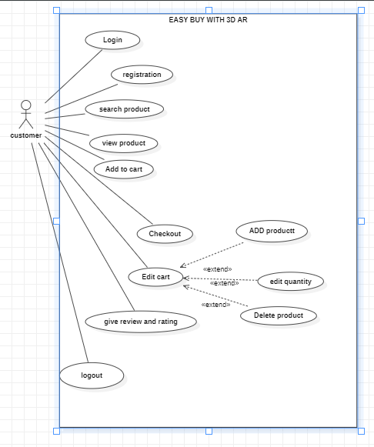

Figure 1 use case diagram for customer

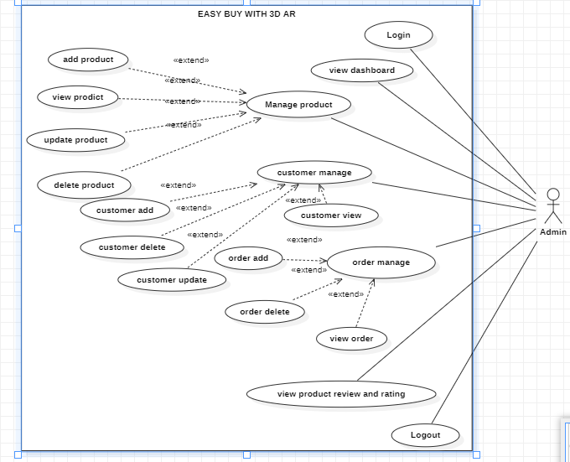

Figure 2 use case diagram for Admin

* 1. **Detailed Use Case**

**Table 1 Show Use Case Template: Login**

|  |  |
| --- | --- |
| **Use Case ID:** | UC-1 |
| **Use Case Name:** | Login to the Application |
| **Actors:** | **Primary Actor:** User, Admin **Secondary Actors:** Authentication System |
| **Description:** | A user or admin logs into the application using their email and password. This use case ensures that only registered users and admins can access personalized features and their respective dashboards. |
| **Trigger:** | A user or admin wants to access the app's features and chooses the login option from the app's welcome screen. |
| **Preconditions:** | PRE-1: The user or admin has previously registered an account.  PRE-2: The user or admin has the application installed on their device. |
| **Postconditions:** | POST-1: The user or admin is logged into the app and can access personalized features. POST-2: The system records the login event for security and analytics purposes. |
| **Normal Flow:** | 1. The user or admin selects the "Login" option from the welcome screen.  2. The system displays the login form requesting email and password.  3. The user or admin enters their email and password and submits the form.  4. The system verifies the email and password with the authentication system.  5. The system logs the user or admin into the application.  6. The system redirects the user to the home screen or the admin to the admin dashboard.  7. The system displays a welcome message with the user's or admin's name. |
| **Alternative Flows:** | **AF-1: Incorrect Password or Email**  1. User or admin enters incorrect email or password.  2. The system displays an error message indicating invalid login credentials.  3. User or admin can retry logging in or use the "Forgot Password" option. **AF-2: Forgot Password**  1. User or admin selects "Forgot Password" option.  2. System prompts user or admin to enter their registered email.  3. User or admin enters email and submits the form.  4. System sends password reset instructions to the entered email. |
| **Exceptions:** | EX-1: Authentication System Unavailable  1. System detects that the authentication service is down.  2. System displays a message to the user or admin indicating that login is currently unavailable and to try again later. |
| **Business Rules** | BR-1: Users and admins must provide a valid email address and password to log in.  BR-2: Passwords must meet the security requirements (e.g., minimum length, complexity).  BR-3: Users and admins will be locked out after 5 consecutive failed login attempts for 15 minutes to prevent brute-force attacks. |
| **Assumptions:** | A-1: It is assumed that users and admins will remember their login credentials or use the "Forgot Password" option if needed.   1. A-2: It is assumed that users and admins have a stable internet connection to interact with the authentication system. |

**Table 2 Show Use Case Template: Signup**

|  |  |
| --- | --- |
| **Use Case ID:** | UC-2 |
| **Use Case Name:** | Signup for an Account |
| **Actors:** | **Primary Actor:** User,  **Secondary Actors:** Authentication System, Email Service |
| **Description:** | A user or admin signs up for a new account by providing necessary details and verifying their email. This use case ensures that only valid users and admins can create accounts and access the application's features. |
| **Trigger:** | A user or admin wants to create a new account and selects the signup option from the app's welcome screen. |
| **Preconditions:** | PRE-1: The user has not previously registered with the same email.  PRE-2: The user has the application installed on their device. |
| **Postconditions:** | POST-1: The user account is created and stored in the authentication system.  POST-2: A verification email is sent to the user provided email address.  POST-3: The system logs the signup event for security and analytics purposes. |
| **Normal Flow:** | 1. The user selects the "Signup" option from the welcome screen.  2. The system displays the signup form requesting necessary details (e.g., name, email, password, and role).  3. The user fills in the form with the required details and submits it.  4. The system checks if the email is already registered.  5. The system stores the new account details in the authentication system.  6. The system sends a verification email to the provided email address.  7. The user clicks the verification link in the email.  8. The system verifies the email and activates the account.  9. The system displays a confirmation message indicating successful signup and email verification. |
| **Alternative Flows:** | **AF-1: Email Already Registered**  1. The system detects that the email is already registered.  2. The system displays an error message indicating the email is already in use.  3. The user can choose to log in instead or use a different email to sign up.  **AF-2: Email Verification Failed**  1. The user or admin does not receive the verification email.  2. The user or admin requests the system to resend the verification email.  3. The system resends the verification email. |
| **Exceptions:** | **EX-1: Authentication System Unavailable**  1. The system detects that the authentication service is down.  2. The system displays a message indicating that signup is currently unavailable and to try again later.  **EX-2: Invalid Email Format**  1. The system detects that the entered email format is invalid.  2. The system prompts the user or admin to enter a valid email address. |
| **Business Rules** | BR-1: Users must provide a valid email address that is not already registered.  BR-2: Passwords must meet the security requirements (e.g., minimum length, complexity).  BR-3: Users must verify their email address before they can access full features of the application. |
| **Assumptions:** | A-1: It is assumed that users will provide accurate information during signup.  A-2: It is assumed that users have a stable internet connection to interact with the authentication system and receive emails. |

**Table 3 Show Use Case Template:** **View product**

|  |  |
| --- | --- |
| **Use Case ID:** | UC-3 |
| **Use Case Name:** | View Product |
| **Actors:** | **Primary Actor:** User **Secondary Actors:** Application, Device Camera |
| **Description:** | A user can view products in 3D augmented reality (AR) to visualize how they will look in a real-world environment. This use case enhances the shopping experience by providing a realistic view of the products. |
| **Trigger:** | A user wants to see how a product will look in their environment and selects the 3D AR option |
| **Preconditions:** | • PRE-1: The user has a device capable of AR and has granted camera permissions. |
| **Postconditions:** | • POST-1: The user views the product in 3D AR.  • POST-2: The system logs the AR view event for analytics. |
| **Normal Flow:** | 1. The user navigates to the product details page. 2. The system displays the "View in 3D AR" option. 3. The user selects the "View in 3D AR" option. 4. The system activates the device's camera and requests necessary permissions. 5. The user grants the necessary permissions. 6. The system loads the 3D model of the product. 7. The user points the device's camera to a surface where they want to place the product. 8. The system renders the 3D model of the product in the real-world environment through the device's camera. 9. The user views and interacts with the 3D model. |
| **Alternative Flows:** | **AF-1: Camera Permissions Denied**   1. The user denies the camera permissions. 2. The system displays a message indicating that camera permissions are required for AR. 3. The user can retry and grant permissions. |
| **Exceptions:** | **EX-1: AR System Unavailable**   1. The system detects that the AR service is down. 2. The system displays a message to the user indicating that AR is currently unavailable and to try again later. |
| **Business Rules** | • BR-1: Users must grant camera permissions to use AR.  • BR-2: The 3D models must be optimized for real-time rendering. |
| **Assumptions:** | • A-1: It is assumed that users will have compatible devices to use AR.  • A-2: It is assumed that users have a stable internet connection for downloading 3D models. |

**Table 4 Show Use Case Template:** **Add to cart**

|  |  |
| --- | --- |
| **Use Case ID:** | UC-4 |
| **Use Case Name:** | Add to Cart |
| **Actors:** | **Primary Actor:** Customer **Secondary Actors:** Easy buy with 3D AR, Product Database |
| **Description:** | A customer can add a product to their shopping cart to proceed with the purchasing process at a later time. |
| **Trigger:** | A customer decides to purchase a product and selects the option to add it to their cart. |
| **Preconditions:** | • PRE**-1:** The customer is using the Easy buy with 3D AR app.  • PRE**-2:** The customer has selected a product that is available in the product database. |
| **Postconditions:** | • POST**-1:** The product is added to the customer's shopping cart.  • POST**-2:** The system updates the cart and reflects the new tota |
| **Normal Flow:** | • The customer opens the Easy buy with 3D AR app.  • The customer navigates to the product details page for a desired product.  • The system displays the product details, including the "Add to Cart" option.  • The customer selects the "Add to Cart" option.  • The system checks the product availability in the database.  • The system adds the product to the customer's shopping cart.  • The system updates the cart and displays a confirmation message, including the updated cart total and a link to view the cart.  • The customer can continue shopping or proceed to the cart. |
| **Alternative Flows:** | • The customer selects the "Add to Cart" option.  • The system checks the product availability in the database.  • The system finds that the product is out of stock.  • The system displays a message indicating that the product is currently out of stock and cannot be added to the cart. |
| **Exceptions:** | • The customer selects the "Add to Cart" option.  • The system fails to add the product to the cart due to a network error.  • The system displays an error message and suggests the customer try again later. |
| **Business Rules** | • BR**-1:** Only products that are in stock can be added to the cart.  • BR**-2:** The system must update the cart total and display the updated information to the customer |
| **Assumptions:** | • A**-1:** It is assumed that customers have a stable internet connection while using the app.  • A**-2:** It is assumed that the product database is regularly updated with current stock information. |

**Table 5 Show Use Case Template:** **Edit Cart**

|  |  |
| --- | --- |
| **Use Case ID:** | UC-5 |
| **Use Case Name:** | Edit Cart |
| **Actors:** | **Primary Actor:** Customer **Secondary Actors:** Easy buy with 3D AR, Product Database |
| **Description:** | A customer can edit the items in their shopping cart by updating quantities or removing items before proceeding to checkout. |
| **Trigger:** | A customer wants to review and modify the contents of their shopping cart. |
| **Preconditions:** | • PRE**-1:** The customer is using the Easy buy with 3D AR App.  • PRE**-2:** The customer has added items to their shopping cart. |
| **Postconditions:** | • POST**-1:** The shopping cart is updated with the customer's modifications.  • POST**-2:** The system updates the cart and reflects the new total. |
| **Normal Flow:** | • The customer opens the e-commerce app.  • The customer navigates to their shopping cart.  • The system displays the current contents of the chart, including product names, quantities, prices, and the total amount.  • The customer selects an item to edit.  • The customer updates the quantity of the selected item or chooses to remove the item from the cart.  • The system updates the cart to reflect the changes.  • The system displays the updated cart contents and new total.  • The customer continues shopping or proceeds to checkout. |
| **Alternative Flows:** | • The customer selects an item to edit and increases the quantity.  • The system checks the product availability in the database.  • The system finds that the additional quantity is not available.  • The system displays a message indicating the available quantity and adjusts the item quantity accordingly. |
| **Exceptions:** | • The customer selects an item to edit.  • The system fails to update the cart due to a network error.  • The system displays an error message and suggests the customer try again later. |
| **Business Rules** | • BR**-1:** The system must accurately reflect current stock levels when updating item quantities.  • BR**-2:** The system must display the updated cart total after any modifications. |
| **Assumptions:** | * **A-1:** It is assumed that customers have a stable internet connection while using the app. * **A-2:** It is assumed that the product database is regularly updated with current stock information. |

**Table 6 Show Use Case Template:** **Make payment**

|  |  |
| --- | --- |
| **Use Case ID:** | UC-6 |
| **Use Case Name:** | Make Payment |
| **Actors:** | **Primary Actor:** Customer **Secondary Actors:** Easy buy with 3D AR, Stripe Payment Gateway |
| **Description:** | A customer can make a payment for their order using Stripe as the payment gateway. This use case handles the process of securely processing the payment and completing the order. |
| **Trigger:** | A customer proceeds to checkout and decides to pay for their order using Stripe. |
| **Preconditions:** | • **PRE-1:** The customer is using the Easy buy with 3D AR App.  • **PRE-2:** The customer has items in their shopping cart.  • **PRE-3:** The customer has entered valid shipping information. |
| **Postconditions:** | • POST**-1:** The payment is successfully processed.  • POST**-2:** The order is created and confirmed.  • POST**-3:** The system updates the inventory and logs the transaction. |
| **Normal Flow:** | • The customer opens the Easy buy with 3D AR App and navigates to their shopping cart.  • The customer reviews the cart contents and proceeds to checkout.  • The system prompts the customer to enter shipping information if not already provided.  • The customer enters the required shipping information.  • The system displays the order summary and the option to choose a payment method.  • The customer selects Stripe as the payment method.  • The system redirects the customer to the Stripe payment interface.  • The customer enters their payment details (credit card information) on the Stripe interface.  • The system sends the payment details to Stripe for processing.  • Stripe processes the payment and returns a response to the e-commerce system.  • The system receives the payment confirmation from Stripe.  • The system confirms the order and displays a confirmation message to the customer, including the order number and details.  • The system updates the inventory and logs the transaction for analytics. |
| **Alternative Flows:** | • • Stripe processes the payment and returns a declined response.  • The system displays a message to the customer indicating that the payment was declined and suggests checking the payment details or using a different payment method.  • The customer can retry with a different payment method or correct the payment details and try again. |
| **Exceptions:** | • The customer attempts to proceed with payment.  • The system fails to communicate with Stripe due to a network error.  • The system displays an error message and suggests the customer try again later. |
| **Business Rules** | • BR**-1:** Payment details must be securely transmitted to Stripe.  • BR**-2:** The order is not confirmed until payment is successfully processed. |
| **Assumptions:** | • A**-1:** It is assumed that customers have a stable internet connection while making the payment.  • A**-2:** It is assumed that Stripe's services are operational and available. |

**Table 7 Show Use Case Template:** **Manage product**

|  |  |
| --- | --- |
|  | UC-7 |
| **Use Case Name:** | Manage Product |
| **Actors:** | **Primary Actor:** Admin **Secondary Actors:** Easy buy with 3D AR, Product Database |
| **Description:** | An admin can manage products in the e-commerce app, including adding new products, updating existing products, and deleting products. |
| **Trigger:** | The admin wants to perform product management tasks such as adding, updating, or deleting a product. |
| **Preconditions:** | • PRE**-1:** The admin is logged into the e-commerce app with the appropriate permissions.  • PRE**-2:** The product database is accessible. |
| **Postconditions:** | • POST**-1:** The product database is updated with the changes made by the admin.  • POST**-2:** The system logs the product management actions for audit purposes. |
| **Normal Flow:** | • The admin logs into the e-commerce app with their credentials.  • The admin navigates to the product management section.  • The system displays options to add, update, or delete products.  • The admin selects the option to add a new product.  • The system displays a form for entering product details (name, description, price, category, images, stock quantity, etc.).  • The admin fills in the required product details.  • The admin submits the form to add the product.  • The system validates the entered data.  • The system saves the new product to the product database.  • The system displays a confirmation message indicating that the product has been added successfully. |
| **Alternative Flows:** | • The admin submits the form to add or update a product.  • The system detects invalid or incomplete product details.  • The system displays an error message indicating the issues with the entered data.  • The admin corrects the details and resubmits the form. |
| **Exceptions:** | • The admin attempts to add, update, or delete a product.  • The system cannot access the product database due to a database error.  • The system displays an error message indicating that the action cannot be completed at this time and suggests trying again later. |
| **Business Rules** | • BR**-1:** All product details must be validated before being saved to the database.  • BR**-2:** Only admins with appropriate permissions can perform product management tasks.  • BR**-3:** The system must log all product management actions for audit purposes. |
| **Assumptions:** | • A**-1:** It is assumed that admins have a stable internet connection while performing product management tasks.  • A**-2:** It is assumed that the product database is regularly backed up and maintained. |

* 1. **Functional Requirements**

**User Authentication and Registration**

**User Registration:**

Users shall be able to register for an account by providing their email, password, and additional required details.

The system shall validate the uniqueness of the provided email address.

Upon successful registration, the system shall send a verification email to the registered email address.

**User Login:**

Users shall be able to log in using their registered email and password.

The system shall authenticate user credentials against the stored database.

If authentication is successful, the system shall grant access to personalized features and dashboards.

If authentication fails, the system shall display an error message indicating invalid login credentials.

**Password Recovery:**

Users shall be able to recover their password by providing their registered email address.

The system shall send a password reset link to the provided email address.

Upon clicking the password reset link, users shall be redirected to a page where they can reset their password.

**Product Management**

**Add New Product:**

Admins shall be able to add new products to the system by providing product details such as name, description, price, and category.

The system shall validate the completeness and correctness of the provided product information.

**Update Product Information:**

Admins shall be able to update existing product details, including name, description, price, and category.

The system shall reflect the updated product information immediately in the product catalog.

**Delete Product:**

Admins shall be able to delete products from the system.

The system shall prompt for confirmation before permanently deleting a product.

**3D Augmented Reality**

**:**

Users shall be able to view products in 3D augmented reality to visualize them in their environment.

The system shall support AR-enabled devices and provide an intuitive interface for interacting with AR content.

**Order Management**

**Place Order**

Users shall be able to add products to their cart and proceed to checkout to place an order.

The system shall calculate the total order amount, including taxes and shipping fees.

Upon order placement, the system shall generate an order confirmation with a unique order ID.

**Submit Review**

Users are provided with the functionality to submit their reviews and ratings for products they have purchased or interacted with. This capability allows users to share their experiences and opinions about the products, helping other potential buyers make informed decisions.

Users shall be able to submit reviews and ratings for products they have purchased.

The system shall allow users to provide textual reviews and assign ratings on a predefined scale.

**View Reviews**

Users shall be able to view reviews and ratings submitted by other users for products.The system shall display reviews in a user-friendly format, sorted by relevance or recency.

* 1. **Non-Functional Requirements**

Identifier**:** NFR-1

* **Title:** Fast Response Time
* **Description:** The system should respond to user actions within 2 seconds for 85% of requests.

Identifier**:** NFR-2

* **Title:** Handle High Load
* **Description:** The system should support up to 10,000 concurrent users without performance issues.

Identifier**:** NFR-3

* **Title:** High Uptime
* **Description:** The system should have 80% uptime, excluding scheduled maintenance.

Identifier**:** NFR-4

* **Title****:** Daily Backups
* **Description:** The system should perform daily backups of critical data, stored securely for 30 days.

Identifier**:** NFR-5

* **Title:** Data Encryption
* **Description:** The system should encrypt all sensitive data both in transit and at rest.

Identifier**:** NFR-6

* **Title:** Multi-Factor Authentication
* **Description:** The system should use multi-factor authentication (MFA) for admin users.

Identifier**:** NFR-7

* **Title:** Consistent Interface
* **Description:** The system should provide a consistent user interface across all pages and functions.

Identifier**:** NFR-8

* **Title:** Accessibility Compliance
* **Description:** The system should comply with WCAG 2.1 AA accessibility standards.

Identifier**:** NFR-9

* **Title****:** Scalable Architecture
* **Description:** The system should support horizontal scaling to handle increasing loads.

Identifier**:** NFR-10

* **Title:** Modular Code
* **Description:** The system should be developed using modular code to ease maintenance and updates.

Identifier**:** NFR-11

* **Title:** Monitoring and Alerts
* **Description:** The system should have monitoring and alert mechanisms for detecting and notifying people about issues.

# **Usability**

Identifier**:** USE-1

* **Title:** Easy Product Search
* **Description:** The system shall allow users to search for products using a search bar and filter options with minimal effort.

Identifier**:** USE-2

* **Title:** Simple Registration Process
* **Description:** The system shall provide a straightforward registration process that requires minimal user input and offers clear instructions.
* **Rationale:** To ensure users can easily create an account without confusion.
* **Priority:** High

Identifier**:** USE-3

* **Title:** Intuitive Navigation
* **Description:** The system shall provide an intuitive navigation structure that allows users to easily move between different sections of the app.

Identifier**:** USE-4

* **Title:** Clear Error Messages
* **Description:** The system shall display clear and informative error messages that help users understand what went wrong and how to fix it.

Identifier**:** USE-5

* **Title:** Quick Checkout Process
* **Description:** The system shall provide a streamlined checkout process that allows users to complete their purchases with minimal steps.

Identifier**:** USE-6

* **Title:** Accessible Design
* **Description:** The system shall comply with WCAG 2.1 AA standards to ensure accessibility for users with disabilities.

Identifier**:** USE-7

* **Title:** Consistent User Interface
* **Description:** The system shall provide a consistent user interface design across all pages and functions.

Identifier**:** USE-8

* **Title:** Efficient Order Management
* **Description:** The system shall allow users to easily view, edit, and track their orders from a centralized order management page.

Identifier**:** USE-9

* **Title:** Personalized User Dashboard
* **Description:** The system shall provide a personalized dashboard for users that displays relevant information such as order history, recommended products, and account settings.

Identifier**:** USE-10

* **Title:** Help and Support
* **Description:** The system shall provide easy access to help and support resources, including FAQs, user guides, and contact options.

1. **Design and Architecture**



6. 1. **System Architecture**

The architectural design of the "Easy Buy with 3D Augmented Reality" app utilizes a combination of 3-tier and MVC (Model-View-Controller) architectures. This hybrid approach ensures scalability, maintainability, and a clear separation of concerns. The architecture is divided into the following major subsystems:

**Presentation Tier (Client-side)**

**View (MVC):** This layer is responsible for the user interface and user experience. It includes the Flutter components that render the AR content and manage user interactions.

**Controller (MVC):** The controller handles the input from the view, processes user actions, and updates the view accordingly. It acts as an intermediary between the view and the model.

**Logic Tier (Server-side)Model (MVC):** This layer includes the core business logic and application data. In the context of the 3-tier architecture, it is part of the application server that processes requests and applies the necessary business rules.

**Business Logic Layer (3-tier):** This tier is responsible for executing the core application logic, interacting with the data layer, and responding to the presentation tier's requests.

**Data Tier (Server-side)**

Data Access Layer (3-tier): This layer manages data storage and retrieval. It interacts with the database to perform CRUD (Create, Read, Update, Delete) operations and ensures data integrity and security.

Figure 3 Architecture Diagra

* 1. **Process Flow/Representation**

Figure 4 Activity Diagram

* 1. **Design Models**

**Sequence Diagram:**

Figure 5 System Sequence Diagram

Figure 6 Signup sequence diagram

Figure 7 login sequence diagram

Figure 8 View product sequence diagram

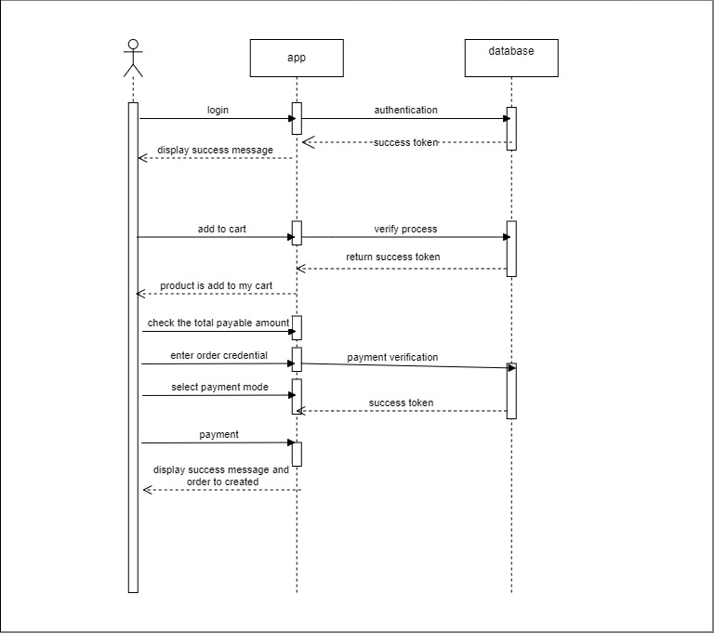

Figure 9 Product order sequence diagram

**ERD:**

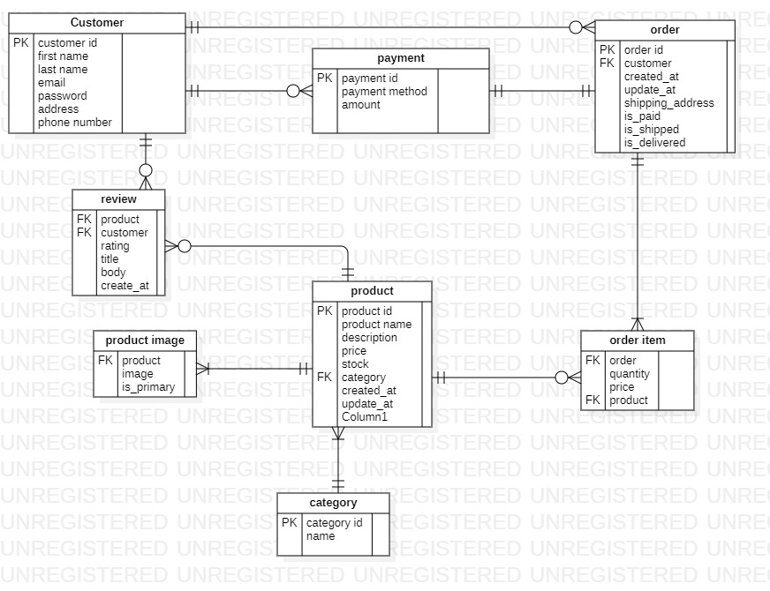

Figure 10 ERD diagram

**Class diagram**

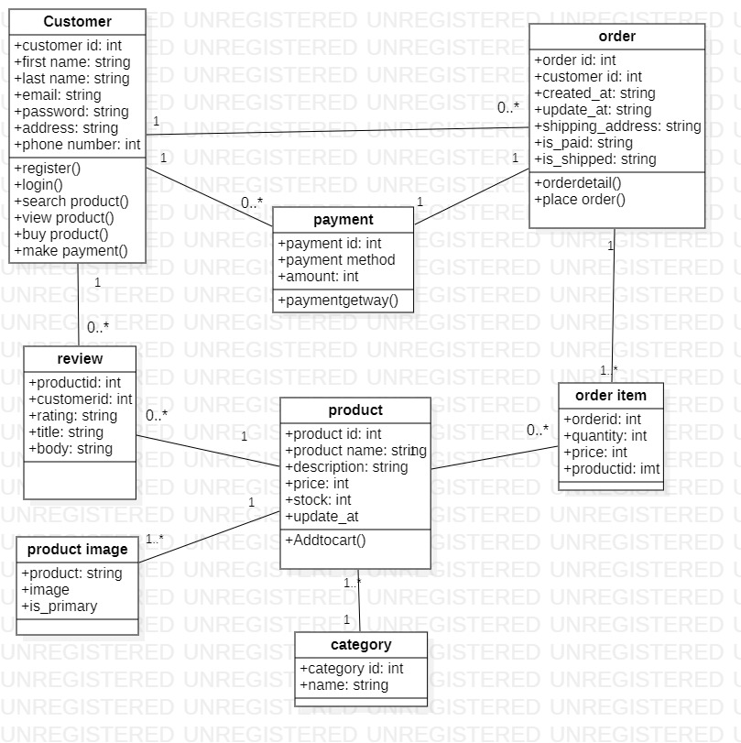

Figure 11 Class Diagram

1. **Implementation**

This chapter provides an overview of the implementation details for the "Easy Buy with 3D Augmented Reality" app. It includes descriptions of the algorithms used, along with the external APIs that enable various functionalities in the project. UML diagrams may be added for visual support if applicable.

1. 1. **Algorithm**

The primary algorithms used in the project focus on Augmented Reality (AR) rendering, user authentication, and product recommendation. Below is a natural language explanation of these algorithms.

* + 1. **AR Rendering Algorithm**

To render decor items within a user’s physical space, the AR rendering algorithm follows these steps:

**Initialize Camera and AR Session**: The app accesses the device’s camera and initializes an AR session using the selected AR SDK (such as ARKit or ARCore).

**Detect Surface**: The algorithm detects horizontal surfaces within the user’s space and aligns with real-world coordinates.

**Load 3D Model**: Based on the selected decor item, a 3D model is retrieved from the database and placed within the AR view.

**Scale and Position Adjustment**: The algorithm scales the model to realistic dimensions and enables the user to reposition it by moving their device.

**Real-time Rendering**: The app continues real-time rendering as the user moves around to maintain a realistic and immersive experience.

* 1. **External APIs**

Various external APIs support the project by adding specialized functionalities, such as AR processing and payment handling. Table 5.1 lists the APIs used in the project along with their purposes and implementation locations.

*Table 5.1: Details of APIs used in the project*

|  |  |  |  |
| --- | --- | --- | --- |
| **Name of API** | **Description of API** | **Purpose of usage** | **List down the function/class name in which it is used** |
| |  | | --- | | ARKit/ARCore |  |  | | --- | |  | | AR SDKs for iOS (ARKit) and Android (ARCore) supporting AR features. | Enables AR visualization of decor items in real environments. | ARRenderer, ObjectPlacer |
| |  | | --- | | Stripe API |  |  | | --- | |  | | A payment processing API for secure transactions**.** | Facilitates payment handling during checkout. | PaymentProcessor |

* 1. **User Interface**

## A screenshot of a login form Description automatically generated Figure 2 Login

## Figure 3 Verification

## Figure 3 Sign up

1. **Testing and Evaluation**

This chapter provides a comprehensive overview of the testing methodologies employed for the "Easy Buy with 3D Augmented Reality" app, ensuring the application meets all functional and non-functional requirements.

3. 1. **Manual Testing**

Manual testing involves executing test cases without automation to ensure all functionalities operate as intended. The following sections outline the types of manual testing conducted.

1. * 1. **System testing**

System testing is performed after the system has been developed to verify that the application operates as intended and meets all requirements. This testing helps identify errors that may not be visible to users and includes several testing types:

**Unit Testing**

**Functional Testing**

**Integration Testing**

**End-to-End Testing**

**User Acceptance Testing (UAT)**

All testing must be completed before the application is deployed to users.

* + 1. **Unit Testing**

Unit testing focuses on validating individual components of the application to ensure they work correctly.

* **Unit Testing 1:** User Login

*Table 5.1: Login Unit Testcase*

|  |  |  |  |  |
| --- | --- | --- | --- | --- |
| **No.** | **Test case/Test script** | **Attribute and value** | **Expected result** | **Result** |
| 1. | Verify user login after clicking the 'Login' button | Username: L001  Password: 1234 | Successfully log into the main page as a user. | Pass |
| 2. | Verify unsuccessful login with incorrect password | Username: L001  Password: wrongpass | Error message displayed indicating incorrect credentials. | |  | | --- | | Pass |  |  | | --- | |  | |
| 3. | Verify login with empty username | Username:  Password: 1234 | Error message displayed indicating required fields. | Pass |
| 4. | Verify login with empty password | Username: L001  Password: | Error message displayed indicating required fields | Pass |

* **Unit Testing 2:** Edit Profile

**Testing Objective:** To ensure the edit profile functionality works correctly..

*Table 5.2:* *Edit Profile Unit Testcase*

|  |  |  |  |  |
| --- | --- | --- | --- | --- |
| **No.** | **Test case/Test script** | **Attribute and value** | **Expected result** | **Result** |
| 1. | Verify editing profile information | New Name: huz  NewEmail: huz@example.com | Profile updated successfully message displayed. | Pass |
| 2. | Verify profile update with invalid email | NewEmail: invalid-email | Error message displayed for invalid email format. | Pass |
| 3. | Verify profile update with blank fields | NewName:  New Email: | Error message displayed indicating required fields. | Pass |

* + 1. **Functional Testing**

Functional testing assesses the application’s functionalities against the specified requirements.

* **Functional Testing 1:** Login with Different Roles

*Table 5.3: Login Functional Testcase*

|  |  |  |  |  |
| --- | --- | --- | --- | --- |
| **No.** | **Test case/Test script** | **Attribute and value** | **Expected result** | **Result** |
| 1. | |  | | --- | | Login as a 'User' |  |  | | --- | |  | | Username: User123  Password: password | User main page loaded with user navigation bar. | Pass |
| 2. | Login as an 'Admin' | Username: Admin  Password: adminpass | Admin main page loaded with admin navigation bar. | Pass |
| 3, | |  | | --- | | Login as 'Guest' |  |  | | --- | |  | | Username: Guest  Password: guest | Guest main page loaded with limited navigation options. | Pass |

**Functional Testing 2:** Login with Different Roles

*Table 5.4: Product Management Testcase*

|  |  |  |  |  |
| --- | --- | --- | --- | --- |
| **No.** | **Test case/Test script** | **Attribute and value** | **Expected result** | **Result** |
| 1. | |  |  |  | | --- | --- | --- | | |  | | --- | |  |  |  | | --- | | Add new product | |  |  | | --- | |  | | ProductName: Chair  Price: 49.99 | Product successfully added to the catalog. | Pass |
| 2. | Edit existing product | Product ID: 001  New Price: 39.99 | Product price updated successfully. | Pass |
| 3, | |  |  |  | | --- | --- | --- | | |  | | --- | | Delete product |  |  | | --- | |  | |  |  | | --- | |  | | Product ID: 001 | Product successfully removed from the catalog. | Pass |

* + 1. **Integration Testing**

Integration testing ensures that combined modules work together as expected.

*Table 5.6: Integration Testcase*

|  |  |  |  |  |
| --- | --- | --- | --- | --- |
| **No.** | **Test case/Test script** | **Attribute and value** | **Expected result** | **Result** |
| 1. | Login as a user | Username: User123  Password: password | Login successful; user main page loads with navigation bar | Pass |
| 2. | Upload product image | File: product-image.jpg | File successfully uploaded and displayed in the product catalog.. | Pass |
| 3. | View user profile | - | User profile displayed with correct information. | Pass |
| 4. | Add and view multiple products | - | All products displayed in the catalog without errors. |  |

* 1. **Automated Testing:**

Automated testing utilizes tools to streamline the testing process, enabling the execution of repetitive tests and enhancing coverage.

*Table 5.5: Tools used*

|  |  |  |  |
| --- | --- | --- | --- |
| **Tool Name** | **Tool Description** | **Applied on [list of related test cases / FR / NFR]** | **Results** |
| Selenium | |  | | --- | | Automation tool for web applications testing |  |  | | --- | |  | | |  | | --- | | Functional testing for login and profile edits |  |  | | --- | |  | | |  | | --- | | All tests passed successfully |  |  | | --- | |  | |
| |  | | --- | | JUnit |  |  | | --- | |  | | |  | | --- | | Unit testing framework for Java applications |  |  | | --- | |  | | |  | | --- | | Unit tests for backend functionalities |  |  | | --- | |  | | |  | | --- | | All unit tests passed |  |  | | --- | |  | |
| Postman | |  | | --- | | API testing tool |  |  | | --- | |  | | |  | | --- | | Testing API responses for product management |  |  | | --- | |  | | |  | | --- | | All API responses validated |  |  | | --- | |  | |

1. **Conclusion and Future Work**

This chapter concludes the project and highlights future work.

1. 1. **Conclusion**

The "Easy Buy with 3D Augmented Reality" app successfully fulfills its primary objective of providing an innovative and user-friendly platform for online shopping. Through the integration of 3D augmented reality technology, users can visualize products in real-world settings before making a purchase, enhancing their shopping experience.

The project has undergone rigorous testing, ensuring that all functionalities operate as intended, and the application meets the requirements set forth at the beginning of the development process. Key achievements include:

* **User-Centric Design:** The app has been designed with a focus on user experience, allowing seamless navigation and interaction.
* **Robust Functionality:** Comprehensive functionalities, including user login, profile management, product browsing, and checkout processes, have been implemented and thoroughly tested.
* **Integration of AR Technology:** The incorporation of augmented reality allows users to interact with products in an immersive way, setting the app apart from traditional e-commerce platforms.
* **Scalability and Performance:** The application has been built to handle a growing number of users and products efficiently, ensuring that performance remains optimal even under load.

Overall, this project demonstrates the potential of merging traditional e-commerce with cutting-edge technology, paving the way for a more interactive shopping experience.

* 1. **Future Work**

While the current version of the app has successfully met its initial goals, several areas for future enhancement have been identified:

**Enhanced AR Features:**

Future versions could include more advanced AR capabilities, such as the ability to customize products in real-time (e.g., changing colors, materials) and advanced lighting effects to improve realism.

**User Personalization:**

Implementing machine learning algorithms to provide personalized product recommendations based on user behavior and preferences could enhance the shopping experience.

**Multi-Platform Support:**

Expanding the app's compatibility to include additional platforms (e.g., web and other mobile operating systems) to reach a wider audience.

**Payment Gateway Integration:**

Future iterations could explore integrating additional payment options, to provide users with greater flexibility.

**Social Features:**

Incorporating social sharing options and user reviews could enhance community engagement and trust, encouraging more users to participate in the platform.

**Augmented Reality for Multiple Products:**

Developing functionality that allows users to visualize multiple products simultaneously in their environment could significantly enhance the shopping experience.

**Performance Monitoring and Optimization:**

Implementing continuous performance monitoring tools to track user interactions and identify bottlenecks can lead to ongoing optimizations and improvements.

**Analytics and Reporting:**

Adding analytics features to provide insights into user behavior, sales trends, and product performance can help inform business decisions.

1. **References**

<https://www.livehome3d.com/useful-articles/ar-in-home-design>  
<https://poplar.studio/services/ar-ecommerce/>

<https://www.aircards.co/use-cases/web-ar-ecommer>

https://www.bigcommerce.com/articles/ecommerce/ecommerce-augmented-reality/