Angular

Angular javascript ka framework hai jo front end k liye use hota hai

Npm install -g @angular/cli 🡺 cli ko globally install karne k liye

Components se data ko html main print karna

For example app.component main title=”ali”hai ise html main use karne k liye

App.html main use karne k liye <h1>my name is {{title}} </h1> ise interpolation kehte hain

----------------🡺

Ng stand for `Next generation`

Angular CLI Commands;

Component banana k liye

* Ng generate component “component ka name’

Class banana k liye

Ng generate class `class name`

--------------------------🡺

Inline style component k liye

Ng g c `component name` --inline—style 🡺 is main css k file generate nahi hogi component main hi css styles karni parti hai

Inline template k liye component k liye

Ng g c `component name` --inline—template 🡺is main html k file generate nahi hogi component main hi html karni parti hai

Agar aik hi file main dono kam karne hon to html css

Ng g c “component name” –inline—style –inline—template

Module :

Module aik part of work hota hi jis main hum apna aik hisa store kar lete hain mean k hum auth ka module banalia us main us k component rakh liye jese login register etc

Command🡺 ng g m `module ka name`

Module

🡺Module k ander component banana k liye ng g c moduleName/Component Name🡸

Function

Anguar main function banana k liye

Html mai use call karna hoto jese hum js main onclick se karte the is main 🡺 (click)=”functionNAme()” se karte hain

Function component ki ts file k class wale section main banate hain.

FunctionName(){  
code of function

}

Events:

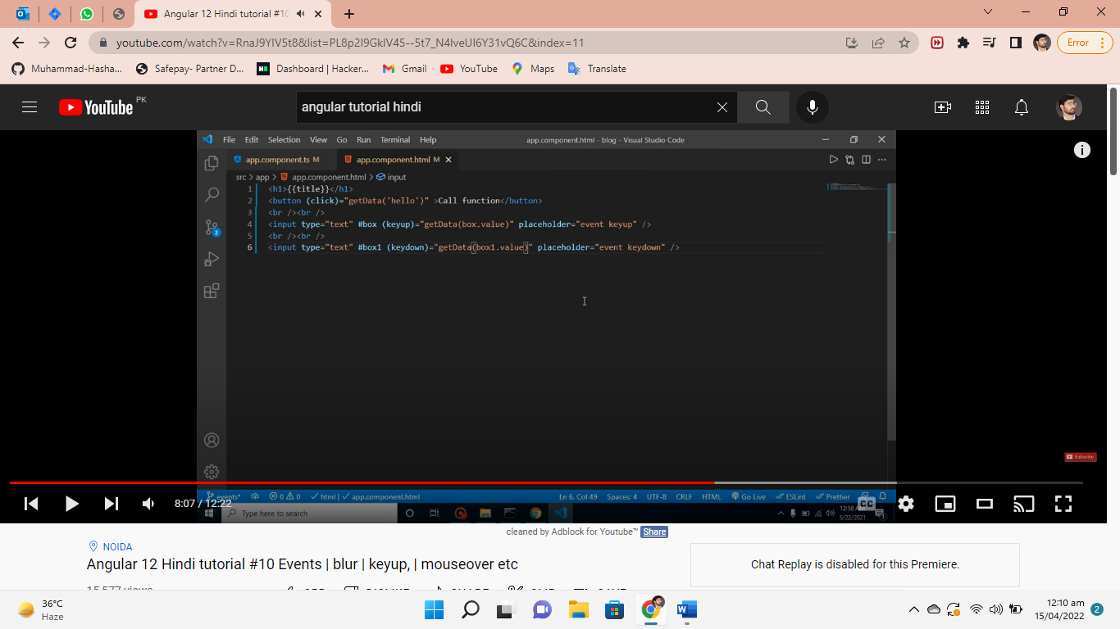

(blur)=”functionNAme()” jab focus hate ga tab chale ga

(mouseover)=”functionNAme()” jese mouse aye ga element par tab chale ga

(mouseleave)=”functionNAme()” jese mouse jaye ga element par tab chale ga

(input)=”functionNAme()” data lene k liye

Input textbox se values lene k liye

