HOMA HEALTHCARE CENTER
— Precision Metabolic Medicine —
UNDER THE GUIDANCE OF
SRI DUDDILLA SRIDHAR BABU GARU
Hon'ble Minister for IT, Electronics & Communications, Industries & Commerce, and Legislative Affairs, Government of Telangana; MLA, Manthani

MNR — NMC — IMA & HOMA CME
ONE-DAY PROGRAMME
Beyond Numbers: Precision Phenotyping in Diabetes & Metabolic Care
📅 Monday, 21 September 2026 | 🕐 9:00 AM – 6:35 PM | 📍 T-Hub, Hyderabad (hall TBD)
CME Credits: Applied (NMC / TSMC)

ENGAGEMENT WITH TELANGANA LEADERSHIP
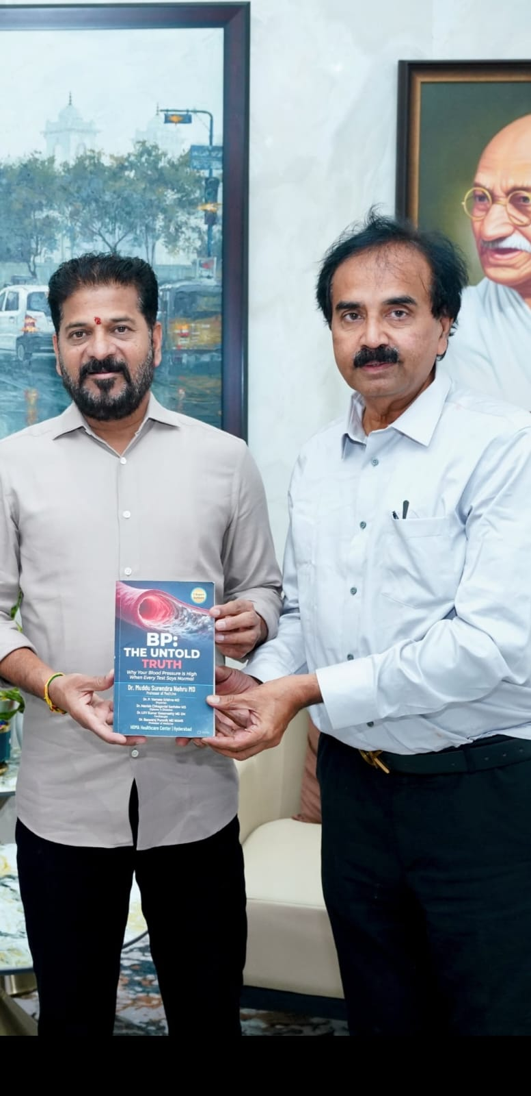  Dr. Muddu presenting "BP: The Untold Truth" to Hon'ble CM Sri Revanth Reddy Garu | 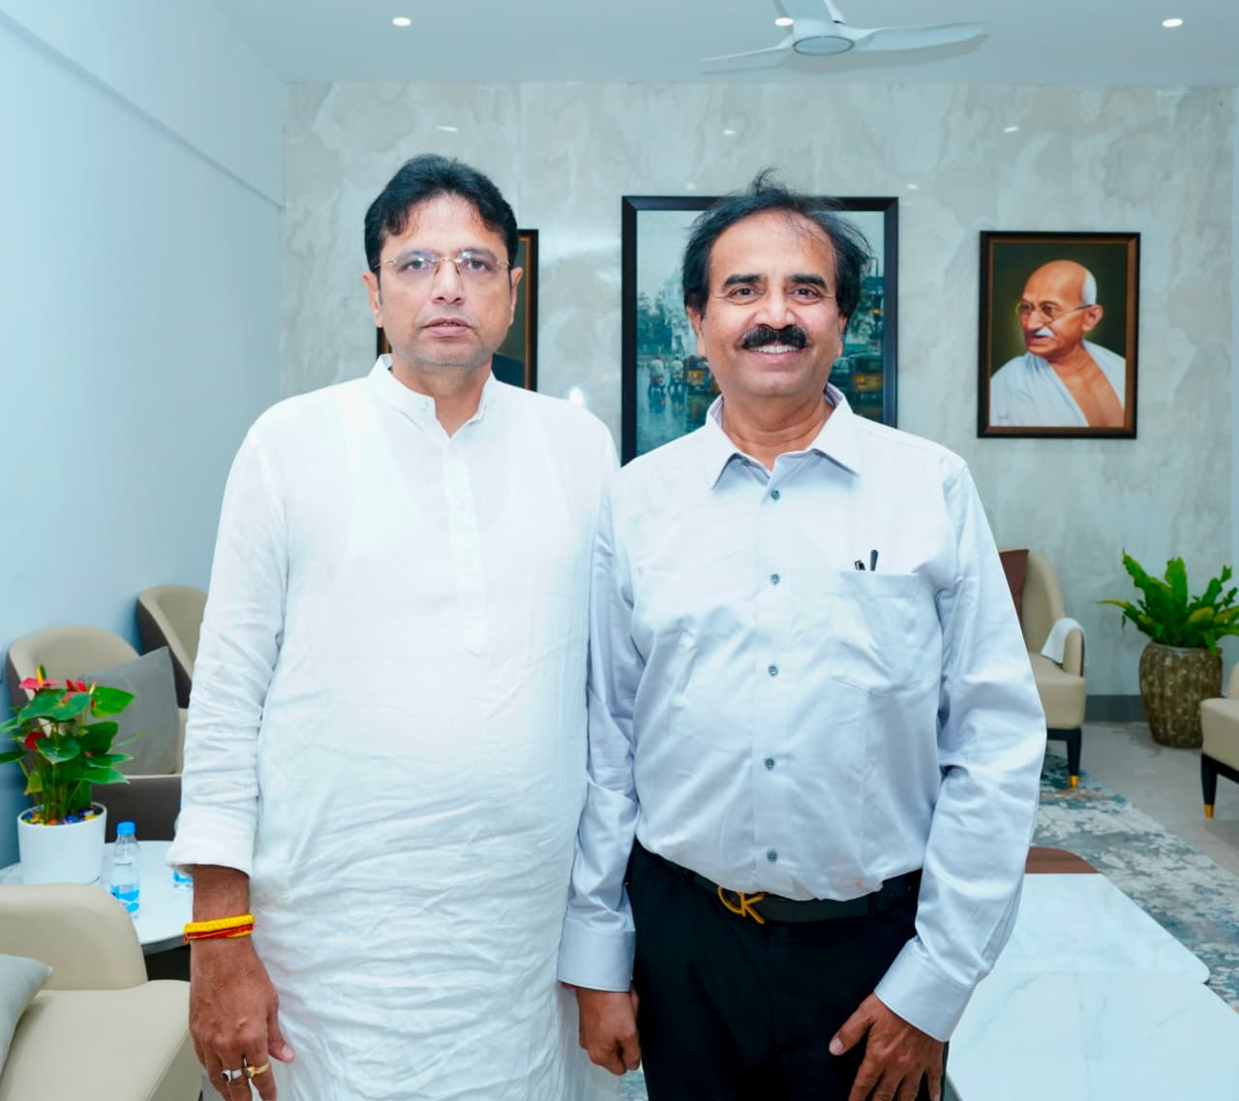  Dr. Muddu with Hon'ble Minister Sri Duddilla Sridhar Babu Garu, Chief Guest

ORGANISING COMMITTEE
ROLE | NAME
Organising Chairperson | Dr. Surendra Nehru Muddu, MD — HOMA Healthcare Center
Scientific Chairperson | Dr. Vasanth Kumar, MD — Professor of Medicine (RSSDI)
Co-Chairpersons | Dr. R.K. Jain (Cardiology) · Dr. Ramesh Hanumkonda — Ex-President, APICON · Dr. Ravinder Reddy, MD, DNB (Cardiology)
Organising Secretary | Dr. Vamsee Krishna
Radiology / Imaging Lead | Dr. Vijay Bhaskar — Vista Imaging (T-Hub)
Joint Organising Secretaries | Dr. Basavaraj Naik · Dr. Riyaz · Dr. Goutham · Dr. Reddy (Mamatha) · Dr. Narayan (Mamatha)
ESI Coordinators | Dr. Naresh (ESI) · Dr. Srinivas (ESI) · Dr. Umesh (ESI)
IMA Coordination | Dr. R. Bai — IMA President, Kukatpally
IMA Hyderabad City Branch | Dr. Ilaiah M (President) · Dr. Vijaya Kumar S (Hon. Secretary) · Dr. Tapadia R (Treasurer)
Scientific Convener | Dr. Ramadevi, MD (Biochemistry)
Workshop Convener | Dr. Surendra Nehru Muddu
Workshop Dietetics Lead | Mrs. Mrunala
BLOCK A — Registration & Scientific Start (before Minister)
Session Chairpersons: Dr. Vasanth Kumar · Dr. Ramesh Hanumkonda
TIME | TOPIC | SPEAKER | CHAIR
8:30–9:00 | Registration & CME Desk | Organising Team | —
9:00–9:15 | Welcome — Beyond HbA1c: Why Metabolic Phenotyping Matters | Dr. Surendra Nehru Muddu | Organising Chair
9:15–9:35 | Lab Matrix: HOMA-IR, TyG, HbA1c, C-Peptide & Autoantibodies | Dr. Ramadevi | Dr. Anunayi
9:35–9:55 | 32-Subtype Framework — Diabetes Beyond Type 1 / Type 2 | Dr. Surendra Nehru Muddu | Dr. Vasanth Kumar
9:55–10:15 | Cardioprotection Beyond Glycemic Control | Dr. R.K. Jain (Senior) | Dr. Ravinder Reddy, MD, DNB (Cardiology)
10:15–10:25 | Assemble for Inaugural / Minister's Arrival | Protocol | —
BLOCK B — Hon'ble Minister (10:30 AM, Confirmed)
TIME | ITEM | LEAD
10:30–10:40 | Welcome of Hon'ble Minister — Approved Protocol Line | Organising Chair
10:40–10:55 | Inauguration — Metric Explorer (Play Store Production) | Dr. Muddu + Hon'ble Minister
10:55–11:05 | Brief Remarks | Hon'ble Minister
11:05–11:10 | "BP: The Untold Truth" — Community Presentation Moment | Dr. Muddu
11:10–11:20 | Group Photograph · Press Bytes | Press Desk
11:20–11:30 | Tea · Resume CME | —
BLOCK C — Late Morning CME
Session Chairpersons: Dr. R.K. Jain · Dr. Vasanth Kumar | Highlighted row = new compulsory addition
TIME | TOPIC | SPEAKER | CHAIR
11:30–11:50 | Major Cardiac Complications in Diabetes | Dr. Srinivas Kumar, MD DM (+ Dr. Loknath / Dr. Narsa Raju) | Dr. R.K. Jain
11:50–12:10 | Cardiac Interventions in Diabetes — Practical Choices | Dr. Ravinder Reddy, MD, DNB (Cardiology) · Dr. Kumar | Dr. R.K. Jain
12:10–12:30 | Central Obesity and the Role of CT Imaging | Dr. Vijay Bhaskar (Vista Imaging) | Dr. Ramadevi · Dr. Basavaraj Naik · Dr. Venkat, MD
12:30–12:45 | Early Detection of Diabetic Nephropathy | Dr. Prasad / Dr. Manthena | Dr. Subramanyam
12:45–12:55 | Fireside Chat: Urology & Nephrology in Diabetes | Dr. Mallikarjuna (Asian Institute of Urology & Nephrology) | —
13:00–13:30 | Lunch Break | — | —
BLOCK D — Afternoon CME
Session Chairpersons: Dr. Ramesh Hanumkonda · Dr. Vasanth Kumar | Highlighted row = new compulsory addition
TIME | TOPIC | SPEAKER | CHAIR
13:30–13:50 | SGLT2 Inhibitors in Current Practice | Dr. Rakesh Sahay | —
13:50–14:10 | MASLD / NAFLD in Diabetes | Dr. Pradeep | Dr. Mardha
14:10–14:30 | Diabetic Neuropathy | Dr. Chandra Sekhar, MD, Prof. (Mulugu) | Dr. Jyothi (Neurology)
14:30–14:40 | Fireside Chat, 10 min | Dr. S.V. Prasad (Neurology) | —
14:40–14:55 | Diabetic Retinopathy Screening | Dr. Prasad (Ophthalmology) | Dr. Maddiah
14:55–15:10 | Pediatric Obesity | Dr. Soujanya Vidadala | Dr. Athaullah · Dr. Lohith (Dentist) · Dr. Ravi (IMA Kukatpally)
15:10–15:25 | Urology and Andrology Complications in Diabetes | Dr. Syed Mohammed Ghouse, MS, MCh (Urology) — arranged through Dr. Yakiah | —
15:25–15:40 | Diabetes in Pregnancy & GDM / PCOS | Dr. Nandi / Dr. Gowri / Dr. Fahmida Banu | Dr. Riyaz Ahmed, MD, Professor
15:40–15:55 | Diabetic Foot & Limb Salvage | Dr. Venkat (Ortho) · Dr. Srinivas (Surgery) | Dr. Govind Reddy · Dr. Ramana Babu, MS (Ortho)
15:55–16:10 | Tea Break | — | —
16:10–16:30 | Precision Pharmacotherapy by Phenotype | Dr. Ramesh Hanumkonda (Ex-President, APICON) | Dr. Vasanth Kumar
16:30–16:45 | Diabesity & Metabolic / Bariatric Surgery | Dr. Bikshith | Dr. Srinivas
16:45–17:00 | Panel — Is HbA1c Enough? HOMA-IR / TyG in Screening | Muddu · Vasanth Kumar · Ramadevi · R.K. Jain · Pradeep | Moderator: Dr. Vamsee Krishna
BLOCK E — Workshops & International Faculty (5:00 PM – 6:35 PM)
Workshop Chair: Dr. Surendra Nehru Muddu · Co-Chair: Dr. Vamsee Krishna
TIME | WORKSHOP | FACULTY
17:00–17:20 | W1 — What is Metric Explorer? Live Clinical Walkthrough | Dr. Muddu · Dr. Basavaraj Naik · Dr. Goutham
17:20–17:40 | W2 — Diet & Exercise Design by Phenotype | Dr. Muddu · Mrs. Mrunala · Dr. Soujanya Vidadala · Dr. Bikshith
17:40–18:00 | W3 — Metabolism Calculator & Data Analysis (HOMA Online Tools) | Dr. Muddu · Dr. Ramadevi · Dr. Vamsee Krishna
18:00–18:10 | Diabetes Peripheral Vascular Disease (Hybrid, USA) | Dr. Paladugu Ramesh (Dallas)
18:10–18:20 | Tobacco & Diabetes / Pain Management in Diabetes (Hybrid, USA — time pending) | Dr. Murali Mohan Agnirekula (Florida)
18:20–18:30 | Fireside Chat, Evening Session | Dr. Shivram, Prof. of Medicine (Khammam)
18:30–18:35 | Valedictory · CME Feedback · Certificates Process | Organising Chair
Still to confirm before print: T-Hub hall/room name · exact spellings of repeated Dr. S.V. Prasad entries (Ophthalmology vs Neurology) · full name of ESI faculty beside Dr. Umesh.

REGISTRATION & PAYMENT
 | Scan to pay via UPI (mention your name)  WhatsApp us to register: +91 99637 21999  Or visit: muddusurendranehru.github.io/homa-cme-2026

