Aug 3, 2026 ppp-psb-srh

CV 5101: Steps to download, solve, and submit assignments
- Browse to cv-5100 GitHub repo. https://github.com/mude-sel2026/CV-5101
- Search for the link to new assignment.
  - first link is for starter code and problem statement.
  - second link is for “accepting the assignment.
- Open GitHub Desktop.
- Add => clone. Make sure to clone your assignment-repo.
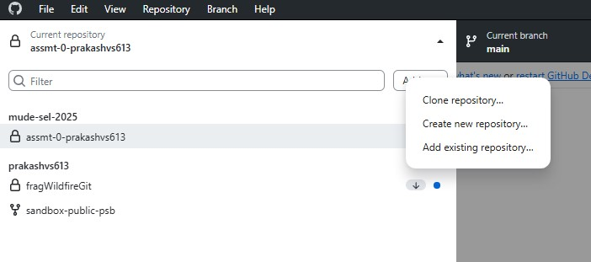

- Solve the assignment (edit readme.md and add other programs) on VS Code.
- Commit on GitHub Desktop after adding a commit note.
- Push.
- Go to browser and check if your assignment-repo is updated.

