HW10:

Services

Martin Mudenda Bbela
2582912

Overview

Modify the Services app:
- Use a ProgressBar view instead/in addition to the Toast to display the progress made by the service

Method

MyService

The service is refrenced in the Manifest so we can listen to calls from it

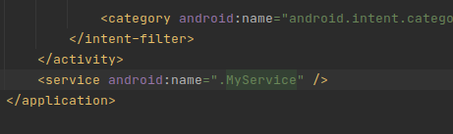

We create a service which will be started by the Main activity that will will wait and send progress to the Main activity.

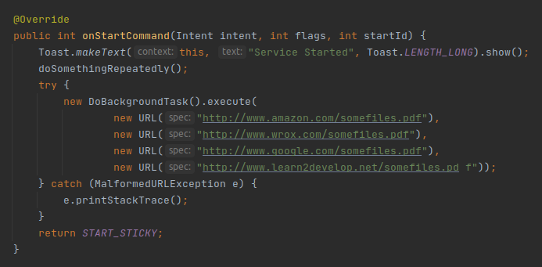
The DoBackGroundTask() is a custom Async Task and internally will send progress to the main activity.

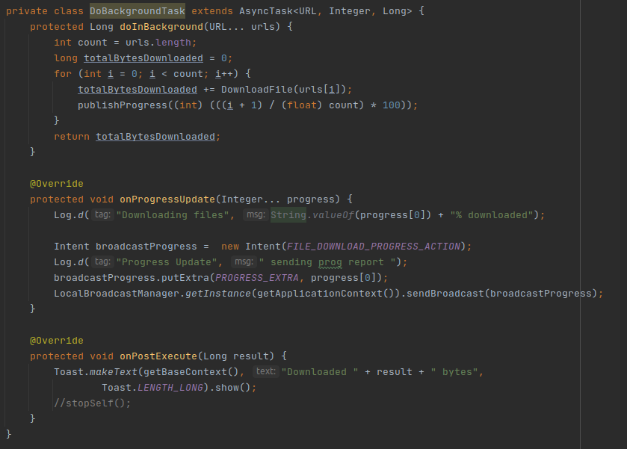

Main Activity

The Main Activity is simply 2 buttons and a progress Bar. We hide the Progress Bar on Create and only make it visible when the the service has started.

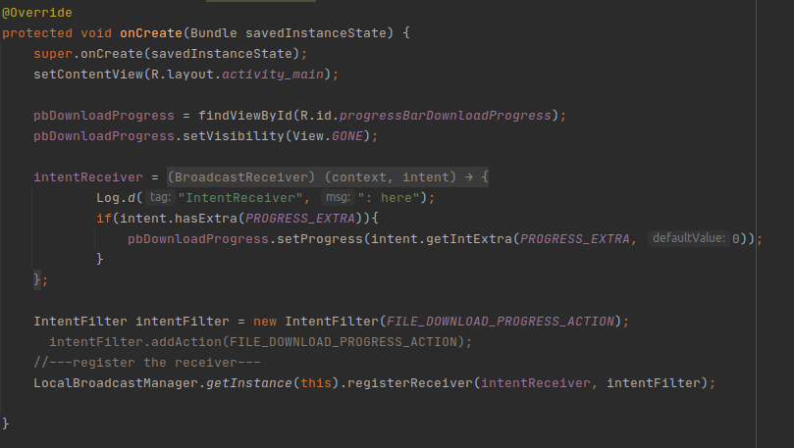

Result

The user is able to start the service and see the download progress in the Main activty.

