HW11:

Location Based Application

Martin Mudenda Bbela
2582912

Overview
Refactor the first location-based service demo app:
- Add two buttons for the map view and satellite view
- Add another button for displaying current location
- When clicking a location on the map, add a marker and move the camera to that location
- Add a EditText view and a button such that when you enter a valid address, the camera will move to that location

Method

LocationListener

This is set to update the current Location Value in which will be used in the Main activity when CurrentLocation is pressed.

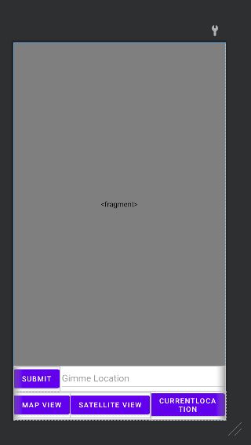
The Layout looks like the picture attached picture. All the buttonsTexts and fragments are wired in onCreate. A new MapFragment is created refrencing the Fragment in the layout. We use onMapReady to setup all the interactions on this screen to take away any chance of Null pointers. First we turn on the location listener to to get current location information.
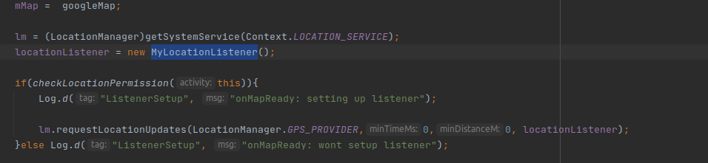

Then we wire the buttons to switch between Map and Satellite View respectively.

The submit button will take the location in the Edit Text and attempt to write move the Map to that Location. As well as set a Marker on it.

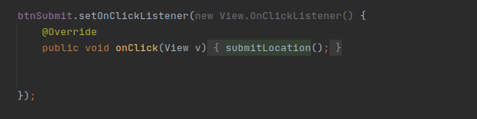
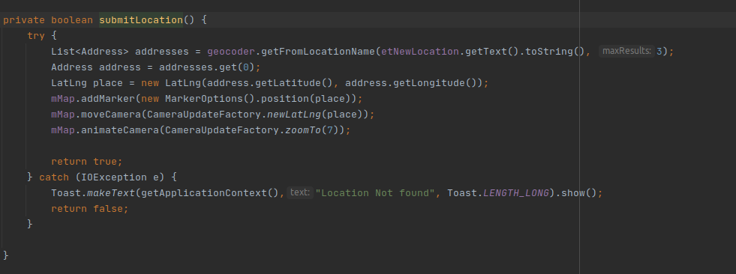

Current Location Will attempt to setup the current Location as the MapView. This will only work if the listener is working so ensure you have granted the application permission to listen for movements.
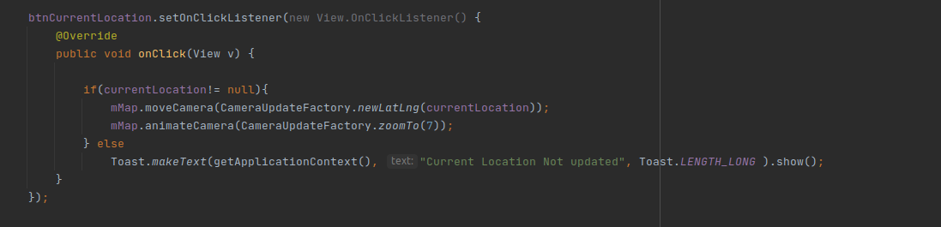

Finally the application is able to take a place the user has clicked and set a marker on that location.

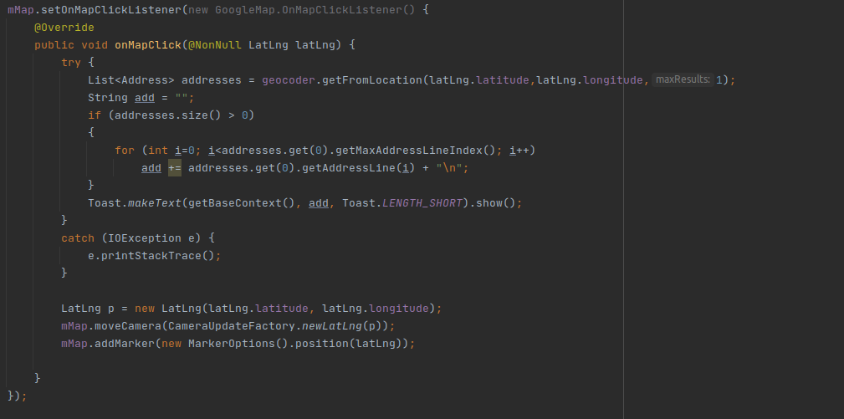

Results
Users are able to submit Locations as well as move the camera around and switch between Map and Setellite View.



