HW12:

Sensor List Activity

Martin Mudenda Bbela
2582912

Overview
Build the sensor listing app using the code provided. In the homework submission, please include the screenshot for all the sensors that are supported by your phone. Please also show at least three sensors’ capabilities and their values.

Method

Main Activity

The Main activity is simply a recyclerView linked to a sensor List that gets populated on initilalizing the Activity.
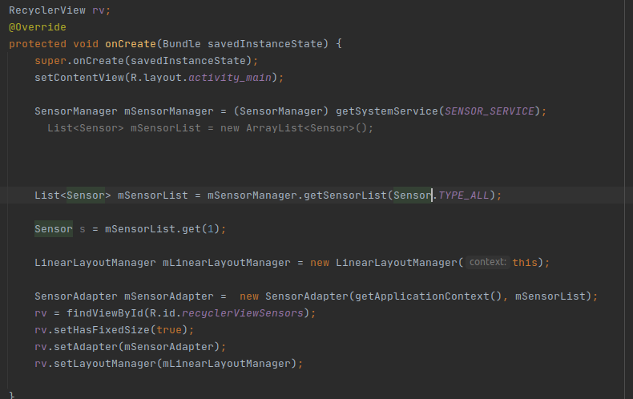

SensorAdapter

This implements a recyclerView adapter. It is setup to take in the SensorList and Populate the recycler view with the names of the sensors. It will also setup an onclickListener for each item to open the SensorOverview Activity to give information about the sensor

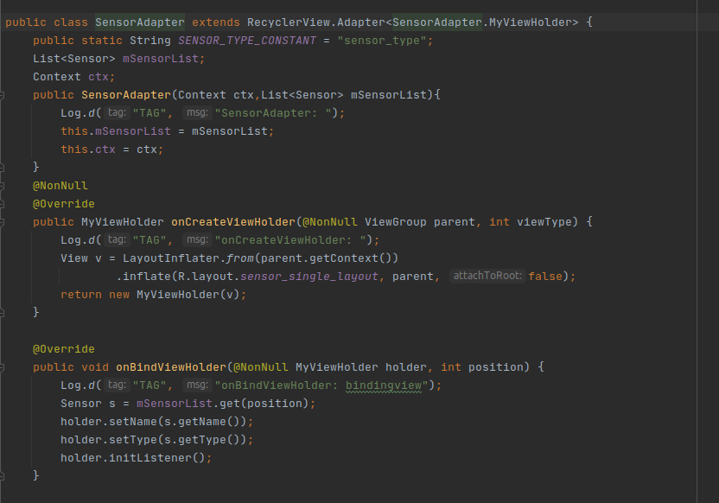
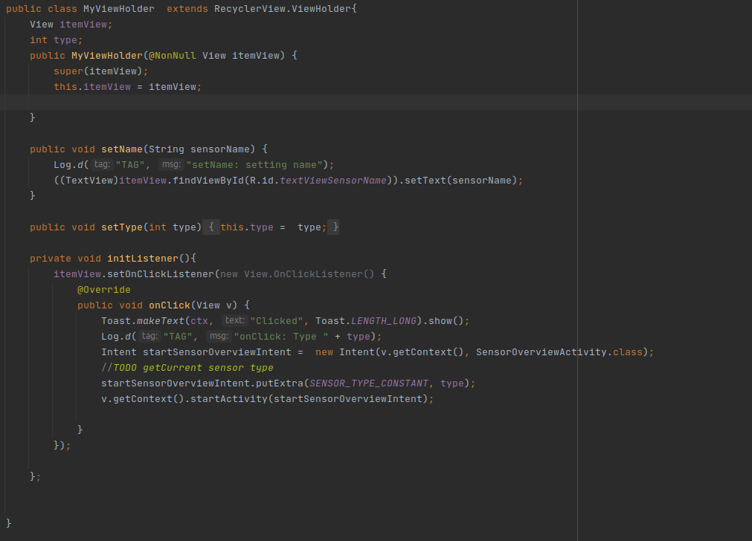

SensorOverviewAvctivity.
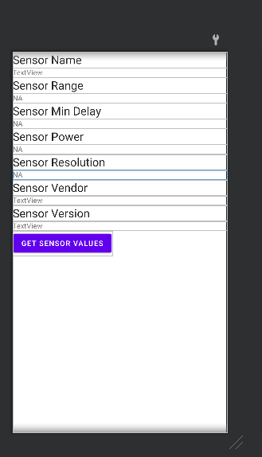
This will take the selected sensor and give an overview of information about it. It uses the passed in intent to retrieve all the information about the current Sensor. You can Also click into the Sensor Values to see the readings the current sensor is outputting
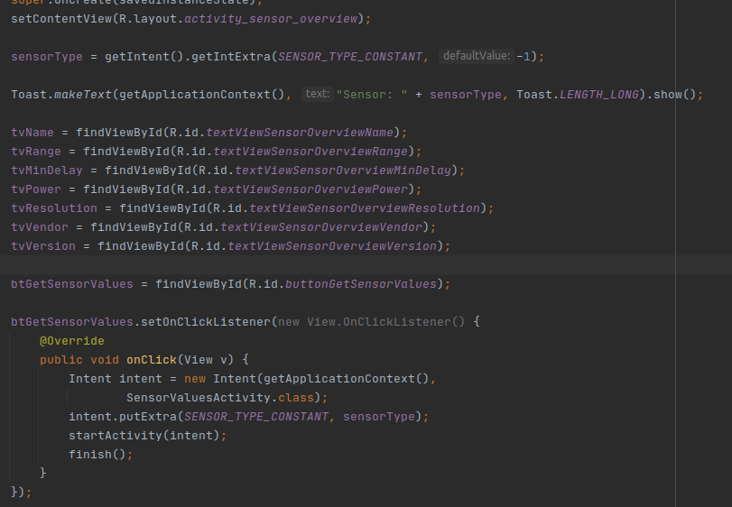

SensorValuesActivity
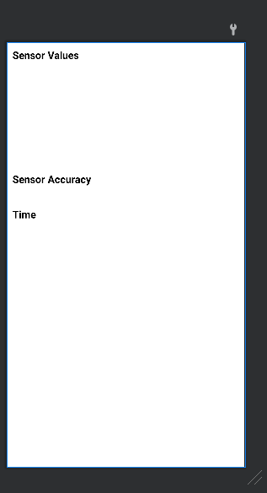
This Activity will take the current sensor and brought in through the intent and register it to output the values to this screen.

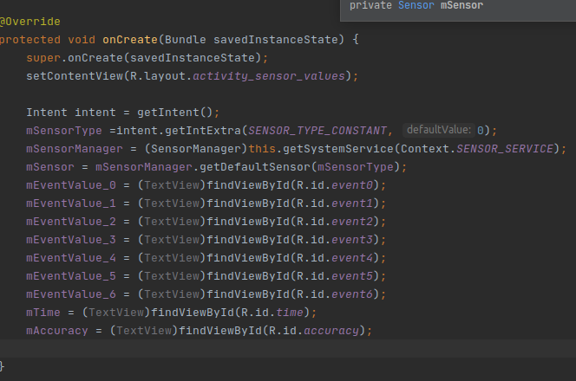

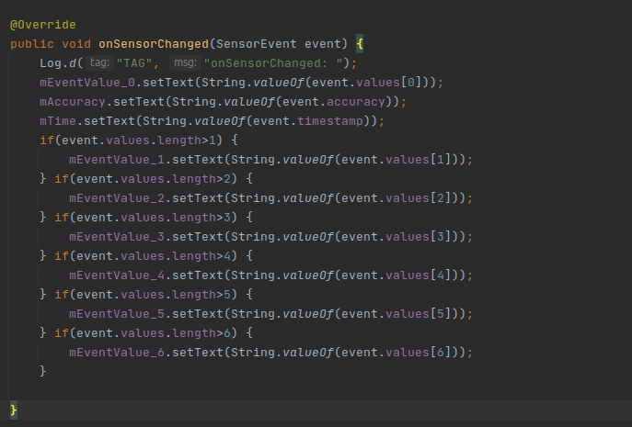

Result

User is able to see all the sensors in their current device. The user can further look into MetaData about that sensor and even see what sensor values are being output.
