HW13:

Proximity Sensor

Martin Mudenda Bbela
2582912

Overview

When you run the demo app for the proximity sensor and place an object very close to the proximity sensor on your phone, the Hello-World label would turn to black, which makes it impossible to see the label anymore. Modify the app so that the “Hello World” text is still visible by changing the text color to white (or some light color) when the proximity sensor return a distance below the maximum range.

Method

The layout will simply be the The Hello World in the middle of a constraint layout
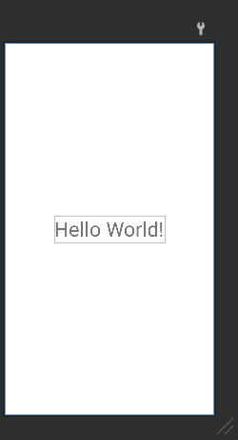
We register and unregister it on resume and onPause respectively.

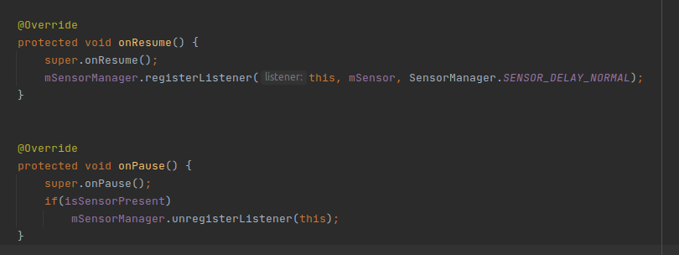

OnSensorChange we will change the color of the Text and Background depending on the value of the Proximity.
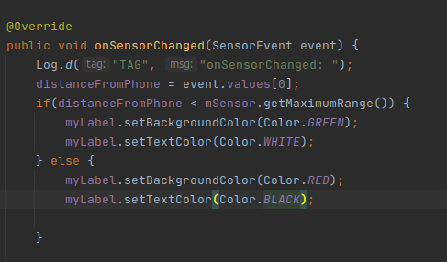

Result

The User is able to update the HelloWorld string by getting closer or further from the proximity sensor.

