HW14:

Proximity Sensor

Martin Mudenda Bbela
2582912

Overview

Based on the shake detection code provided, develop an app that stores at least three songs (or any audio files), and on shaking your phone, the app plays the next song on the list of songs.

Method

The main activity will simply start the service to listen for the shake activity.

OnCreate we will setup the gyroscope sensor and create URIs to the mp3 Paths that we are going to play using the media player.
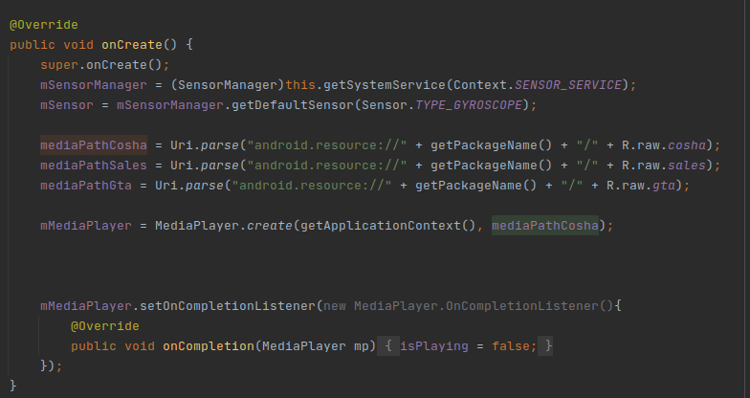

In the Service register the Sensor and unregister the listener
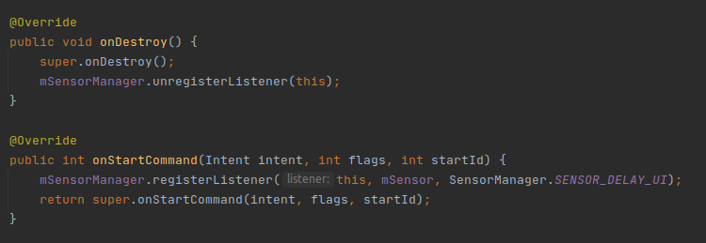
When the sensor value has changed we randomly pick another uri and reset the media player then add the new one to it.
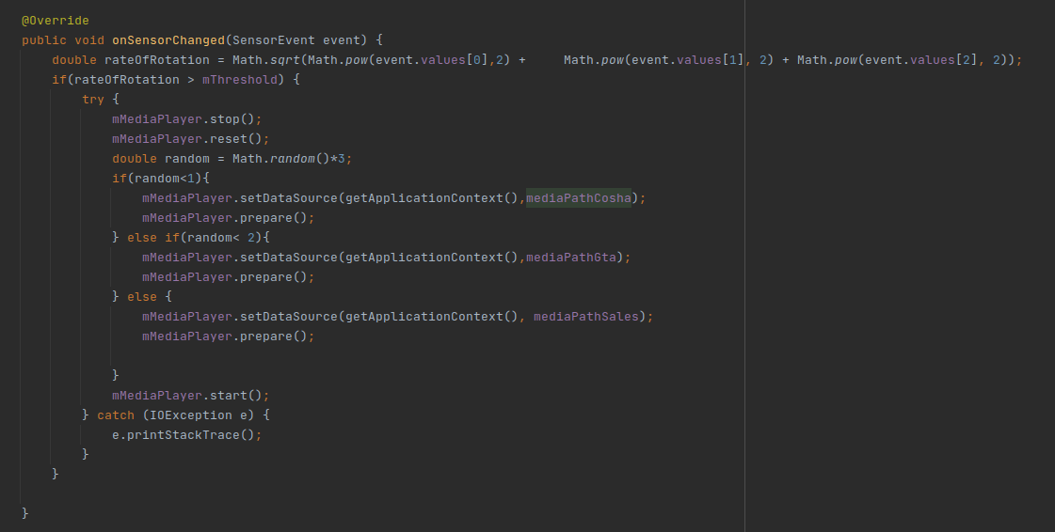

Result.

There is no visual indicator but you should hear one of the three songs play everytime you shake the device.

