HW15:

Pedometer App

Martin Mudenda Bbela
2582912

Overview

Build the pedometer app using the step detector sensor

Method

Using the steps described in the notes I built a step detector that contains a SQL lite Database that will host the number of steps taken on each day. Then Main activity will have a ListView which will be populated through an adapter from the stepCountList. This List pulls from the DB everytime the application starts.
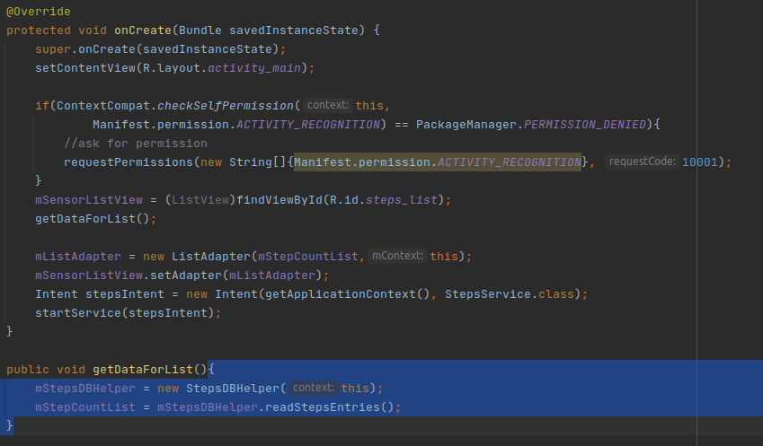

The Database is very similar to the DB created for the contact Manager except it will host the date and the number of steps.

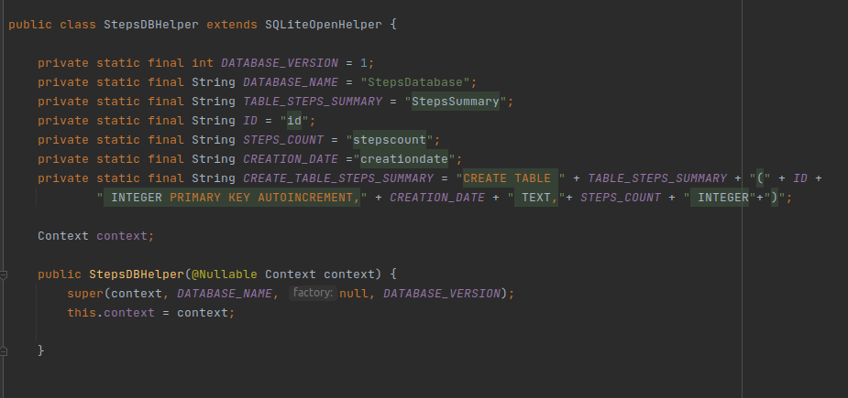

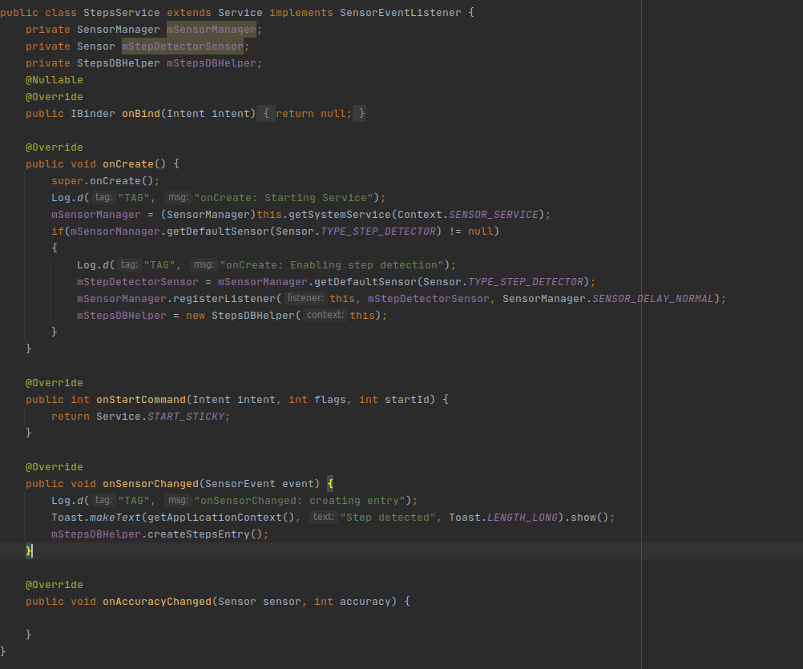
A service is started from the Main Activity. This service will listen for steps and then output them to the Database everytime a step has been detected.

Result.

User is able to see the number of steps taken each day

