HW16:

Pedometer App

Martin Mudenda Bbela
2582912

Overview

The the improved pedometer app with the custom activity detection algorithm has a design issue: the step data are pulled from the SQLite database only at the start of the app. So, if you have run the app for a few minutes with multiple steps, the display the main activity won’t change at all. To see the data collected, you would have to close the app and restart it.
To address this issue, modify the app so that whenever a new batch of steps are recorded, the display on the main activity would be updated. Alternatively, you may add a refresh button on the main activity layout to retrieve the data and display it.
The app actually has another issue: the step count is not as accurate as the step counter. Do some experiments (you will need to carry your phone and walk for say, 100 steps, and compare what is recorded in your app with respect to the actual steps you made) and tune the 3 thresholds used for step counting so that they would work for you – meaning the step count is almost as accurately as the actual number of steps

Method

So following the Notes Given I created an Application that will read the steps someone takes and output them to the screen after persisting. As it is a lot I will assume we all understand what needed to be done t get this application to work in its basic Form. But essentially we create a service that will register a step detector so that on a step being detected will use the Gyroscope and accelarometer to calculate the actual steps since it is more accurate. This information is passed to a database which is queried in the Main activity to update the layout with information about how much work has been done including number of steps and how many calories were burned.

To make the screen update whenever I wanted. I added an update button to the Main Activity that when pressed will run run calculateDataMartix() thereby updating the data on the main Activity.
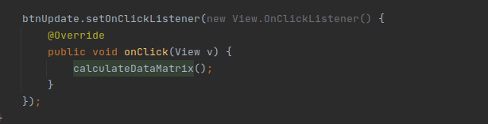

The next issue was tweaking the Peak Values. After a lot of Testing I found out reducing the Values of all the peaks made it a lot more accurate. It did cause some overcorrection by considering some walking steps to be jogging steps but I felt the misreprisentation was negligible

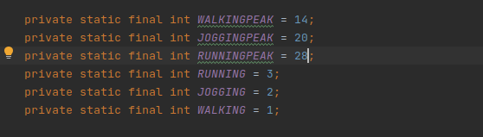

Results

I am able to see how Much walking Running and Jogging I have done as well as update the Data on Request.

