HW3:

Fragment Keyboard

Martin Mudenda Bbela
2582912

Overview
Develop a notepad app with custom keypad:
- Top fragment: display the note entered
- Bottom fragment: display several rows of letters, numbers, and symbols (each as a button) for text input; when a user pushes a button, the corresponding input is appended in the top fragment

Method
I used the updated pattern to create this a listener between the two fragments in the main activity. In this case I create a Button Press View Model that will host a string as truth. This will be used to communicate between the two Fragments.
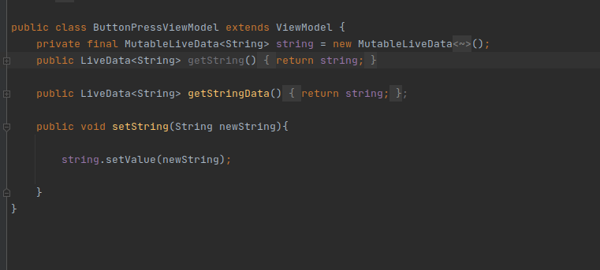

The Main activity will be completely bare. The layout will hold two Fragments that I will Statically add two fragments in the layout itself
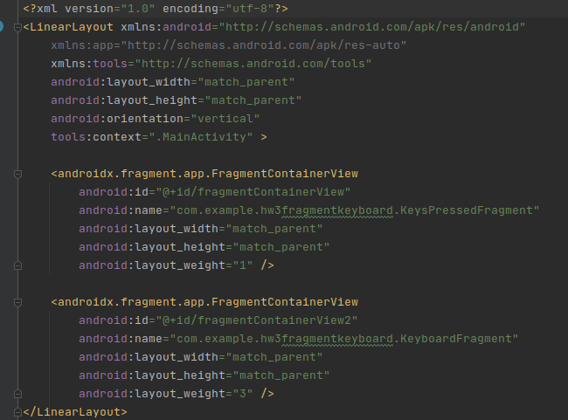

There will be two Fragments. The First we will discuss is the KeyboardFragment that will have a string of Truth. This will be appended to as keys are pressed and will also be deleted from with the backspace button. The ViewModel is taken from the ViewModelProvider so it is a singleton. This will be given the new String which will be sent to the other Fragment.
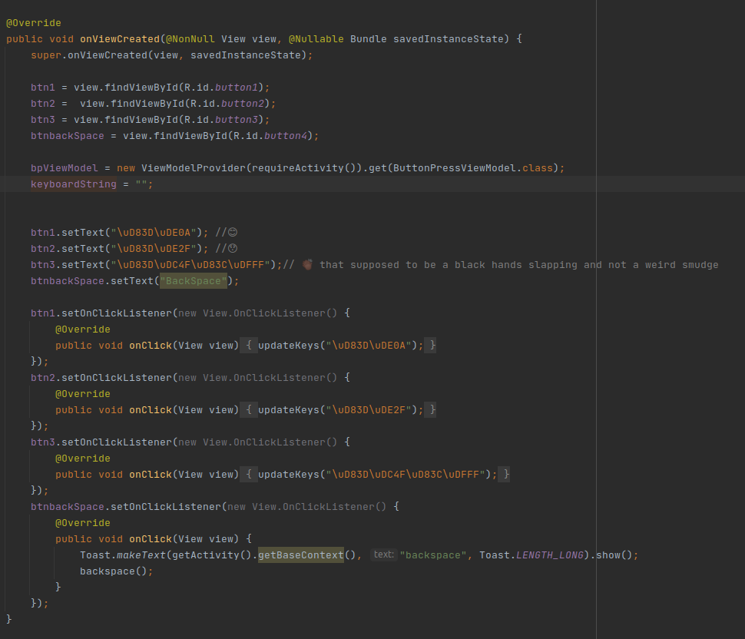
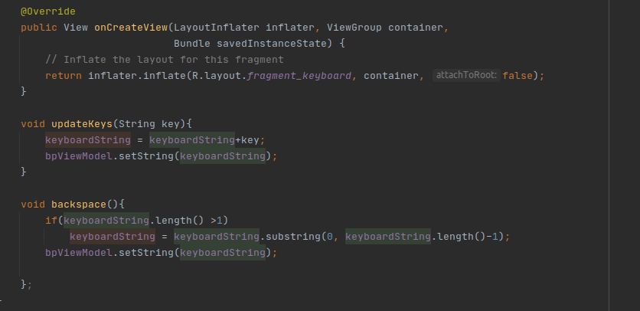

The next fragment, the KeyPressedFragment, will take the ButtonPressViewModel and listen for when the string has been updated and use it to update the the TextView
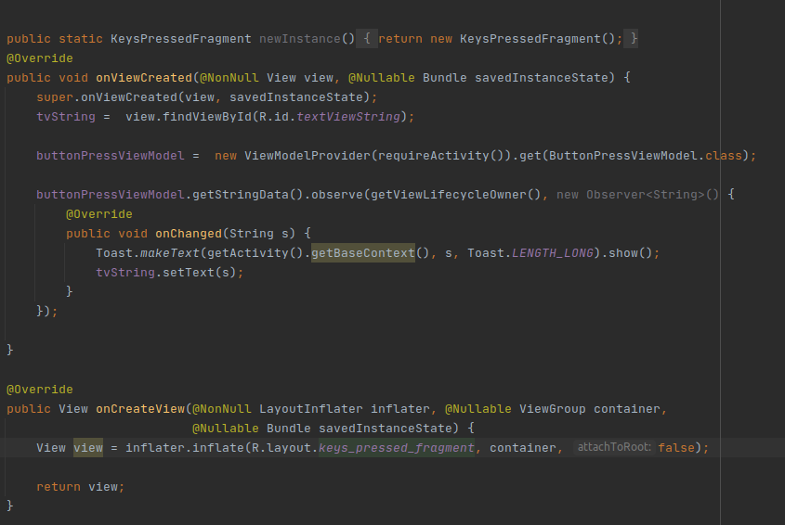

Result

Users are able to type out emoji strings in our minimalist keyboard as well as delete from them as needed
