HW4:

Multiple Layouts

Martin Mudenda Bbela
2582912

Overview:
This project is an android application that has two activites. Both activities will be blank except for the ability to switch between then at the click of a button found on each activity. The Main activity will also contain a count of how many times the application has switched back and forth Since it was opened.

Method:

Activity 1:
Created a new project called HW1. This will contain a blank activity.
First the Main activity is created. The Main activity has a Button and a Text View.
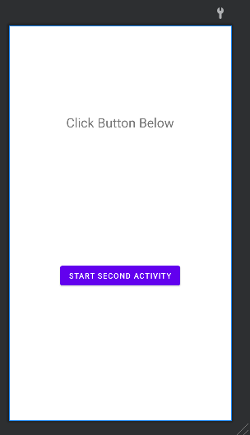
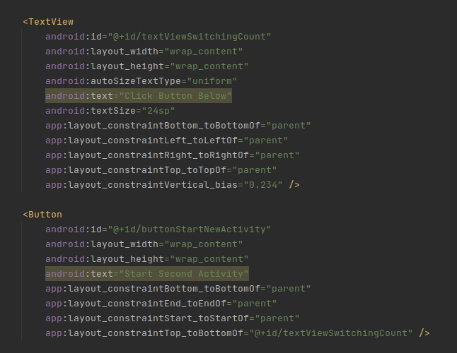

The Button and text view are wired into the Main activity.
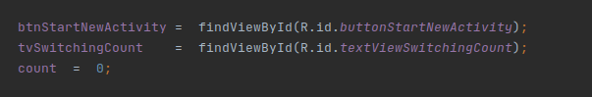

Note that a Int variable count has been initialized with zero. This will represent the number of times the activity has been switched back and forth. Next the btnStartNewActivity is wired to a trigger opening the next activity with an intent.

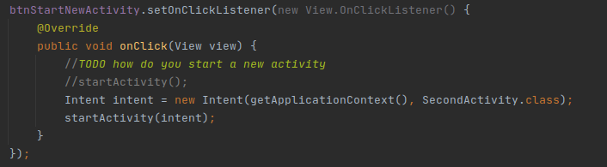

When the activity switches, it will trigger the current activity to run onPause(). This method is Overriden, allowing the textViewSwitchingCount to update with an incremented count value.
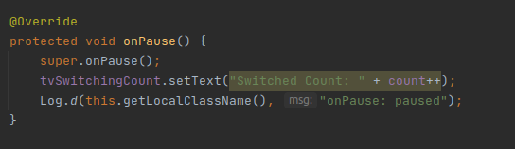

Activity2:

Much like Activity1, Activity2 will consist of a Button and a TextView
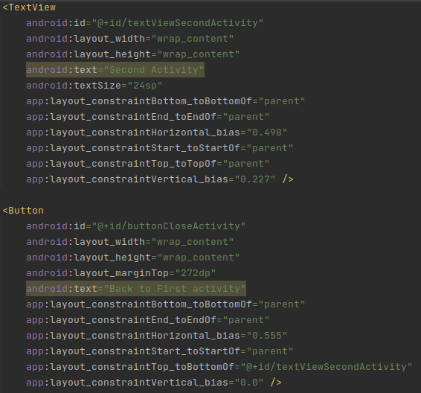
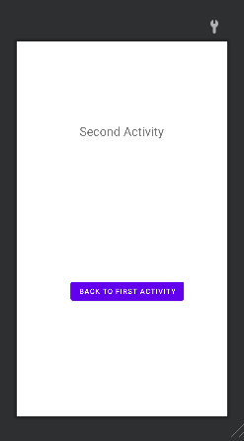

Activity2 will only have the btn wired to close this activity again revealing activity one again.
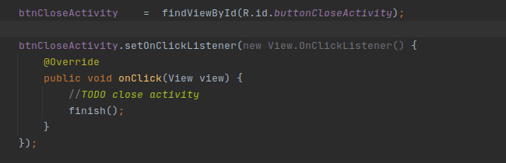

Result:

The application works as expected. Allowing the user to switch between activites and keeping count of how many times it has switched to activity 2.

