HW5:

App Bar layout

Martin Mudenda Bbela
2582912

Overview:
Modify the ActionBar app by by altering the behavior when each action item is clicked in the following ways:
- When item1 through item4 is clicked, a TextView should be displayed at the upper-left, upper-right, bottom-left, and buttom-right on the screen, respectively
- When item5 is clicked, all existing TextViews that have been added to the screen should be cleared

Method:

Manifest
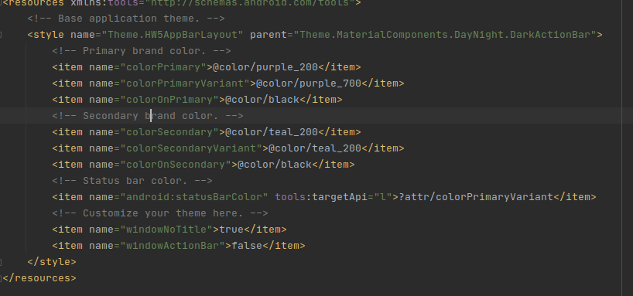
set windows action bar to False in both Day and night themes

Main Activity
layout
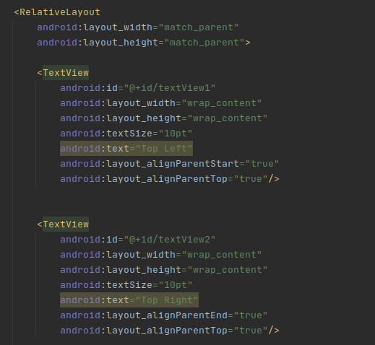
The Layout has 4 TextView objects anchored to each corner of the Relative Layout. Each object is named after the corner they are anchored to.

Activity
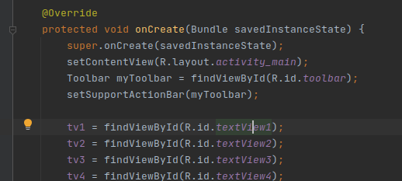
Wire in the TextViews in onCreate and initialize the custom Toolbar. Setup the custom toolbar in onCreateOptionsMenu().

To Create the Options Menu we create a MenuItem and set a default Icon, then set it to only show as action if there is room.

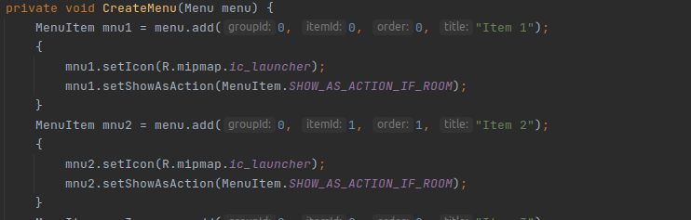

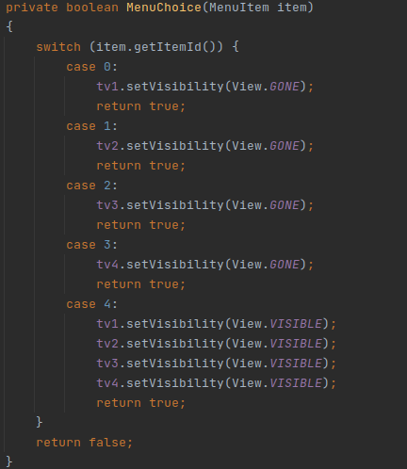
Now that the options have been created. We wire an on MenuChoice method into onOptionItemSelected. This will set the visibility of the TextViews off depending on which option Item is selected. It will also finally set the last option which will make all of the TextViews Visible.
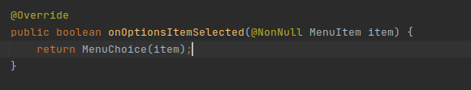

Result:
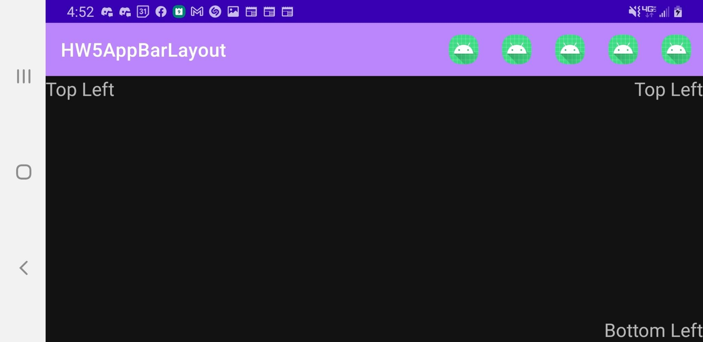
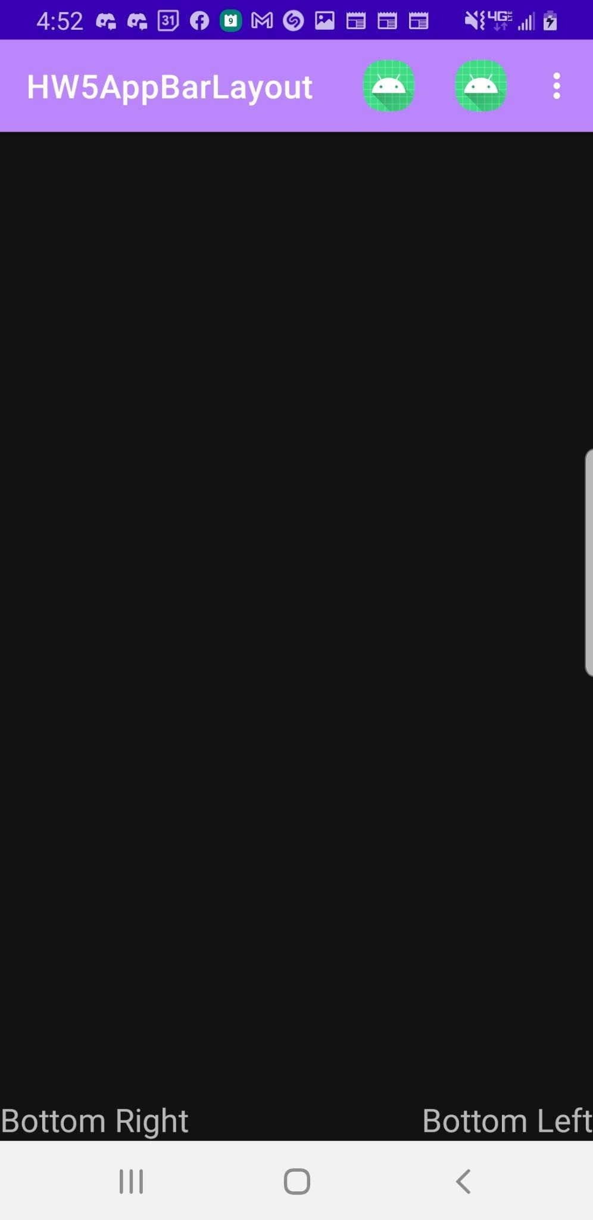
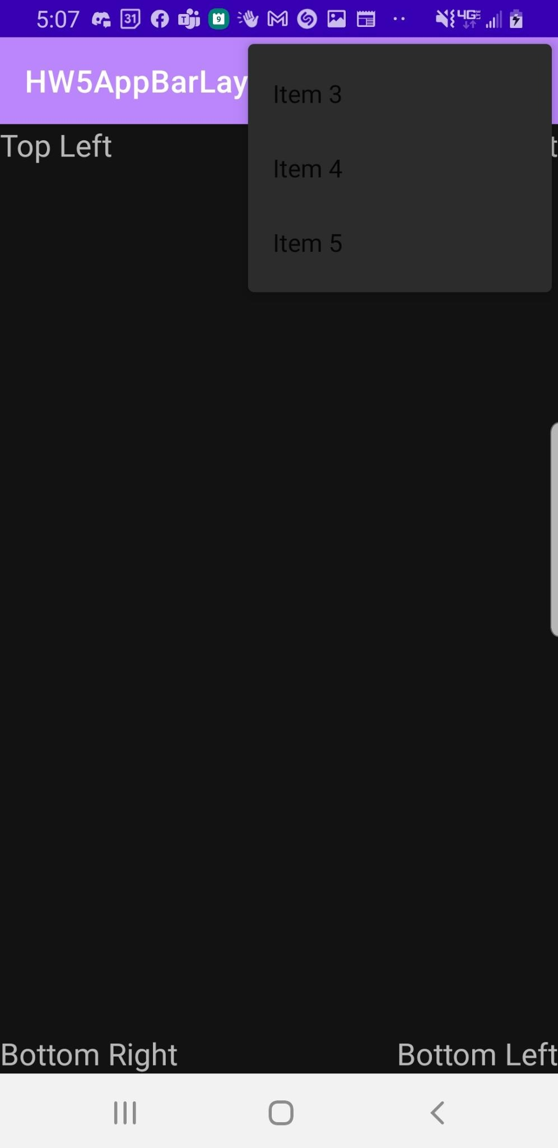
The AppBar will only show the MenuItems as Icons when they are available. Each MenuItem will make one of the TextViews invisible except the Item 5 option which will make them all visible again

