HW7:

MENU APP

Martin Mudenda Bbela
2582912

Overview

Make the following modification to the Menu app we just build:
- Add a EditText for the user to enter a URL
- Place the button on the right of the EditText and rename to “submit”
- Add another button beneath the EditText and name it to ”bookmark”
- On clicking the submit button, the URL should be displayed in the WebView
- On clicking the bookmark button, the current URL should be saved as a bookmark
- The menu for the app now should display a list of saved bookmarks
- On selecting a saved bookmark, the corresponding webpage should be displayed

Method

Layout

The Layout was setup as described. With an EditText and 3 Buttons, as well as a WebView Below it.

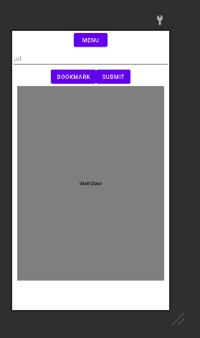

Main Activity

The WebView, EditText and Buttons are initialized in the onCreate before they are used. The Menu Button is attached to the ContextMenu of this activity. Later I will explain how the menu is created

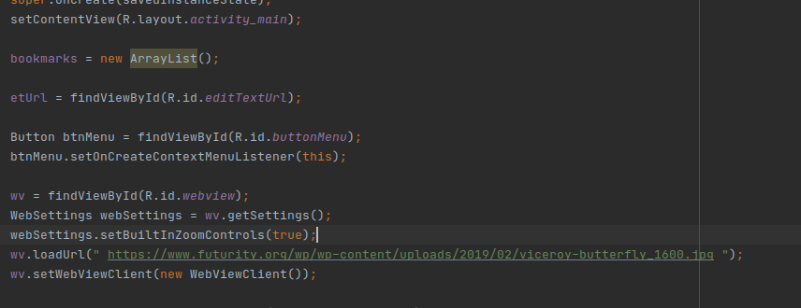

The Submit Button was wired to open the url contained in the EditText in the webview.
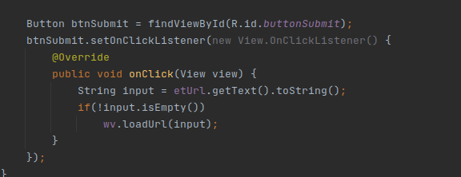

The Context Menu is created and it is populated by running through the bookmarks list and making each one a menuItem. As the list start off as empty it will be an empty list until bookmarks are added to it.
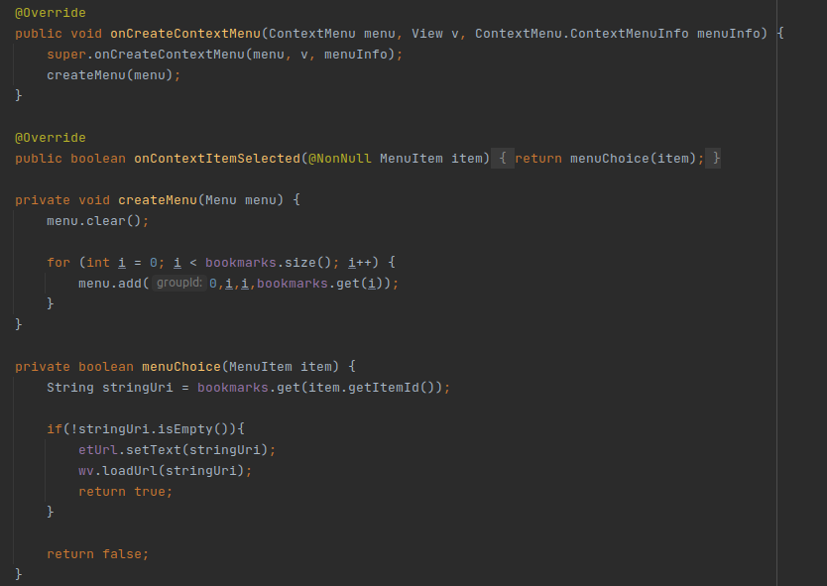

The Bookmark Button Will save the URL in the bookmarks List which will be used to populate the context Menu.

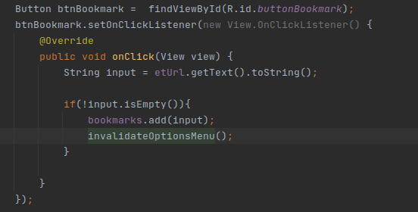
The invalidateOptionsMenu() will force the ContextMenu To recreate itself. This will run through the bookmarks again and add them to the Menu.

Results

User are able to view websites written in the url and save them to view later.

