

Mini Project 6

Time Series Forecasting - Sales Prediction



May 28, 2019

Saurabh MUDGal

Contents

Problem Statement 2

Read the data as time series objects in R. Plot the data. What are the major features you notice in the series? How do the two series differ? 3

Before a formal extraction of time series components is done, can you check for seasonal changes in the data for the two series separately? Particularly whether there are more variability in a season compared to the others, whether seasonal variations are changing across years etc. Compare the behavior of the two series. 5

Decompose each series to extract trend and seasonality, if there are any. Which seasonality is more appropriate – additive or multiplicative? Explain the seasonal indices. In which month(s) do you see higher sales and which month(s) you see lower sales? Any difference in the nature of demand of the two items? 7

Decompose Item- A 7

Decompose Item-B 10

Can you extract the residuals for the two decomposition exercises and check if they form a stationary series? Do a formal test for stationarity writing down the null and alternative hypothesis. What is your conclusion in each case? 13

Before the final forecast is undertaken one would like to compare a few models. Use the last 21 months as hold-out sample fit a suitable exponential smoothing model to the rest of the data and calculate MAPE. What are the values of α, β and γ? What role do they play in the modeling? For the same hold-out period compare forecast by decomposition and compute MAPE. Which model gives smaller MAPE? Give a comparison for the two demands. 15

**Item A Forecast** 15

**Item B Forecast** 18

Use the ‘best’ model obtained from above to forecast demand for the period Oct 2017 to December 2018 for both items. Provide forecasted values as well as their upper and lower confidence limits. If you are the store manager what decisions would you make after looking at the demand of the two items over years? 19

Conclusion 22

Appendix 22

R Markdown 23

Including Plots 46

# Problem Statement

The attached data shows monthly demand of  two different types of consumable items in a certain store from January 2002 to September 2017. The ultimate objective of this exercise is to predict sales for the period October 2017 to December 2018.

1. Read the data as time series objects in R. Plot the data. What are the major features you notice in the series? How do the two series differ?
2. Before a formal extraction of time series components is done, can you check for seasonal changes in the data for the two series separately? Particularly whether there are more variability in a season compared to the others, whether seasonal variations are changing across years etc. Compare the behavior of the two series.

* Decompose each series to extract trend and seasonality, if there are any. Which seasonality is more appropriate – additive or multiplicative? Explain the seasonal indices. In which month(s) do you see higher sales and which month(s) you see lower sales? Any difference in the nature of demand of the two items?

1. Can you extract the residuals for the two decomposition exercises and check if they form a stationary series? Do a formal test for stationarity writing down the null and alternative hypothesis. What is your conclusion in each case?
2. Before the final forecast is undertaken one would like to compare a few models. Use the last 21 months as hold-out sample fit a suitable exponential smoothing model to the rest of the data and calculate MAPE. What are the values of α, β and γ? What role do they play in the modeling? For the same hold-out period compare forecast by decomposition and compute MAPE. Which model gives smaller MAPE? Give a comparison for the two demands.
3. Use the ‘best’ model obtained from above to forecast demand for the period Oct 2017 to December 2018 for both items. Provide forecasted values as well as their upper and lower confidence limits. If you are the store manager what decisions would you make after looking at the demand of the two items over years?



# Read the data as time series objects in R. Plot the data. What are the major features you notice in the series? How do the two series differ?

Reading the data from attached file in R – refer appendix for code

> head(Sales_data)

Year Month Item.A Item.B

1 2002 1 1954 2585

2 2002 2 2302 3368

3 2002 3 3054 3210

4 2002 4 2414 3111

5 2002 5 2226 3756

6 2002 6 2725 4216

Item

<int>

Dda209542585220022230233683200233054321042002424143111520025222637566200262725421

Data is collected for item A and item B over time in ordered manner , hence its time series data . Converting data to times series object .- Refer Appendix for code

**Plot the date**

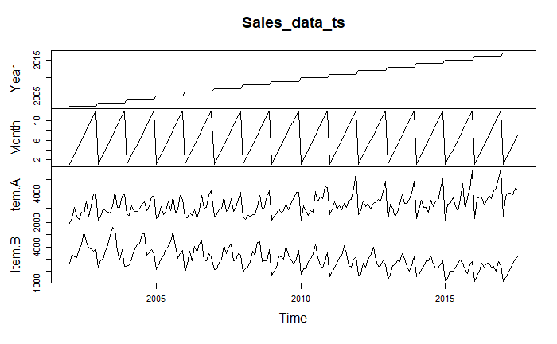

**Sale data Item-A**

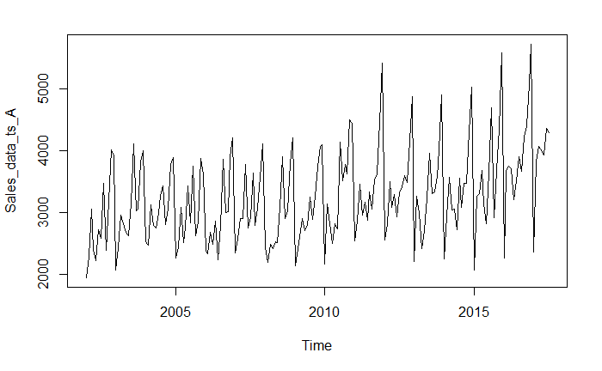

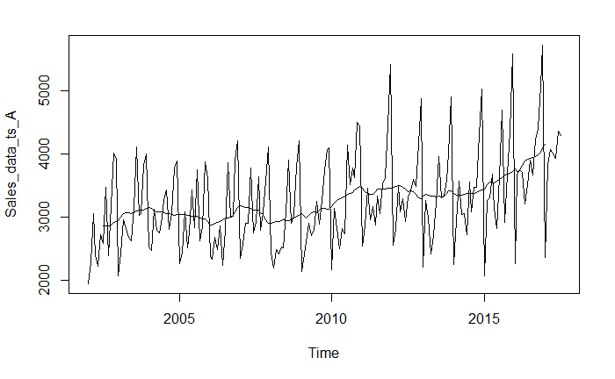

* Its seasonal time series starting from 2002, January with no specific trend.
* Trend – No
* Seasonality – Yes
* Outliers – No
* Abrupt change - No

**Sales data item B**

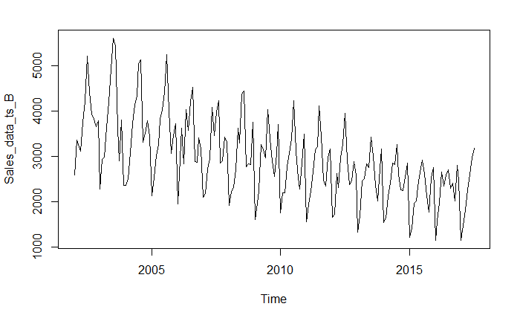

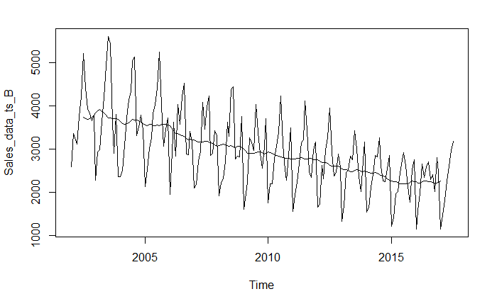

* Data shows a decreasing trend and seasonality as sales goes high during some part of year and then comes down.
* Trend – Decreasing trend
* Seasonality – Yes
* Outliers – No
* Abrupt change - No
* Both the series have seasonal component but item B only has trend component .

# Before a formal extraction of time series components is done, can you check for seasonal changes in the data for the two series separately? Particularly whether there are more variability in a season compared to the others, whether seasonal variations are changing across years etc. Compare the behavior of the two series.

To get the seasonal change in the data , lets plot the monthly plot.

Monthly plot Item A

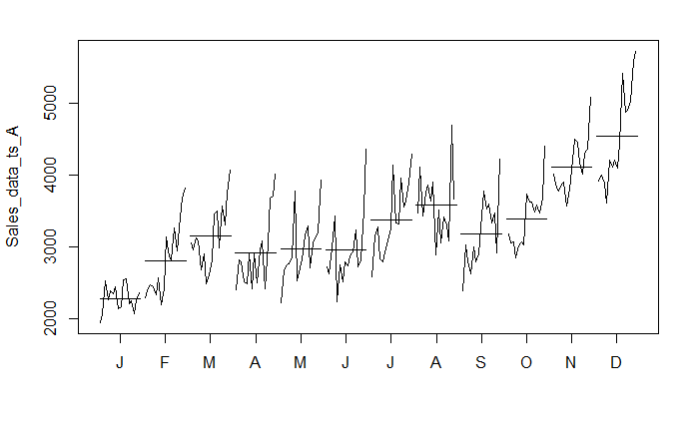

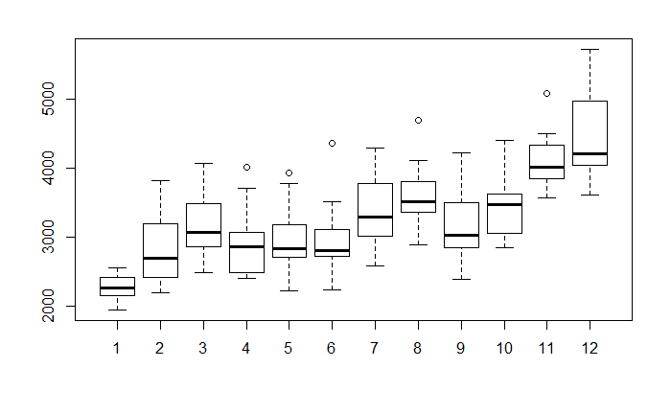

* Highest sailing months are months of November and December and seasonality is not constant but increasing year on year for past couple of years .
* Lowest sales is January
* Overall sales is increasing every month year on year except August.

Month plot for item B

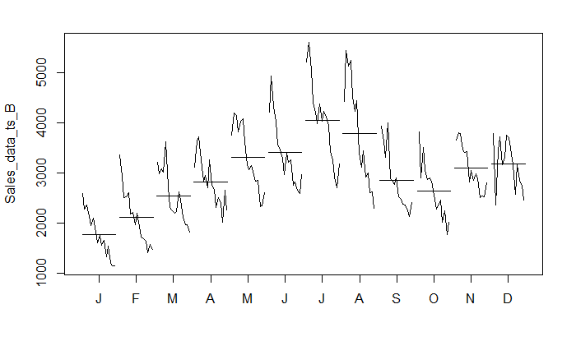

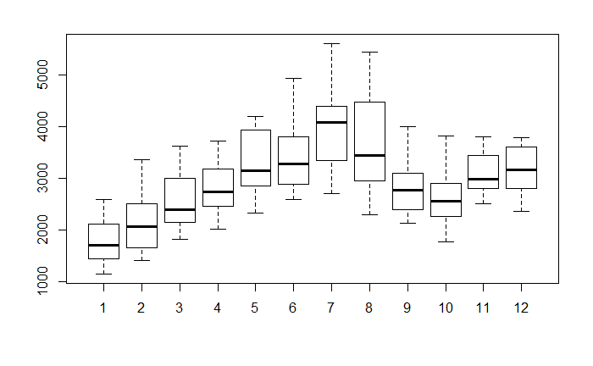

* Sales increases from Jan till July and then start decreasing till October and then again start increasing till then end of year.
* Overall sale is coming down each month year on year .

‘

**Comparing both items sale :**

* There are more variations in seasons in item A as compare to item B
* Item A – overall sale is going up each month, year on year but Item B sales is coming down each month year on year .

# Decompose each series to extract trend and seasonality, if there are any. Which seasonality is more appropriate – additive or multiplicative? Explain the seasonal indices. In which month(s) do you see higher sales and which month(s) you see lower sales? Any difference in the nature of demand of the two items?

Extract the trend, seasonality and random component for item A and item B

## Decompose Item- A

* Since the seasonal variation is relatively constant with time - additive model will be used
* Plot the item A sales

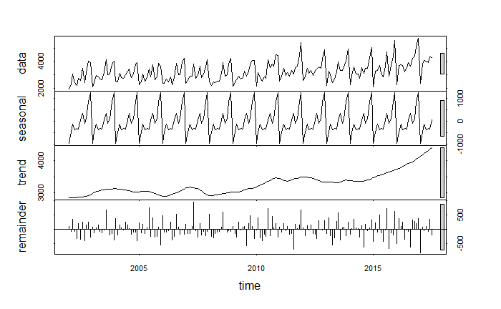

* **Trend** – No specific trend as such for item -A sale ,but if we divide the series in two parts then we can say that there is upward trend from 2015.
* **Seasonality** – Constant
* There are few **random** components as we have few spike is reminder – these are not explained by trend and seasonality .
* Highest sale is in month of December
* Lowest sale is in month of January

**Shows graph to compare actual series and De-seasonalise series :**

**De-seasonalise series** is able to explain the average sales but when there are low and high sales then it’s not able to explain the actual data .

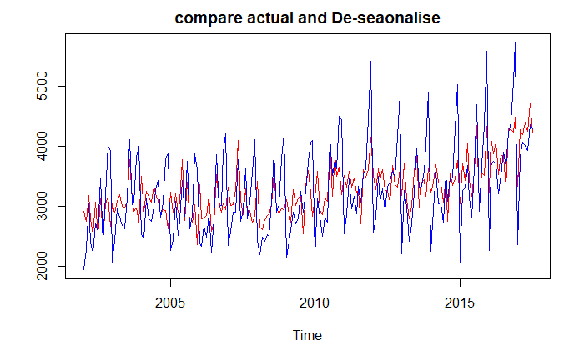

* Assume seasonality is **not** **constant**:
* Plot the item A sale

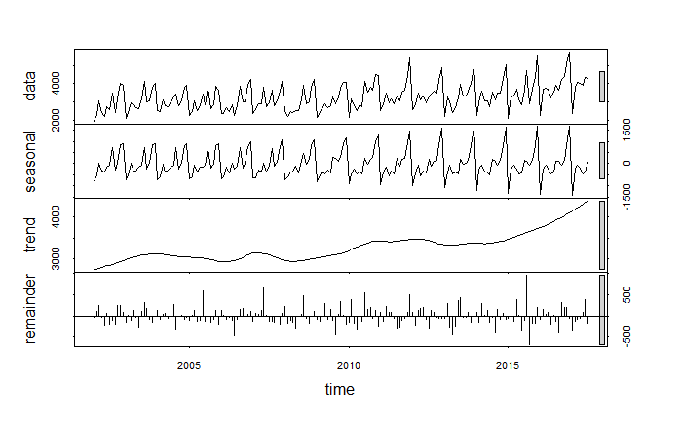

* Here remainder component has less spikes so seasonality is able to explain the data

**Shows graph to compare actual series and De-seasonalise series :**

De-seasonalise series has only trend and error component .

Trend and error component are not able to explain the data as red line is far below then act

**With s.window = 7**

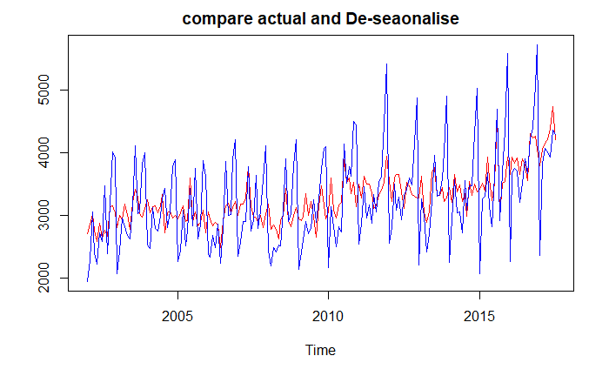

**With s.window = 3**

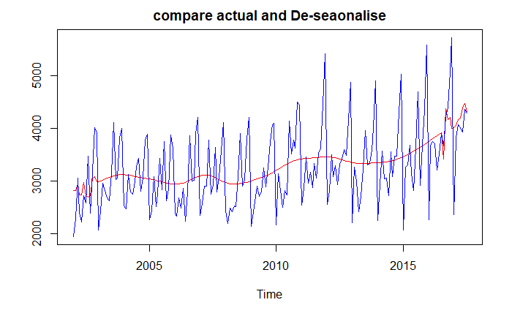

## Decompose Item-B

* Since the seasonal variation is relatively constant with time - additive model will be used

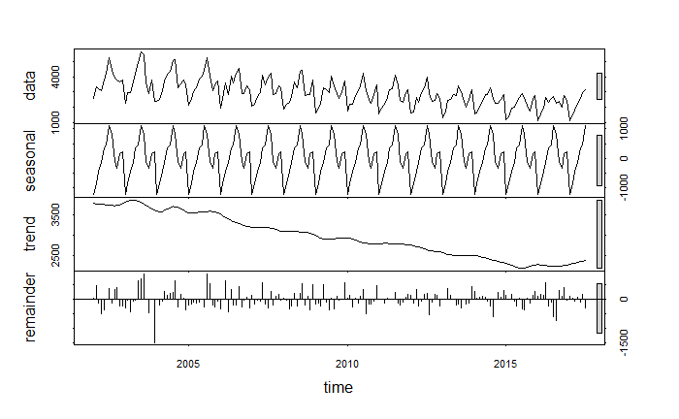

* Trend : Few bumps in initial years , than shows as decreasing trend in sales from 2007 till 2015 and then stabilising .
* Seasonlity – constant .
* Highest sale is in month of July.
* Lowest sale is in month of January

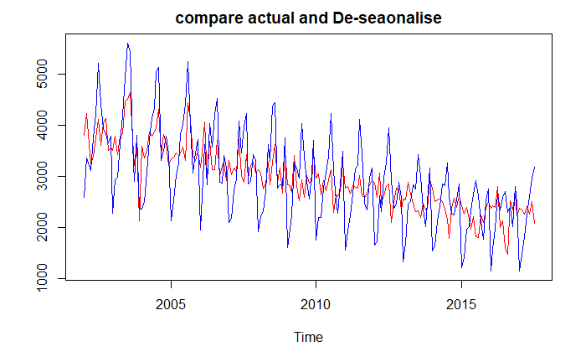

**Assume seasonality is not constant:**

Here seasonality is not able to explain the actual data and trend has role to play.

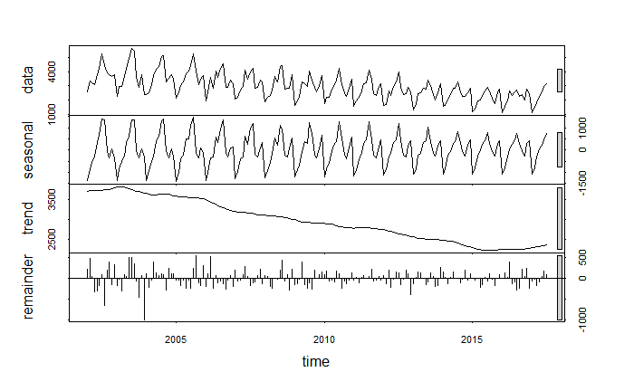

**Shows graph to compare actual series and De-seasonalise series :**

De-seasonalise series has only trend and error component .

Trend and error component are not able to explain the data as red line is far then actual

s.window = 7

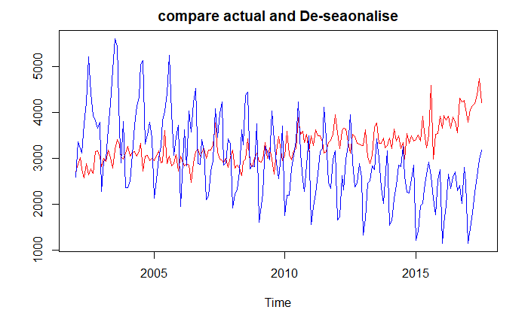

s.window =3

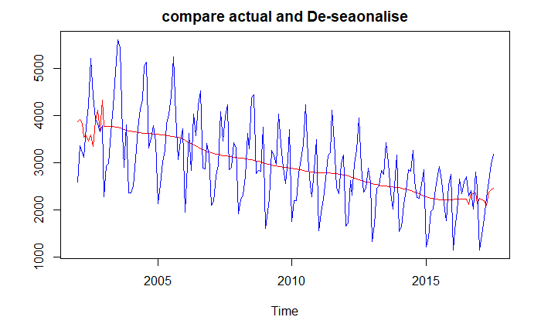

* De-seasonalise series is not able to explain the actual data and hence trend and error component has major role to play to explain the data .

**Conclusion**

* Both the sales series seasonality is not constant .
* If we compare two items then it shows that both sale is lowest in January but item A has highest sale in December and item B has highest sale in July.
* Demand of item A has been increasing after 2015 and demand of item B has been decreasing till 2015 and has now becoming constant .

# Can you extract the residuals for the two decomposition exercises and check if they form a stationary series? Do a formal test for stationarity writing down the null and alternative hypothesis. What is your conclusion in each case?

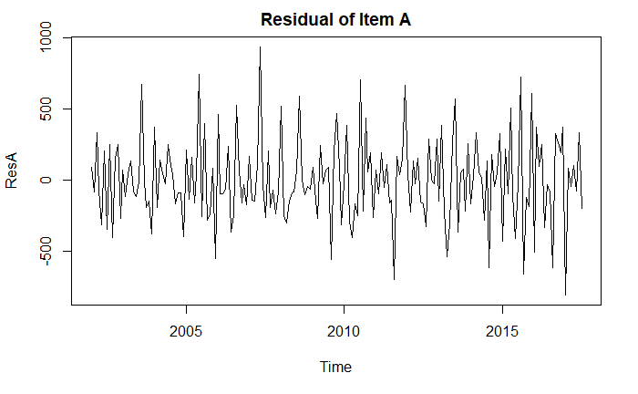

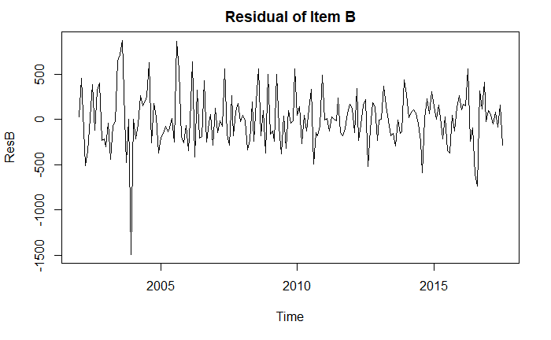

* Plot shows that mean is constant for both the series, hence residuals for the series is stationary
* Performing Augmented Dicky fuller test to check the stationarity of time-series of item-A.

**Null hypothesis:**

H0 = Time series is not stationary

**Alternate hypothesis:**

Ha = Time series is stationary

> adf.test(Sales_data_ts_A)

p-value smaller than printed p-value

Augmented Dickey-Fuller Test

data: Sales_data_ts_A

Dickey-Fuller = -7.8632, Lag order = 5, p-value = 0.01

alternative hypothesis: stationary

* P value is less than .05 hence Null hypothesis is rejected – Series is stationary
* Augmented Dicky fuller test to check the stationarity of time-series of item-B.

**Null hypothesis:**

H0 = Time series is not stationary

**Alternate hypothesis:**

Ha = Time series is stationary

> adf.test(Sales_data_ts_B)

p-value smaller than printed p-value

Augmented Dickey-Fuller Test

data: Sales_data_ts_B

Dickey-Fuller = -12.967, Lag order = 5, p-value = 0.01

alternative hypothesis: stationary

* P value is less than .05 hence Null hypothesis is rejected – Series is stationary

# Before the final forecast is undertaken one would like to compare a few models. Use the last 21 months as hold-out sample fit a suitable exponential smoothing model to the rest of the data and calculate MAPE. What are the values of α, β and γ? What role do they play in the modeling? For the same hold-out period compare forecast by decomposition and compute MAPE. Which model gives smaller MAPE? Give a comparison for the two demands.

## **Item A Forecast**

* Divide item A data into test and hold out sample . Hold out sample has last 21 months data .
* Forecasting using **decomposition,** Actual data in blue and forecasted in red .
* Decomposition method is able to forecast better when the sales volume is lower and decreasing trend.

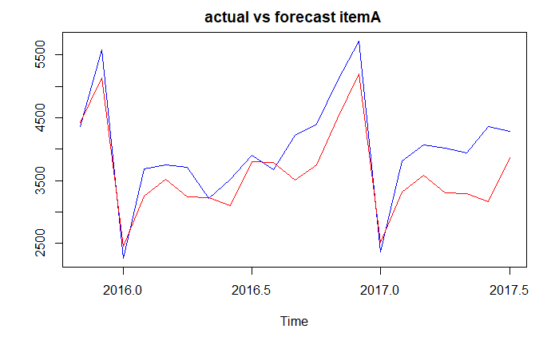

* Calculate Accuracy using MAPE

Mean absolute percentage error in actual and forecasted data :

MAPE is 10%

> MAPE

[1] 0.105762

* Applying Exponential smoothing - Holt-Winter’s method

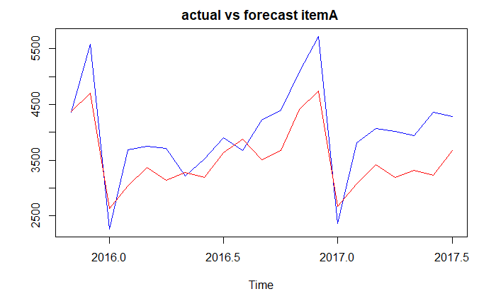

> itemA_FC1$model

Holt-Winters' additive method

Call:

hw(y = itemA_T, h = 21)

Smoothing parameters:

alpha = 0.0587

beta = 1e-04

gamma = 0.0064

Initial states:

l = 2956.0292

b = 3.725

s = 1181.297 856.9921 115.8834 -41.8724 330.7963 88.3319

-350.0979 -253.7954 -386.6735 -159.4867 -487.1291 -894.2462

sigma: 330.8995

AIC AICc BIC

2791.968 2796.103 2844.87

Value of gamma and Beta are very close to 0 and hence they are not significant , only alpha which has got 5% significance

**Accuracy**

Mean absolute percentage error in actual and forecasted data is 13.7%

MAPE

[1] 0.1374336

**Conclusion for Item A**

Both the model is able to forecast lower sales value with better accuracy then higher values but MAPE value is lower for decomposition method as compared to holt-winters method.

## **Item B Forecast**

* Divide item B data into test and hold out sample . Hold out sample has last 21 months data .
* Apply **Decomposition** method to forecast hold out sample

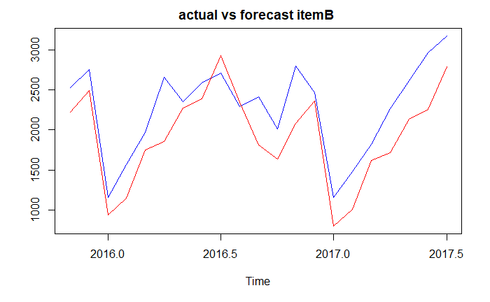

* Calculate Accuracy using MAPE

Mean absolute percentage error is 16.9%

> MAPE ##17%

[1] 0.1694894

* Applying Exponential smoothing - **Holt-Winter** method as item B sale has both trend and seasonality.

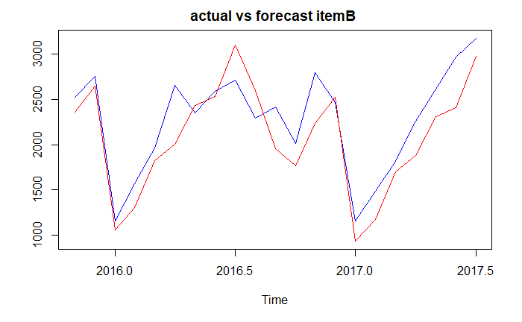

* Here alpha and beta values are negligible but gamma is 26% significant.

> itemB_FC1$model

Holt-Winters' additive method

Call:

hw(y = itemB_T, h = 21)

Smoothing parameters:

alpha = 1e-04

beta = 1e-04

gamma = 0.2681

Initial states:

l = 3946.4018

b = -10.3181

s = 205.4364 96.3795 -328.4512 -144.3679 894.7028 1189.823

442.1344 426.9279 -161.0965 -445.9498 -914.2891 -1261.249

sigma: 334.1357

AIC AICc BIC

2795.199 2799.334 2848.103

* Mean absolute percentage error is 12.1%

MAPE= mean(abs(vec2[,1]-vec2[,2])/vec2[,1])

> MAPE

[1] 0.1211512

**Conclusion for item B**

* Both the model is able to forecast lower sales value with better accuracy then higher values
* MAPE value is lower for Holt-Winter’s method as compared to decomposition method

# Use the ‘best’ model obtained from above to forecast demand for the period Oct 2017 to December 2018 for both items. Provide forecasted values as well as their upper and lower confidence limits. If you are the store manager what decisions would you make after looking at the demand of the two items over years?

Item A

Since Item A sales forecast was better with decomposition model hence using same to predict

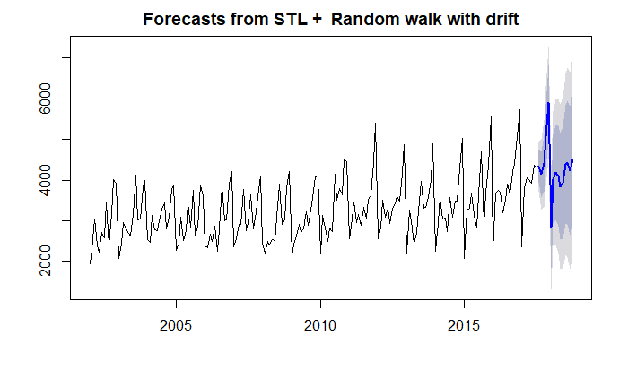

Blue line shows forecasted values and purple and grey band shows the 80% and 95% confidence interval respectively . The forecasted values in blue follow same seasonality as recent historical values in black.

> itemA_Dec_for$lower

80% 95%

Aug 2017 3938.300 3728.050

Sep 2017 3575.023 3276.098

Oct 2017 3708.876 3340.837

Nov 2017 4261.174 3833.980

Dec 2017 5009.750 4529.664

Jan 2018 1839.431 1310.833

Feb 2018 2941.129 2367.287

Mar 2018 3031.021 2414.483

Apr 2018 2857.650 2200.468

May 2018 2530.614 1834.479

Jun 2018 2543.662 1809.996

Jul 2018 2932.677 2162.695

Aug 2018 2911.531 2106.283

Sep 2018 2650.878 1811.282

Oct 2018 2851.933 1978.798

> itemA_Dec_for$upper

80% 95%

Aug 2017 4732.646 4942.897

Sep 2017 4704.389 5003.315

Oct 2017 5099.361 5467.400

Nov 2017 5875.152 6302.347

Dec 2017 6823.557 7303.643

Jan 2018 3836.522 4365.119

Feb 2018 5109.155 5682.997

Mar 2018 5360.356 5976.894

Apr 2018 5340.544 5997.727

May 2018 5160.675 5856.811

Jun 2018 5315.517 6049.182

Jul 2018 5841.737 6611.719

Aug 2018 5953.830 6759.078

Sep 2018 5822.948 6662.545

Oct 2018 6150.717 7023.852

**Item B**

Holt winters mode forecast is better for Item B sales . hence using same for prediction .

Starting from Oct 2017 to Dec 2018.

Forecast has been shown as blue line with 80% and 95% confidence interval shown as purple and grey colour band .

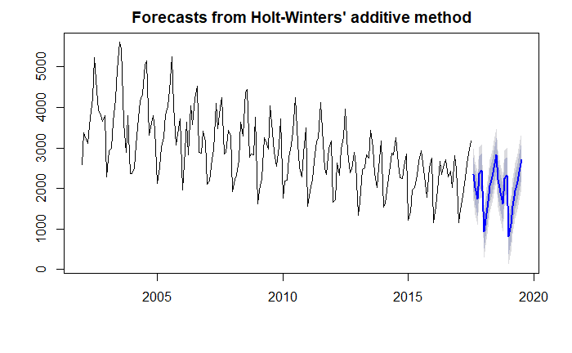

Upper and lower limit

$upper

80% 95%

Aug 2017 2772.401 2997.662

Sep 2017 2442.400 2667.661

Oct 2017 2170.111 2395.372

Nov 2017 2791.558 3016.819

Dec 2017 2862.313 3087.574

Jan 2018 1362.684 1587.945

Feb 2018 1665.257 1890.518

Mar 2018 2104.628 2329.889

Apr 2018 2482.040 2707.301

May 2018 2707.459 2932.720

Jun 2018 2936.739 3162.000

Jul 2018 3257.552 3482.813

Aug 2018 2681.414 2919.933

Sep 2018 2351.414 2589.934

Oct 2018 2079.125 2317.645

$lower

80% 95%

Aug 2017 1921.3444 1696.0834

Sep 2017 1591.3442 1366.0832

Oct 2017 1319.0548 1093.7938

Nov 2017 1940.5019 1715.2409

Dec 2017 2011.2561 1785.9950

Jan 2018 511.6268 286.3657

Feb 2018 814.1997 588.9385

Mar 2018 1253.5706 1028.3093

Apr 2018 1630.9823 1405.7210

May 2018 1856.4004 1631.1389

Jun 2018 2085.6800 1860.4183

Jul 2018 2406.4921 2181.2302

Aug 2018 1780.2665 1541.7471

Sep 2018 1450.2658 1211.7462

Oct 2018 1177.9759 939.4561

## Conclusion

* As per the forecast, sale for item A follows the historical pattern, hence the average sale in slightly higher then pervious value. So Item A stock should be maintain as per past few years trend as the item is still popular among the consumer.
* As per the forecast, sale for item B is keep decreasing year on Year as the demand is going down.So the stock should be planned in that manner and seasonality should be also consider while keeping stock of items .Also its better to start exploring other consumable items to increase profit as item A sales has been going down year on year.

# Appendix

Sales Forecast

Saurabh Mudgal

28 May 2019

## R Markdown

This is an R Markdown document. Markdown is a simple formatting syntax for authoring HTML, PDF, and MS Word documents. For more details on using R Markdown see <http://rmarkdown.rstudio.com>.

When you click the **Knit** button a document will be generated that includes both content as well as the output of any embedded R code chunks within the document. You can embed an R code chunk like this:

# read the data   
#Set working directory  
  
library("forecast")

## Warning: package 'forecast' was built under R version 3.5.3

setwd("C://BACP//Module 6 - Time Series Forecasting//Project")  
getwd()

## [1] "C:/BACP/Module 6 - Time Series Forecasting/Project"

Sales_data = read.csv("Demand.csv", skip=1)  
attach(Sales_data)  
  
head(Sales_data)

## Year Month Item.A Item.B  
## 1 2002 1 1954 2585  
## 2 2002 2 2302 3368  
## 3 2002 3 3054 3210  
## 4 2002 4 2414 3111  
## 5 2002 5 2226 3756  
## 6 2002 6 2725 4216

View(Sales_data)  
  
plot(Sales_data[,3])

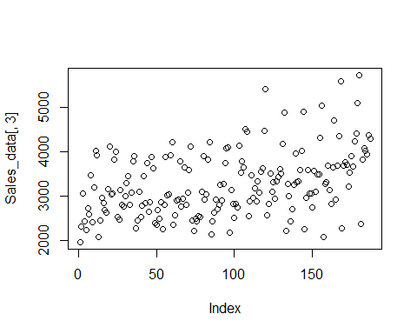

#create time series object item A  
  
Sales_data_ts = ts(Sales_data,frequency = 12, start = c(2002,1))  
plot.ts(Sales_data_ts)

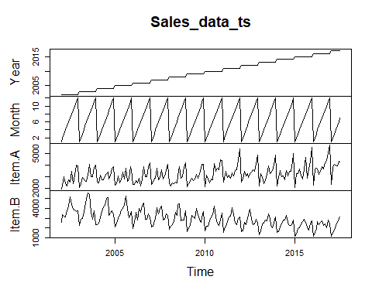

Sales_data_ts_A = ts(Sales_data[,3], frequency = 12,start = c(2002,1))  
  
library(forecast)  
trend_A = ma(Sales_data_ts_A,12,centre =T)  
plot(Sales_data_ts_A)  
lines(trend_A)

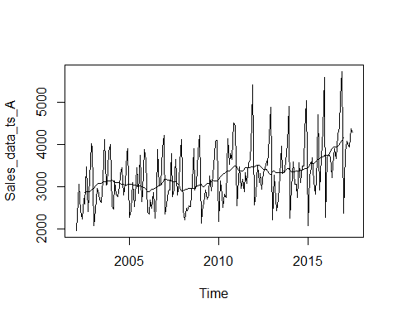

#to get the straight line of the plot.  
#abline(reg=lm(Sales_data_ts_A~time(Sales_data_ts_A)))  
  
#create time series object item B  
  
Sales_data_ts_B = ts(Sales_data[,4], frequency = 12,start = c(2002,1))  
plot.ts(Sales_data_ts_B)

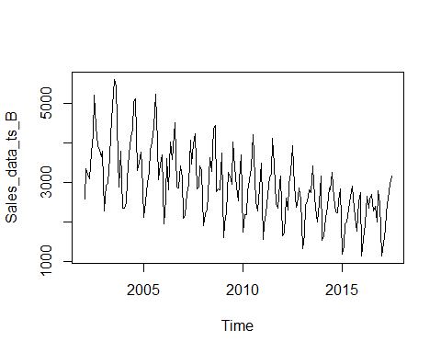

#month plot  
monthplot(Sales_data_ts_A)

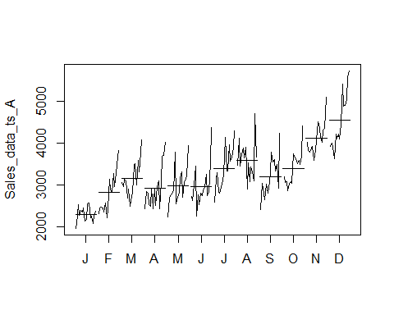

monthplot(Sales_data_ts_B)

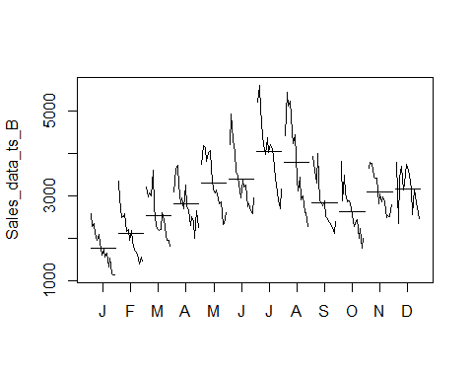

boxplot(Sales_data_ts_A~cycle(Sales_data_ts_A))

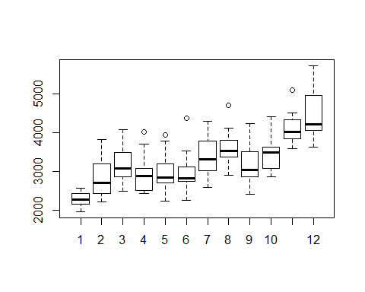

boxplot(Sales_data_ts_B~cycle(Sales_data_ts_B))

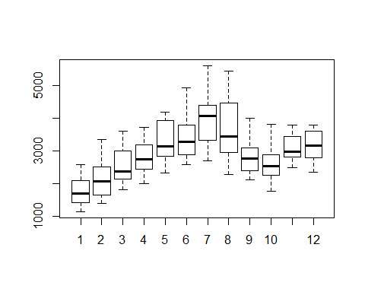

##################################################################  
## Addtitive or Multiplicative   
##################################################################  
##Decompose TS data into seaosonlity ,trend and irregular components   
  
#Sales_data_CompA = decompose(Sales_data_ts_A)  
  
#assume seasonality is constant - additive model  
itemA_Dec = stl(Sales_data_ts_A,s.window = "p")  
itemB_Dec = stl(Sales_data_ts_B,s.window = "p")  
plot(itemA_Dec)

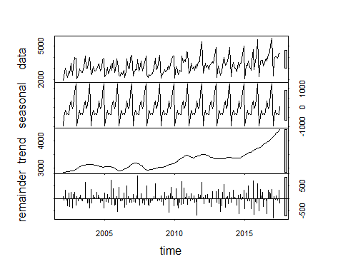

plot(itemB_Dec)

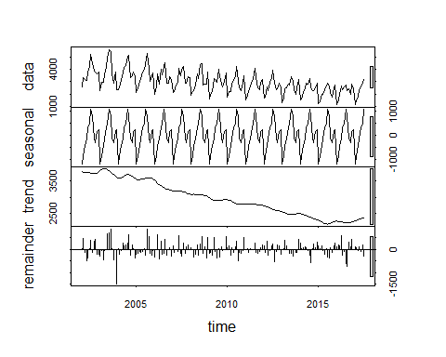

#itemA_Dec_D = decompose(Sales_data_ts_A,"multiplicative")  
#plot(itemA_Dec_D)  
  
  
  
#assume seasonality is not constant - Multiplicative model  
 itemA_Dec7 = stl(Sales_data_ts_A,s.window = 7)  
 plot(itemA_Dec7)

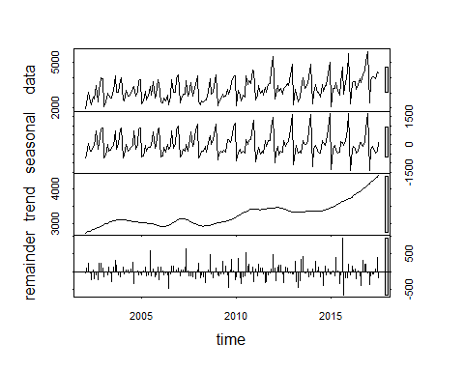

##check for smaller value of window  
 itemA_Dec3 = stl(Sales_data_ts_A,s.window = 3)  
 plot(itemA_Dec3)

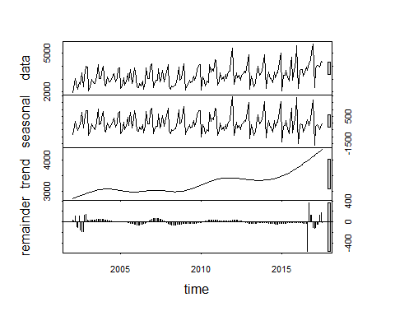

# Deseasonal is sum of trend and remainder .  
 DeseasonRev = (itemA_Dec7$time.series[,2]+itemA_Dec7$time.series[,3])  
 ts.plot(DeseasonRev,Sales_data_ts_A, col=c("red", "blue"), main= "compare actual and De-seaonalise")

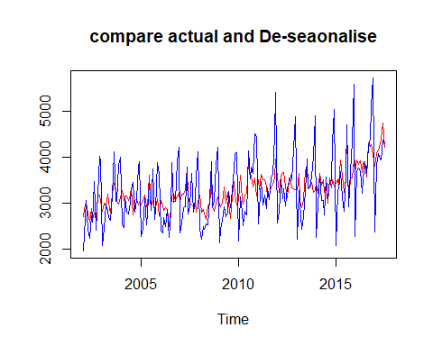

DeseasonRev3 = (itemA_Dec3$time.series[,2]+itemA_Dec3$time.series[,3])  
 ts.plot(DeseasonRev3,Sales_data_ts_A, col=c("red", "blue"), main= "compare actual and De-seaonalise")

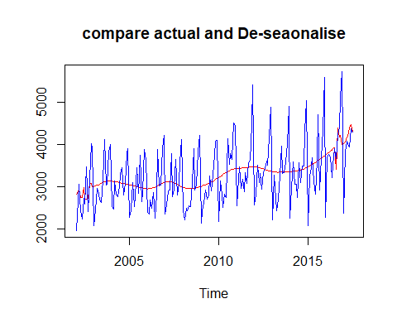

DeseasonRev_Const = (itemA_Dec$time.series[,2]+itemA_Dec$time.series[,3])  
 ts.plot(DeseasonRev_Const,Sales_data_ts_A, col=c("red", "blue"), main= "compare actual and De-seaonalise")

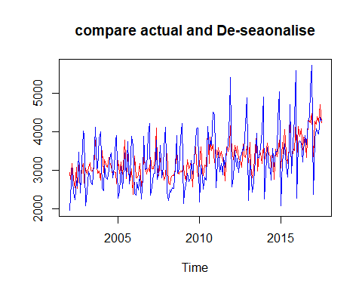

##item B  
itemB_Dec = stl(Sales_data_ts_B,s.window = "p")  
plot(itemB_Dec)



DeseasonRevB_Const = (itemB_Dec$time.series[,2]+itemB_Dec$time.series[,3])  
 ts.plot(DeseasonRevB_Const,Sales_data_ts_B, col=c("red", "blue"), main= "compare actual and De-seaonalise")

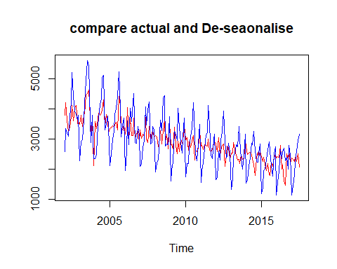

#assume seasonlaity is not constant   
  
 itemB_Dec7 = stl(Sales_data_ts_B,s.window = 7)  
 plot(itemB_Dec7)

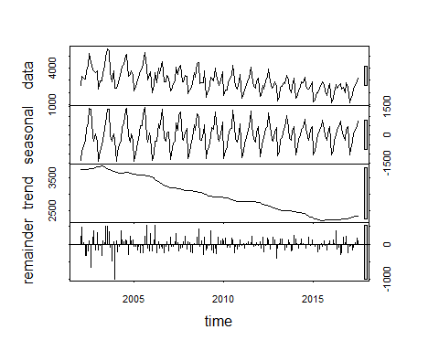

DeseasonRev1 = (itemB_Dec7$time.series[,2]+itemB_Dec7$time.series[,3])  
 ts.plot(DeseasonRev,Sales_data_ts_B, col=c("red", "blue"), main= "compare actual and De-seaonalise")

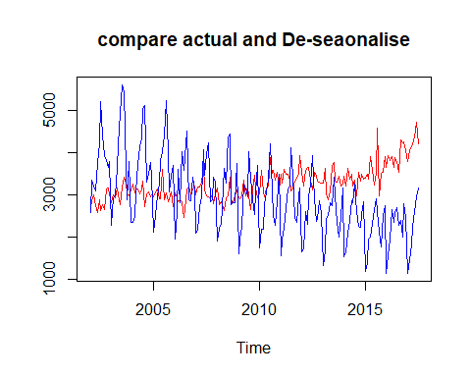

itemB_Dec3 = stl(Sales_data_ts_B,s.window = 3)  
 plot(itemB_Dec3)

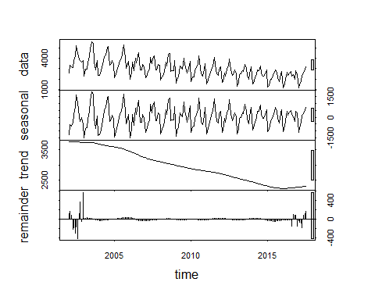

DeseasonRev1B = (itemB_Dec3$time.series[,2]+itemB_Dec3$time.series[,3])  
 ts.plot(DeseasonRev1B,Sales_data_ts_B, col=c("red", "blue"), main= "compare actual and De-seaonalise")

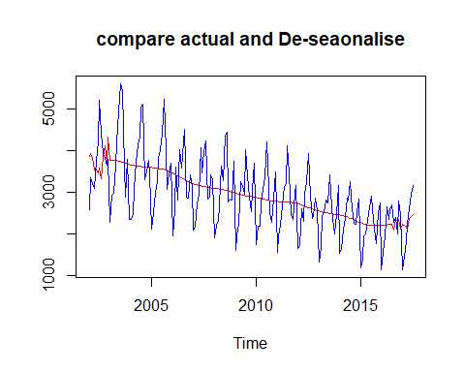

### assume multilicative model   
   
 #Sales_data_ts_A_log = log(Sales_data_ts_A)  
 #itemA_Dec_M = stl(Sales_data_ts_A_log,s.window = "p")  
 #plot(itemA_Dec_M)  
 #itemA_Dec_M$time.series[1:12,1]  
 #itemA_Dec_M_exp = exp(itemA_Dec_M$time.series[1:12,1])  
 #plot(itemA_Dec_M_exp,type= 'l')  
   
   
 ##################################################################  
 #####Residuals ##############  
 ##################################################################  
ResA = itemA_Dec$time.series[,3]  
ResB = itemB_Dec$time.series[,3]  
plot(ResA,main = "Residual of Item A")

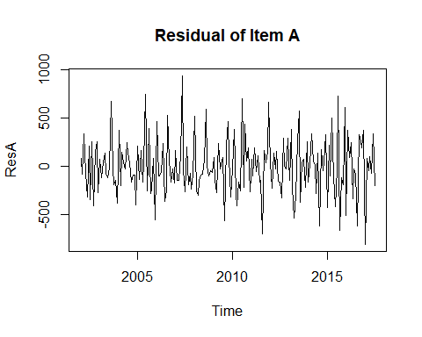

plot(ResB,main = "Residual of Item B")

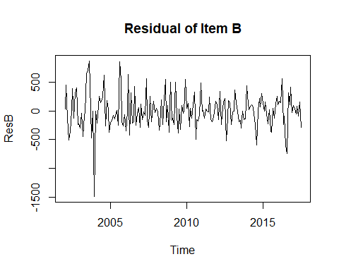

#Sales_data_CompB = decompose(Sales_data_ts_B)  
#plot(Sales_data_CompB)  
  
#check for stationarity####  
library(tseries)

## Warning: package 'tseries' was built under R version 3.5.3

adf.test(Sales_data_ts_A)

## Warning in adf.test(Sales_data_ts_A): p-value smaller than printed p-value

##   
## Augmented Dickey-Fuller Test  
##   
## data: Sales_data_ts_A  
## Dickey-Fuller = -7.8632, Lag order = 5, p-value = 0.01  
## alternative hypothesis: stationary

adf.test(Sales_data_ts_B)

## Warning in adf.test(Sales_data_ts_B): p-value smaller than printed p-value

##   
## Augmented Dickey-Fuller Test  
##   
## data: Sales_data_ts_B  
## Dickey-Fuller = -12.967, Lag order = 5, p-value = 0.01  
## alternative hypothesis: stationary

######forecast MOdel ##########  
  
  
# naive decomposition method ##############  
  
##item A #########  
  
#Divide the data into test and hold out sample   
itemA_Dec_T <- window(Sales_data_ts_A, start=c(2002,1), end=c(2015,10))  
itemA_Dec_HO <- window(Sales_data_ts_A, start=c(2015,11), end=c(2017,7))  
  
#Decompose data itemA  
itemA_DecF=stl(itemA_Dec_T,s.window = 7)  
  
itemA_Dec_for = forecast(itemA_DecF, method="rwdrift", h=21)  
vec1 = cbind(itemA_Dec_HO,itemA_Dec_for$mean)  
ts.plot(vec1,col=c("blue", "red"), main="actual vs forecast itemA ")

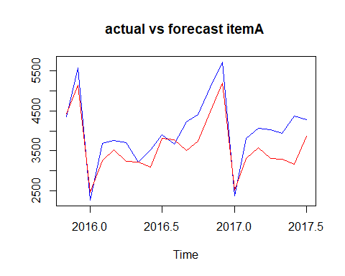

MAPE= mean(abs(vec1[,1]-vec1[,2])/vec1[,1])  
MAPE ##10%

## [1] 0.105762

#item B  
  
#Divide the data into test and hold out sample   
itemB_Dec_T <- window(Sales_data_ts_B, start=c(2002,1), end=c(2015,10))  
itemB_Dec_HO <- window(Sales_data_ts_B, start=c(2015,11), end=c(2017,7))  
  
#Decompose data itemB  
itemB_DecF=stl(itemB_Dec_T,s.window = 7)  
  
#library("forecast")  
  
itemB_Dec_for = forecast(itemB_DecF, method="rwdrift", h=21)  
vec1 = cbind(itemB_Dec_HO,itemB_Dec_for$mean)  
ts.plot(vec1,col=c("blue", "red"), main="actual vs forecast itemB ")

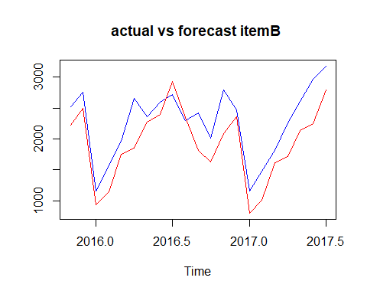

MAPE= mean(abs(vec1[,1]-vec1[,2])/vec1[,1])  
MAPE ##17%

## [1] 0.1694894

#item A  
  
##holt-winter's method   
#divide the item A data into test and hold out sample   
  
itemA_T <- window(Sales_data_ts_A, start=c(2002,1), end=c(2015,10))  
itemA_HO <- window(Sales_data_ts_A, start=c(2015,11), end=c(2017,7))  
  
itemA_FC1= hw(itemA_T,h=21)  
itemA_FC1$model

## Holt-Winters' additive method   
##   
## Call:  
## hw(y = itemA_T, h = 21)   
##   
## Smoothing parameters:  
## alpha = 0.0587   
## beta = 1e-04   
## gamma = 0.0064   
##   
## Initial states:  
## l = 2956.0292   
## b = 3.725   
## s = 1181.297 856.9921 115.8834 -41.8724 330.7963 88.3319  
## -350.0979 -253.7954 -386.6735 -159.4867 -487.1291 -894.2462  
##   
## sigma: 330.8995  
##   
## AIC AICc BIC   
## 2791.968 2796.103 2844.872

vec2 = cbind(itemA_HO,itemA_FC1$mean)  
ts.plot(vec2,col=c("blue", "red"), main="actual vs forecast itemA ")

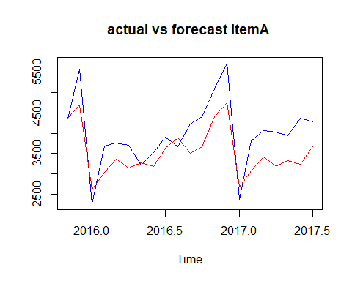

MAPE= mean(abs(vec2[,1]-vec2[,2])/vec2[,1])  
MAPE

## [1] 0.1374336

#forecast for future   
#plot(itemA_FC1)  
  
  
# item B  
##holt-winter's method   
  
#divide the item B data into test and hold out sample   
  
itemB_T <- window(Sales_data_ts_B, start=c(2002,1), end=c(2015,10))  
itemB_HO <- window(Sales_data_ts_B, start=c(2015,11), end=c(2017,7))  
  
#applying holtes-winter method as item B sales has both seasonality and trend .  
  
itemB_FC1= hw(itemB_T,h=21)  
itemB_FC1$model

## Holt-Winters' additive method   
##   
## Call:  
## hw(y = itemB_T, h = 21)   
##   
## Smoothing parameters:  
## alpha = 1e-04   
## beta = 1e-04   
## gamma = 0.2681   
##   
## Initial states:  
## l = 3946.4018   
## b = -10.3181   
## s = 205.4364 96.3795 -328.4512 -144.3679 894.7028 1189.823  
## 442.1344 426.9279 -161.0965 -445.9498 -914.2891 -1261.249  
##   
## sigma: 334.1357  
##   
## AIC AICc BIC   
## 2795.199 2799.334 2848.103

vec2 = cbind(itemB_HO,itemB_FC1$mean)  
ts.plot(vec2,col=c("blue", "red"), main="actual vs forecast itemB ")

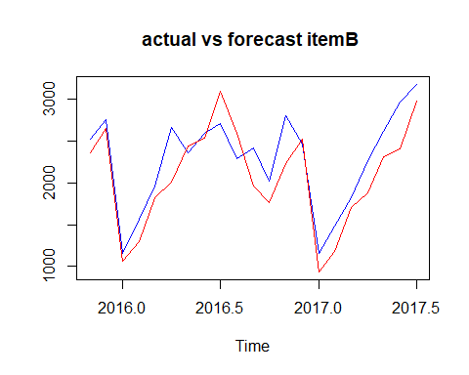

MAPE= mean(abs(vec2[,1]-vec2[,2])/vec2[,1])  
MAPE

## [1] 0.1211512

##Forecast demand of item A and item B for oct 2017 to Dec 2018.  
  
#item A  
  
itemA_FC_Future =stl(Sales_data_ts_A,s.window = 7)  
  
itemA_Dec_for = forecast(itemA_FC_Future, method="rwdrift", h=15)  
plot(itemA_Dec_for)

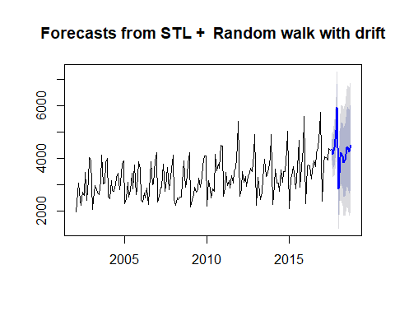

itemA_Dec_for$upper

## 80% 95%  
## Aug 2017 4732.646 4942.897  
## Sep 2017 4704.389 5003.315  
## Oct 2017 5099.361 5467.400  
## Nov 2017 5875.152 6302.347  
## Dec 2017 6823.557 7303.643  
## Jan 2018 3836.522 4365.119  
## Feb 2018 5109.155 5682.997  
## Mar 2018 5360.356 5976.894  
## Apr 2018 5340.544 5997.727  
## May 2018 5160.675 5856.811  
## Jun 2018 5315.517 6049.182  
## Jul 2018 5841.737 6611.719  
## Aug 2018 5953.830 6759.078  
## Sep 2018 5822.948 6662.545  
## Oct 2018 6150.717 7023.852

itemA_Dec_for$lower

## 80% 95%  
## Aug 2017 3938.300 3728.050  
## Sep 2017 3575.023 3276.098  
## Oct 2017 3708.876 3340.837  
## Nov 2017 4261.174 3833.980  
## Dec 2017 5009.750 4529.664  
## Jan 2018 1839.431 1310.833  
## Feb 2018 2941.129 2367.287  
## Mar 2018 3031.021 2414.483  
## Apr 2018 2857.650 2200.468  
## May 2018 2530.614 1834.479  
## Jun 2018 2543.662 1809.996  
## Jul 2018 2932.677 2162.695  
## Aug 2018 2911.531 2106.283  
## Sep 2018 2650.878 1811.282  
## Oct 2018 2851.933 1978.798

#itmem B  
  
#install.packages("forecast")  
library(forecast)  
itemB_FC_Future = hw(Sales_data_ts_B,start=c(2017,10),15)  
itemB_FC_Future$upper

## 80% 95%  
## Aug 2017 2772.401 2997.662  
## Sep 2017 2442.400 2667.661  
## Oct 2017 2170.111 2395.372  
## Nov 2017 2791.558 3016.819  
## Dec 2017 2862.313 3087.574  
## Jan 2018 1362.684 1587.945  
## Feb 2018 1665.257 1890.518  
## Mar 2018 2104.628 2329.889  
## Apr 2018 2482.040 2707.301  
## May 2018 2707.459 2932.720  
## Jun 2018 2936.739 3162.000  
## Jul 2018 3257.552 3482.813  
## Aug 2018 2681.414 2919.933  
## Sep 2018 2351.414 2589.934  
## Oct 2018 2079.125 2317.645

#itemb_FC_F = forecast::hw(Sales_data_ts_B,15)  
head(itemB_FC_Future)

## $model  
## Holt-Winters' additive method   
##   
## Call:  
## hw(y = Sales_data_ts_B, h = 15, start = c(2017, 10))   
##   
## Smoothing parameters:  
## alpha = 1e-04   
## beta = 1e-04   
## gamma = 0.3467   
##   
## Initial states:  
## l = 3954.4932   
## b = -9.6422   
## s = 228.2649 145.7592 -326.3423 -114.366 819.3452 1111.888  
## 440.7485 383.7293 -116.5732 -428.0651 -890.4834 -1253.905  
##   
## sigma: 332.0414  
##   
## AIC AICc BIC   
## 3166.658 3170.279 3221.587   
##   
## $mean  
## Jan Feb Mar Apr May Jun Jul  
## 2017   
## 2018 937.1552 1239.7282 1679.0992 2056.5112 2281.9294 2511.2094 2832.0218  
## Aug Sep Oct Nov Dec  
## 2017 2346.8725 2016.8723 1744.5830 2366.0301 2436.7843  
## 2018 2230.8402 1900.8400 1628.5507   
##   
## $level  
## [1] 80 95  
##   
## $x  
## Jan Feb Mar Apr May Jun Jul Aug Sep Oct Nov Dec  
## 2002 2585 3368 3210 3111 3756 4216 5225 4426 3932 3816 3661 3795  
## 2003 2285 2934 2985 3646 4198 4935 5618 5454 3624 2898 3802 2369  
## 2004 2369 2511 3079 3728 4151 4326 5054 5138 3310 3508 3790 3446  
## 2005 2127 2523 3017 3265 3822 4027 4420 5255 4009 3074 3465 3718  
## 2006 1954 2604 3626 2836 4042 3584 4225 4523 2892 2876 3420 3159  
## 2007 2101 2181 2724 2954 4092 3470 3990 4239 2855 2897 3433 3307  
## 2008 1914 2214 2320 2714 3633 3295 4377 4442 2774 2840 2828 3758  
## 2009 1610 1968 2248 3262 3164 2972 4041 3402 2898 2555 3056 3717  
## 2010 1755 2193 2198 2777 3076 3389 4231 3118 2524 2280 2862 3502  
## 2011 1558 1940 2226 2676 3145 3224 4117 3446 2482 2349 2986 3163  
## 2012 1651 1725 2622 2316 2976 3263 3951 2917 2380 2458 2883 2579  
## 2013 1330 1686 2457 2514 2834 2757 3425 3006 2369 2017 2507 3168  
## 2014 1545 1643 2112 2415 2862 2822 3260 2606 2264 2250 2545 2856  
## 2015 1208 1412 1964 2018 2329 2660 2923 2626 2132 1772 2526 2755  
## 2016 1154 1568 1965 2659 2354 2592 2714 2294 2416 2016 2799 2467  
## 2017 1153 1482 1818 2262 2612 2967 3179   
##   
## $upper  
## 80% 95%  
## Aug 2017 2772.401 2997.662  
## Sep 2017 2442.400 2667.661  
## Oct 2017 2170.111 2395.372  
## Nov 2017 2791.558 3016.819  
## Dec 2017 2862.313 3087.574  
## Jan 2018 1362.684 1587.945  
## Feb 2018 1665.257 1890.518  
## Mar 2018 2104.628 2329.889  
## Apr 2018 2482.040 2707.301  
## May 2018 2707.459 2932.720  
## Jun 2018 2936.739 3162.000  
## Jul 2018 3257.552 3482.813  
## Aug 2018 2681.414 2919.933  
## Sep 2018 2351.414 2589.934  
## Oct 2018 2079.125 2317.645  
##   
## $lower  
## 80% 95%  
## Aug 2017 1921.3444 1696.0834  
## Sep 2017 1591.3442 1366.0832  
## Oct 2017 1319.0548 1093.7938  
## Nov 2017 1940.5019 1715.2409  
## Dec 2017 2011.2561 1785.9950  
## Jan 2018 511.6268 286.3657  
## Feb 2018 814.1997 588.9385  
## Mar 2018 1253.5706 1028.3093  
## Apr 2018 1630.9823 1405.7210  
## May 2018 1856.4004 1631.1389  
## Jun 2018 2085.6800 1860.4183  
## Jul 2018 2406.4921 2181.2302  
## Aug 2018 1780.2665 1541.7471  
## Sep 2018 1450.2658 1211.7462  
## Oct 2018 1177.9759 939.4561

plot(itemB_FC_Future)

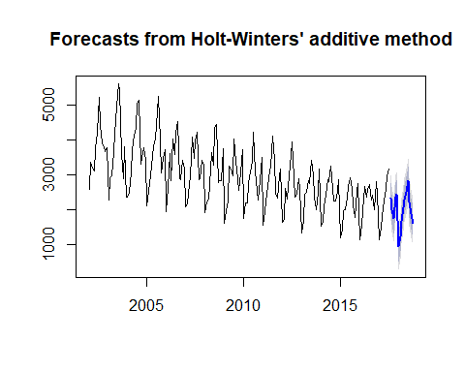

## Including Plots

You can also embed plots, for example:



Note that the echo = FALSE parameter was added to the code chunk to prevent printing of the R code that generated the plot. ..