THE STATE UNIVERSITY OF ZANZIBAR (SUZA)

SCHOOL OF COMPUTING, COMMUNICATION AND MEDIA STUDIES
DEPARTMENT OF COMPUTER SCIENCE AND INFORMATION
TECHNOLOGY TUNGUU- CAMPUS

COURSE CODE: INF 3108
COURSE TITLE: HUMAN RESOURSE MANAGEMENT AND INFORMATION SYSTEM
COURSE INSTRUCTOR: DR. ASHURA
GROUP MEMBERS:

STUDENT NAME | REG. NUMBER
1.LUQMAN ALI IBRAHIM | BITAM/11/23/019/TZ
2. IBRAHIM ASAA MOH’D | BITAM/11/23/073/TZ
3. YUSSRA ABOUD MBARAK | BITAM/11/23/060/TZ

Data Management for HRIS: Hardware Considerations
Human Resource Information Systems (HRIS) depend heavily on hardware infrastructure to ensure efficient data collection, processing, storage, security, and retrieval. Hardware considerations involve selecting and maintaining the physical equipment required to support HRIS operations. The quality of hardware directly affects system performance, reliability, scalability, and user satisfaction.

1. Introduction
Hardware refers to the physical components of a computer system that enable an HRIS to function. Organizations must carefully evaluate their hardware requirements to ensure that the HRIS can handle employee records, payroll processing, recruitment activities, performance management, and other HR functions efficiently.

2. Major Hardware Components in HRIS

Computers and Workstations
These are used by HR personnel and managers to access the HRIS. They should have sufficient processing power, memory, and storage capacity to run HR applications smoothly.

Servers
Servers store HR databases and run HR applications. Organizations may use on-premise servers or cloud-based servers depending on their needs. Reliable servers ensure continuous access to employee information.

Storage Devices
Storage devices such as hard disk drives (HDDs), solid-state drives (SSDs), and backup storage systems are used to store employee records, payroll data, and other HR information securely.

Networking Equipment
Routers, switches, modems, and internet connections enable communication between users and the HRIS. Strong networking infrastructure ensures quick and secure access to HR data.

Input Devices
Keyboards, scanners, biometric devices, and barcode readers help collect employee information accurately and efficiently.

Output Devices
Printers, monitors, and projectors are used to display and generate HR reports, employee records, and management information.

Simple Diagram of HRIS Hardware Structure
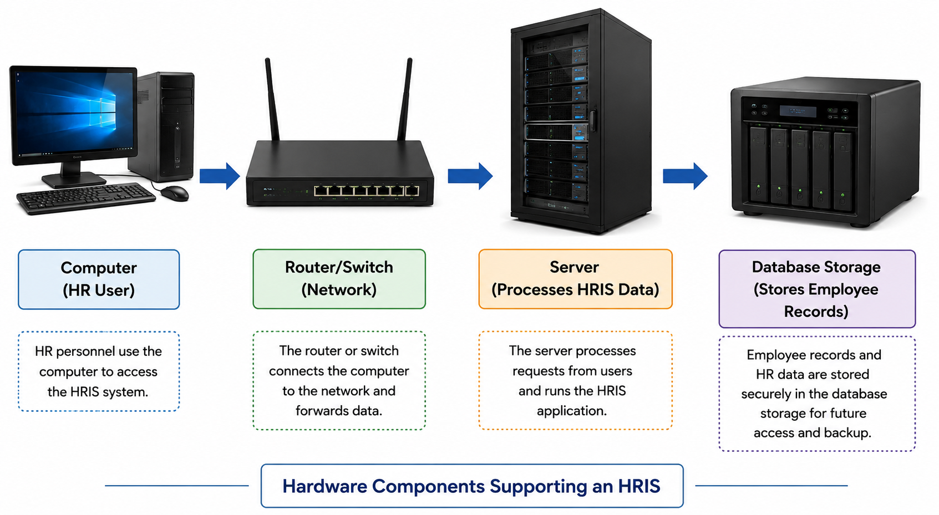
Figure 1: Hardware Components Supporting an HRIS
HR personnel use computers to access the Human Resource Information System (HRIS). Data travels through network devices such as routers and switches to the server, where requests are processed. Employee information is then stored securely in database storage systems for future access and backup.

3. Factors to Consider When Selecting Hardware for HRIS
Performance: Hardware should process HR transactions quickly and efficiently.
Reliability: Equipment should operate consistently with minimal downtime.
Scalability: Hardware should support future organizational growth and increasing data volumes.
Security: Systems should protect sensitive employee information from unauthorized access.
Compatibility: Hardware must be compatible with HRIS software and operating systems.
Cost: Organizations should balance performance requirements with available budgets.
Maintenance and Support: Hardware should be easy to maintain and supported by vendors.

4. Importance of Hardware Considerations in HRIS
Improves efficiency in HR operations.
Ensures accurate processing of employee information.
Provides secure storage of sensitive HR data.
Supports quick generation of reports and analytics.
Enhances employee and management access to information.
Reduces system failures and operational interruptions.

5. Challenges Related to Hardware in HRIS
Organizations may face challenges such as high acquisition costs, maintenance expenses, hardware failures, rapid technological changes, and data security risks. Regular upgrades and proper planning are necessary to overcome these challenges.

6. Conclusion
Hardware considerations are a critical aspect of data management in HRIS. Appropriate hardware ensures reliable system performance, secure data storage, efficient processing, and future scalability. Organizations that invest in suitable hardware infrastructure can improve HR service delivery and support strategic decision-making.

7. References (APA Style)
Kavanagh, M. J., Johnson, R. D., & Thite, M. (2020). Human Resource Information Systems: Basics, Applications, and Future Directions. Sage Publications.
Laudon, K. C., & Laudon, J. P. (2022). Management Information Systems: Managing the Digital Firm. Pearson.
Stair, R., & Reynolds, G. (2021). Principles of Information Systems. Cengage Learning.

