**WRITE A C PROGRAM TO FIND Ε -CLOSURE FOR ALL THE STATES IN A NON-DETERMINISTIC FINITE AUTOMATA (NFA) WITH Ε -MOVES.**

AIM:

TO WRITE A C PROGRAM TO FIND Ε -CLOSURE FOR ALL THE STATES IN A NON-DETERMINISTIC FINITE AUTOMATA (NFA) WITH Ε -MOVES.

ALGORITHM:

1. GET THE FOLLOWING AS INPUT FROM THE USER.

I. NUMBER OF STATES IN THE NFA

II. NUMBER OF SYMBOLS IN THE INPUT ALPHABET INCLUDING

III. INPUT SYMBOLS IV. NUMBER OF FINAL STATES AND THEIR NAMES

2. DECLARE A 3-DIMENSIONAL MATRIX TO STORE THE TRANSITIONS AND INITIALIZE ALL THE ENTRIES WITH -1

3. GET THE TRANSITIONS FROM EVERY STATE FOR EVERY INPUT SYMBOL FROM THE USER AND STORE IT IN THE MATRIX. FOR EXAMPLE, CONSIDER THE NFA SHOWN BELOW. THERE ARE 3 STATES 0, 1, AND 2 THERE ARE THREE INPUT SYMBOLS Ε, 0 AND 1. AS THE ARRAY INDEX ALWAYS STARTS WITH 0, WE ASSUME 0TH SYMBOL IS Ε, 1ST SYMBOL IS 0 AND 2ND SYMBOL IS 1.

PROGRAM:

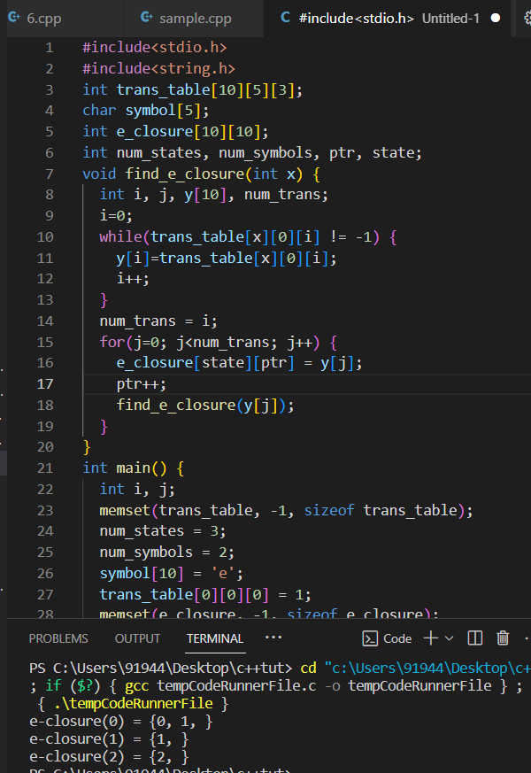

RESULT:  
THUS THE PROGRAM WAS EXECUTED SUCCESSFULLY