Contents
List of Technologies 1
Design pattern 1
ERM 2
Activity Diagram 4
Component interaction diagram 4
Feature added 5
Feature Missed 5

List of Technologies used

- PHP 5.5.9
- Apache/2.4.7
  - url rewriting
- Composer for installing dependencies
- PhpStorm IDE (First time used heard it’s good).
- VMware to host deployment server in Ubuntu server 14.04.
- Putty to interact with server.
- Adminer web interface to MySQL server.
- Visio for creating diagram
- MySQL 5.5.43
- MySQL workbench
- Yii 2.0.4 (I had experience in Yii 1 point something while back took risk with Yii 2 at least could learn something new)
  - Database migration for version dB not used as accordingly as per time shortage.
  - Gii to scaffold CRUD code.
  - Yii 2-mpdf for pdf generation
  - Yii 2 swiftmailer for email.
  - Yii 2 html templating
  - Yii 2 widgets for grid page and detail page.
  - Http cache header to Cache static content. Yii even caches pages through files.
- Bootstrap for boiler plate front end code.
- JQuery although not used much

Design pattern
I used Yii framework so most of the design pattern are being implemented through the framework
- Yii
  - Front controller, all request goes through index.php this why some similar operation can be applied to each request without violated DRY.
  - MVC code structure pattern for provide well define way of how component interact with each other.
  - Data layer pattern
    - Active Record used by Yii to relate to dB entity row. It’s a row mapping pattern
    - And Yii 2 I notice it also used table gateway pattern whose class are suffix by Query.
  - Singleton for register setting like session and login user object in yii (identity class).
  - Template pattern used at most places to extend and functionality like all models in Yii extend from base. Same goes with controller. I created base model and controller with common functionality.
  - Decorator not actually like object oriented decorator but it’s basically a pre hook to test access control.
  - Mixin pattern are used regularly by framework so does with Yii to implement sort of multiple inheritance through PHP magic methods like __get, __call.

ERM

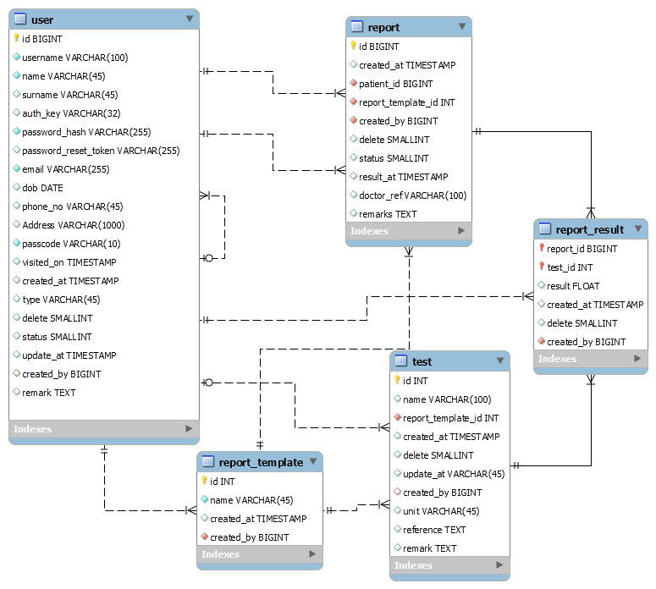

- Enhancement: I have delete column in all entity because of soft delete feature although I didn’t implemented it buts handy to have to recover from accidental delete.
- Enhancement: All date time should be stored in UTC which I didn’t realized it at late stage
- User
  - Password are stored in hash form.
  - Enhancement: Password reset token to recover from lost password
  - Enhancement: Another feature that should be in such system secure the patient confidentially is data anonymization which could be done by encrypting patient identifying fields like email, phone no.
  - Enhancement: Type is to identify user type like patient or user, it provides basic level of access control require to fulfill the assignment actual ACL would be better served through RBS (Role base system), its provided by Yii 2 but didn’t implemented based on duration.
- Report
  - Report template are predefine reports with tests which user can select for patient and fill in its details.
  - Separated tests so that there would be repository of tests which user can map to report based on report template it belongs to without reentering those tests.
  - There is a view which joins 3 tables report, results and test to provide complete report detail.
  - Enhancement: There can be doctor reference list in dB for assigning doctor to report.

Activity Diagram

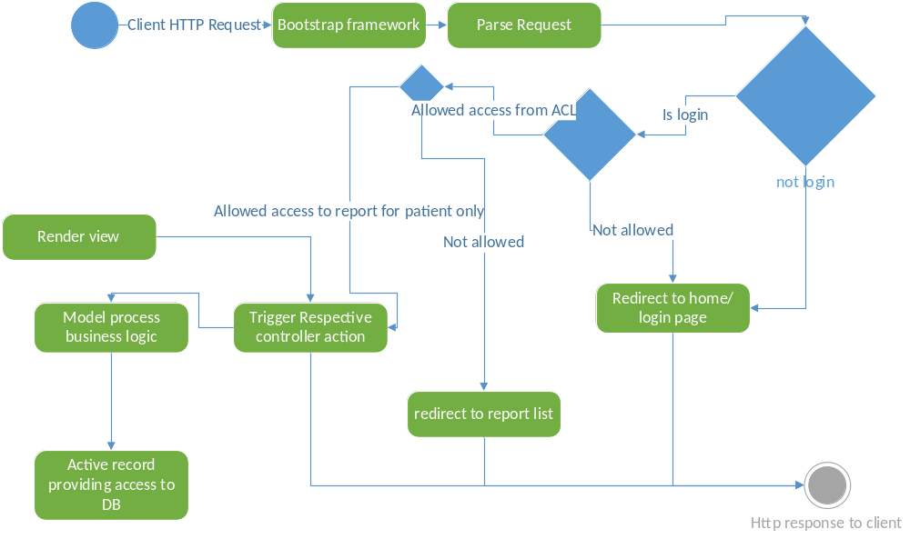

Component interaction diagram

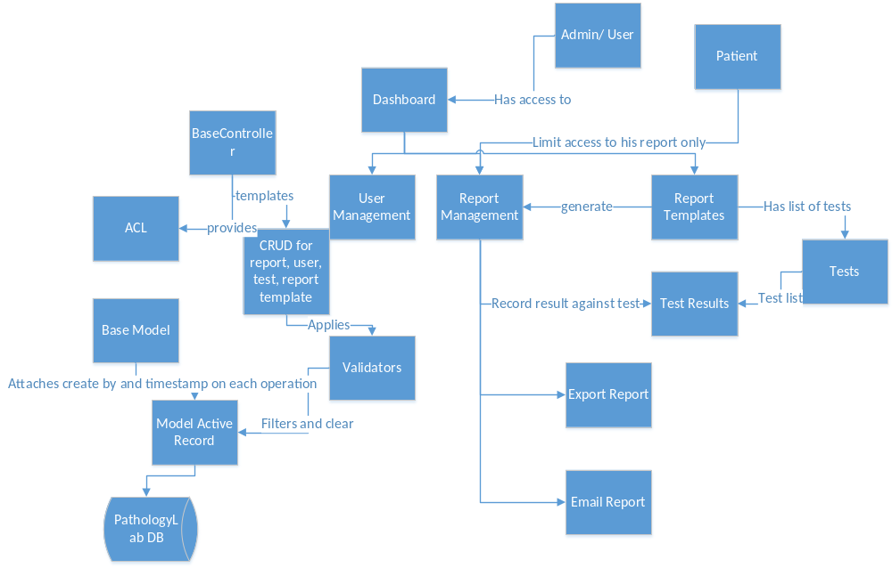

Feature added
- I added check to restrict user from opening up other user record or reports.

Further enhancement
- From usability point of entering report test result is big tiresome a better approach could be to provide user with grid with all the test of template report so he/she can enter result in one go.
- UI experience is poor I admit but considering the time duration in such duration even designs are not finalized.

