**软件测试上机报告**



第二次上机作业

**学 院___智能与计算学部______**

**专 业____ 软件工程__________**

**姓 名_______宋高超___ ____**

**学 号_____3017214075________**

**年 级_______ 2017____ __**

**班 级_______ 2__ _____**

# 实验要求

**Tasks:**

1. Install Selenium with Eclipse.
2. Install Firefox and SeleniumIDE plugin.
3. Try to record and export scripts using SeleniumIDE.
4. Please complete the following task using Selenium Webdriver:

“Selenium Lab.xlsx” contains information about the students, and http://103.120.226.190/selenium-demo/git-repo can view someone’s information after logging in (student id as username, git address as password). Please check each record in the excel to make sure that each student’s information is consistent with the information on the website.

**Requirements for the experiment:**

1. Finish the tasks above individually.
2. Check in your java code to github or gitee
3. Please send your experiment report to 智慧树, the following information should be included in your report:
   1. The brief description that you install Selenium, Firefox and SeleniumIDE.
   2. Steps for recording and exporting scripts.
   3. Steps for testing the website using Selenium.

**Submission deadline:** 23:59 March 31, 2020.

# 源代码

**package** GitQuery;

**import** **static** org.hamcrest.CoreMatchers.~~is~~;

**import** **static** org.junit.Assert.*;

**import** java.io.File;

**import** java.util.HashMap;

**import** java.util.Iterator;

**import** java.util.Map;

**import** java.util.Map.Entry;

**import** java.util.Set;

**import** org.junit.After;

**import** org.junit.Before;

**import** org.junit.Test;

**import** org.openqa.selenium.By;

**import** org.openqa.selenium.Dimension;

**import** org.openqa.selenium.WebDriver;

**import** org.openqa.selenium.chrome.ChromeDriver;

**import** jxl.Sheet;

**import** jxl.Workbook;

**public** **class** GitLogTest {

**private** WebDriver driver;

**private** **static** **void** everyTest(WebDriver driver, String url, String key, String value) {

driver.get(url);

driver.manage().window().setSize(**new** Dimension(550, 693));

driver.findElement(By.*name*("user_number")).click();

driver.findElement(By.*name*("user_number")).sendKeys(key);

driver.findElement(By.*name*("password")).click();

driver.findElement(By.*name*("password")).click();

driver.findElement(By.*name*("password")).sendKeys(value);

driver.findElement(By.*cssSelector*(".btn")).click();

driver.findElement(By.*cssSelector*(".mb-2:nth-child(6) > code")).click();

*assertThat*(driver.findElement(By.*cssSelector*(".mb-2:nth-child(6) > code")).getText(), *is*(value));

}

@Before

**public** **void** setUp() {

System.*setProperty*("webdriver.chrome.driver",

"E:\\AboutEclipse\\Chromedriver\\chromedriver_win32\\chromedriver.exe");

driver = **new** ChromeDriver();

}

@After

**public** **void** tearDown() {

driver.quit();

}

@Test

**public** **void** gitQuery() {

**try** {

Workbook book = Workbook.*getWorkbook*(**new** File("E:\\AboutEclipse\\softwaretest\\src\\Selenium+Lab2020.xls"));

HashMap<String, String> map = **new** HashMap<String, String>();

Sheet sheet = book.getSheet(0);

**int** index = 0;

**while** (!sheet.getCell(1, index).getContents().equals("")) {

index++;

}

**for** (**int** i = 0; i < index; i++) {

map.put(sheet.getCell(1, i).getContents(), sheet.getCell(2, i).getContents());

}

book.close();

Set<Map.Entry<String, String>> set = map.entrySet();

Iterator it = set.iterator();

**while** (it.hasNext()) {

Map.Entry<String, String> ele = (Entry<String, String>) it.next();

*everyTest*(driver, "http://103.120.226.190/selenium-demo/git-repo", ele.getKey(), ele.getValue());

}

} **catch** (Exception e) {

e.printStackTrace();

}

}

}

# 运行结果

1. **The brief description that you install Selenium, Firefox and SeleniumIDE.**

To install the Firefox, I search it in Chrome and download it.



To install the Selenium, I search the plugin in the firefox and add it to my browser.

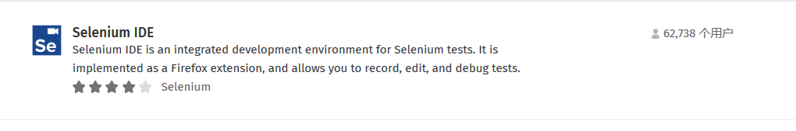

To install the java package of Selenium, I download it from the share of teacher.

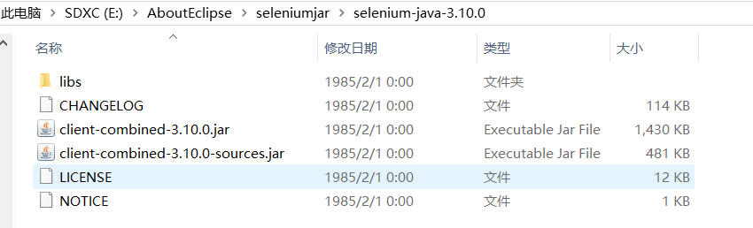

Then I add it to the library of my Java Project.

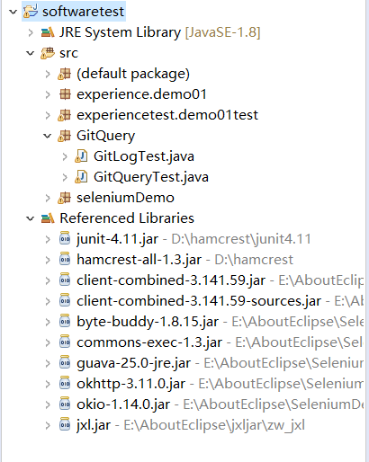

1. **Steps for recording and exporting scripts.**

Frist, I open the plugin of the selenium IDE, then build a new project. After giving it the url, I start to record.

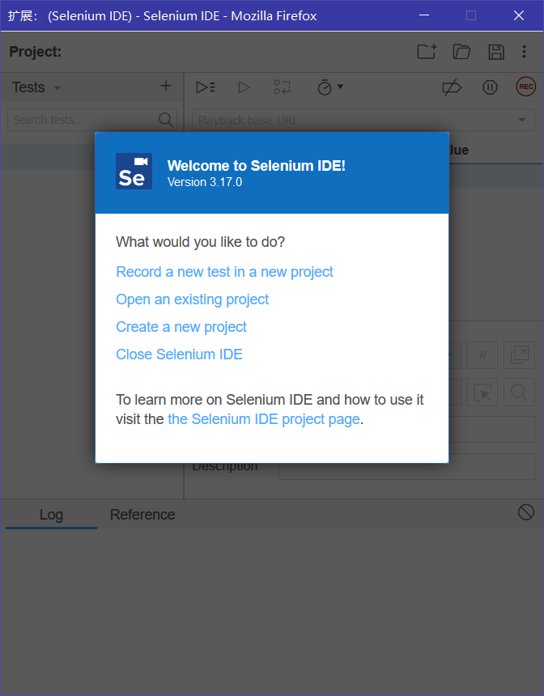

After recording, the window back as follows.

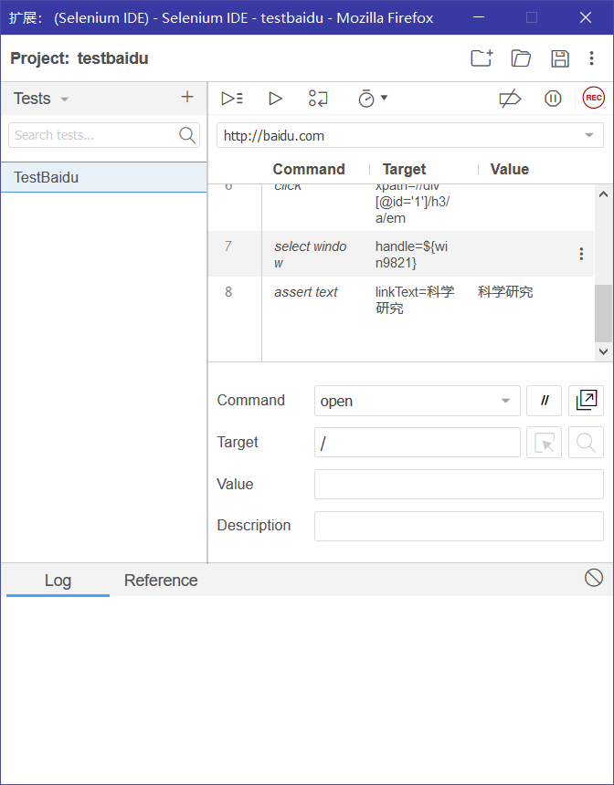

Then export it to .java file.

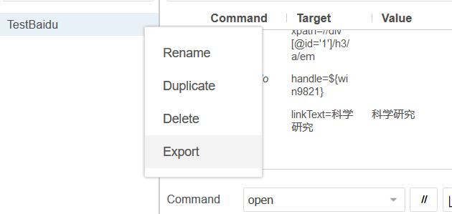

Open it, we can find the final .java file is successfully generated.

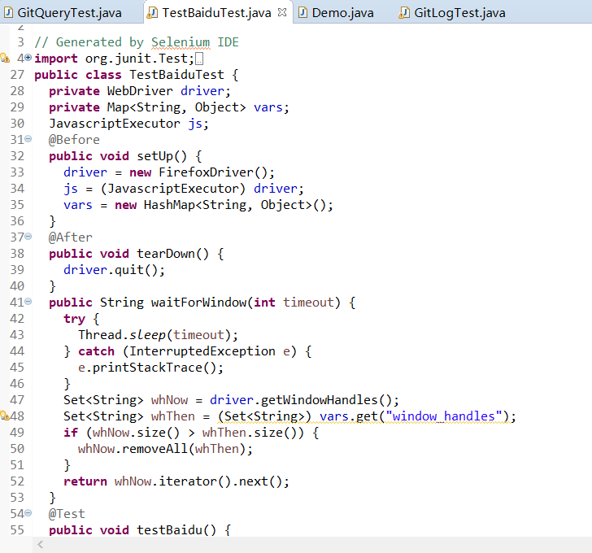

1. **Steps for testing the website using Selenium.**
2. Check the verison of Chrome and download the chrome driver which match it.

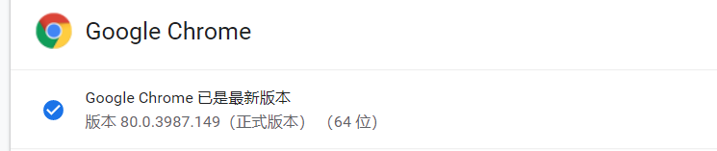

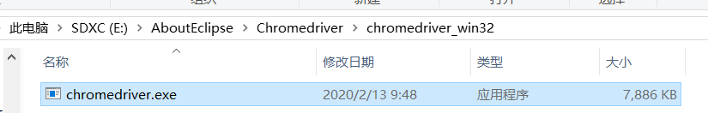

1. Download jxl.jar to process the .xls file.



1. In the java test script, set the property to let the system to find the chrome driver.

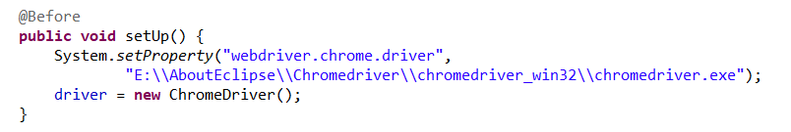

1. Make the test step clearly.

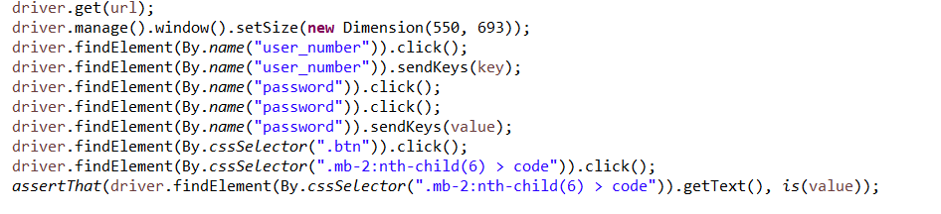

1. Change the .xlsx to .xls to process it easily



1. Read the .xls file and store it in the HashMap<String,String>

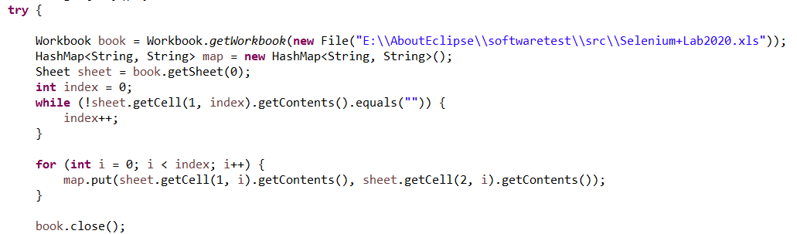

1. Finish the main test method

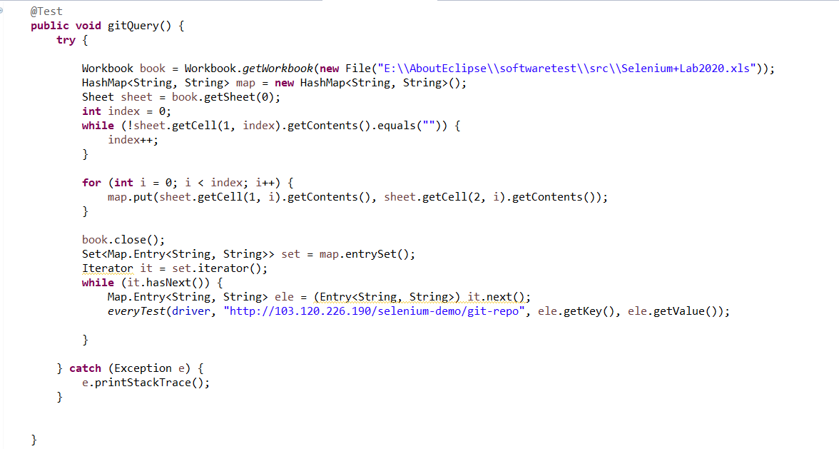

1. Start the test script, we can find it is testing automatically.

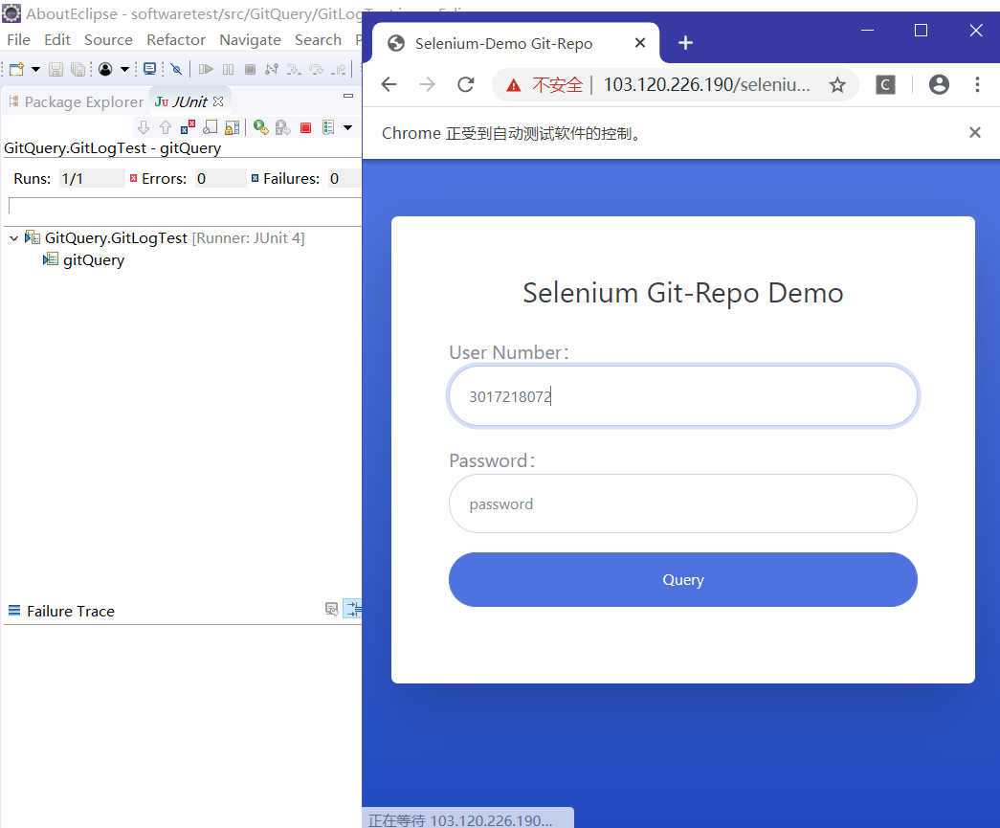

1. After testing, we can find the test cases all passed.

