**软件测试上机报告**



第四次上机作业

**学 院___智能与计算学部______**

**专 业____ 软件工程__________**

**姓 名_______宋高超___ ____**

**学 号_____3017214075________**

**年 级_______ 2017____ __**

**班 级_______ 2__ _____**

# 实验要求

**Tasks:**

1. Install MuJava. The instruction of how to install and use Mujava can be seen in <https://cs.gmu.edu/~offutt/mujava/> .
2. Two small programs are given for your task. BubbleSort.java is an implementation of bubble sort algorithm and BackPack.java is a solution of 01 backpack problem. Try to generate Mutants of 2 given programs with MuJava.
3. Write testing sets for 2 programs with Junit, and run mutants on the test sets with MuJava.

**Requirements for the experiment:**

1. Finish the tasks above individually.
2. Check in your java code to github or gitee.
3. Post your experiment report to “智慧树” , the following information should be included in your report:
   1. The brief description that you install MuJava
   2. Steps for generating Mutants
   3. Steps for making test sets and running mutants.
   4. Your mutants result (The number of live mutants, killed mutants, etc.)

# 源代码

BackPackTest.java

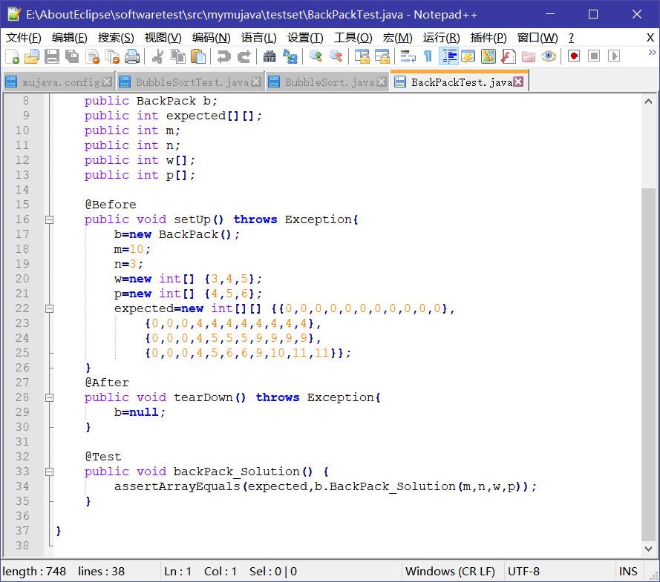

BubbleSortTest.java

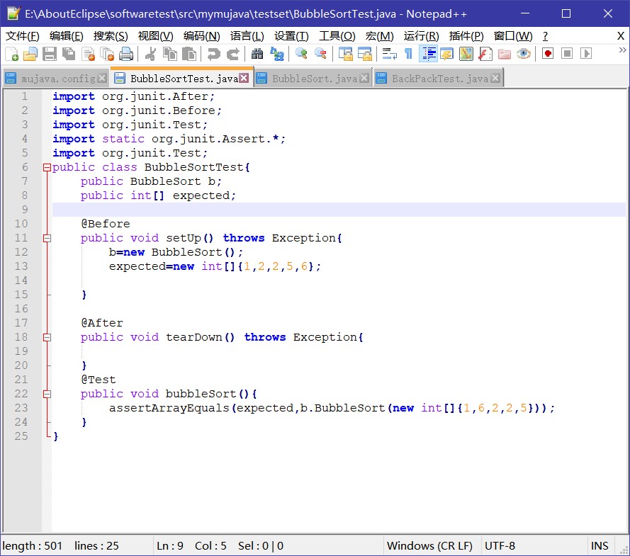

# 实验步骤

1. The brief description that I install MuJava.

First, I install the package given by teacher and add it to the classpath of my system.

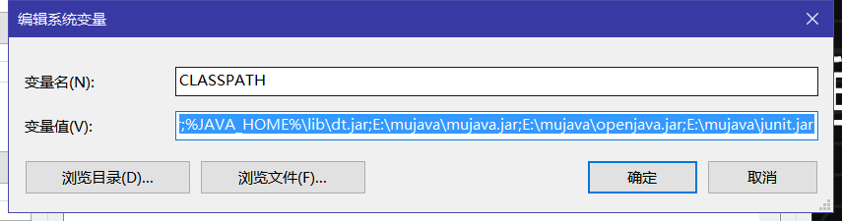

Then I make a directory in E:\AboutEclipse\softwaretest\src\mymujava and decide to make this directory to be my mujava home directory.

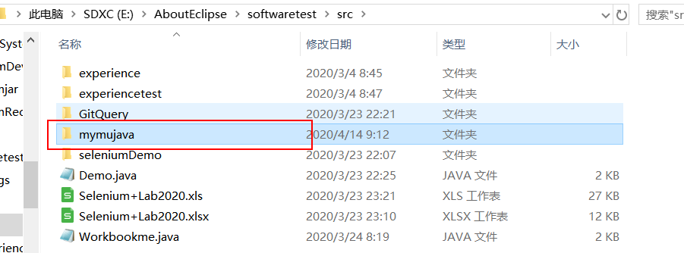

Build a new mujava.config file and tell the system this directory is mujava home directory.

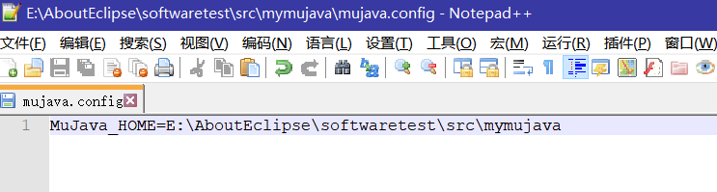

Then I use cmd and use the command ans follows to build the directorys : java mujava.makeMujavaStructure :

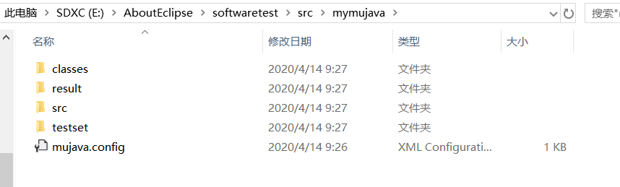

After this, the project of mujava is build successfully.

1. Steps for generating Mutants

Copy the teacher’s BubbleSort.java and BackPack.java to the MujavaHome/src， then compile them in cmd and copy the .class file to the folder MujavaHome/classes.



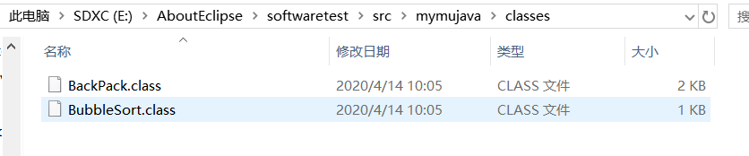

In the powershell, use the command java mujava.gui.GenMutantsMain to get the Mutants.

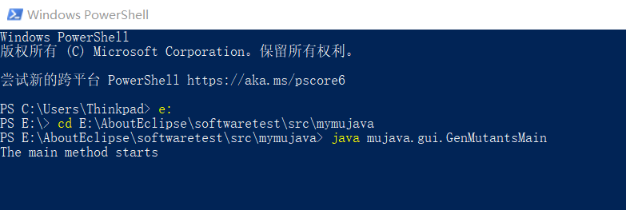

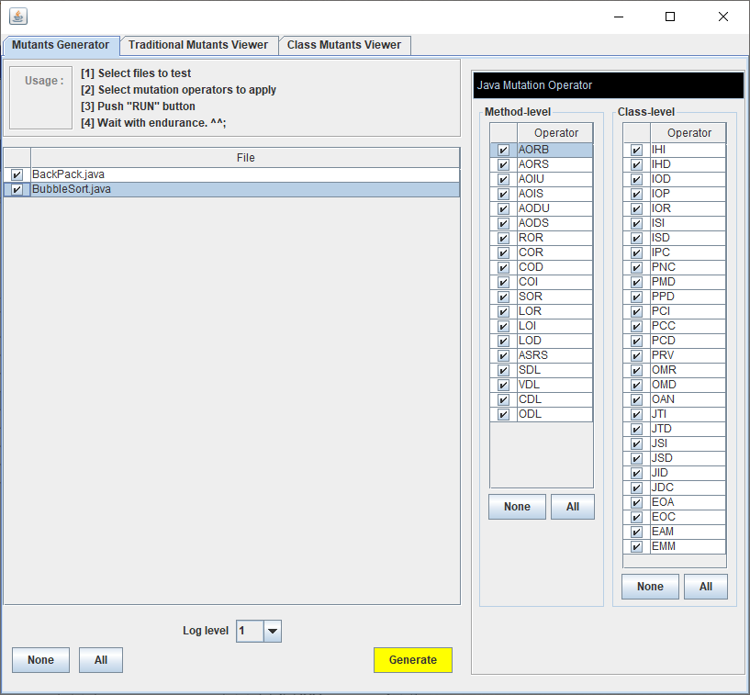

Click the generate button. We can find it is generating the Mutants.

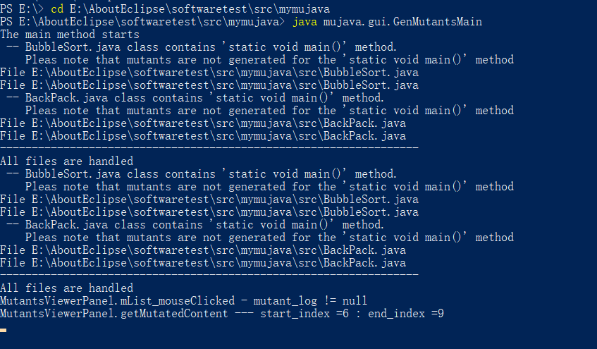

Finally we can find it generate the Mutans fuccessfully.

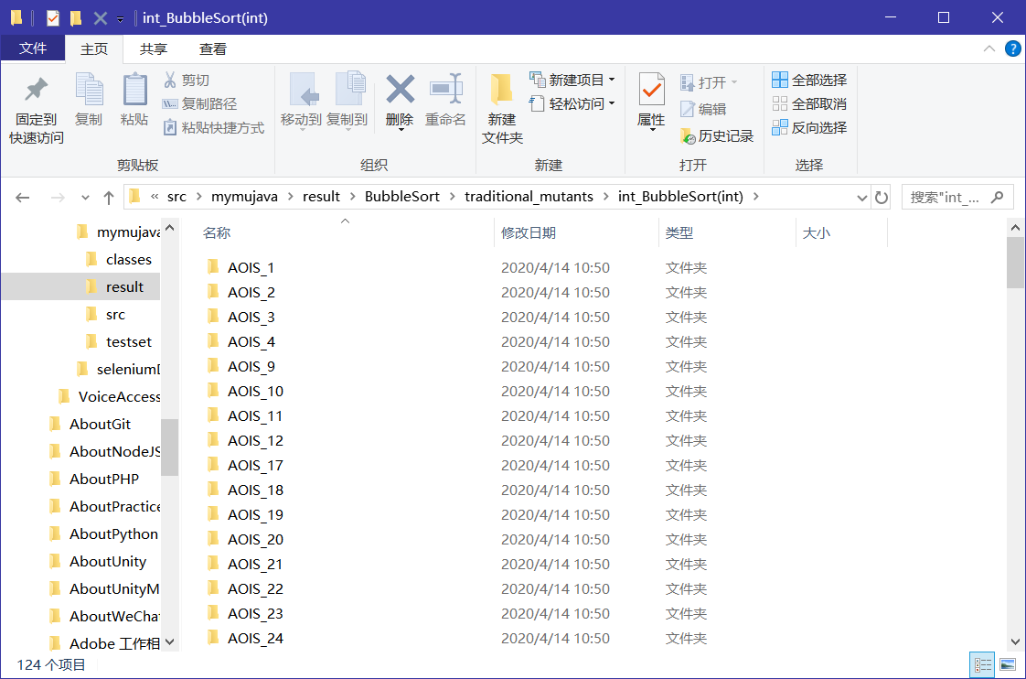

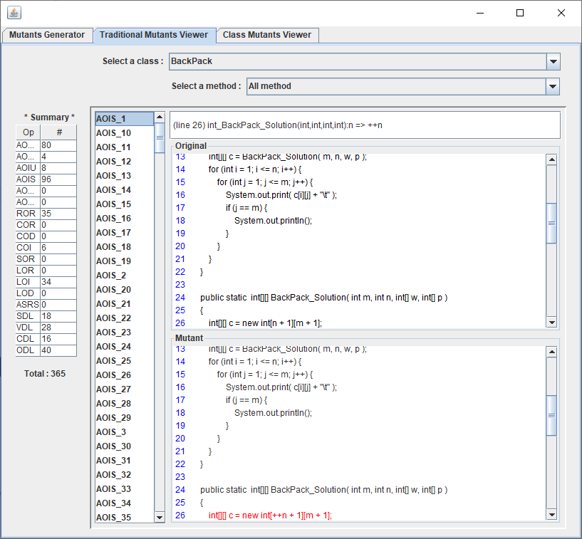

1. Steps for making test sets and running mutants.

First I write the test case in the MujavaHome/testset





Then I compile them in cmd, finally we can find the .class file of the testcases.

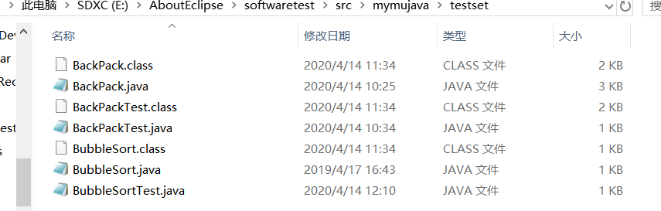

Then I use the command java mujava.gui.RunTestMain to contorl the gui and start to run the mutants.

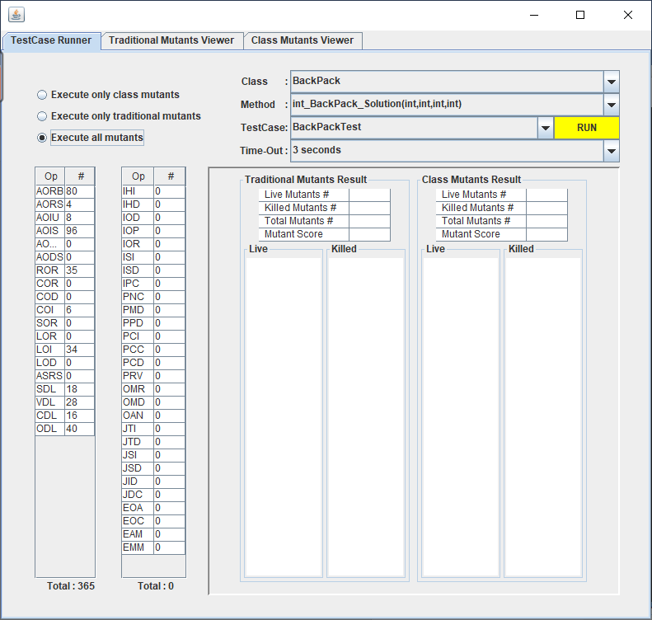

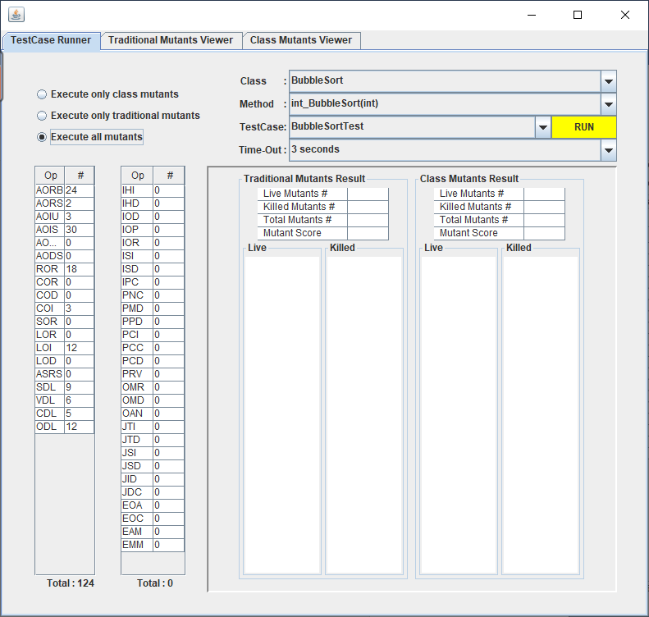

It is running

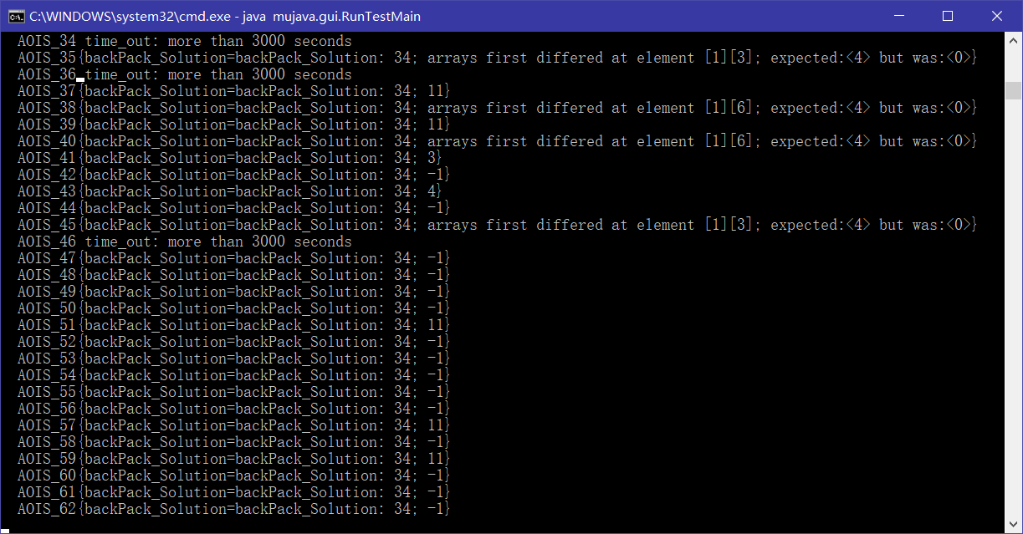

1. The final result are as follows:

