1) Write a shell script to ask your name, program name and enrollment number and print it on the screen.

Echo “Enter your name:”  
Read Name  
Echo “Enter your program name:”  
Read Prog  
Echo “Enter your enrollment number:”  
Read Enroll  
Clear  
Echo “Details you entered”  
Echo Name: $Name  
Echo Program Name: $Prog  
Echo Enrolment Number: $Enroll

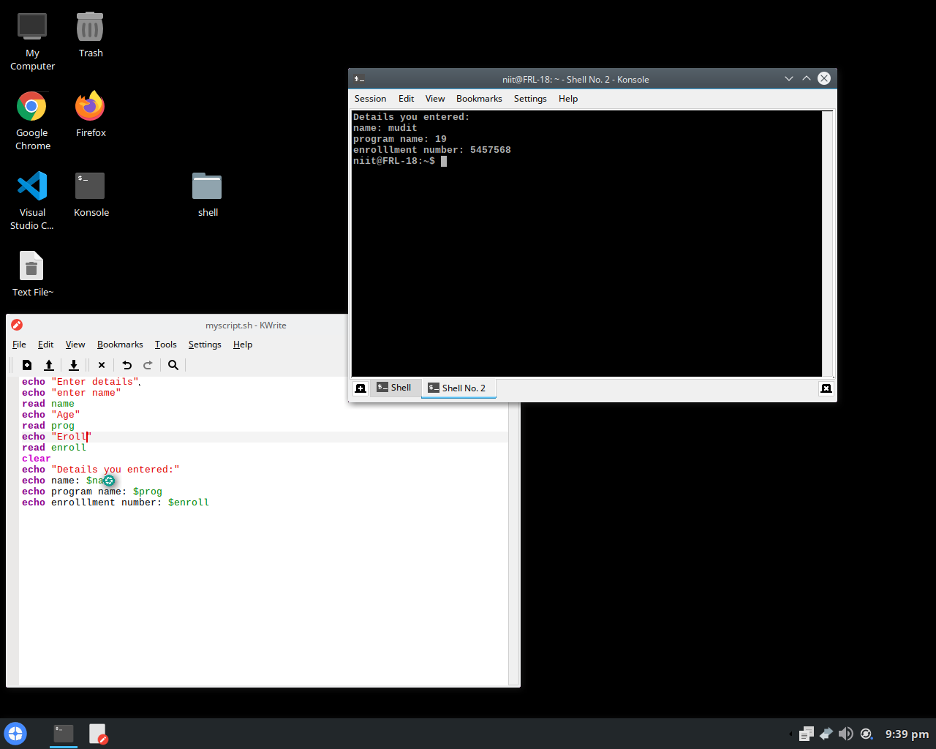

2) Write a shell script to find the sum, the average and the product of the four integers entered

Echo “Enter four integers with space between”  
Read a b c d  
Sum =`expr $a + $b + $c + $d`  
Avg =`expr $sum / 4`  
Dec =`expr $sum % 4`  
Dec =`expr \ ($dec \\* 1000 \) / 4`  
Product =`expr $a \\* $b \\* $c \\* $d`  
Echo Sum = $sum  
Echo Average = $avg. $dec  
Echo Product = $product

OUTPUT  
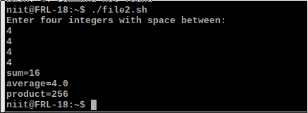

3) Write a shell program to exchange the values of two variables

Echo “Enter value for a:”  
Read a  
Echo “Enter value for b:”  
Read b  
Clear  
Echo “Values of variables before swapping”  
Echo A = $a  
Echo B = $b  
Echo Values of variables after swapping  
a = `expr $a + $b`  
b = `expr $a – $b`  
a = `expr $a – $b`  
Echo A = $a  
Echo B = $b

OUTPUT

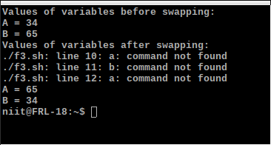

4) Find the lines containing a number in a file

Echo “Enter filename”  
Read filename  
Grep [0-9] $filename

echo "enter filename"

read filename

grep [0-9] $filename

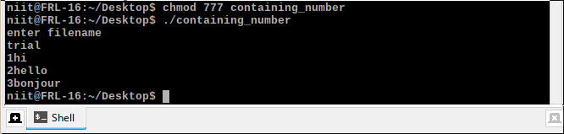

5) Write a shell script to display the digits which are in odd position in a given 5 digit number

Echo “Enter a 5 digit number”  
Read num  
n = 1  
while [ $n -le 5 ]  
do  
a = `Echo $num | cut -c $n`  
Echo $a  
n = `expr $n + 2`  
done

echo "Enter a 5 digit number"

read num

n=1

while [ $n -le 5 ]

do

a=`echo $num | cut -c $n`

echo $a

n=`expr $n + 2`

done

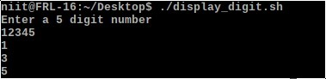

6) Write a shell program to reverse the digits of five digit integer

Echo “Enter a 5 digit number”  
Read num  
n = $num  
rev=0  
while [ $num -ne 0 ]  
do  
r = `expr $num % 10`  
rev = `expr $rev \\* 10 + $r`  
num = `expr $num / 10`  
done  
Echo “Reverse of $n is $rev”

echo 'Enter a 5 digit number'

read num

n=$num

rev=0

while [ $num -ne 0 ]

do

r=`expr $num % 10`

rev=`expr $rev \\* 10 + $r`

num=`expr $num / 10`

done

echo Reverse of $n is $rev

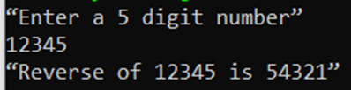

7) Write a shell script to find the largest among the 3 given numbers

Echo “Enter 3 numbers with spaces in between”  
Read a b c  
1 = $a  
if [ $b -gt $l ]  
then  
l = $b  
fi  
if [ $c -gt $l ]  
then  
l = $c  
fi  
Echo “Largest of $a $b $c is $l”

echo 'Enter 3 numbers with spaces in between'

read a b c

l=$a

if [ $b -gt $l ];

then

l=$b

fi

if [ $c -gt $l ];

then

l=$c

fi

echo Largest of $a $b $c is $l

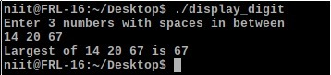

8) Write a shell program to search for a given number from the list of numbers provided using binary search method

Echo “Enter array limit”  
Read limit  
Echo “Enter elements”  
n = 1  
while [ $n -le $limit ]  
do  
Read num  
eval arr$n = $num  
n =`expr $n + 1`  
done  
Echo “Enter key element”  
Read key  
low = 1  
high = $n  
found = 0  
while [ $found -eq 0 -a $high -gt $low ]  
do  
mid = `expr \( $low + $high \) / 2`  
eval t = \$arr$mid  
if [ $key -eq $t ]  
then  
found = 1  
elif [ $key -lt $t ]  
then  
high =`expr $mid – 1`  
else  
low =`expr $mid + 1`  
fi  
done  
if [ $found -eq 0 ]  
then  
Echo “Unsuccessful search”  
else  
Echo “Successful search”  
fi

echo “Enter array limit”

read limit

echo “Enter elements”

n=1

while [ $n -le $limit ]

do

read num

eval arr$n=$num

n=`expr $n + 1`

done

echo “Enter key element”

read key

low=1

high=$n

found=0

while [ $found -eq 0 -a $high -gt $low ]

do

mid=`expr \( $low + $high \) / 2`

eval t=\$arr$mid

if [ $key -eq $t ]

then

found=1

elif [ $key -lt $t ]

then

high=`expr $mid – 1`

else

low=`expr $mid + 1`

fi

done

if [ $found -eq 0 ]

then

echo “Unsuccessful search”

else

echo “Successful search”

fi

