1.

Code to print factorial of given number

echo "Enter the number for calculating the factorial" read NNN

Initial=1

for((X=2;X<=NNN;X++))

{ Inil=$((Initial\*X))

}

echo $Inil

#Code by MUDIT MOHIT



2. Code for prime numbers upto 100

echo "Enter the starting number of range: " read M

echo "Enter the last number of range: " read L

echo "Prime numbers between $M and $L are: "

while [ $M -le $L ] do N=2 i=0

while [ $N -le `expr $M / 2` ] do if [ `expr $M % $N` -eq 0 ] then i=1

break

fi

N=`expr $N + 1` done

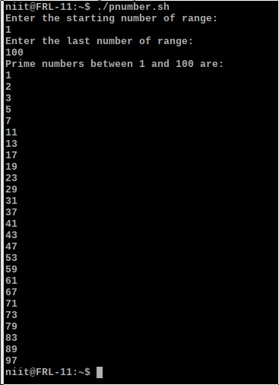

if [ $i -eq 0 ] then

echo $M fi

M=`expr $M + 1` done

#Code BY MUDIT MOHIT

3. #Code to generate grade according to your marks scored

#This will show your grade echo "Let's check your grade" echo "Enter your scored marks" read mmm

if [ $mmm -ge 90 ] then echo "your grade is A" elif [ $mmm -ge 70 ] then echo "your grade is B " elif [ $mmm -ge 40 ] then echo "your grade is C" else echo "your grade is F"

fi

#Code by MUDIT MOHIT

