Title: Handwritten Digit Recognition Using Convolutional Neural Networks

Abstract:

Handwritten digit recognition is a fundamental problem in the field of computer vision and pattern recognition, with a wide range of applications, including automated postal services, bank check processing, and digitized document management. This project presents a robust solution for handwritten digit recognition using Convolutional Neural Networks (CNNs).

The proposed system leverages the power of deep learning and CNN architecture to automatically learn and extract relevant features from handwritten digit images. A comprehensive dataset of handwritten digits is used for training and evaluation, ensuring diversity and accuracy in recognition.

The CNN model comprises multiple layers of convolutional and pooling operations, followed by fully connected layers, which enable the network to hierarchically learn complex patterns and representations from the input images. Transfer learning techniques are also explored to fine-tune pre-trained models for enhanced recognition performance.

In addition to the model architecture, this project addresses preprocessing techniques such as image normalization, data augmentation, and noise reduction to improve the robustness of the system against variations in handwriting styles and image quality.

The performance of the CNN-based handwritten digit recognition system is rigorously evaluated through metrics like accuracy, precision, recall, and F1-score. The results demonstrate the effectiveness of the proposed approach in achieving state-of-the-art accuracy levels in recognizing handwritten digits.

This project contributes to the advancement of machine learning techniques in the domain of character recognition and showcases the potential of CNNs in solving real-world problems. The developed system can be readily integrated into various applications that require handwritten digit recognition, thus offering a reliable and efficient solution for automating digit-based data processing tasks.

Introduction:

Handwritten digit recognition has long been a critical task in the field of computer vision and artificial intelligence. Its applications span a wide range of domains, from automating postal services to processing bank checks and digitizing historical documents. The ability to accurately and efficiently recognize handwritten digits holds significant importance in improving the automation and efficiency of various industries.

Traditional methods for handwritten digit recognition relied on handcrafted feature extraction and machine learning algorithms. These approaches often struggled with variations in writing styles, sizes, and orientations, making them less adaptable to the real-world variability of handwritten characters.

In recent years, the advent of deep learning, particularly Convolutional Neural Networks (CNNs), has revolutionized the field of image recognition, including handwritten digit recognition. CNNs are well-suited to automatically learn hierarchical features from data, making them highly effective for tasks like character recognition.

This project focuses on harnessing the power of CNNs to develop a robust and accurate system for handwritten digit recognition. The CNN architecture allows the model to automatically discover and extract relevant features from input images, effectively addressing the challenges posed by diverse handwriting styles and varying image quality.

In addition to the model architecture, this project explores various preprocessing techniques, including image normalization, data augmentation, and noise reduction, to enhance the model's resilience to real-world data. The objective is to create a system that not only achieves high recognition accuracy but is also adaptable to the complexities of handwritten characters encountered in practical scenarios.

The outcomes of this project are expected to contribute significantly to the advancement of machine learning techniques in the realm of character recognition. By achieving state-of-the-art accuracy levels in recognizing handwritten digits, this system can serve as a valuable tool for automating data processing tasks, thereby increasing efficiency and reducing the margin of error in numerous applications. In the subsequent sections, we delve into the methodology, data, experiments, and results that form the foundation of this Handwritten Digit Recognition using CNN project.

Existing Systems:

Handwritten digit recognition has been a longstanding research area, and several systems and approaches have been developed over the years. These systems can be broadly categorized into two main types: traditional methods and deep learning-based methods. Here, we provide an overview of both categories:

1. \*\*Traditional Methods:\*\*

a. \*\*Optical Character Recognition (OCR) Systems:\*\* These systems have been widely used for digit recognition. They typically involve the segmentation of characters from images, followed by feature extraction and classification. Classical machine learning algorithms such as Support Vector Machines (SVM), k-Nearest Neighbors (k-NN), and decision trees have been employed for classification. However, these methods often struggle with variations in writing styles and require handcrafted feature engineering.

b. \*\*Template Matching:\*\* Template matching involves comparing a portion of an image with predefined templates of digits. It is a simple and intuitive approach but is highly sensitive to variations in size, orientation, and noise.

c. \*\*Neural Networks (Non-CNN):\*\* Before the rise of CNNs, traditional neural networks were used for character recognition. These networks required careful design of the architecture and feature extraction.

2. \*\*Deep Learning-Based Methods:\*\*

a. \*\*Convolutional Neural Networks (CNNs):\*\* CNNs have become the de facto standard for handwritten digit recognition. LeNet-5, one of the early CNN architectures, was used to recognize digits in the MNIST dataset, setting the stage for CNNs' dominance in this field. Modern CNN architectures, such as VGGNet, ResNet, and Inception, have also been adapted for digit recognition tasks.

b. \*\*Recurrent Neural Networks (RNNs):\*\* While CNNs excel at capturing spatial features, RNNs, particularly Long Short-Term Memory (LSTM) networks, have been used to recognize sequences of digits, such as handwritten postal codes or bank check amounts.

c. \*\*Hybrid Models:\*\* Some systems combine CNNs with other techniques, such as Hidden Markov Models (HMMs) or Conditional Random Fields (CRFs), to improve recognition accuracy, especially for cursive handwriting.

3. \*\*Commercial Solutions:\*\*

a. \*\*Tesseract OCR:\*\* Tesseract is an open-source OCR engine developed by Google. It has been trained on a vast amount of text data and can recognize not only handwritten digits but also printed text.

b. \*\*Microsoft Azure Cognitive Services:\*\* Microsoft's cloud-based service offers a variety of computer vision capabilities, including handwritten digit recognition, with the ability to integrate recognition into applications.

These existing systems have made significant strides in handwritten digit recognition, especially with the advent of deep learning. However, challenges persist, such as recognizing digits in unconstrained environments and handling variations in handwriting styles. New research continues to push the boundaries of accuracy and adaptability in digit recognition systems.

\*\*Problem Statement:\*\*

Handwritten digit recognition remains a challenging task due to the inherent variability in human handwriting styles and image quality. Traditional methods, relying on handcrafted features and classical machine learning algorithms, often struggle to achieve high accuracy in recognizing handwritten digits in real-world scenarios. To address this challenge, there is a need to develop an efficient and accurate system that can automatically recognize handwritten digits, enabling automation and accuracy improvements in various applications, including postal services, finance, and document management.

\*\*Objectives:\*\*

The primary objective of this project is to design and implement a Handwritten Digit Recognition system using Convolutional Neural Networks (CNNs) to overcome the limitations of traditional approaches. The specific objectives are as follows:

1. \*\*Develop a CNN Architecture:\*\* Design a deep learning CNN architecture tailored for handwritten digit recognition. The architecture should include convolutional layers, pooling layers, and fully connected layers to automatically learn and extract features from digit images.

2. \*\*Dataset Collection and Preprocessing:\*\* Gather a comprehensive dataset of handwritten digits that encompasses a wide range of writing styles and variations. Implement preprocessing techniques, including image normalization, data augmentation, and noise reduction, to enhance the model's robustness to real-world data.

3. \*\*Model Training and Evaluation:\*\* Train the CNN model on the dataset, optimizing for accuracy and generalization. Evaluate the model's performance using appropriate metrics such as accuracy, precision, recall, and F1-score to ensure its effectiveness in recognizing handwritten digits.

4. \*\*Hyperparameter Tuning:\*\* Experiment with different hyperparameters, including learning rates, batch sizes, and network architectures, to fine-tune the model for optimal performance.

5. \*\*Transfer Learning:\*\* Explore the potential of transfer learning by fine-tuning pre-trained CNN models (e.g., VGGNet or ResNet) to leverage their learned features for improved recognition accuracy.

6. \*\*Real-time Recognition:\*\* Implement a real-time digit recognition pipeline that accepts input images of handwritten digits and provides accurate predictions. Ensure the system's efficiency and responsiveness for practical applications.

7. \*\*Deployment and Integration:\*\* Develop the system into a user-friendly application or API that can be integrated into various domains, such as automated postal services or document management systems.

8. \*\*Performance Benchmarking:\*\* Compare the developed system's performance against existing handwritten digit recognition methods, including traditional OCR systems and deep learning-based approaches, to assess its competitiveness and advantages.

By achieving these objectives, this project aims to contribute a robust and accurate solution to the problem of handwritten digit recognition, with the potential to enhance automation and accuracy in numerous real-world applications.

Proposed System: Handwritten Digit Recognition Using CNN

The proposed system leverages Convolutional Neural Networks (CNNs) to develop a highly accurate and efficient solution for recognizing handwritten digits. This system addresses the limitations of traditional methods by harnessing the power of deep learning and modern computer vision techniques. Below is an overview of the key components and functionalities of the proposed system:

1. Data Collection and Preparation:

Dataset Acquisition: Gather a diverse and extensive dataset of handwritten digit images. This dataset should include digits written by individuals with varying handwriting styles, sizes, and orientations.

Data Preprocessing: Implement preprocessing techniques to prepare the dataset, including image normalization, resizing, and data augmentation to enhance the model's ability to generalize to different handwriting variations.

2. CNN Model Architecture:

Convolutional Layers: Design a deep CNN architecture with multiple convolutional layers to automatically extract features from input images. These layers are responsible for detecting edges, shapes, and patterns.

Pooling Layers: Integrate pooling layers to downsample feature maps, reducing computational complexity while preserving essential information.

Fully Connected Layers: Include fully connected layers to enable high-level feature learning and decision-making.

3. Model Training and Optimization:

Training: Train the CNN model on the preprocessed dataset using appropriate loss functions and optimization algorithms. Implement techniques like dropout to prevent overfitting.

Hyperparameter Tuning: Experiment with various hyperparameters, such as learning rates, batch sizes, and network architectures, to optimize the model's performance.

4. Transfer Learning (Optional):

Pre-trained Models: Explore the use of pre-trained CNN models (e.g., VGGNet or ResNet) as a starting point for the architecture. Fine-tune these models on the handwritten digit dataset to leverage their learned features.

5. Real-time Recognition:

User-Friendly Interface: Develop a user-friendly application or API that allows users to input images of handwritten digits for recognition.

Real-time Prediction: Implement a real-time prediction pipeline that processes input images and provides accurate digit recognition results.

Block diagram

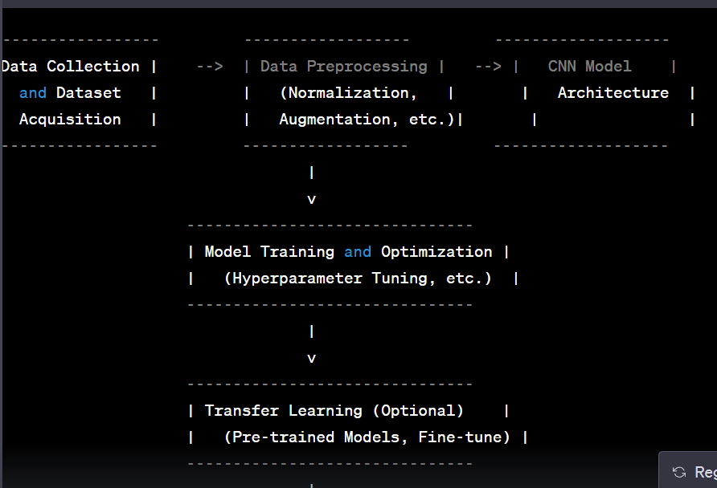

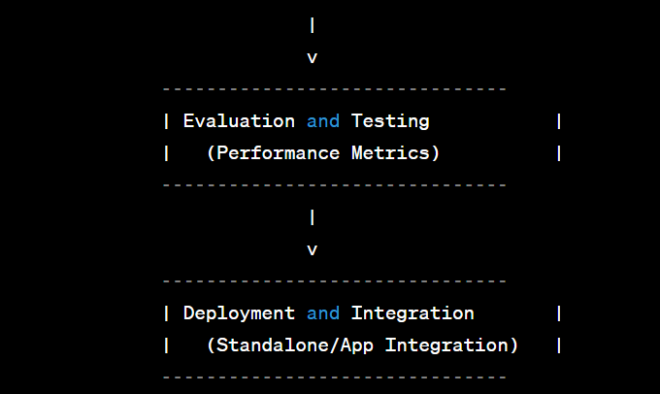

Modules description

Certainly, here's a detailed description of each module/component in the proposed Handwritten Digit Recognition System using CNN:

Data Collection and Dataset Acquisition:

Description: This module is responsible for acquiring a diverse and comprehensive dataset of handwritten digit images. It involves collecting digit samples from various sources and contributors to ensure a wide range of handwriting styles and variations.

Functionality: Gather, curate, and preprocess a high-quality dataset of handwritten digit images.

Data Preprocessing:

Description: Data preprocessing is essential to prepare the dataset for training. It includes techniques such as image normalization, resizing, data augmentation, and noise reduction to enhance the model's ability to generalize to different handwriting styles and image variations.

Functionality: Prepare the dataset for training by applying transformations and enhancements.

CNN Model Architecture:

Description: This module defines the architecture of the Convolutional Neural Network (CNN). It specifies the structure, layers, and parameters of the neural network responsible for feature extraction and digit recognition.

Functionality: Design the CNN model's architecture for efficient feature extraction and digit classification.

Model Training and Optimization:

Description: Training the CNN model on the preprocessed dataset involves optimization using loss functions and optimization algorithms. Techniques like dropout and batch normalization may be employed to prevent overfitting.

Functionality: Train the CNN model, fine-tune hyperparameters, and optimize the model's weights.

.

Real-time Recognition:

Description: The real-time recognition module provides a user-friendly interface that allows users to input images of handwritten digits for recognition. It processes the input images and provides accurate digit recognition results.

Functionality: Create an interactive interface for users to submit images and receive real-time digit recognition results.