DELETED PARTITION RECOVERY
Experiment 3: Recovering Deleted Partitions Using TestDisk and FTK Imager
1. Introduction
A partition is a logical division of a storage device that the operating system treats as a separate volume. Partitions can be deleted accidentally, maliciously, or as part of an attempt to conceal digital evidence. Deleting a partition does not immediately erase the underlying data; instead, it usually removes or corrupts the partition table entry that points to that data, leaving the actual file content intact on the disk until it is overwritten.
In digital forensic investigations, the ability to recover deleted partitions and the data within them is critical, since suspects may delete or reformat partitions to hide incriminating files. This experiment focuses on identifying, recovering, and analyzing deleted partitions using TestDisk for partition-level recovery and FTK Imager for imaging and further file-level examination.
TestDisk is an open-source tool that can locate lost partitions by scanning the disk for known partition structures and boot sector signatures, and can rewrite a corrupted or missing partition table. FTK Imager is then used to create a forensic image of the recovered partition and to browse, export, and verify the data it contains.
2. Requirements
Hardware
- Computer/Laptop
- Storage device with a deleted or missing partition
- External storage device for storing recovered data
Software
- TestDisk
- FTK Imager
- Windows operating system
Evidence
- Storage media containing the deleted partition
- Destination folder for recovered data and forensic images
3. Methodology
The investigation is performed using the following steps:
Identify Affected Disk → Scan for Lost Partitions → Analyze Partition Structure → Recover/Rewrite Partition Table → Image Recovered Partition → Explore and Extract Data → Verify Recovered Evidence
The main principle followed during the investigation is: “Deleting a partition removes the pointer to the data, not the data itself, so the original evidence can often be reconstructed if it has not been overwritten.”
4. Procedure
Step 1: Identify the Affected Disk
The disk on which the partition was deleted or lost is identified using Disk Management or a similar utility, and its size and drive letter/number are noted. The disk should not be written to before recovery is attempted, since new writes can overwrite the very data being recovered.
- Disk/Drive number
- Total disk size
- Known/expected partition layout, if available
- Date and time recovery was attempted
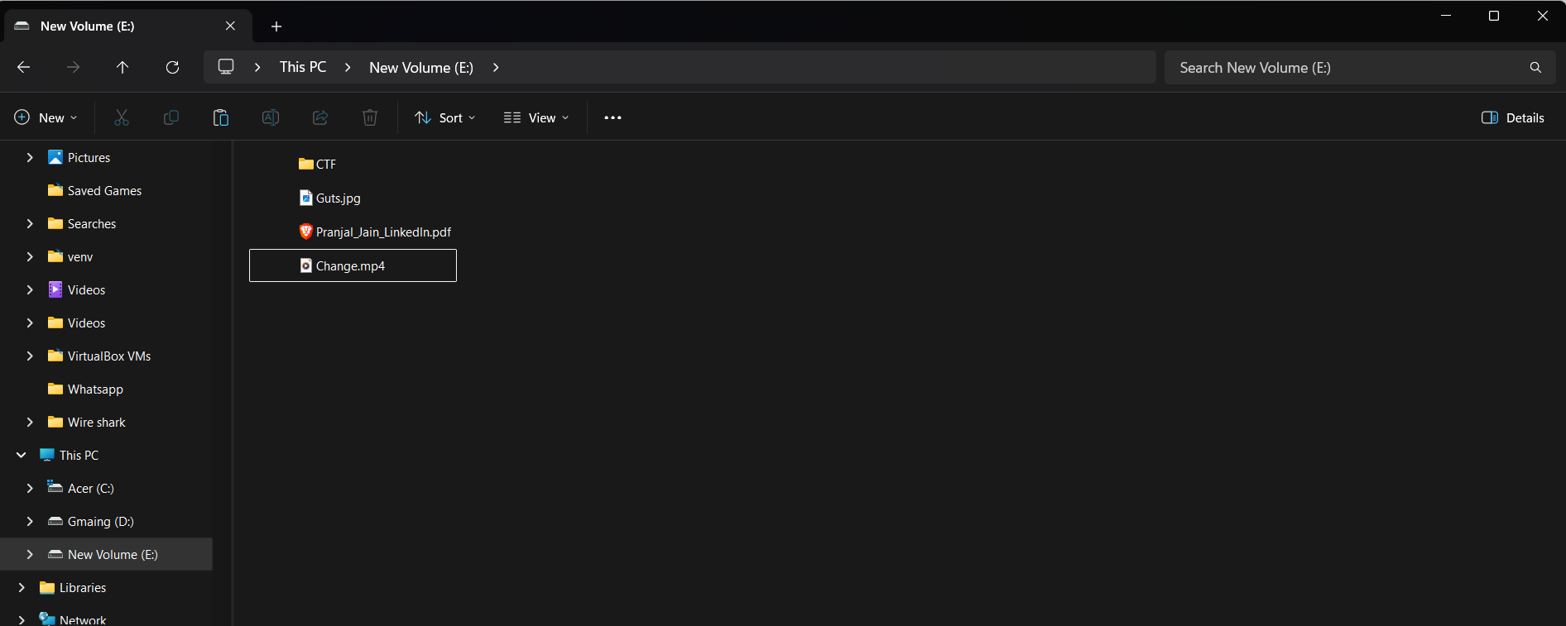
Fig 1: Original evidence files on the source volume before the partition was deleted.
Step 2: Scan for Lost Partitions Using TestDisk
- Run TestDisk with administrator privileges.
- Select the affected disk from the list of available drives.
- Choose the appropriate partition table type (e.g., Intel/PC partition table for MBR disks, or the EFI GPT option for GPT disks); TestDisk can also attempt to detect this automatically.
- Select the “Analyse” option to display the current in-memory partition structure.
- Select “Quick Search” to have TestDisk scan the disk for partition structures that are no longer listed.
- Review the list of partitions found, noting any marked as deleted or not currently in the partition table.
If the quick search does not locate the missing partition, a “Deeper Search” can be run, which scans the disk sector by sector for older or partially overwritten partition structures.
Step 3: Recover the Partition Table
- Select the partition(s) that should be restored from the list of found partitions.
- Verify the partition using the “P” option, which lists a sample of files inside it to confirm the correct partition has been identified.
- Choose “Write” to save the corrected partition table back to the disk.
- Restart the system if required, so the operating system re-reads the updated partition table.
Writing the partition table is the only step in this procedure that modifies the original disk; it should therefore be performed only after the correct partition has been positively verified.
Step 4: Image the Recovered Partition Using FTK Imager
- Open FTK Imager with administrator privileges.
- From the menu, select: File → Create Disk Image.
- Select the recovered partition (or the full physical disk) as the evidence source.
- Specify a destination folder on a separate storage device for the forensic image.
- Enter the case number, evidence number, description, and examiner details.
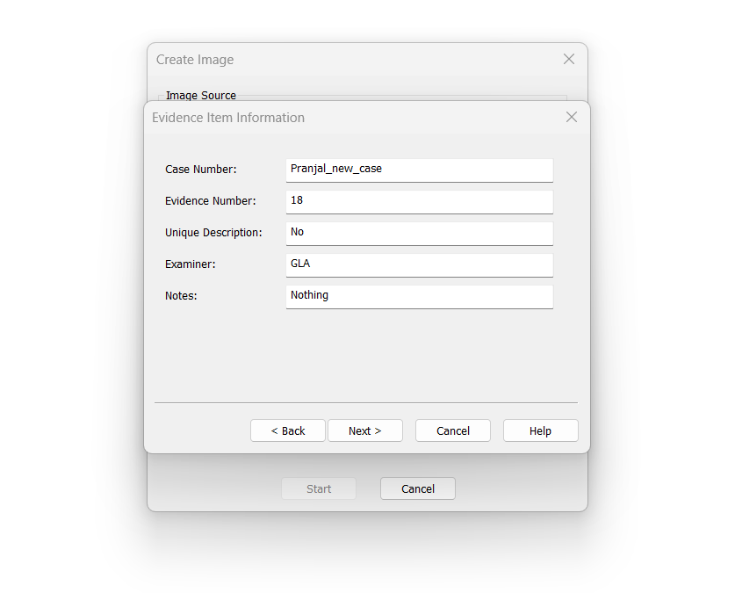
Fig 2: Evidence Item Information dialog in FTK Imager, recording case number, evidence number, examiner, and notes.
- Start the imaging process and allow FTK Imager to calculate the acquisition hash values (MD5/SHA-1).
Imaging the recovered partition immediately after recovery preserves the restored data in a stable, verifiable form before any further analysis is carried out.
Step 5: Explore and Extract Data
- In FTK Imager, select File → Add Evidence Item and load the newly created image.
- Browse the Evidence Tree to examine the folders and files within the recovered partition.
- Identify files and folders of interest, including any recovered deleted files shown in red.
- Export selected files or the entire folder structure to a separate working directory using File → Export Files.
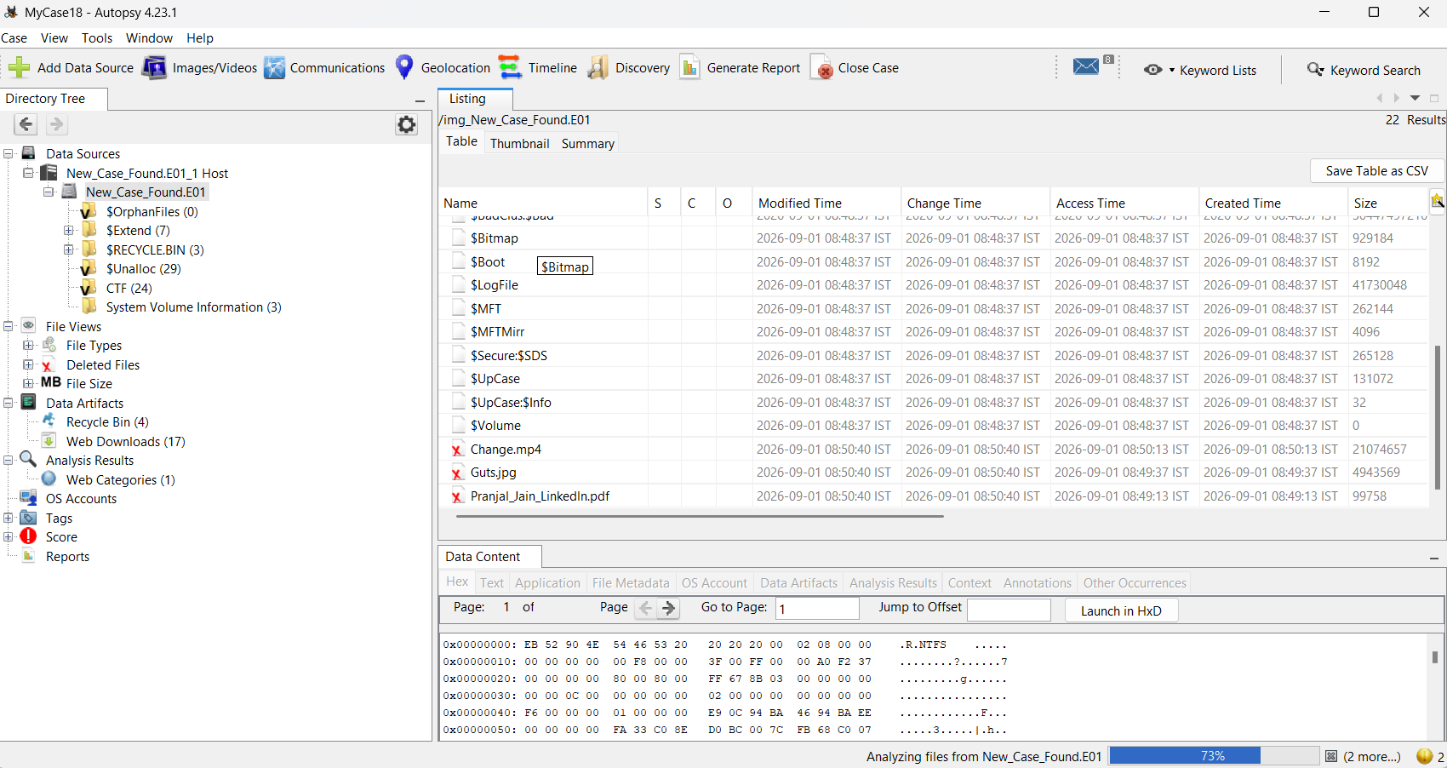
Fig 3: Autopsy listing showing recovered deleted files (marked with a red X) within the recovered partition, along with their MACB timestamps.
5. Verification of Recovered Evidence
Once the partition has been imaged, the recovered data is verified to confirm that the recovery process produced a consistent and readable file system.
Check | Tool Used | Expected Result
Partition structure | TestDisk | Correct partition type and size listed
Image acquisition hash | FTK Imager | MD5/SHA-1 recorded at acquisition
File system readability | FTK Imager Evidence Tree | Folders and files browsable without errors

If the recovered file system can be browsed without errors and the acquisition hash of the image is successfully recorded, the recovery and imaging process is considered verified.
6. Evidence Analysis
Once the recovered partition has been imaged and verified, the investigator examines its contents. The analysis may include:
- Identifying files and folders that were present on the deleted partition
- Comparing recovered file names/timestamps against known or expected data
- Recovering individual deleted files within the restored partition, where possible
- Documenting any data that could not be recovered or was partially overwritten
- Recording hash values of key recovered files for future reference
7. Precautions
- Never write to the affected disk before attempting recovery.
- Work from a forensic image or a write-protected copy wherever possible.
- Verify a partition with TestDisk's list/preview option before writing changes.
- Record the disk geometry and partition details before and after recovery.
- Image the recovered partition before performing detailed file analysis.
- Maintain a proper chain of custody for the original disk and all recovered data.
- Document every step performed, including tool names and versions used.
8. Result
The deleted partition was successfully located and its partition table structure was reconstructed using TestDisk. The recovered partition was then imaged using FTK Imager, and the acquisition hash values were recorded. The recovered data was examined and found to be consistent with the expected file structure, confirming that the deleted partition and its contents were successfully restored.
9. Conclusion
In this experiment, the process of recovering a deleted partition and analyzing its data was successfully performed. TestDisk was used to scan the disk, identify the lost partition structure, and restore the partition table, while FTK Imager was used to create a verified forensic image of the recovered partition and to browse and extract its contents.
This process demonstrates that deleting a partition does not necessarily destroy the underlying data, and that with the appropriate forensic tools, such data can often be recovered and examined as part of a digital investigation. It also reinforces the importance of working on a verified copy and documenting every recovery step to preserve the evidentiary value of the restored data.
Key Learning
- Understanding how partition deletion affects the partition table versus the underlying data
- Using TestDisk to scan for and recover lost/deleted partitions
- Rewriting a corrected partition table safely after verification
- Using FTK Imager to acquire and verify a forensic image of a recovered partition
- Browsing and exporting recovered data for further analysis
- Maintaining evidence integrity throughout the partition recovery process

