Advance Numerical Technique Laboratory

Lab 1

**Q.1** Solve this boundary value problem using shooting method and classical runge kutta method.

$$y^{'}y^{''}+1+{(y')}^{2}= 0$$

$$y\left(0\right)=1$$

$$y\left(1\right)=2$$

$$a_{0}=0.5$$

$$a_{1}=1$$

$$h=0.2$$

**Solution** :-

Rearranging differential equation, we get,

$$y^{''}= \frac{-1-({y')}^{2}}{y'}$$

**Iteration 1**

$$For a_{0}=0.5$$

|  |  |  |  |  |  |  |
| --- | --- | --- | --- | --- | --- | --- |
| x/y/y’ | x = 0 | x = 0.2 | x = 0.4 | x = 0.6 | x = 0.8 | x = 1.0 |
| y | 1.0 | 1.0770 | 1.1135 | 1.1135 | 1.0770 | 1.0000 |
| y' | 0.5 | 0.2785 | 0.0898 | -0.0898 | -0.2786 | -0.5001 |

|  |  |  |  |  |  |  |
| --- | --- | --- | --- | --- | --- | --- |
| x/y/y’ | x = 0 | x = 0.2 | x = 0.4 | x = 0.6 | x = 0.8 | x = 1.0 |
| y | 1.0 | 1.1661 | 1.2805 | 1.3563 | 1.3998 | 1.4139 |
| y' | 1.0000 | 0.6858 | 0.4683 | 0.2947 | 0.1427 | -0.0002 |

Using secant method,

$$a_{new}=1.7079$$

**Iteration 2**

$$For a_{0}=1.0$$

|  |  |  |  |  |  |  |
| --- | --- | --- | --- | --- | --- | --- |
| x/y/y’ | x = 0 | x = 0.2 | x = 0.4 | x = 0.6 | x = 0.8 | x = 1.0 |
| y | 1.0 | 1.1661 | 1.2805 | 1.3563 | 1.3998 | 1.4139 |
| y' | 1.0000 | 0.6858 | 0.4683 | 0.2947 | 0.1427 | -0.0002 |

|  |  |  |  |  |  |  |
| --- | --- | --- | --- | --- | --- | --- |
| x/y/y’ | x = 0 | x = 0.2 | x = 0.4 | x = 0.6 | x = 0.8 | x = 1.0 |
| y | 1.0000 | 1.2812 | 1.4844 | 1.6388 | 1.7572 | 1.8466 |
| y' | 1.7079 | 1.1751 | 0.8794 | 0.6745 | 0.5152 | 0.3820 |

Using secant method,

$$a_{new}=1.9589$$

**Iteration 3**

$$For a_{0}=1.9589$$

|  |  |  |  |  |  |  |
| --- | --- | --- | --- | --- | --- | --- |
| x/y/y’ | x = 0 | x = 0.2 | x = 0.4 | x = 0.6 | x = 0.8 | x = 1.0 |
| y | 1.0000 | 1.2812 | 1.4844 | 1.6388 | 1.7572 | 1.8466 |
| y' | 1.7079 | 1.1751 | 0.8794 | 0.6745 | 0.5152 | 0.3820 |

|  |  |  |  |  |  |  |
| --- | --- | --- | --- | --- | --- | --- |
| x/y/y’ | x = 0 | x = 0.2 | x = 0.4 | x = 0.6 | x = 0.8 | x = 1.0 |
| y | 1.0000 | 1.3261 | 1.5613 | 1.7428 | 1.8859 | 1.9990 |
| y' | 2.0039 | 1.3568 | 1.0240 | 0.8026 | 0.6356 | 0.4996 |

Using secant method,

$$a_{new}=2.0058$$

**Iteration 4**

$$For a_{0}=2.0039$$

|  |  |  |  |  |  |  |
| --- | --- | --- | --- | --- | --- | --- |
| x/y/y’ | x = 0 | x = 0.2 | x = 0.4 | x = 0.6 | x = 0.8 | x = 1.0 |
| y | 1.0000 | 1.3261 | 1.5613 | 1.7428 | 1.8859 | 1.9990 |
| y' | 2.0039 | 1.3568 | 1.0240 | 0.8026 | 0.6356 | 0.4996 |

|  |  |  |  |  |  |  |
| --- | --- | --- | --- | --- | --- | --- |
| x/y/y’ | x = 0 | x = 0.2 | x = 0.4 | x = 0.6 | x = 0.8 | x = 1.0 |
| y | 1.0000 | 1.3263 | 1.5618 | 1.7434 | 1.8867 | 2.0000 |
| y' | 2.0058 | 1.3579 | 1.0249 | 0.8034 | 0.6364 | 0.5003 |

Using secant method,

$$a_{new}=2.0058$$

Here the last two values of $a$ are nearly same, which means the value of $a$ converges. Below is the graph of the differential equation solved numerically.

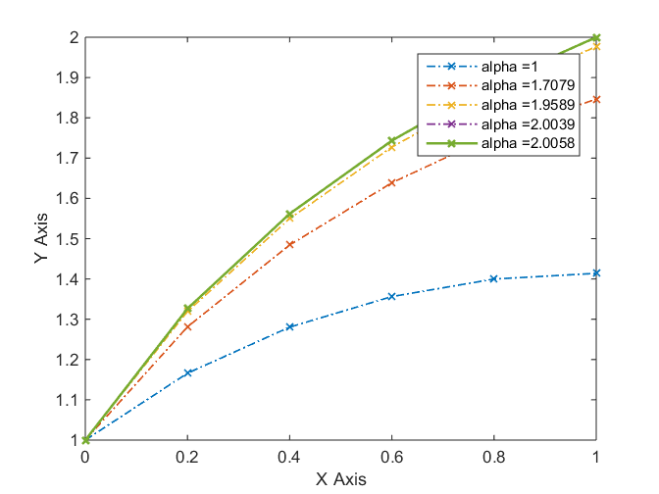

Fig. 1 Graph of the y values calculated

**Q.2** Solve this boundary value problem using shooting method and classical runge kutta method.

$$y^{''}-y= 0$$

$$y\left(0\right)=0$$

$$y\left(1\right)=1$$

$$a_{0}=0.3$$

$$a_{1}=0.4$$

$$h=0.1$$

**Solution** :-

**Iteration 1**

$$For a_{0}=0.3$$

|  |  |  |  |  |  |  |  |  |  |  |  |
| --- | --- | --- | --- | --- | --- | --- | --- | --- | --- | --- | --- |
|  | x = 0 | x = 0.2 | x = 0.4 | x = 0.6 | x = 0.8 | x = 1.0 | x = 0.2 | x = 0.4 | x = 0.6 | x = 0.8 | x = 1.0 |
| y | 0 | 0.0852 | 0.1713 | 0.2591 | 0.3495 | 0.4434 | 0.5417 | 0.6455 | 0.7557 | 0.8735 | 1 |
| y' | 0.8509 | 0.8552 | 0.868 | 0.8895 | 0.9199 | 0.9595 | 1.0087 | 1.068 | 1.138 | 1.2194 | 1.313 |

|  |  |  |  |  |  |  |  |  |  |  |  |
| --- | --- | --- | --- | --- | --- | --- | --- | --- | --- | --- | --- |
|  | x = 0 | x = 0.2 | x = 0.4 | x = 0.6 | x = 0.8 | x = 1.0 | x = 0.2 | x = 0.4 | x = 0.6 | x = 0.8 | x = 1.0 |
| y | 0 | 0.0401 | 0.0805 | 0.1218 | 0.1643 | 0.2084 | 0.2547 | 0.3034 | 0.3552 | 0.4106 | 0.4701 |
| y' | 0.4 | 0.402 | 0.408 | 0.4181 | 0.4324 | 0.4511 | 0.4742 | 0.5021 | 0.535 | 0.5732 | 0.6172 |

Using secant method,

$$a_{new}=-0.85092$$

**Iteration 2**

$$For a_{0}=0.4$$

|  |  |  |  |  |  |  |  |  |  |  |  |
| --- | --- | --- | --- | --- | --- | --- | --- | --- | --- | --- | --- |
|  | x = 0 | x = 0.2 | x = 0.4 | x = 0.6 | x = 0.8 | x = 1.0 | x = 0.2 | x = 0.4 | x = 0.6 | x = 0.8 | x = 1.0 |
| y | 0 | 0.0401 | 0.0805 | 0.1218 | 0.1643 | 0.2084 | 0.2547 | 0.3034 | 0.3552 | 0.4106 | 0.4701 |
| y' | 0.4 | 0.402 | 0.408 | 0.4181 | 0.4324 | 0.4511 | 0.4742 | 0.5021 | 0.535 | 0.5732 | 0.6172 |

|  |  |  |  |  |  |  |  |  |  |  |  |
| --- | --- | --- | --- | --- | --- | --- | --- | --- | --- | --- | --- |
|  | x = 0 | x = 0.2 | x = 0.4 | x = 0.6 | x = 0.8 | x = 1.0 | x = 0.2 | x = 0.4 | x = 0.6 | x = 0.8 | x = 1.0 |
| y | 0 | -0.0852 | -0.1713 | -0.2591 | -0.3495 | -0.4434 | -0.5417 | -0.6455 | -0.7557 | -0.8735 | -1.0000 |
| y' | -0.8509 | -0.8552 | -0.868 | -0.8895 | -0.9199 | -0.9595 | -1.0087 | -1.068 | -1.138 | -1.2194 | -1.3130 |

Using secant method,

$$a_{new}=-0.8509$$

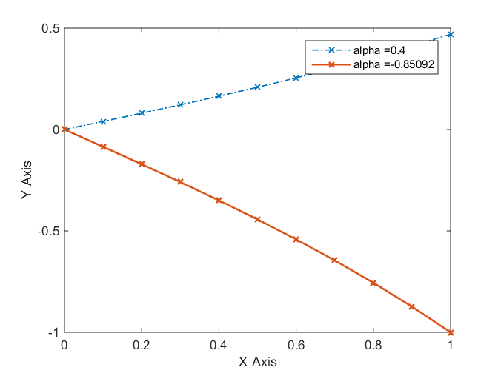

Fig. 2 Graph of the y values calculated