Advance Numerical Technique Laboratory

Lab 2

**Q.1** Solve this boundary value problem using shooting method and classical runge kutta method.

$$y^{''}= x+y$$

$$y\left(0\right)=0$$

$$y\left(1\right)=0$$

$$h=0.25$$

**Solution** :-

Trigonal Matrix

$$\left[\begin{matrix}-33 & 16 & 0 \\ 16 & -33 & 16 \\ 0 & 16 & -33\end{matrix}\right]Y= \left[\begin{matrix}0.25 \\ 0.50 \\ 0.75\end{matrix}\right]$$

$$Y= \left[\begin{aligned}-0.349 \\ -0.0563 \\ -0.05\end{aligned}\right]$$

Plot = $\left[\begin{aligned}0 \\ 0.25 \\ 0.50 \\ 0.75 \\ 1\end{aligned}\begin{aligned}0 \\ -0.349 \\ -0.0563 \\ -0.05 \\ 0\end{aligned}\right]$

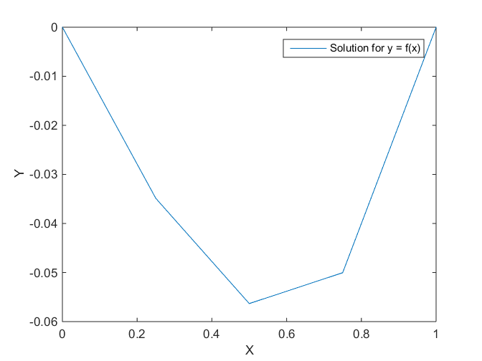

Fig. 1 Graph of the y values calculated

**Q.2** Solve this boundary value problem using shooting method and classical runge kutta method.

$$y^{''}-y= 0$$

$$y\left(0\right)=0$$

$$y\left(0.5\right)=1$$

$$a_{0}=0.3$$

$$a_{1}=0.4$$

$$h=0.1$$

**Solution** :-

Trigonal Matrix

$$\left[\begin{matrix}-198 & 101 & 0 & 0 \\ 98 & -198 & 102 & 0 \\ 0 & 97 & -198 & 103 \\ 0 & 0 & 96 & -198\end{matrix}\right]Y= \left[\begin{matrix}-98.6 \\ 0.8 \\ 1.2 \\ -131.416\end{matrix}\right]$$

$$Y=\left[\begin{aligned}1.0903 \\ 1.1612 \\ 1.2143 \\ 1.2525\end{aligned}\right]$$

Plot = $\left[\begin{aligned}0 \\ 0.1 \\ 0.2 \\ 0.3 \\ 0.4 \\ 0.5\end{aligned}\begin{aligned}1 \\ 1.0903 \\ 1.1612 \\ 1.2143 \\ 1.2525 \\ 1.2790\end{aligned}\right]$

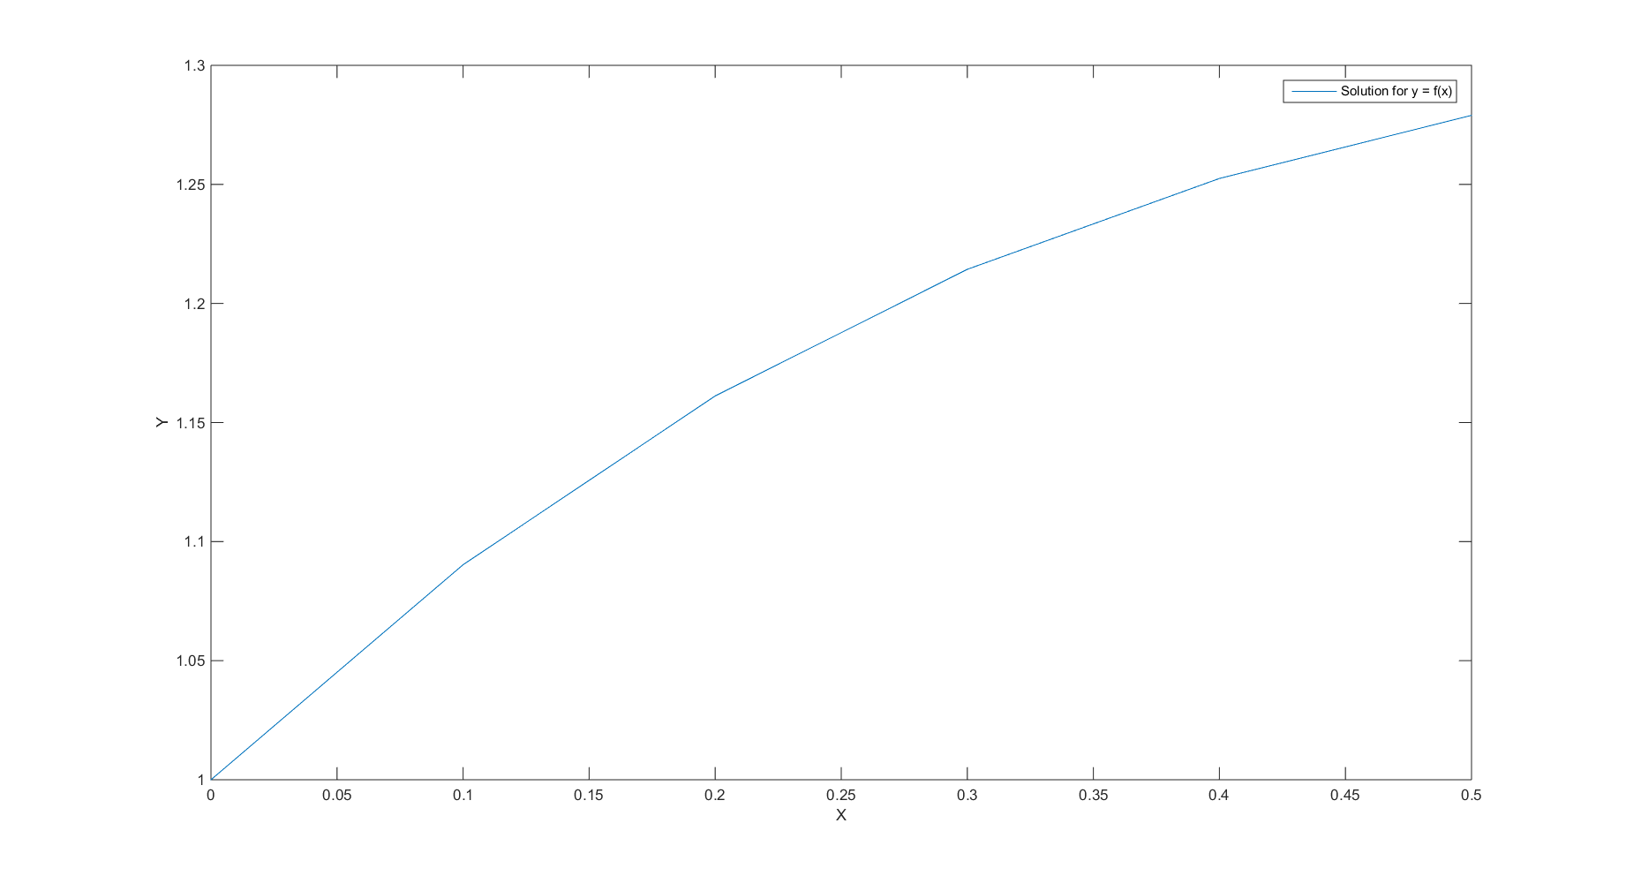

Fig. 2 Graph of the y values calculated