Advance Numerical Technique Laboratory

Lab 3

**Q.1** Solve

$$y^{''''}+81y= 81x2$$

$$y\left(0\right)=0;y\left(1\right)=0$$

$$y^{''}\left(0\right)=0;y^{''}\left(1\right)=0$$

$$h=0.05$$

**Solution** :-

ans(:,:,1)=0.022684,-0.125163

ans(:,:,2)=0.045055,-0.254413

ans(:,:,3)=0.066790,-0.390762

ans(:,:,4)=0.087548,-0.536079

ans(:,:,5)=0.10697,-0.69103

ans(:,:,6)=0.12466,-0.85498

ans(:,:,7)=0.14021,-1.02594

ans(:,:,8)=0.15320,-1.20050

ans(:,:,9)=0.16318,-1.37367

ans(:,:,10)=0.16974,-1.53889

ans(:,:,11)=0.17244,-1.68785

ans(:,:,12)=0.17093,-1.81048

ans(:,:,13)=0.16489,-1.89481

ans(:,:,14)=0.15411,-1.92699

ans(:,:,15)=0.13851,-1.89114

ans(:,:,16)=0.11819,-1.76944

ans(:,:,17)=0.093445,-1.542066

ans(:,:,18)=0.064844,-1.187313

ans(:,:,19)=0.033274,-0.681666

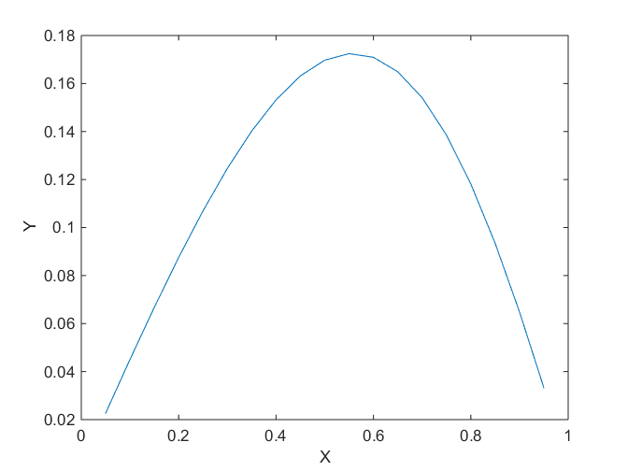

Fig. 1 Graph of the y values calculated