Advance Numerical Technique Laboratory

Lab 2

**Q.1** Solve this boundary value problem using shooting method and classical runge kutta method.

$$y^{''}-2xy^{'}-2= -4x$$

$$y\left(0\right)-y'(0)=0$$

$$2y\left(1\right)-y'(1)=1$$

$$h=0.1$$

**Solution** :-

mat_A =

-222.0000 200.0000 0 0 0 0 0

101.0000 -202.0000 99.0000 0 0 0 0

0 102.0000 -202.0000 98.0000 0 0 0

0 0 103.0000 -202.0000 97.0000 0 0

0 0 0 104.0000 -202.0000 96.0000 0

0 0 0 0 105.0000 -202.0000 95.0000

0 0 0 0 0 106.0000 -202.0000

0 0 0 0 0 0 107.0000

0 0 0 0 0 0 0

0 0 0 0 0 0 0

0 0 0 0 0 0 0

Columns 8 through 11

0 0 0 0

0 0 0 0

0 0 0 0

0 0 0 0

0 0 0 0

0 0 0 0

94.0000 0 0 0

-202.0000 93.0000 0 0

108.0000 -202.0000 92.0000 0

0 109.0000 -202.0000 91.0000

0 0 90.0000 -238.0000

vec_b =

0

-0.4000

-0.8000

-1.2000

-1.6000

-2.0000

-2.4000

-2.8000

-3.2000

-3.6000

-21.8000

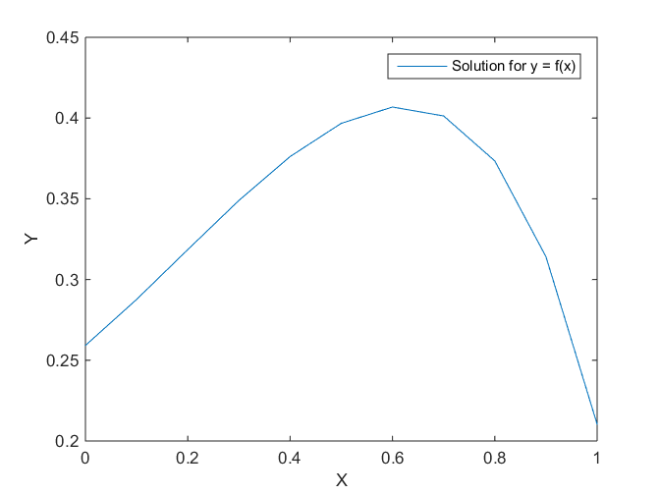

Fig. 1 Graph of the y values calculated