Advance Numerical Technique Laboratory

Lab 4

**Q.1** Solve

$$y'' = .5*(1+x+y)^3$$

$$y\left(0\right)= 0, y\left(1\right)= 0, h=0.02$$

e = 10^-5

**Solution** :-

y =

Columns 1 through 9

0 -0.0099 -0.0196 -0.0291 -0.0383 -0.0474 -0.0562 -0.0647 -0.0730

Columns 10 through 18

-0.0811 -0.0889 -0.0964 -0.1036 -0.1106 -0.1172 -0.1235 -0.1295 -0.1352

Columns 19 through 27

-0.1405 -0.1454 -0.1500 -0.1542 -0.1579 -0.1613 -0.1642 -0.1666 -0.1686

Columns 28 through 36

-0.1701 -0.1711 -0.1715 -0.1714 -0.1707 -0.1694 -0.1674 -0.1648 -0.1615

Columns 37 through 45

-0.1575 -0.1527 -0.1471 -0.1406 -0.1333 -0.1251 -0.1158 -0.1056 -0.0943

Columns 46 through 51

-0.0818 -0.0681 -0.0532 -0.0369 -0.0192 0

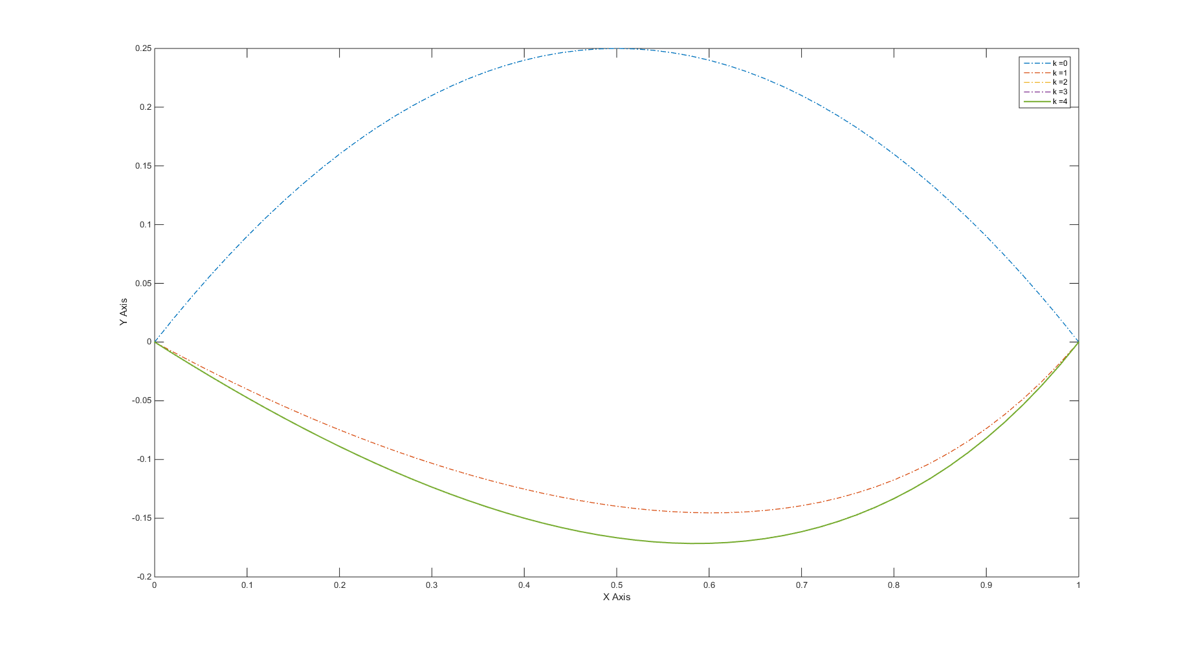

Fig1: Plot at every iteration

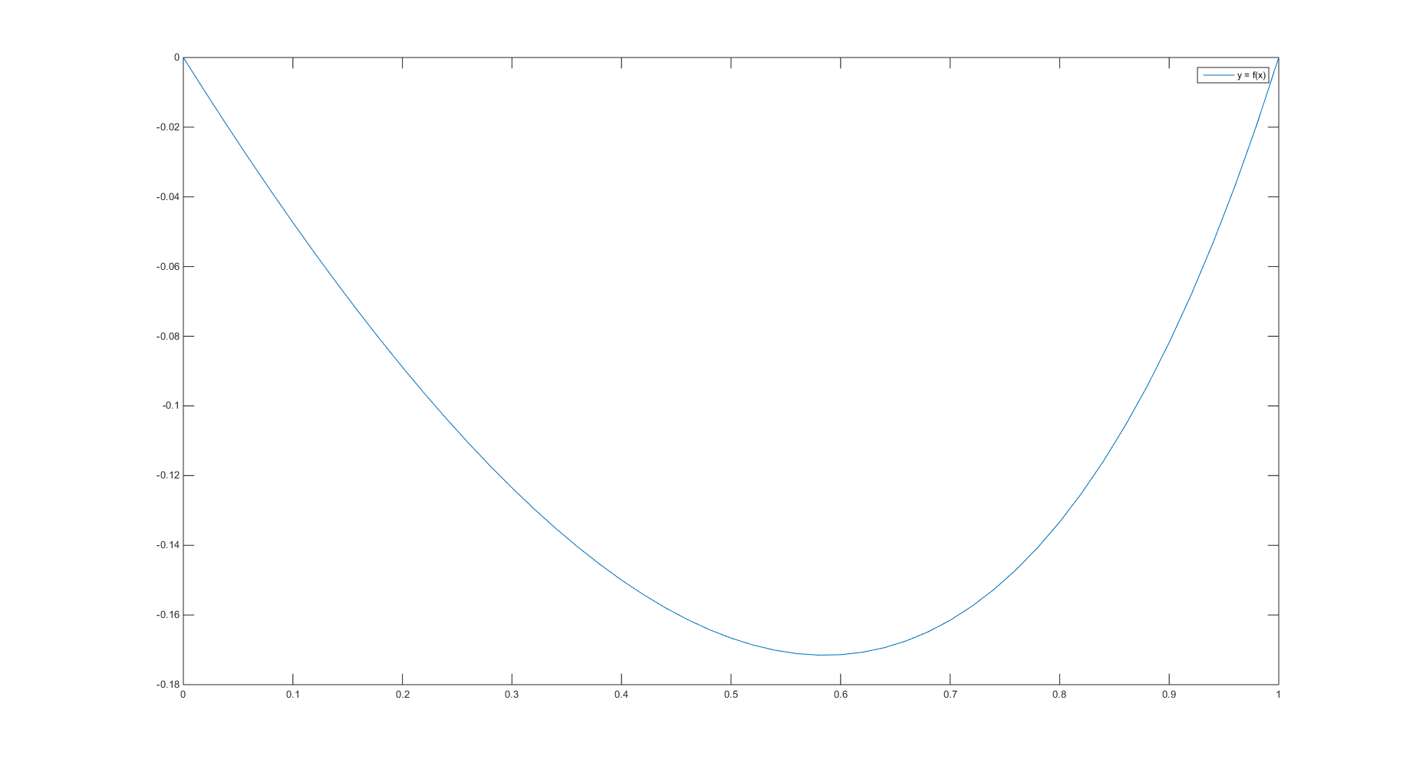

Fig2: Plot at final iteration

**Q.2** Solve

$$y''' + yy'' + 1 - (y')^2 = 0$$

$$y(0) = 0, y'(0) = 0$$

$$y'(10) = 1$$

$$h = 0.1;$$

e = 10^-5

**Solution** :-

w =

Columns 1 through 9

0 0.0059 0.0232 0.0508 0.0878 0.1332 0.1863 0.2461 0.3119

0 0.1183 0.2267 0.3253 0.4145 0.4947 0.5664 0.6299 0.6860

Columns 10 through 18

0.3829 0.4586 0.5382 0.6213 0.7074 0.7959 0.8865 0.9790 1.0729

0.7352 0.7779 0.8149 0.8467 0.8739 0.8969 0.9162 0.9324 0.9458

Columns 19 through 27

1.1680 1.2642 1.3611 1.4588 1.5569 1.6555 1.7544 1.8536 1.9530

0.9569 0.9659 0.9733 0.9792 0.9839 0.9877 0.9906 0.9929 0.9947

Columns 28 through 36

2.0525 2.1521 2.2519 2.3517 2.4516 2.5515 2.6514 2.7514 2.8513

0.9960 0.9971 0.9979 0.9984 0.9989 0.9992 0.9994 0.9996 0.9997

Columns 37 through 45

2.9513 3.0513 3.1513 3.2513 3.3513 3.4513 3.5513 3.6513 3.7513

0.9998 0.9999 0.9999 0.9999 1.0000 1.0000 1.0000 1.0000 1.0000

Columns 46 through 54

3.8513 3.9513 4.0513 4.1513 4.2513 4.3513 4.4513 4.5513 4.6513

1.0000 1.0000 1.0000 1.0000 1.0000 1.0000 1.0000 1.0000 1.0000

Columns 55 through 63

4.7513 4.8513 4.9513 5.0513 5.1513 5.2513 5.3513 5.4513 5.5513

1.0000 1.0000 1.0000 1.0000 1.0000 1.0000 1.0000 1.0000 1.0000

Columns 64 through 72

5.6513 5.7513 5.8513 5.9513 6.0513 6.1513 6.2513 6.3513 6.4513

1.0000 1.0000 1.0000 1.0000 1.0000 1.0000 1.0000 1.0000 1.0000

Columns 73 through 81

6.5513 6.6513 6.7513 6.8513 6.9513 7.0513 7.1513 7.2513 7.3513

1.0000 1.0000 1.0000 1.0000 1.0000 1.0000 1.0000 1.0000 1.0000

Columns 82 through 90

7.4513 7.5513 7.6513 7.7513 7.8513 7.9513 8.0513 8.1513 8.2513

1.0000 1.0000 1.0000 1.0000 1.0000 1.0000 1.0000 1.0000 1.0000

Columns 91 through 99

8.3513 8.4513 8.5513 8.6513 8.7513 8.8513 8.9513 9.0513 9.1513

1.0000 1.0000 1.0000 1.0000 1.0000 1.0000 1.0000 1.0000 1.0000

Columns 100 through 101

9.2513 9.3513 1.0000 1.0000

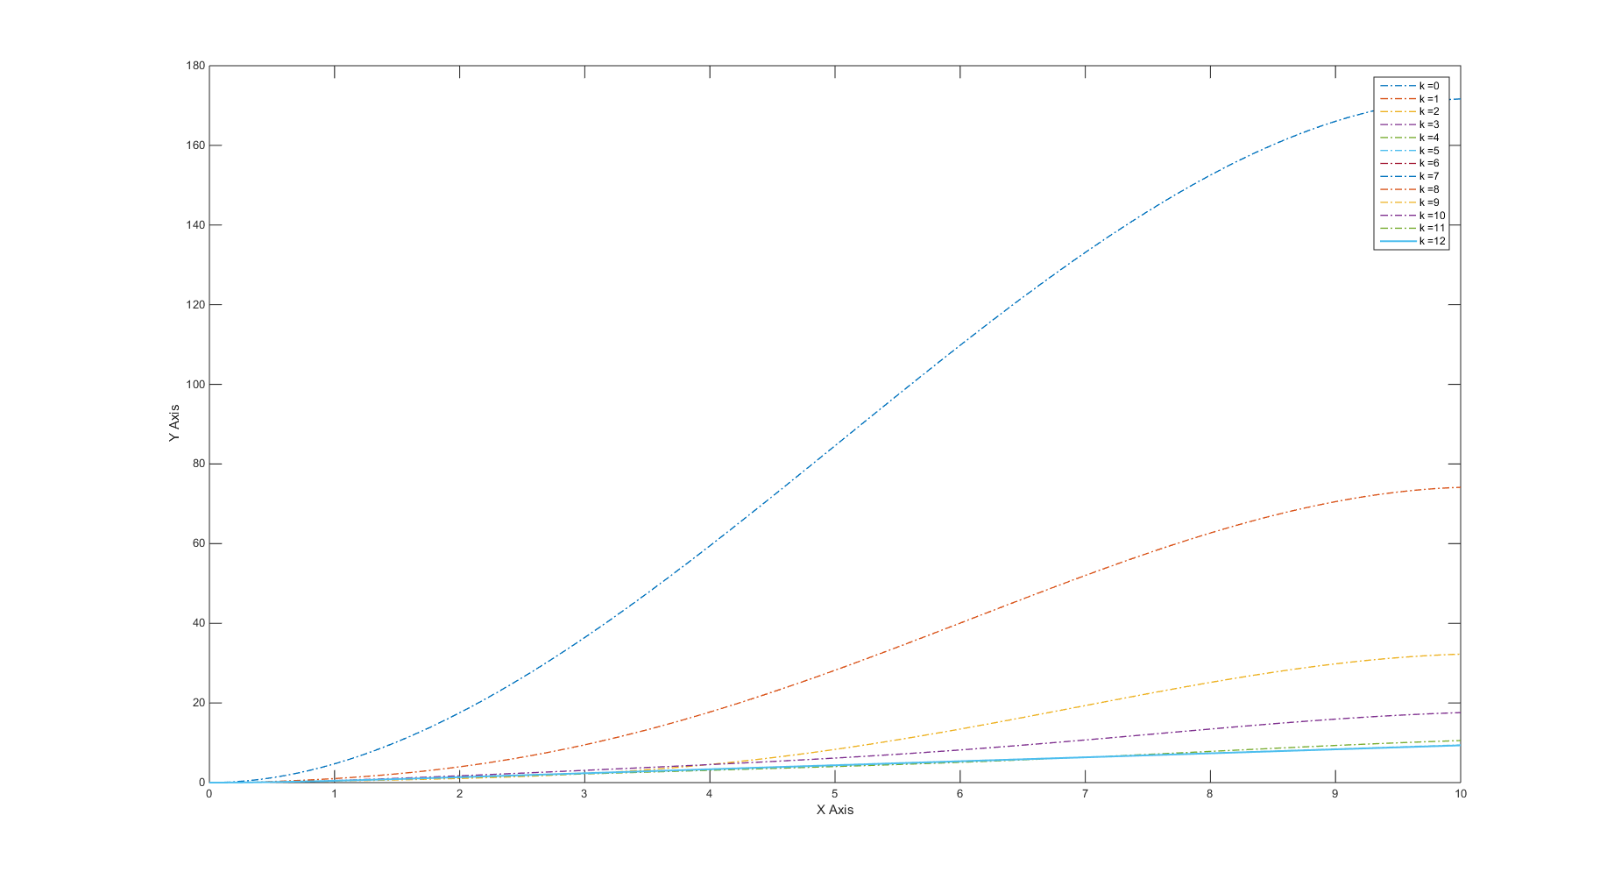

Fig1: Plot of y at every iteration

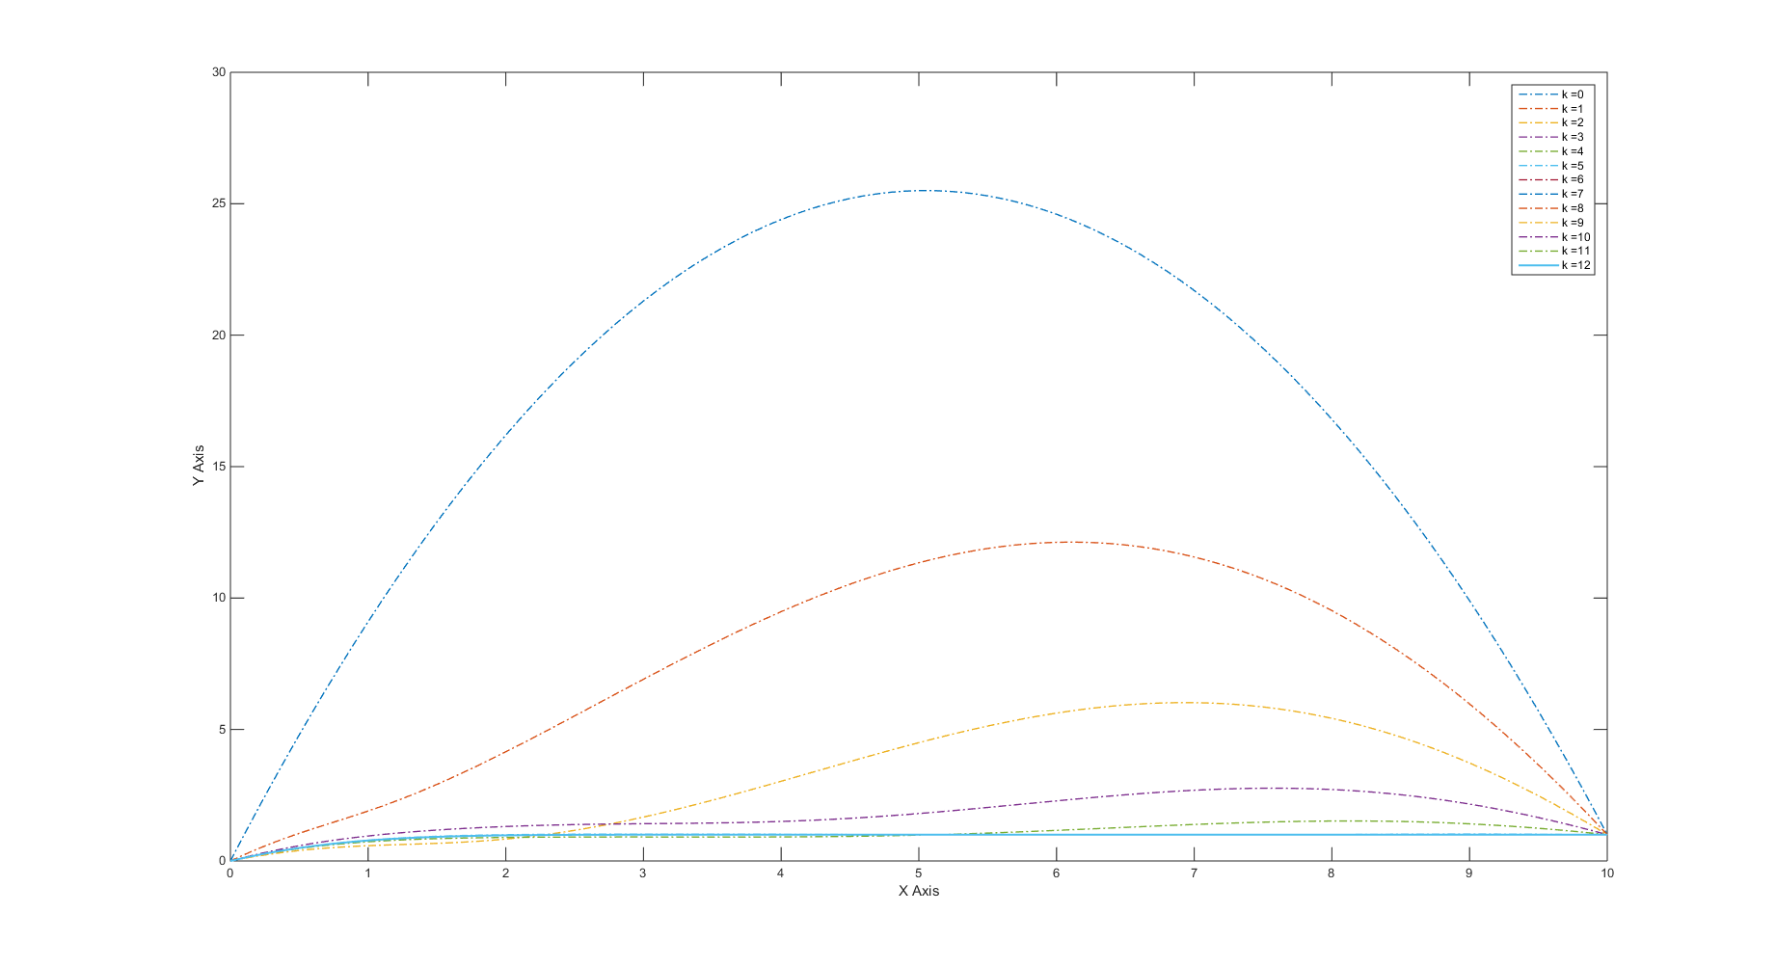

Fig2: Plot of y’ at every iteration

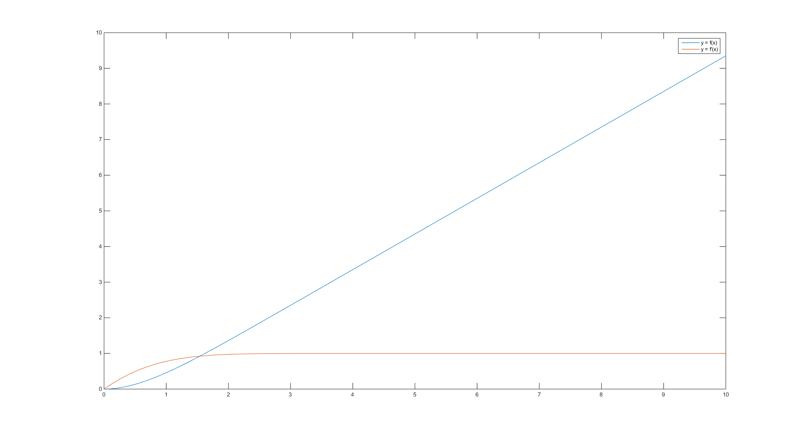

Fig3: Plot at final iteration