Advance Numerical Technique Laboratory

Lab 8

**Q.1** Solve linear BVP and implement Spline Interpolation Method

y'' + 2y' + y = 30x

y(0) = 0, y(1) = 0

h = 1/2

**Solution** :-

w =

0 -1.7045 0

13.5124 13.1405 15.7438

x =

0 0.5000 1.0000

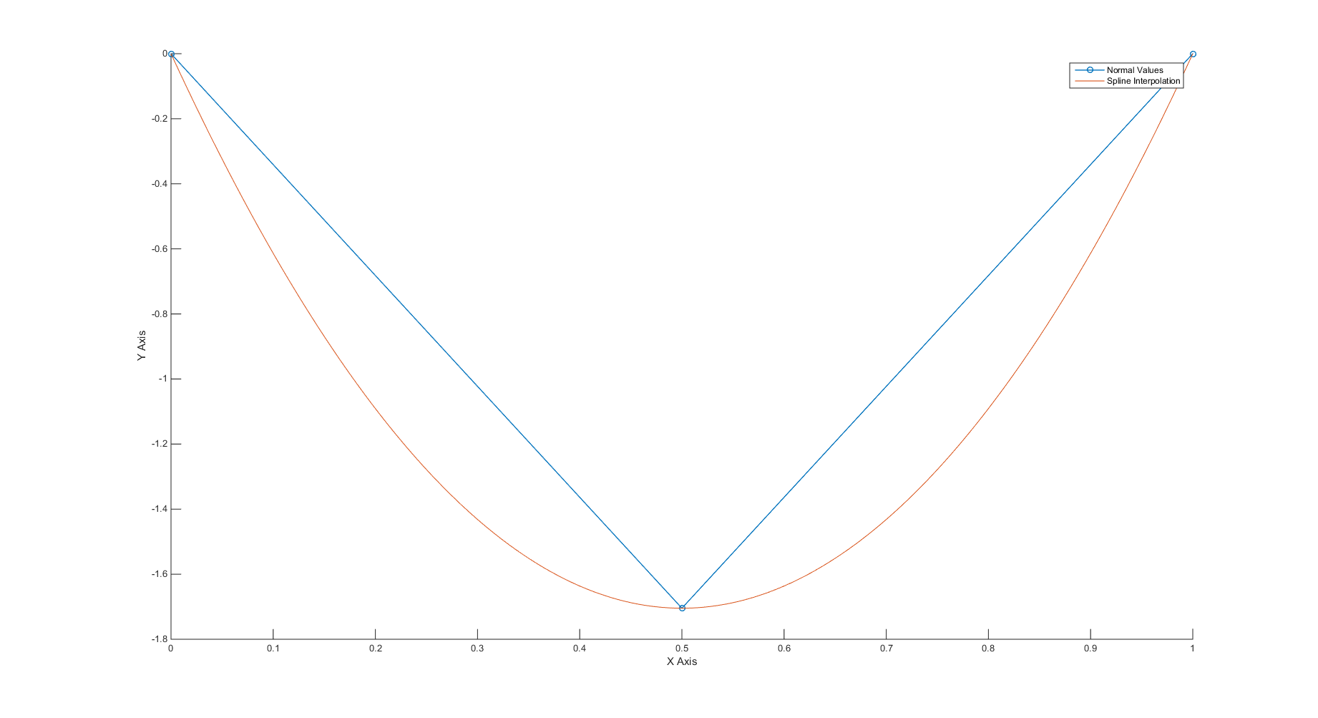

Fig1: Final Plot

**Q.2** Solve Possion’s Equation using 5-Point Method and Gauss Seidal Method

d2u/dx2 + d2u/dy2 = x^2 + y^2

u(x ,y) = 0 for 0 <= x,y <= 1

h = 1/4

Solution:-

u =

ans =

0 0 0 0 0

0 -0.0142 -0.0245 -0.0254 0

0 -0.0245 -0.0391 -0.0379 0

0 -0.0254 -0.0379 -0.0365 0

0 0 0 0 0

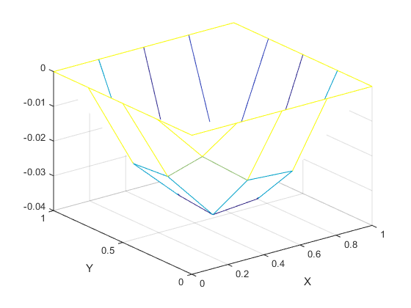

Fig2: Plot