Advance Numerical Technique Laboratory

Lab 9

**Q.1** Solve using Line by Line Algorithm

d2u/dx2 + d2u/dy2 = x^2 + y^2

u(x ,y) = 0 for 0 <= x,y <= 1

h = 1/4

**Solution** :-

u =

0 0 0 0 0

0 -0.0142 -0.0246 -0.0254 0

0 -0.0246 -0.0391 -0.0379 0

0 -0.0254 -0.0379 -0.0366 0

0 0 0 0 0

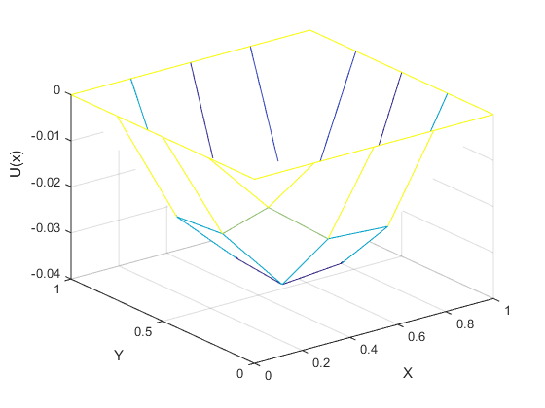

Fig1: Final Plot