Module 2: Excel for Data Analytics

What is Microsoft Excel?
Microsoft Excel is a spreadsheet software developed by Microsoft that is used to store, organize, analyze, and visualize data in the form of rows and columns. Excel allows users to perform calculations, create reports, analyze trends, and generate charts using formulas and functions. In many organizations, Excel is one of the first tools used for data analysis because it is easy to learn, flexible, and widely available.

Why Excel is Used for Data Analytics
Excel is widely used in data analytics because it provides powerful tools that help analysts clean data, perform calculations, summarize information, and visualize patterns. Businesses use Excel to understand their data and make better decisions.
Excel helps analysts to:
• Organize raw data into structured tables
• Perform calculations using formulas and functions
• Analyze patterns and trends
• Create charts and visual reports
• Build dashboards for business insights

Example of Excel for Data Analytics
Below is a simple example of a sales dataset that can be analyzed in Excel. Analysts can use such data to identify which region has the highest sales, which product performs best, and how sales change over time.
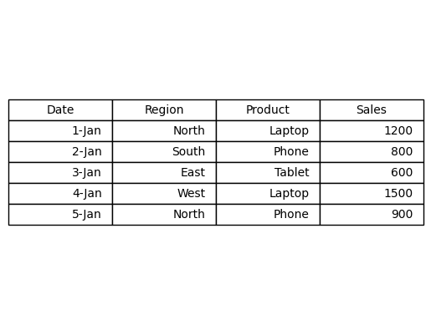

Usage of Excel in Data Analytics
Excel is commonly used in data analytics for the following tasks:
• Sales analysis and performance tracking
• Financial reporting and budgeting
• Customer data analysis
• Marketing campaign performance analysis
• Inventory and supply chain analysis

Advantages of Using Excel for Data Analytics
• Easy to learn and widely available
• Supports powerful formulas and functions
• Allows quick data visualization using charts
• Suitable for small and medium datasets
• Helps create dashboards and reports quickly

Disadvantages of Using Excel for Data Analytics
• Not suitable for very large datasets
• Manual errors can occur if formulas are incorrect
• Limited automation compared to programming tools like Python
• Collaboration is more difficult compared to cloud tools

Conclusion
Microsoft Excel is one of the most important tools used by data analysts. It helps transform raw data into useful insights through formulas, functions, charts, and dashboards. Although advanced analytics tools exist, Excel remains a fundamental skill for anyone working in data analytics.

